CO3 – CO3 – Exception Handling and Multithreaded Programming
AT3 – Assignment-2

Q1 – Student Grade Calculator – ArithmeticException

Code
import java.util.*;
public class Main {
public static void main(String[] args) {
Scanner sc = new Scanner(System.in);
System.out.print("Enter total marks: ");
int total = sc.nextInt();
System.out.print("Enter number of subjects: ");
int subjects = sc.nextInt();

try {
double average = (double) total / subjects;
System.out.println("Average: " + average);
} catch (ArithmeticException e) {
System.out.println("Error: Number of subjects cannot be zero.");
}
}
}

Output Screenshot
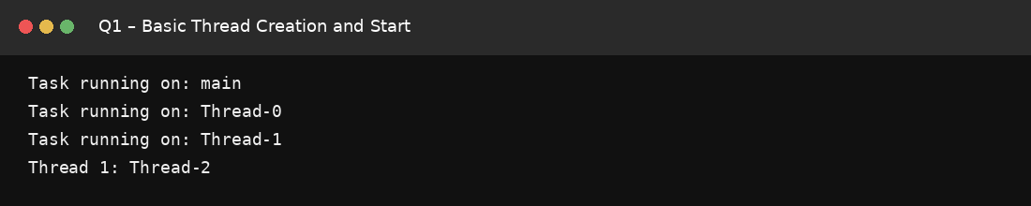

Q2 – Bank Withdrawal – Insufficient Balance Exception

Code
import java.util.*;
class InsufficientBalanceException extends Exception {
InsufficientBalanceException(String message) {
super(message);
}
}
public class Main {
public static void main(String[] args) {
Scanner sc = new Scanner(System.in);
System.out.print("Enter balance: ");
double balance = sc.nextDouble();
System.out.print("Enter withdrawal: ");
double amount = sc.nextDouble();

try {
if (amount > balance)
throw new InsufficientBalanceException("Insufficient balance");
balance -= amount;
System.out.println("Withdrawal successful");
System.out.println("Updated balance: " + balance);
} catch (InsufficientBalanceException e) {
System.out.println("Error: " + e.getMessage());
}
}
}

Output Screenshot
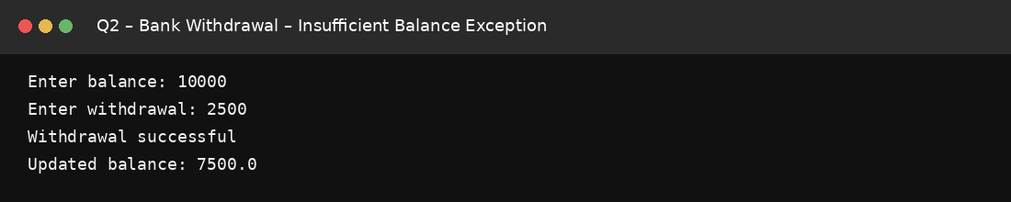

Q3 – Employee Age Validator – User-Defined Exception

Code
import java.util.*;
class InvalidAgeException extends Exception {
InvalidAgeException(String message) {
super(message);
}
}
public class Main {
static void validateAge(int age) throws InvalidAgeException {
if (age < 18 || age > 60)
throw new InvalidAgeException("Age must be between 18 and 60");
}

public static void main(String[] args) {
Scanner sc = new Scanner(System.in);
System.out.print("Enter employee name: ");
String name = sc.nextLine();
System.out.print("Enter age: ");
int age = sc.nextInt();

try {
validateAge(age);
System.out.println(name + " registered successfully.");
} catch (InvalidAgeException e) {
System.out.println("Error: " + e.getMessage());
}
}
}

Output Screenshot
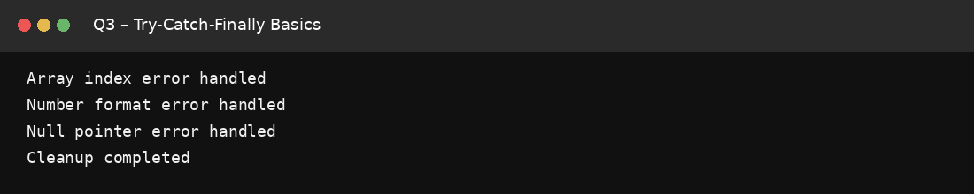

Q4 – Student Record Search – ArrayIndexOutOfBoundsException

Code
import java.util.*;
public class Main {
public static void main(String[] args) {
int[] marks = {85, 90, 78, 92, 88};
Scanner sc = new Scanner(System.in);
System.out.print("Enter index: ");
int index = sc.nextInt();

try {
System.out.println("Marks: " + marks[index]);
} catch (ArrayIndexOutOfBoundsException e) {
System.out.println("Error: Invalid index.");
}
}
}

Output Screenshot
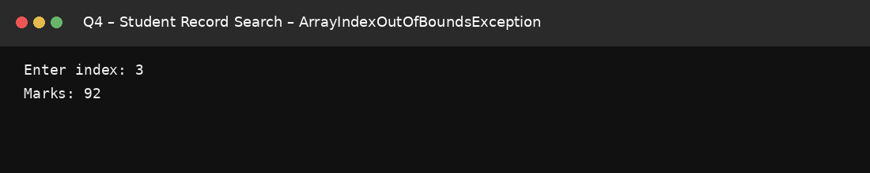

Q5 – Product Price Input – NumberFormatException

Code
import java.util.*;
public class Main {
public static void main(String[] args) {
Scanner sc = new Scanner(System.in);
System.out.print("Enter product price: ");
String input = sc.nextLine();

try {
double price = Double.parseDouble(input);
System.out.println("Price: " + price);
} catch (NumberFormatException e) {
System.out.println("Error: Invalid numeric price.");
}
}
}

Output Screenshot
