CO4 – CO4 – Applet Programming, Event Handling, AWT and GUI Design
AT2 – Laboratory Performance Questions

Q1 – Applet Displaying Name, Roll Number and Course

Code
import java.applet.Applet;
import java.awt.*;

public class Main extends Applet {
public void paint(Graphics g) {
g.setFont(new Font("Serif", Font.BOLD, 24));
g.setColor(Color.BLUE);
g.drawString("Name: Anirudh", 40, 60);

g.setFont(new Font("SansSerif", Font.PLAIN, 22));
g.setColor(Color.RED);
g.drawString("Roll No: 101", 40, 110);

g.setFont(new Font("Monospaced", Font.ITALIC, 22));
g.setColor(Color.GREEN);
g.drawString("Course: Java Programming", 40, 160);
}
}

Output Screenshot
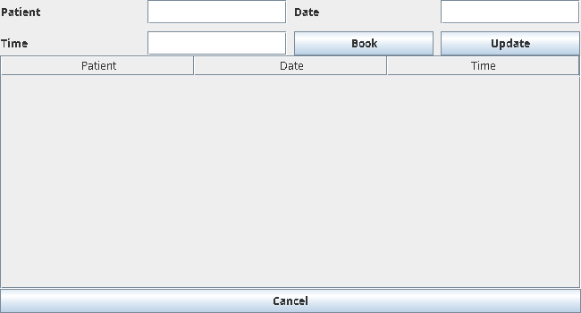

Q2 – Stand-alone and HTML Embedded Applet

Code
import java.applet.Applet;
import java.awt.*;

public class DemoApplet extends Applet {
public void paint(Graphics g) {
g.drawString("Java Applet", 50, 70);
g.drawString("Works in AppletViewer / embedded HTML", 50, 110);
}
}

/*
HTML file: demo.html
<applet code="DemoApplet.class" width="400" height="200"></applet>
*/

Output Screenshot
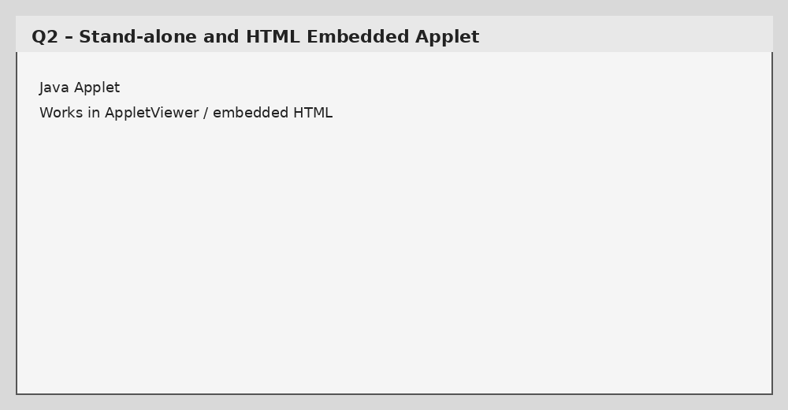

Q3 – Applet Square Calculator

Code
import java.applet.Applet;
import java.awt.*;
import java.awt.event.*;

public class Main extends Applet implements ActionListener {
TextField input = new TextField(10);
Button square = new Button("Square");
Label result = new Label("Result");

public void init() {
add(new Label("Number"));
add(input);
add(square);
add(result);
square.addActionListener(this);
}

public void actionPerformed(ActionEvent e) {
try {
int n = Integer.parseInt(input.getText());
result.setText("Square = " + (n * n));
} catch (NumberFormatException ex) {
result.setText("Enter a valid number");
}
}
}

Output Screenshot
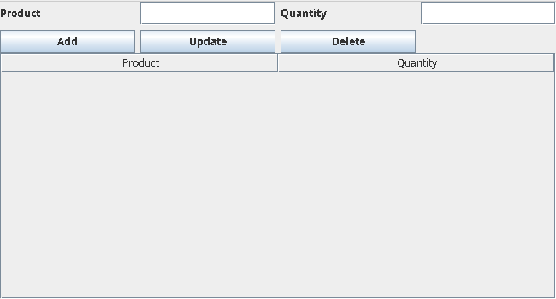

Q4 – Swing Layout Managers Demonstration

Code
import javax.swing.*;
import java.awt.*;
import java.awt.event.*;

public class Main extends JFrame implements ActionListener {
JPanel panel = new JPanel();
JRadioButton flow = new JRadioButton("FlowLayout", true);
JRadioButton border = new JRadioButton("BorderLayout");
JRadioButton grid = new JRadioButton("GridLayout");

Main() {
setTitle("Layout Manager Demo");
setSize(600, 300);
setDefaultCloseOperation(EXIT_ON_CLOSE);

ButtonGroup group = new ButtonGroup();
group.add(flow); group.add(border); group.add(grid);
flow.addActionListener(this);
border.addActionListener(this);
grid.addActionListener(this);

JPanel top = new JPanel();
top.add(flow); top.add(border); top.add(grid);
add(top, BorderLayout.NORTH);
add(panel, BorderLayout.CENTER);
updateLayout();
}

void updateLayout() {
if (flow.isSelected()) panel.setLayout(new FlowLayout());
else if (border.isSelected()) panel.setLayout(new BorderLayout());
else panel.setLayout(new GridLayout(2, 2));

panel.removeAll();
panel.add(new JButton("One"));
panel.add(new JButton("Two"));
panel.add(new JButton("Three"));
panel.add(new JButton("Four"));
panel.revalidate();
panel.repaint();
}

public void actionPerformed(ActionEvent e) { updateLayout(); }

public static void main(String[] args) {
new Main().setVisible(true);
}
}

Output Screenshot
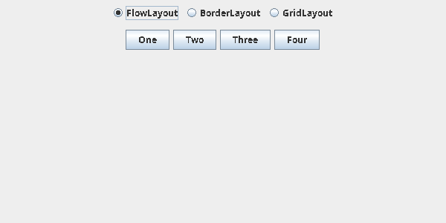

Q5 – AWT Registration Form

Code
import java.awt.*;
import java.awt.event.*;

public class Main extends Frame implements ActionListener {
TextField name = new TextField();
TextField email = new TextField();
Checkbox agree = new Checkbox("I agree");
Choice course = new Choice();
Button submit = new Button("Register");
Label result = new Label();

Main() {
setLayout(new GridLayout(5, 2, 8, 8));
course.add("Java");
course.add("Python");
course.add("C++");

add(new Label("Name")); add(name);
add(new Label("Email")); add(email);
add(new Label("Course")); add(course);
add(agree); add(submit);
add(new Label("Result")); add(result);

submit.addActionListener(this);
setSize(450, 300);
setVisible(true);
addWindowListener(new WindowAdapter() {
public void windowClosing(WindowEvent e) { dispose(); }
});
}

public void actionPerformed(ActionEvent e) {
result.setText("Registered: " + name.getText() +
" - " + course.getSelectedItem());
}

public static void main(String[] args) { new Main(); }
}

Output Screenshot
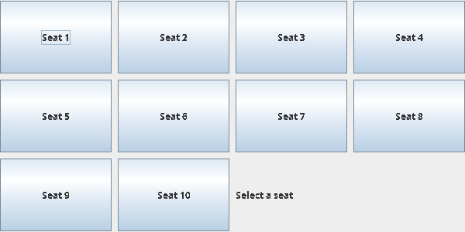

Q6 – Delegation Event Model

Code
import java.awt.*;
import java.awt.event.*;

public class Main extends Frame implements ActionListener, ItemListener {
Button button = new Button("Click");
Checkbox check = new Checkbox("Java");
Label result = new Label("Event: ");

Main() {
setLayout(new FlowLayout());
add(button);
add(check);
add(result);

button.addActionListener(this);
check.addItemListener(this);

setSize(400, 200);
setVisible(true);
addWindowListener(new WindowAdapter() {
public void windowClosing(WindowEvent e) { dispose(); }
});
}

public void actionPerformed(ActionEvent e) {
result.setText("ActionEvent from Button");
}

public void itemStateChanged(ItemEvent e) {
result.setText("ItemEvent from Checkbox");
}

public static void main(String[] args) { new Main(); }
}

Output Screenshot
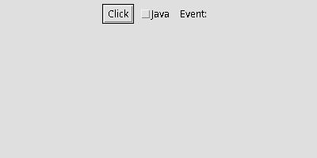

Q7 – Different Event Sources

Code
import java.awt.*;
import java.awt.event.*;

public class Main extends Frame implements ActionListener, ItemListener {
TextField text = new TextField(15);
Button button = new Button("Button");
Checkbox box = new Checkbox("Check");
Label result = new Label("Event source: ");

Main() {
setLayout(new FlowLayout());
add(text); add(button); add(box); add(result);

button.addActionListener(this);
text.addActionListener(this);
box.addItemListener(this);

addWindowListener(new WindowAdapter() {
public void windowClosing(WindowEvent e) {
result.setText("Event source: Window");
dispose();
}
});

setSize(500, 200);
setVisible(true);
}

public void actionPerformed(ActionEvent e) {
result.setText("Event source: " + e.getSource().getClass().getSimpleName());
}

public void itemStateChanged(ItemEvent e) {
result.setText("Event source: Checkbox");
}

public static void main(String[] args) { new Main(); }
}

Output Screenshot
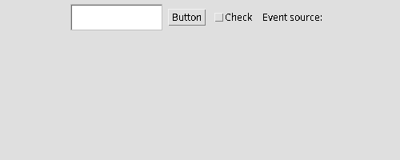

Q8 – Menu-Driven Swing Calculator

Code
import javax.swing.*;
import java.awt.*;

public class Main extends JFrame {
JTextField a = new JTextField();
JTextField b = new JTextField();
JLabel result = new JLabel("Result");

Main() {
setTitle("Calculator");
setLayout(new GridLayout(3, 2, 8, 8));
add(new JLabel("A")); add(a);
add(new JLabel("B")); add(b);
add(result);

JMenuBar bar = new JMenuBar();
JMenu menu = new JMenu("Operations");
String[] ops = {"Add", "Subtract", "Multiply", "Divide", "Clear", "Exit"};

for (String op : ops) {
JMenuItem item = new JMenuItem(op);
item.addActionListener(e -> calculate(op));
menu.add(item);
}
bar.add(menu);
setJMenuBar(bar);

setSize(400, 250);
setDefaultCloseOperation(EXIT_ON_CLOSE);
setVisible(true);
}

void calculate(String op) {
try {
double x = Double.parseDouble(a.getText());
double y = Double.parseDouble(b.getText());
if (op.equals("Add")) result.setText("Result: " + (x + y));
else if (op.equals("Subtract")) result.setText("Result: " + (x - y));
else if (op.equals("Multiply")) result.setText("Result: " + (x * y));
else if (op.equals("Divide")) result.setText("Result: " + (x / y));
else if (op.equals("Clear")) { a.setText(""); b.setText(""); result.setText("Result"); }
else if (op.equals("Exit")) System.exit(0);
} catch (Exception e) {
result.setText("Invalid input");
}
}

public static void main(String[] args) { new Main(); }
}

Output Screenshot
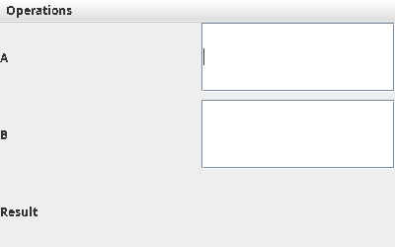

Q9 – Applet Drawing Basic Shapes

Code
import java.applet.Applet;
import java.awt.*;
import java.awt.event.*;

public class Main extends Applet implements ItemListener {
Choice color = new Choice();
String selected = "Blue";

public void init() {
color.add("Blue");
color.add("Red");
color.add("Green");
color.addItemListener(this);
add(color);
}

public void itemStateChanged(ItemEvent e) {
selected = color.getSelectedItem();
repaint();
}

public void paint(Graphics g) {
if (selected.equals("Red")) g.setColor(Color.RED);
else if (selected.equals("Green")) g.setColor(Color.GREEN);
else g.setColor(Color.BLUE);

g.drawLine(50, 80, 200, 80);
g.drawRect(50, 110, 120, 70);
g.drawOval(220, 110, 100, 70);
}
}

Output Screenshot
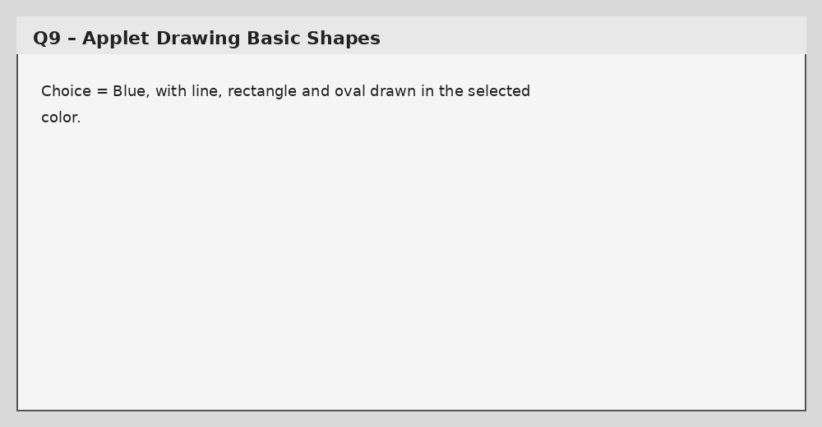

Q10 – Student Record GUI

Code
import javax.swing.*;
import javax.swing.table.DefaultTableModel;
import java.awt.*;

public class Main {
public static void main(String[] args) {
JFrame f = new JFrame("Student Record");
f.setLayout(new BorderLayout());

JTextField name = new JTextField();
JTextField roll = new JTextField();
JButton add = new JButton("Add");
JButton update = new JButton("Update");
JButton delete = new JButton("Delete");

JPanel p = new JPanel(new GridLayout(2, 5, 6, 6));
p.add(new JLabel("Name")); p.add(name);
p.add(new JLabel("Roll")); p.add(roll);
p.add(add); p.add(update); p.add(delete);

DefaultTableModel model =
new DefaultTableModel(new String[]{"Name", "Roll"}, 0);
JTable table = new JTable(model);

add.addActionListener(e ->
model.addRow(new Object[]{name.getText(), roll.getText()}));
update.addActionListener(e -> {
int r = table.getSelectedRow();
if (r >= 0) {
model.setValueAt(name.getText(), r, 0);
model.setValueAt(roll.getText(), r, 1);
}
});
delete.addActionListener(e -> {
int r = table.getSelectedRow();
if (r >= 0) model.removeRow(r);
});

f.add(p, BorderLayout.NORTH);
f.add(new JScrollPane(table), BorderLayout.CENTER);
f.setSize(600, 350);
f.setDefaultCloseOperation(JFrame.EXIT_ON_CLOSE);
f.setLocationRelativeTo(null);
f.setVisible(true);
}
}

Output Screenshot
