1. **Develop the important backend (Node Js, Express Js, MongoDB) functionalities for a task manager application.**

* Create package.json file and install required libraries (express, mongoose)
* Create task model (schema)
* **TaskModel.js**
* const mongoose = require('mongoose');
* const taskSchema = new mongoose.Schema({
* title: {
* type: String,
* required: true,
* },
* description: String,
* createdAt: {
* type: Date,
* default: Date.now,
* },
* });
* const Task = mongoose.model('Task', taskSchema);
* module.exports = Task;
* Now create index.js file and write server code:

const express = require('express');

const mongoose = require('mongoose');

const app = express();

const PORT = 6001;

app.use(express.json());

const Task = require('./TaskModel.js')

mongoose.connect('mongodb://localhost:27017/database_name', {

  useNewUrlParser: true,

  useUnifiedTopology: true,

}).then(()=>{

    // Get all tasks

        app.get('/', async (req, res) => {

            try {

            const tasks = await Task.find();

            res.json(tasks);

            } catch (err) {

            res.status(500).json({ message: err.message });

            }

        });

    // Create a new task

        app.post('/new-task', async (req, res) => {

            const task = new Task({

                title: req.body.title,

                description: req.body.description,

            });

            try {

                const newTask = await task.save();

                res.status(201).json(newTask);

            } catch (err) {

                res.status(400).json({ message: err.message });

            }

        });

    // Update a task

        app.put('/:id', async (req, res) => {

            try{

                const task = await Task.findById(req.params.id);

                task.title = req.body.title;

                task.description = req.body.description;

                const updatedTask = await task.save();

                res.status(201).json(updatedTask);

            }catch(err){

                res.status(400).json({ message: err.message });

            }

        });

    // Delete a task

        app.delete('/delete-task/:id', async (req, res) => {

            try{

                await Task.deleteOne({_id: req.params.id});

                res.status(201).json({message: "task deleted"});

            }catch(err){

                res.status(400).json({ message: err.message });

            }

        });

}

)

app.listen(PORT, () => {

  console.log(`Server is running on port ${PORT}`);

});

If you want to verify the working of the server, use **thunderclient extension** in vs code or **postman**.

Example:

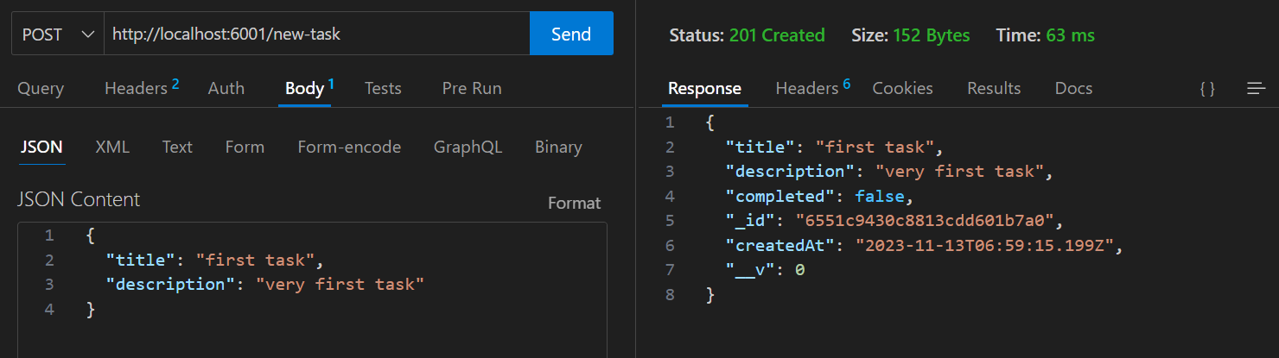

1. **Develop the backend (Node Js, Express Js, MongoDB) for a CRUD application.**

Same as the above question. Crud – create, read, update, delete. Perform the same code from the previous question and use a name you wish apart from tasks.

1. **Develop the backend for a job portal using Node JS, Express JS, MongoDB. Perform important functionalities such as add new job, update job, apply for job, approve job application, etc.,**

same as previous questions. Use jobs instead of tasks. Take another schema for applications.

JobsModel.js:

const mongoose = require('mongoose');

const jobSchema = new mongoose.Schema({

  title: {

    type: String,

    required: true,

  },

  description:{

    type: String,

  },

  companyName: {

    type: String

  }

});

const applicationSchema = new mongoose.Schema({

    applicantId:{

        type: String

    },

    applicantName: {

        type: String

    },

    JobId:{

        type: String,

    },

    status: {

        type: String,

        default: "Pending"

    }

})

const Job = mongoose.model('Job', jobSchema);

const Application = mongoose.model('Application', applicationSchema);

module.exports = Job;

module.exports = Application;

**Index.js:**

const express = require('express');

const mongoose = require('mongoose');

const app = express();

const PORT = 6001;

app.use(express.json());

const {Job, Application}= require('./TaskModel.js')

mongoose.connect('mongodb://localhost:27017/database_name', {

  useNewUrlParser: true,

  useUnifiedTopology: true,

}).then(()=>{

    // Get all jobs

        app.get('/', async (req, res) => {

            try {

            const jobs = await Job.find();

            res.json(jobs);

            } catch (err) {

            res.status(500).json({ message: err.message });

            }

        });

    // Create a new job

        app.post('/new-job', async (req, res) => {

            const job = new Job({

                title: req.body.title,

                description: req.body.description,

            });

            try {

                const newjob = await Job.save();

                res.status(201).json(newjob);

            } catch (err) {

                res.status(400).json({ message: err.message });

            }

        });

    // Update a job

        app.put('/:id', async (req, res) => {

            try{

                const job = await Job.findById(req.params.id);

                job.title = req.body.title;

                job.description = req.body.description;

                const updatedjob = await job.save();

                res.status(201).json(updatedjob);

            }catch(err){

                res.status(400).json({ message: err.message });

            }

        });

    // Delete a job

        app.delete('/delete-task/:id', async (req, res) => {

            try{

                await Job.deleteOne({_id: req.params.id});

                res.status(201).json({message: "job deleted"});

            }catch(err){

                res.status(400).json({ message: err.message });

            }

        });

    //Apply for a job

        app.post('/apply-job', async(req, res)=>{

            const {jobId, applicantName, applicantId} = req.body;

            try{

                const application = new Application({jobId, applicantName, applicantId});

                const newApplication = await application.save();

                res.status(201).json(newApplication);

            }catch(err){

                res.status(400).json({ message: err.message });

            }

        })

    //Approve job application

        app.post('/approve-application/:id', async(req, res)=>{

            try{

                const application = await Application.findById(req.params.id);

                application.status = "Accepted";

                await application.save();

                res.status(201).json(application);

            }catch(err){

                res.status(400).json({ message: err.message });

            }

        })

}

)

app.listen(PORT, () => {

  console.log(`Server is running on port ${PORT}`);

});

1. **Develop and application to send emails (use libraries link Nodemailer, etc.,).**

* Create server files and add basic code.
* Install nodemailer (npm install nodemailer).
* Open ethereal.email and create new account

const express = require('express');

const app = express();

const PORT = 6001;

app.use(express.json());

const nodemailer = require('nodemailer');

    const transporter = nodemailer.createTransport({

        host: 'smtp.ethereal.email',

        port: 587,

        auth: {

            user: ‘replace this with user mail from ethereal’,

            pass: ‘replace this with the password from ethereal’

        }

    });

    // Send email

        app.post('/send-mail', async (req, res) => {

            const {mailTo, subject, text} = req.body;

            try {

                let mailDetails = {

                    from: 'naomie71@ethereal.email',

                    to: mailTo,

                    subject: subject,

                    text: text

                };

                transporter.sendMail(mailDetails, function(err, data) {

                    if(err) {

                        console.log('Error Occurs');

                    } else {

                        console.log('Email sent successfully');

                        res.status(201).json({ message: "mail sent successfully" });

                    }

                });

            } catch (err) {

            res.status(500).json({ message: err.message });

            }

        });

app.listen(PORT, () => {

  console.log(`Server is running on port ${PORT}`);

});

Verify this with postman or thunderclient

