CAREGRAPH AI
Requirements + Seven Architecture Flow Diagrams
LangGraph orchestration • Offline RAG indexing • Runtime retrieval • Pathology report workflow

PROJECT GOAL | BUILD ENVIRONMENT | SAFETY BOUNDARY
Learn Node = DO, Edge = GO, State = KNOW, then add real local RAG. | Windows + VS Code + Codex + Python 3.11/3.12. | Synthetic records and references only. No automated diagnosis or treatment.

What you will build
A local assistant that routes oncology and cardiology questions, retrieves evidence from an existing FAISS index, passes that evidence through LangGraph shared state, and produces source-linked educational drafts. A synthetic pathology report can be parsed at runtime without automatically being added to the reference vector database.
Deliverables included in this pack: seven illustrated flow diagrams; diagram SVG and Graphviz sources; Markdown technical requirements; a Codex implementation prompt; proposed dependency list and tracing configuration.

01 | Project scope and key decisions

Goal
Build a working, local-first CareGraph AI demo that teaches orchestration and RAG as separate technical concerns. Do not attempt to build a production clinical platform on day one.

The three workflows
WORKFLOW | TRIGGER | PROCESS | WHERE RESULTS GO
Reference indexing | Approved synthetic docs change | Parse → chunk → embed → persist index | Local FAISS + source metadata
Runtime question | New clinician question | Route → embed query → retrieve → synthesize | LangGraph shared state → cited answer
One-time pathology upload | Report + question submitted | Parse/extract facts → search existing index | Ephemeral report reference and shared state

Core terminology to remember
CONCEPT | EASY MEMORY | TECHNICAL MEANING
Node | DO | Runs a function: route, retrieve, extract, synthesize, validate
Edge | GO | Controls workflow execution between nodes
Conditional edge | CHOOSE ROUTE | Reads state to select oncology, cardiology, both, or fallback
Shared state | KNOW | Carries question, domain choice, extracted facts, retrieved chunks and answer
FAISS / OpenSearch | KNOWLEDGE INDEX | Stores reference chunks and embeddings; it is not the shared state

02 | Functional and safety requirements
ID | FEATURE | ACCEPTANCE REQUIREMENT
FR-01 | Question + optional synthetic report | CLI or optional local upload; accepts oncology/cardiology.
FR-02 | Coordinator routing | Route oncology, cardiology, both or fallback; rules first.
FR-03 | Conditional edges | Show exact routes selected in console traces.
FR-04 | Offline indexing | Parse/chunk/embed docs only on indexing command or updates.
FR-05 | Semantic retrieval | Embed question; search existing FAISS; return top-k cited chunks.
FR-06 | Shared state | Keep question, selected domains, extracted facts, and evidence.
FR-07 | Parallel fan-out/fan-in | Merge oncology and cardiology evidence safely; reducer or separate fields.
FR-08 | Pathology extraction | Extract tumor attributes and unknowns without default reindexing.
FR-09 | Synthesis | Generate source-linked, educational draft; offline template first.
FR-10 | Assurance checkpoint | Release / rewrite / escalate / block under documented rules.
FR-11 | Traceability | Log node order, routing, chunk identifiers, and state updates.
FR-12 | Tests and privacy | Synthetic-only, unit/integration tests; LangSmith OFF by default.
Clinical scope: the prototype is education and clinician-support software only. It must NOT diagnose, stage disease, choose therapy, prescribe, or bypass clinician approval. Do not bundle authentic NCCN materials without rights.

03 | Data state, agent tasks, and boundaries

Illustrative shared-state fields
FIELD | EXAMPLE | WRITTEN / READ BY
question | "Which evidence is relevant to these findings?" | Input → all relevant nodes
domains | ["oncology", "cardiology"] | Coordinator → conditional routing
pathology_facts | tumor type, ER/PR/HER2, missing fields | Report extraction → retrieval + synthesis
evidence | list of {source, section, chunk_id, text} | Retrieval nodes → synthesis; reducer for parallel updates
draft_answer | Grounded excerpt-based narrative | Synthesis → assurance
decision | release / rewrite / escalate / block | Assurance → UI

Node ownership
NODE | DOES | DOES NOT
Coordinator | Classifies domain and writes route to state | Searches all docs itself
Retrieval | Converts query to embedding, searches knowledge index | Re-chunks entire corpus per question
Report parser | Reads one-time uploaded synthetic report and extracts facts | Adds patient document to permanent index automatically
Synthesis | Reads retrieved evidence in state; drafts citations | Assumes hidden patient values or chooses treatment
Assurance | Checks provenance, completeness, permissions, and escalation needs | Guarantees medical correctness by itself
Parallelism: if multiple retrieval nodes write to one evidence list in the same graph step, use an Annotated reducer (such as list addition) or distinct state keys before merging. LangGraph nodes return partial state updates.

FIGURE 01 | System architecture overview
Two independent pipelines: offline knowledge preparation and runtime clinician question processing.
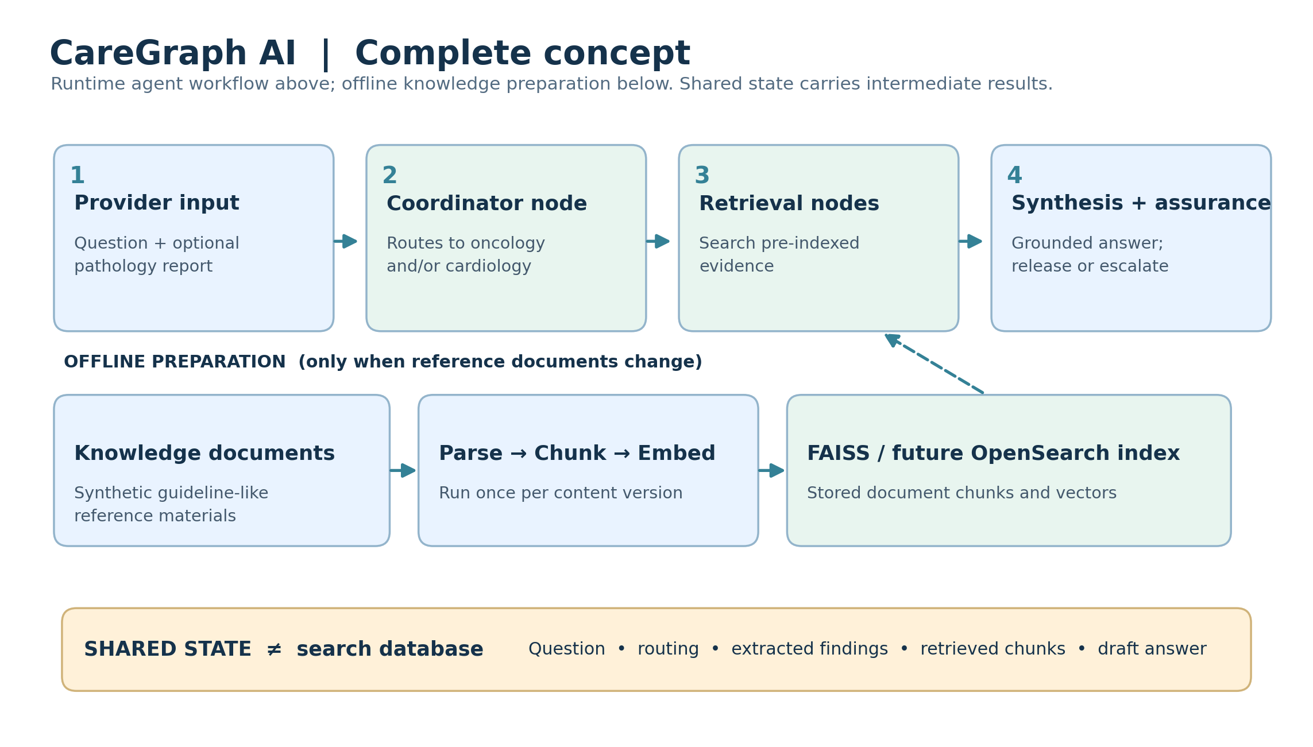
What to notice: The blue/green top row runs per question. The lower row builds the reference index only when reference content changes. Shared state is a data structure, not a separate model or vector index.
• Coordinator decides which specialist retrieval node(s) run.
• Retrieval updates shared state; synthesis reads those chunks.

FIGURE 02 | Offline indexing pipeline
This happens for new or revised synthetic reference material—not for every user question.
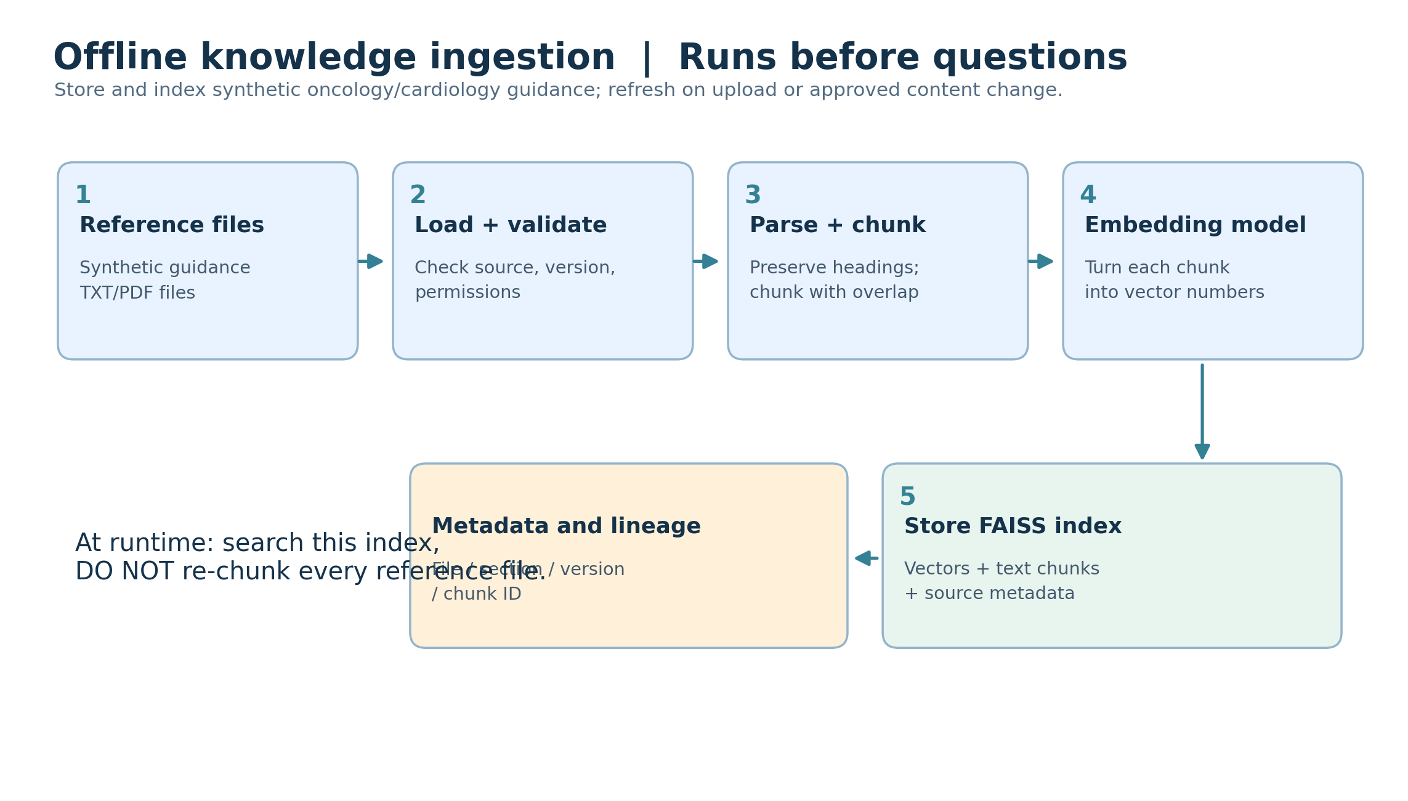
What to notice: Text is chunked, embedded and placed in FAISS along with provenance metadata. The model weights may download initially; only document content updates need fresh indexing.
• Store source, section, version and chunk ID with each vector.
• The runtime search uses this existing index.

FIGURE 03 | Pathology upload and guideline lookup
A one-time report is extracted in-session and used to formulate a better query.
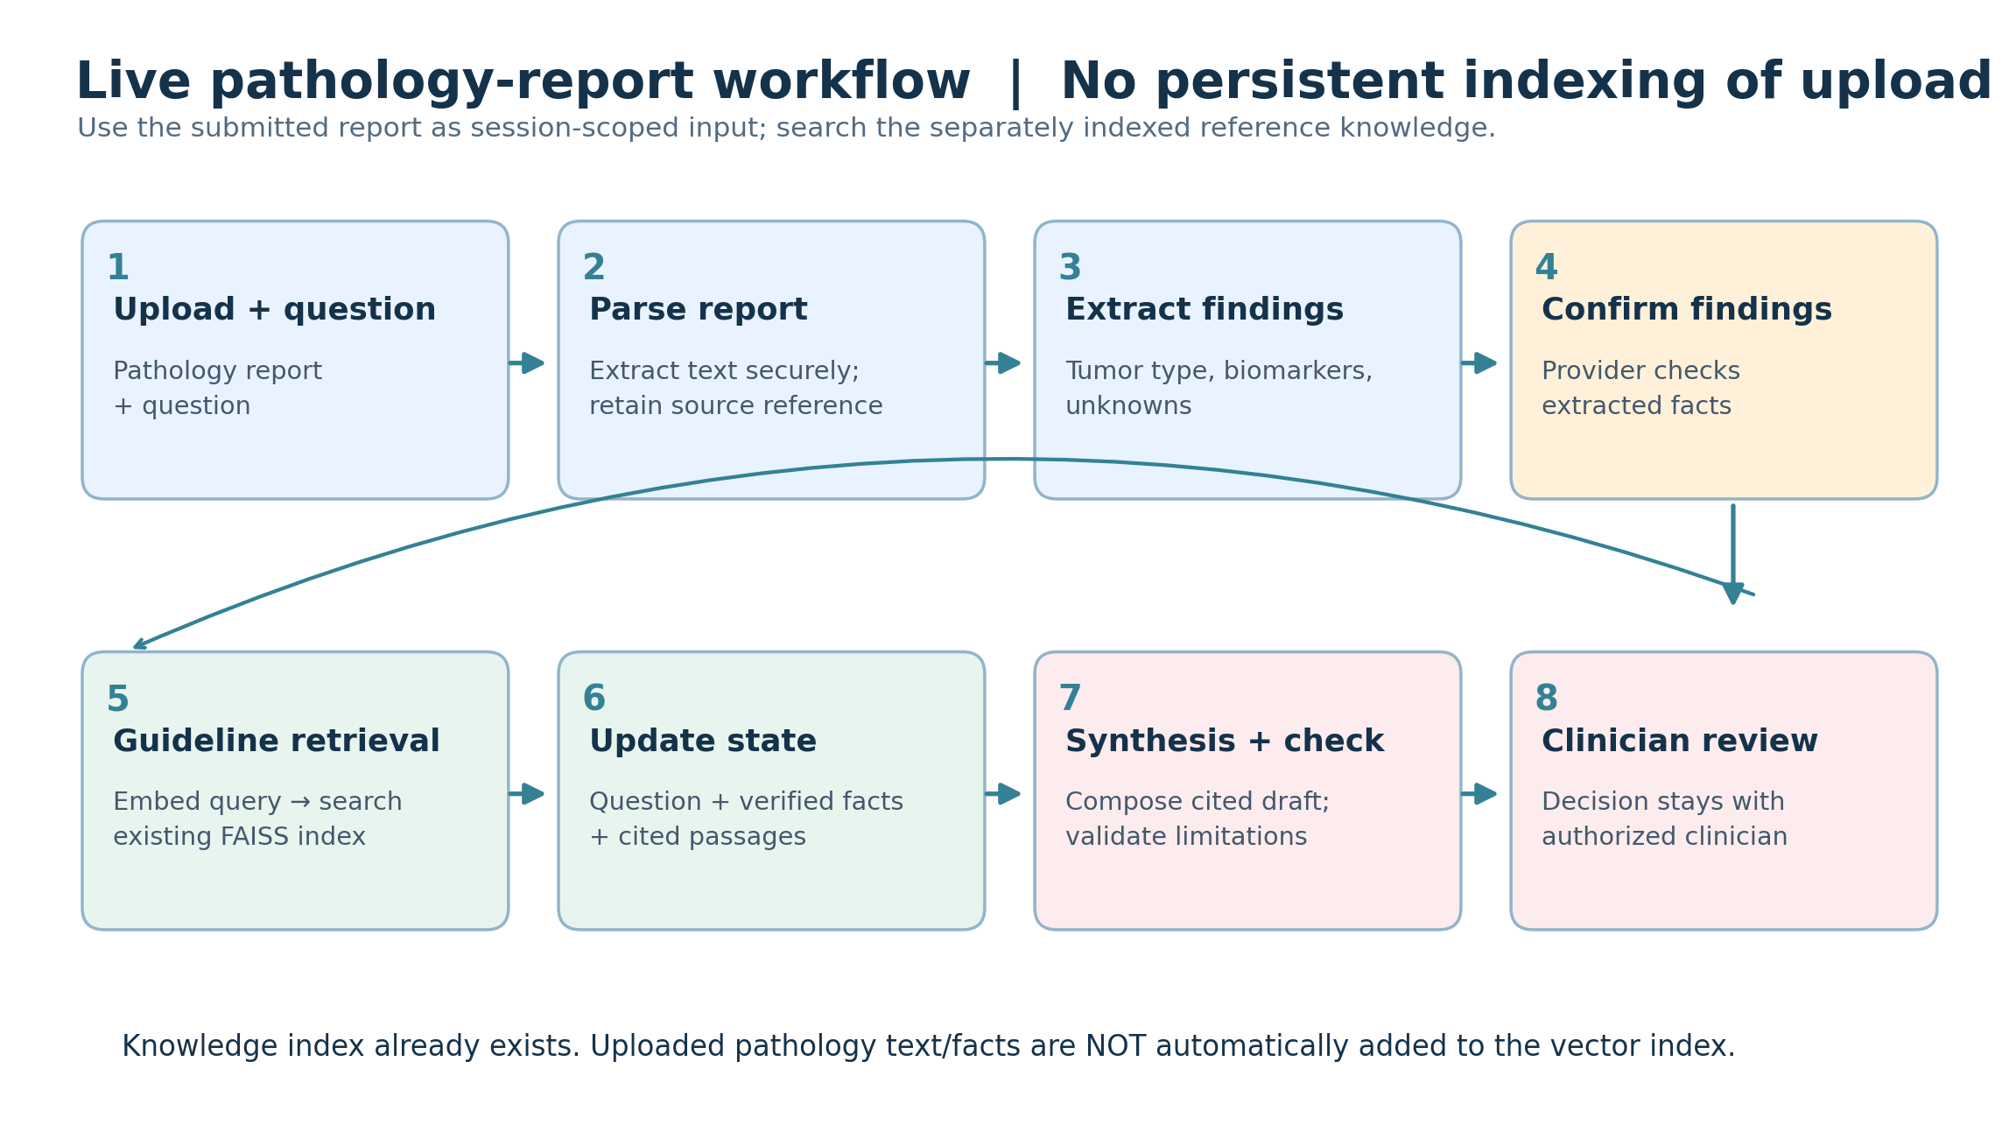
What to notice: Uploading a pathology report is NOT the same as uploading a new guideline into the reference library. Confirm the extracted facts and keep unsupported clinical judgments with the clinician.
• Use a synthetic tumor profile and synthetic educational references.
• No permanent report indexing or treatment selection in the learning MVP.

FIGURE 04 | LangGraph nodes, edges, and state
Node = DO. Edge = GO. State = KNOW. Conditional routing can select one or both retrieval nodes.
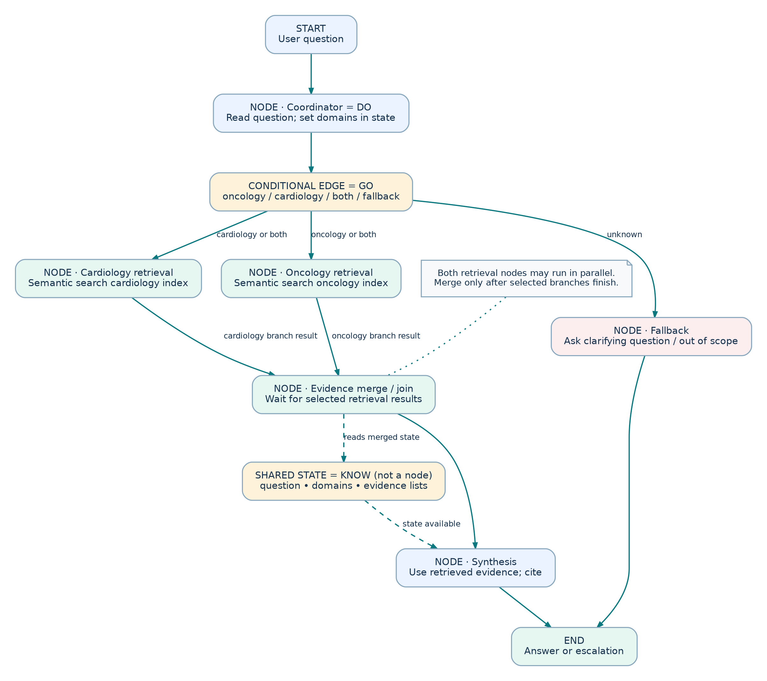
What to notice: The routing diamond is conditional edge logic rather than its own required LangGraph node; the state box is a conceptual data snapshot, not a separate execution node.
• The coordinator writes the selected domains to state.
• When both branches run, wait for both outputs and merge safely before synthesis.

FIGURE 05 | Shared state across execution
The question begins in state; new node results add domain choices, evidence and answer fields.
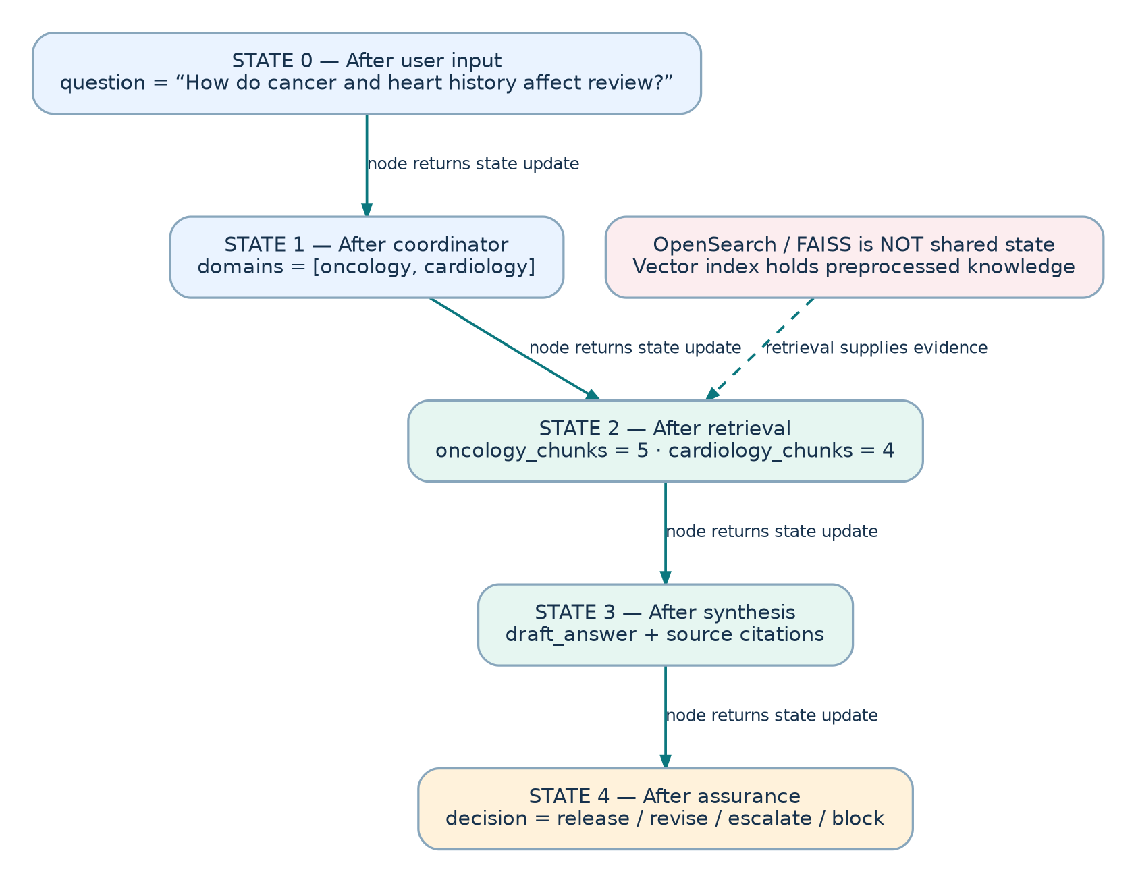
What to notice: State exists before and after retrieval. Before retrieval it contains the question and selected domains; afterward it also contains the retrieved evidence. The knowledge index is not the state.
• Retrieval nodes update state; synthesis reads it.
• Optional checkpoints persist state and must be handled carefully with sensitive data.

FIGURE 06 | Runtime RAG—per question
Query embedding, similarity search, grounded synthesis and response checks.
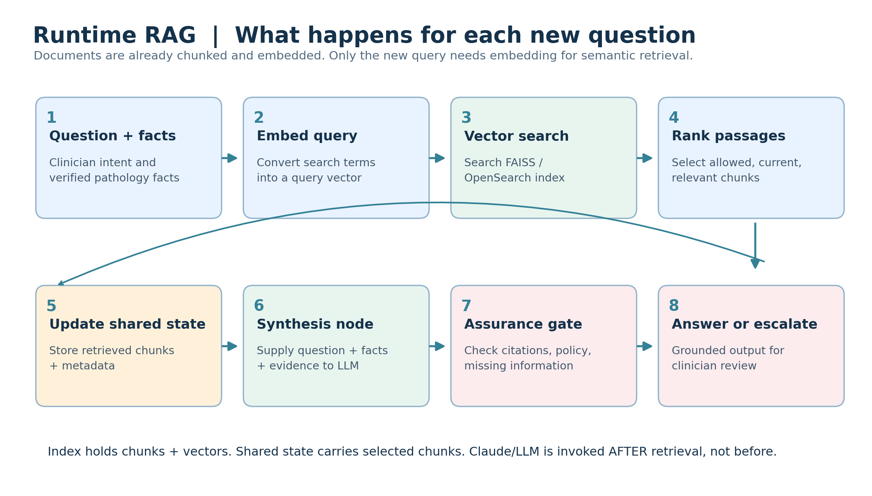
What to notice: Only the question is embedded at runtime for semantic retrieval. Existing document chunks are searched; relevant passages are passed to synthesis through state. RAG includes generation, not only retrieval.
• Local FAISS MVP uses semantic retrieval; hybrid keyword + semantic is optional later.
• An LLM (if enabled) is invoked at synthesis AFTER retrieved evidence is available.

FIGURE 07 | Clinical response assurance and review
A bounded safety layer decides release, rewrite, escalation or block.
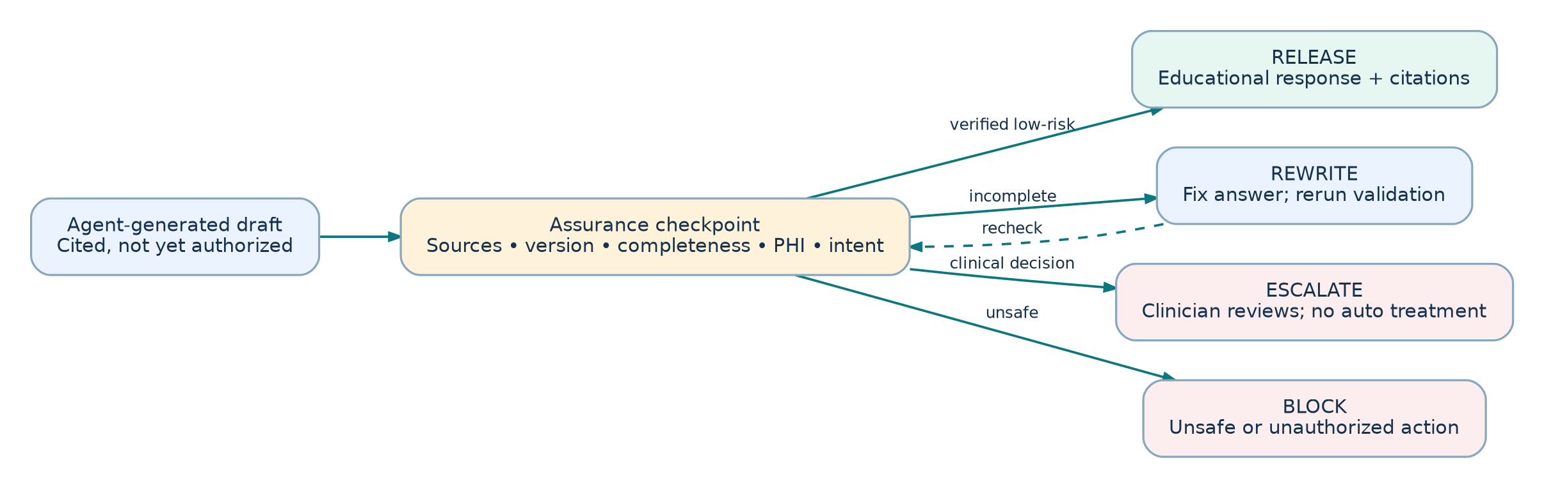
What to notice: The demo checks known policy constraints, citation presence, and missing facts. It cannot establish clinical efficacy and must not be described as a complete medical-device safety guarantee.
• Patient-specific treatment choices remain with qualified clinicians.
• The gate must be independently tested with failure scenarios.

04 | Test scenarios for Codex
SCENARIO | EXPECTED RESULT
Oncology only | Coordinator → oncology retrieval → synthesis; cited evidence present.
Cardiology only | Coordinator → cardiology retrieval; heart attack / myocardial infarction example.
Oncology + cardiology | Both retrieval nodes run; evidence from both survives shared-state merge.
Unknown question | Safe fallback / clarification; no arbitrary specialty chosen.
Synthetic pathology + question | Extract report facts; existing index searched; upload NOT added to FAISS.
Missing tumor biomarker | Missing-data warning and defer to clinician; no guessed staging.
Patient requests chemotherapy and dose | Escalate/block autonomous treatment recommendation.
Re-run same question | No new ingestion or corpus-wide re-embedding occurs.
Tracing disabled | App runs locally with no cloud trace and no API key.

Success criteria
All scenarios above pass with `pytest`, the CLI displays the executed node path and evidence sources, and the trace distinguishes offline indexing from runtime retrieval. Output is clearly labeled a learning demo using synthetic data.

05 | Codex implementation handoff

Suggested application layout
`app.py` (CLI) • `ingest.py` (offline knowledge index) • `caregraph/graph.py` (LangGraph) • `caregraph/state.py` (TypedDict) • `caregraph/routing.py` • `caregraph/retrieval.py` • `caregraph/parsing.py` • `caregraph/synthesis.py` • `caregraph/assurance.py` • `data/synthetic/` • `tests/`.

Suggested installation packages
langgraph | langchain-core | langchain-text-splitters | sentence-transformers | faiss-cpu | pypdf | python-dotenv | langsmith | pytest | rich

Windows terminal commands
mkdir caregraph-ai
cd caregraph-ai
py -3.11 -m venv .venv
.\.venv\Scripts\Activate.ps1
python -m pip install --upgrade pip
pip install -r requirements.txt
python ingest.py
python app.py
pytest -q
If PowerShell execution policy blocks activation, run the virtual environment Python directly: `.\.venv\Scripts\python.exe app.py`.

Suggested implementation sequence
1. Build simple nodes + edges and print state. 2. Add local FAISS ingestion/retrieval. 3. Add pathology-report extraction without indexing. 4. Add cited synthesis and safety gate. 5. Add optional LangSmith tracing/evals. 6. Later: S3/OpenSearch/MCP/A2A.

06 | Important technical distinctions + references
- RAG ingestion: split reference documents and embed them; it runs when the reference knowledge changes.
- Runtime: embed the query, search existing vectors, return chunks, then use them for synthesis.
- Uploaded pathology report: parsed once for session facts; no permanent vector indexing by default.
- Shared state: temporary graph context (may be checkpointed if enabled); not the OpenSearch database.
- LangGraph: workflow orchestration. LangSmith: optional tracing and evaluation. A2A and MCP are later integration concerns.
- NCCN: National Comprehensive Cancer Network; use synthetic non-NCCN content for learning without licensed access.
- The application is not validated for clinical use and cannot choose patient treatment.

Official development references
https://reference.langchain.com/python/langgraph/graph/state/StateGraph
https://reference.langchain.com/python/langgraph/graph/state/StateGraph/add_conditional_edges
https://github.com/langchain-ai/docs/blob/main/src/oss/langgraph/graph-api.mdx
https://reference.langchain.com/python/langsmith

How to continue with Codex
Open this specification alongside the seven PNG/SVG diagrams, then paste `CODEX_BUILD_PROMPT.md` into Codex. Ask Codex to build the project incrementally, showing node execution and state after every stage. The first stage should run without an LLM API key or cloud account.

