**Login Page**

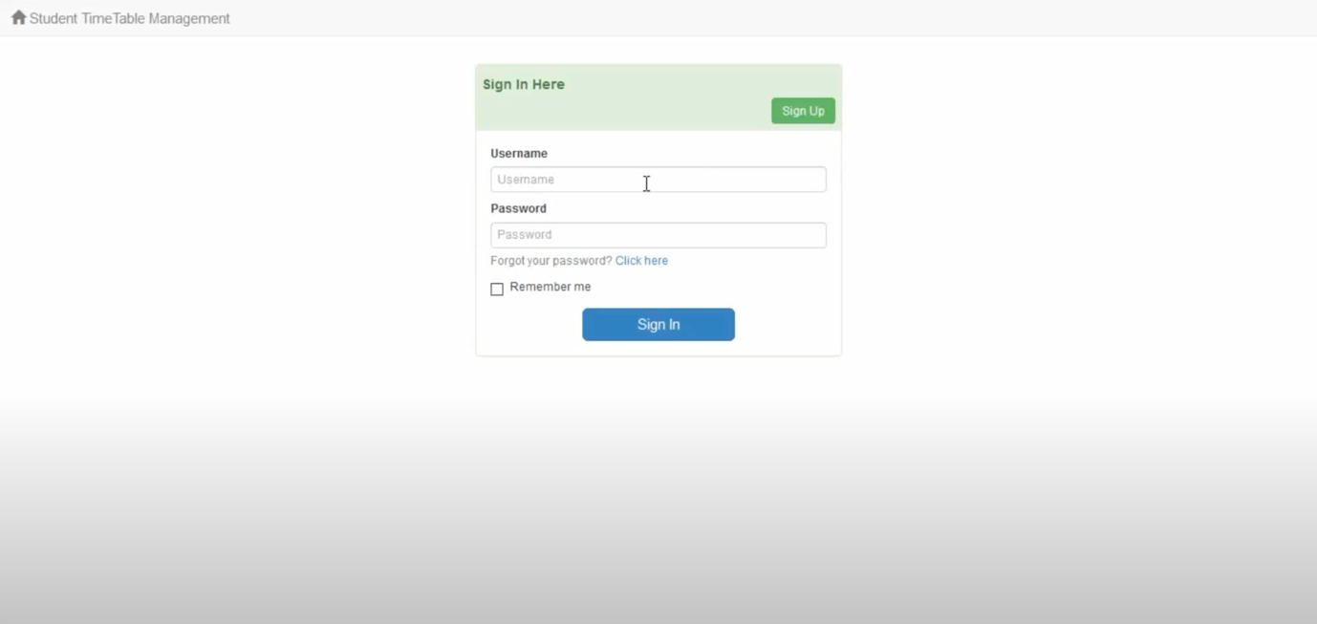

<?php if(!isset($Translation)){ @header('Location: index.php?signIn=1'); exit; } ?>

<?php include_once("$currDir/header.php"); ?>

<?php if($_GET['loginFailed']){ ?>

<div class="alert alert-danger"><?php echo $Translation['login failed']; ?></div>

<?php } ?>

<div class="row">

<div class="col-sm-6 col-lg-4" id="login_splash">

<!-- customized splash content here -->

</div>

<div class="col-sm-6 col-lg-4">

<div class="panel panel-success">

<div class="panel-heading">

<h1 class="panel-title"><strong><?php echo $Translation['sign in here']; ?></strong></h1>

<?php if(sqlValue("select count(1) from membership_groups where allowSignup=1")){ ?>

<a class="btn btn-success pull-right" href="membership_signup.php"><?php echo $Translation['sign up']; ?></a>

<?php } ?>

<div class="clearfix"></div>

</div>

<div class="panel-body">

<form method="post" action="index.php">

<div class="form-group">

<label class="control-label" for="username"><?php echo $Translation['username']; ?></label>

<input class="form-control" name="username" id="username" type="text" placeholder="<?php echo $Translation['username']; ?>" required>

</div>

<div class="form-group">

<label class="control-label" for="password"><?php echo $Translation['password']; ?></label>

<input class="form-control" name="password" id="password" type="password" placeholder="<?php echo $Translation['password']; ?>" required>

<span class="help-block"><?php echo $Translation['forgot password']; ?></span>

</div>

<div class="checkbox">

<label class="control-label" for="rememberMe">

<input type="checkbox" name="rememberMe" id="rememberMe" value="1">

<?php echo $Translation['remember me']; ?>

</label>

</div>

<div class="row">

<div class="col-sm-offset-3 col-sm-6">

<button name="signIn" type="submit" id="submit" value="signIn" class="btn btn-primary btn-lg btn-block"><?php echo $Translation['sign in']; ?></button>

</div>

</div>

</form>

</div>

<?php if(is_array(getTableList()) && count(getTableList())){ /* if anon. users can see any tables ... */ ?>

<div class="panel-footer">

<?php echo $Translation['browse as guest']; ?>

</div>

<?php } ?>

</div>

</div>

</div>

<script>document.getElementById('username').focus();</script>

<?php include_once("$currDir/footer.php"); ?>

**Main Page**

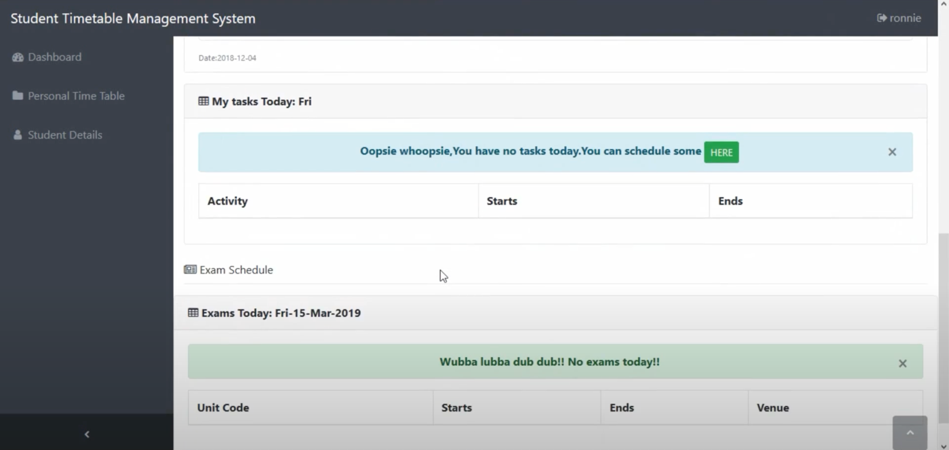

<?php

$memberinfo=getMemberInfo();

$usergroup=$memberinfo['group'];

switch ($usergroup) {

case 'students':

# code...

include'stdview.php';

break;

case 'Class reps':

# code...

include'crview.php';

break;

default:

# code...

include'adminview.php';

break;

}

?>

**Personal Timetable**

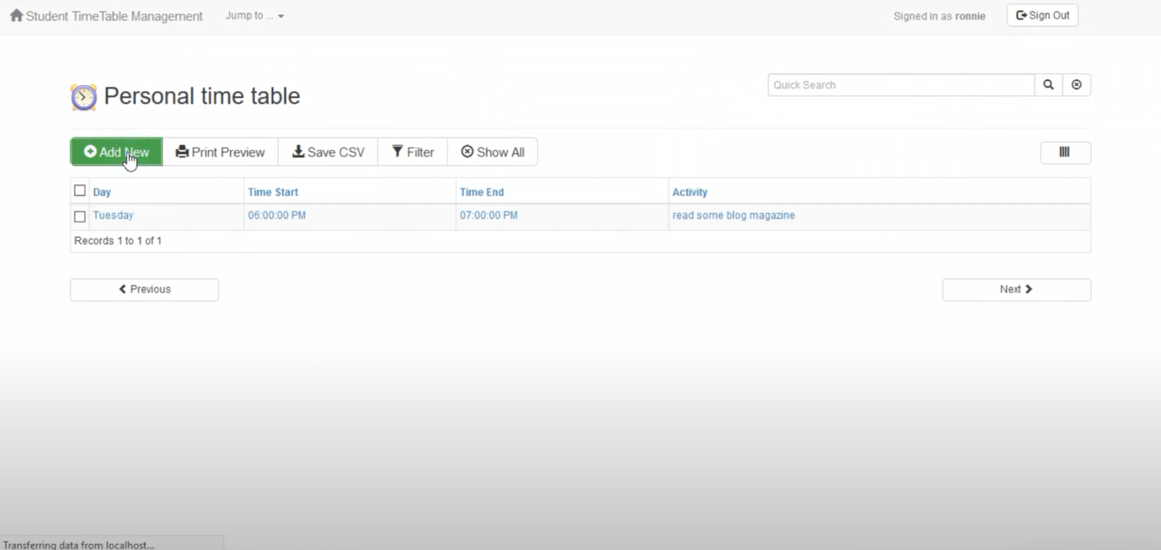

<?php

// This script and data application were generated by AppGini 5.72

// Download AppGini for free from https://bigprof.com/appgini/download/

$currDir = dirname(__FILE__);

include("$currDir/defaultLang.php");

include("$currDir/language.php");

include("$currDir/lib.php");

handle_maintenance();

header('Content-type: text/javascript; charset=' . datalist_db_encoding);

$table_perms = getTablePermissions('personal_time_table');

if(!$table_perms[0]){ die('// Access denied!'); }

$mfk = $_GET['mfk'];

$id = makeSafe($_GET['id']);

$rnd1 = intval($_GET['rnd1']); if(!$rnd1) $rnd1 = '';

if(!$mfk){

die('// No js code available!');

}

switch($mfk){

}

?>

**Student Details**

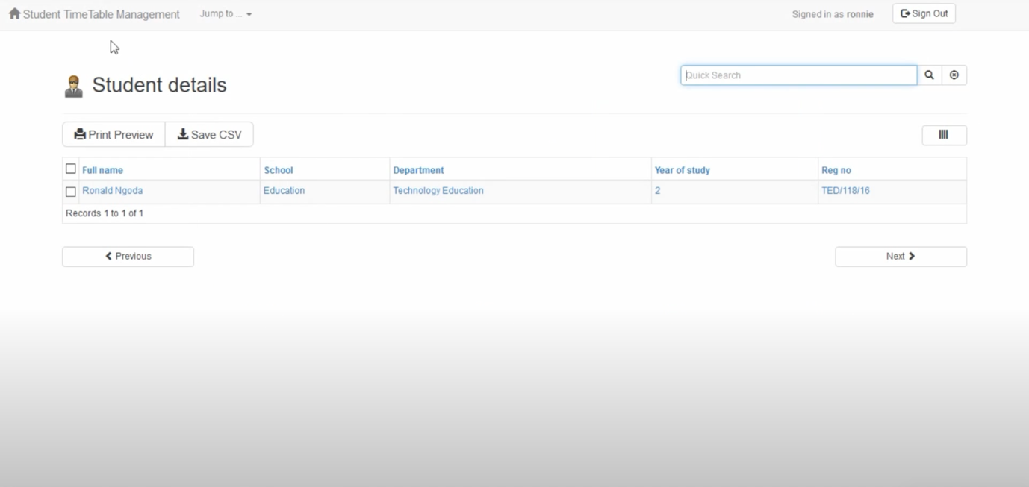

<?php

// This script and data application were generated by AppGini 5.72

// Download AppGini for free from https://bigprof.com/appgini/download/

$currDir = dirname(__FILE__);

include("$currDir/defaultLang.php");

include("$currDir/language.php");

include("$currDir/lib.php");

handle_maintenance();

header('Content-type: text/javascript; charset=' . datalist_db_encoding);

$table_perms = getTablePermissions('student_details');

if(!$table_perms[0]){ die('// Access denied!'); }

$mfk = $_GET['mfk'];

$id = makeSafe($_GET['id']);

$rnd1 = intval($_GET['rnd1']); if(!$rnd1) $rnd1 = '';

if(!$mfk){

die('// No js code available!');

}

switch($mfk){

}

?>

**Class Timetable**

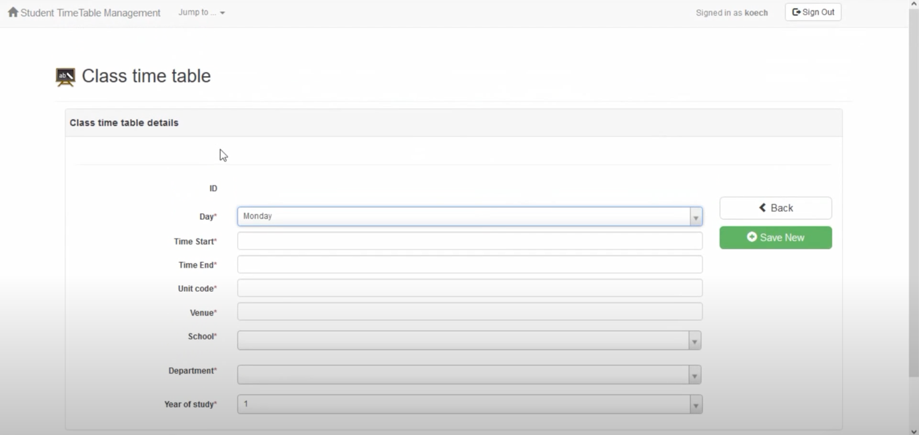

<?php

// This script and data application were generated by AppGini 5.72

// Download AppGini for free from https://bigprof.com/appgini/download/

$currDir = dirname(__FILE__);

include("$currDir/defaultLang.php");

include("$currDir/language.php");

include("$currDir/lib.php");

handle_maintenance();

header('Content-type: text/javascript; charset=' . datalist_db_encoding);

$table_perms = getTablePermissions('class_time_table');

if(!$table_perms[0]){ die('// Access denied!'); }

$mfk = $_GET['mfk'];

$id = makeSafe($_GET['id']);

$rnd1 = intval($_GET['rnd1']); if(!$rnd1) $rnd1 = '';

if(!$mfk){

die('// No js code available!');

}

switch($mfk){

}

?>

**Exam Timetable**

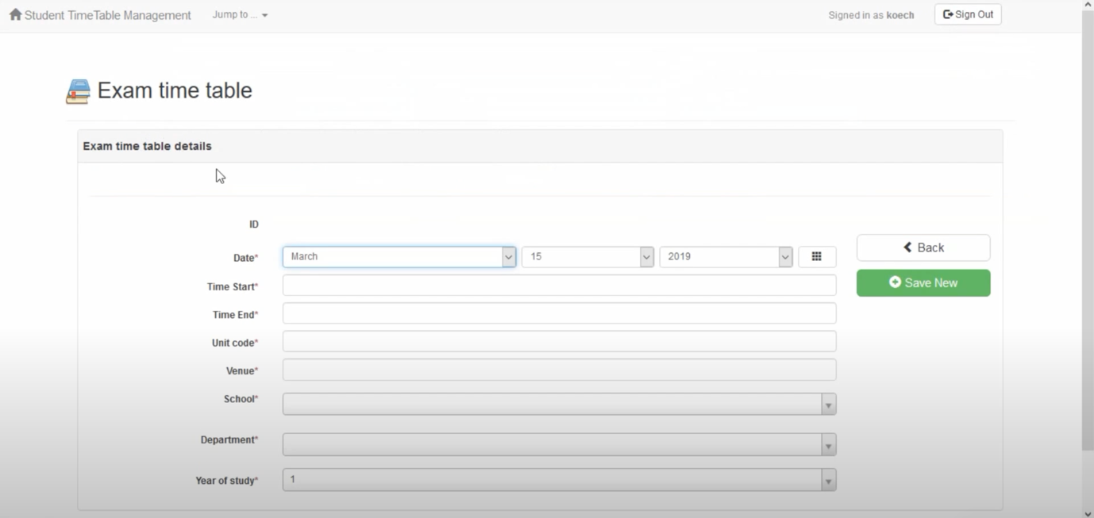

<?php

// This script and data application were generated by AppGini 5.72

// Download AppGini for free from https://bigprof.com/appgini/download/

$currDir = dirname(__FILE__);

include("$currDir/defaultLang.php");

include("$currDir/language.php");

include("$currDir/lib.php");

handle_maintenance();

header('Content-type: text/javascript; charset=' . datalist_db_encoding);

$table_perms = getTablePermissions('exam_time_table');

if(!$table_perms[0]){ die('// Access denied!'); }

$mfk = $_GET['mfk'];

$id = makeSafe($_GET['id']);

$rnd1 = intval($_GET['rnd1']); if(!$rnd1) $rnd1 = '';

if(!$mfk){

die('// No js code available!');

}

switch($mfk){

}

?>

**Departments**

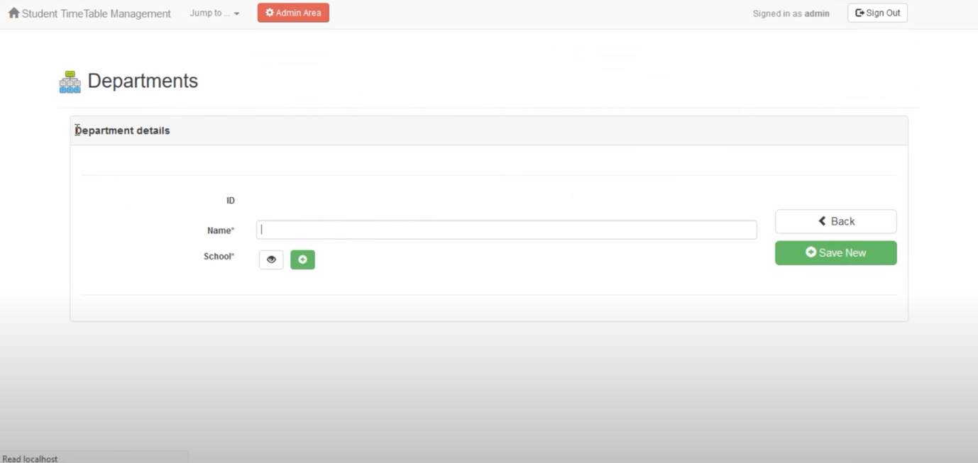

<?php

// This script and data application were generated by AppGini 5.72

// Download AppGini for free from https://bigprof.com/appgini/download/

$currDir = dirname(__FILE__);

include("$currDir/defaultLang.php");

include("$currDir/language.php");

include("$currDir/lib.php");

handle_maintenance();

header('Content-type: text/javascript; charset=' . datalist_db_encoding);

$table_perms = getTablePermissions('departments');

if(!$table_perms[0]){ die('// Access denied!'); }

$mfk = $_GET['mfk'];

$id = makeSafe($_GET['id']);

$rnd1 = intval($_GET['rnd1']); if(!$rnd1) $rnd1 = '';

if(!$mfk){

die('// No js code available!');

}

switch($mfk){

}

?>