PROJECT DOCUMENTATION
InterviewAI
Interview Intelligence for Recruiters
Prepared by: Tirumani Sai Manikanta
Team ID: —
Date: 14 July 2026
GitHub: github.com/sairoxx2895/interviewai
Live demo: interviewai-2clp.onrender.com

1. Introduction

Project Title
InterviewAI — Interview Intelligence for Recruiters

Team Members
Tirumani Sai Manikanta — Full-stack developer (design, backend, Gemini integration, frontend, deployment).

2. Project Overview

Purpose
InterviewAI is a recruiter-empowerment tool that generates role-specific, experience-aware interview question sets using the Google Gemini API. Recruiters, including non-technical interviewers, often struggle to write good questions and to judge answers fairly and consistently. InterviewAI removes that friction: it wraps every generated question with the context an interviewer needs to run a fair, structured, and objective interview — a follow-up prompt, "what a strong answer sounds like", green flags, red flags, and a 1–5 scoring guide.

Features
- Role + level + format aware generation — job role, experience level (Beginner / Intermediate / Advanced), and interview type (Technical / Behavioral / Situational / Mixed), with optional organizational context.
- Structured evaluation framework for every question: follow-up question, evaluation tip, green flags, red flags, and a 1–5 scoring guide.
- Persistent Session Ledger — every generated set is saved locally and can be reopened instantly with zero extra API calls.
- One-click Word export — turns any saved session into a clean, print-ready .docx file.
- Secure key management — the Gemini API key lives only in the server's .env file, never in source control or the browser.
- Zero external services beyond the Gemini API — no database, no auth server, no build step.

3. Architecture
InterviewAI is a lightweight three-tier application — a static single-page frontend, a Flask REST backend, and file-based persistence — with the Gemini API as its only external dependency.

Frontend
A framework-free single-page app: templates/index.html is the app shell, static/js/app.js drives all fetch calls and rendering (the generation form, the results panel with green/red flags and scoring guide, and the Session Ledger sidebar), and static/css/style.css implements the dark, gold-accented design system shown in the screenshots below. No build step or JS framework is required.

Backend
A Python Flask microservice (app.py) exposes the REST API and coordinates two services: gemini_service.py builds the role/level/type-aware prompt, calls the Google Gemini API (google-generativeai) with response_mime_type=application/json, and validates the structured response; docx_export.py turns a saved session into a formatted Word document with python-docx.

Database
There is no database server. Each generated session is persisted as its own JSON file under history/ via history_store.py (list / get / save / delete), which keeps the app zero-config and easy to run anywhere. This can be swapped for a managed database (e.g. PostgreSQL or MongoDB) if the app needs to support multiple concurrent users.

4. Setup Instructions

Prerequisites
- Python 3.9+
- A free Google Gemini API key: https://aistudio.google.com/app/apikey

Installation
git clone https://github.com/sairoxx2895/interviewai
cd interviewai
python -m venv venv
source venv/bin/activate # Windows: venv\Scripts\activate
pip install -r requirements.txt
cp .env.example .env # then paste GEMINI_API_KEY=your_real_key_here

5. Folder Structure

Client (templates/ + static/)
- templates/index.html — single-page app shell
- static/css/style.css — design system + UI styling
- static/js/app.js — frontend logic (fetch calls, rendering)

Server
- app.py — Flask app & all API routes
- gemini_service.py — Gemini API integration + prompt engineering
- docx_export.py — python-docx based Word exporter
- history_store.py — local JSON persistence layer
- history/ — generated session JSON files (gitignored)
- exports/ — generated .docx files (gitignored)
- requirements.txt, .env.example, Procfile

6. Running the Application
Unlike a client/server split, InterviewAI runs as a single Flask process that serves both the API and the static frontend.
python app.py # visit http://localhost:5000
Production deployment uses the included Procfile with gunicorn, and is currently hosted on Render at the live demo link on the cover page.

7. API Documentation
All endpoints return JSON, except the docx export, which streams a file.
Method | Endpoint | Description
GET | / | Serves the InterviewAI single-page app
POST | /api/generate | Generates a new question set via the Gemini API
GET | /api/history | Lists saved sessions (summaries)
GET | /api/history/<id> | Fetches one full saved session
DELETE | /api/history/<id> | Deletes a saved session
POST | /api/export/<id> | Exports a session to a formatted .docx file
GET | /api/health | Health check / confirms the Gemini key is configured

POST /api/generate — request body
Field | Value
role | "Senior React Developer"
experience_level | "advanced" (beginner | intermediate | advanced)
interview_type | "mixed" (technical | behavioral | situational | mixed)
num_questions | 10 (clamped 1–15)
notes | "Team uses trunk-based development, agile roadmap." (optional)

8. Authentication
The current version has no end-user login or session-based authentication — it is designed as a single-recruiter local/deployed tool. Security is instead applied at the configuration layer: the Gemini API key is read only from the server's .env file via python-dotenv and is never sent to the browser or committed to source control; a Flask secret_key (FLASK_SECRET_KEY) is used for any session/cookie signing Flask performs internally. Adding multi-user login (e.g. session cookies or JWT) is listed under Future Enhancements.

9. User Interface
Screenshots of the deployed application (interviewai-2clp.onrender.com):
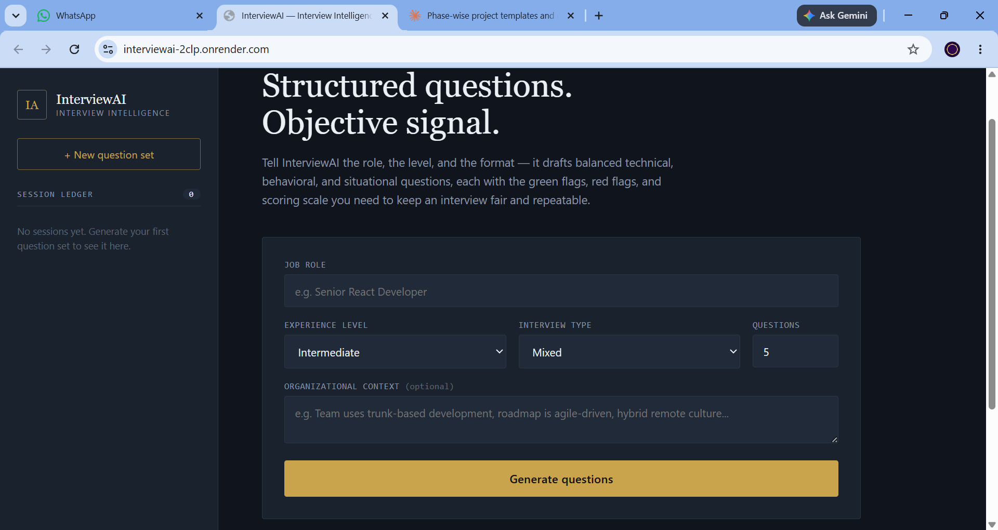
Home screen — job role, experience level, interview type, question count, and optional organizational context.
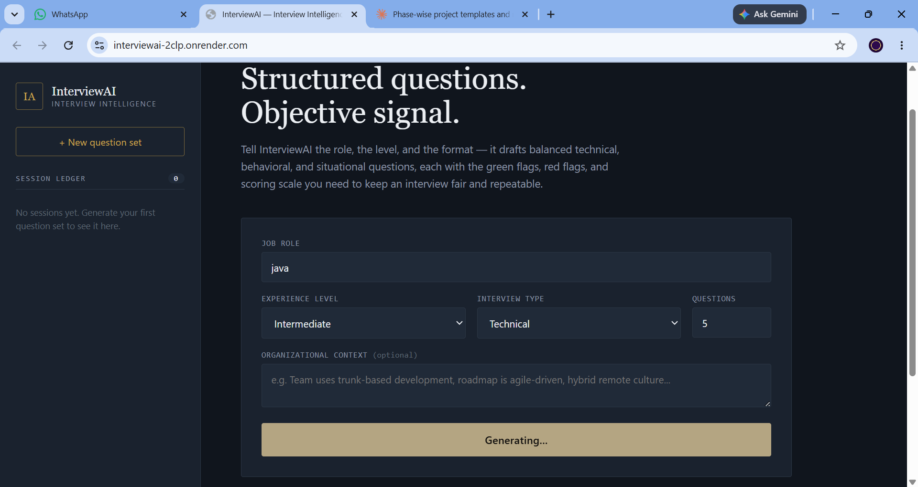
Generating a Technical question set for the role “java” at Intermediate level.
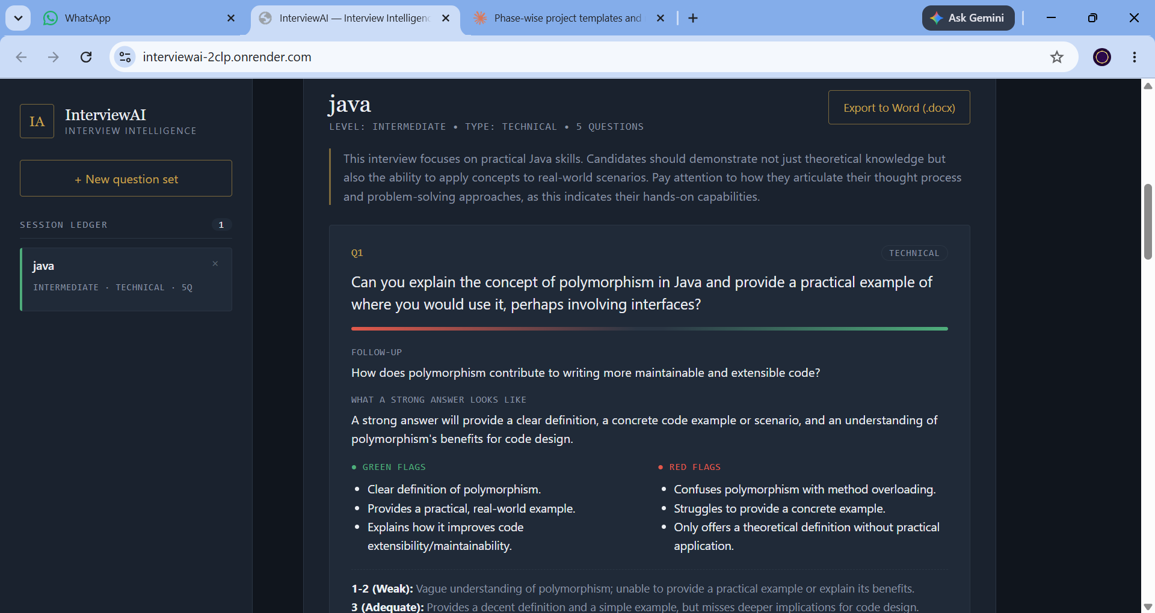
Generated question with follow-up, “what a strong answer looks like”, and colour-coded green/red flags.
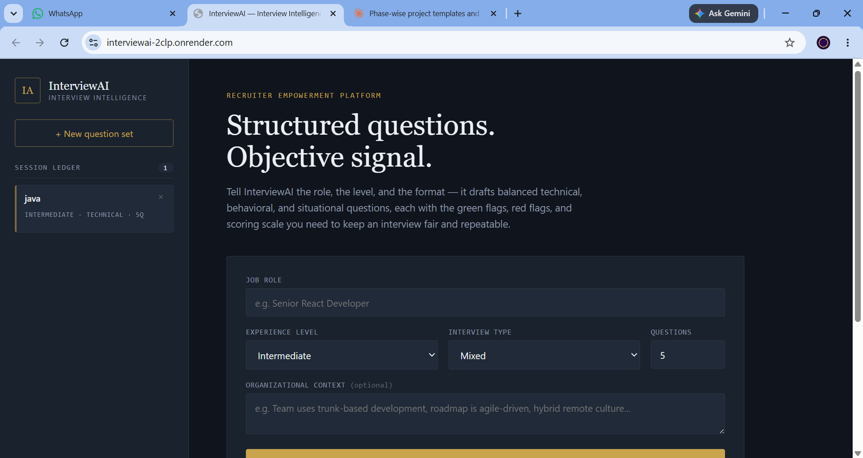
Session saved to the Session Ledger sidebar immediately after generation.

10. Testing
Testing was performed manually against the User Acceptance Testing (UAT) template completed for this project, covering question generation, session reload, Word export, and input validation. Key scenarios verified:
- Generating a mixed technical interview (10 questions) returns follow-ups, evaluation tips, green/red flags and a scoring guide for every question.
- Reopening a session from the Session Ledger loads it instantly with no additional Gemini API call.
- Exporting a session produces a correctly formatted, downloadable .docx file.
- Submitting the form without a job role returns a clear validation error instead of calling Gemini.
One issue was found and fixed during testing: the Export button failed silently if a session's JSON file had been deleted from history/ on disk; this now returns a clear 404 “Session not found” response (see BG-001 in the UAT template).

11. Screenshots or Demo
Live demo:
https://interviewai-2clp.onrender.com
Source code:
https://github.com/sairoxx2895/interviewai
See Section 9 (User Interface) above for annotated screenshots of the home screen, question generation, and the Session Ledger.

12. Known Issues
- Free-tier Gemini API keys are subject to daily quota limits, which can interrupt generation during heavy testing.
- The Render free-tier deployment cold-starts after inactivity, so the first request after idle time can take longer than usual.
- No multi-user support yet — all sessions are stored in a single shared history/ folder on the server.
- Gemini occasionally wraps its JSON response in markdown fences; this is defensively stripped in gemini_service.py, but malformed output can still raise a generation_failed error.

13. Future Enhancements
- Multi-user authentication and per-recruiter session history.
- Move history/session storage from local JSON files to a managed database (e.g. PostgreSQL) for concurrent, multi-user use.
- Team analytics dashboard (questions generated, roles hired for, interviewer scoring trends).
- Additional export formats (PDF, shareable link) alongside the existing Word export.
- Optional port of the Flask API to FastAPI with Pydantic request/response models, as noted in the project README.

