RISC-V Reliable Communication SoC: Test Plan
Oct 31, 2026 · @Vijay Yarabolu

Overview
The SoC passes verification when every message from the PC reaches the SPI slave unchanged, or the system reports FAIL after 3 retries. Corrupted data must never be reported as PASS.
Design under test (DUT): a VeeR EL2 RISC-V SoC that receives a payload over UART, checks it with CRC-16 (ARQ with ACK/NACK), buffers it in a FIFO, sends it over SPI, reads it back, re-checks the CRC and retries on mismatch.
In scope
- IP-level verification of CRC-16, FIFO, SPI (new), UART, GPIO and timer
- AXI4 interconnect and the AXI4 to AXI4-Lite bridge
- SoC-level C tests running on VeeR EL2
- Error injection on the UART input link and the SPI output link
Out of scope
- Internal verification of the VeeR EL2 core (taken as proven, from CHIPS Alliance)
- FPGA timing closure and silicon tests
- Error correction in place (ECC); the project detects and retransmits only
Verification goals
- Each IP meets its register map and protocol on its own.
- The CPU reaches every IP at its address through the interconnect.
- The 15-step communication flow passes end to end in simulation.
- Every injected error is detected, and the retry or NACK path recovers it.

DUT and test environment
The whole SoC is the DUT; the testbench only touches its pins (UART and SPI) and watches one mailbox address on the bus.
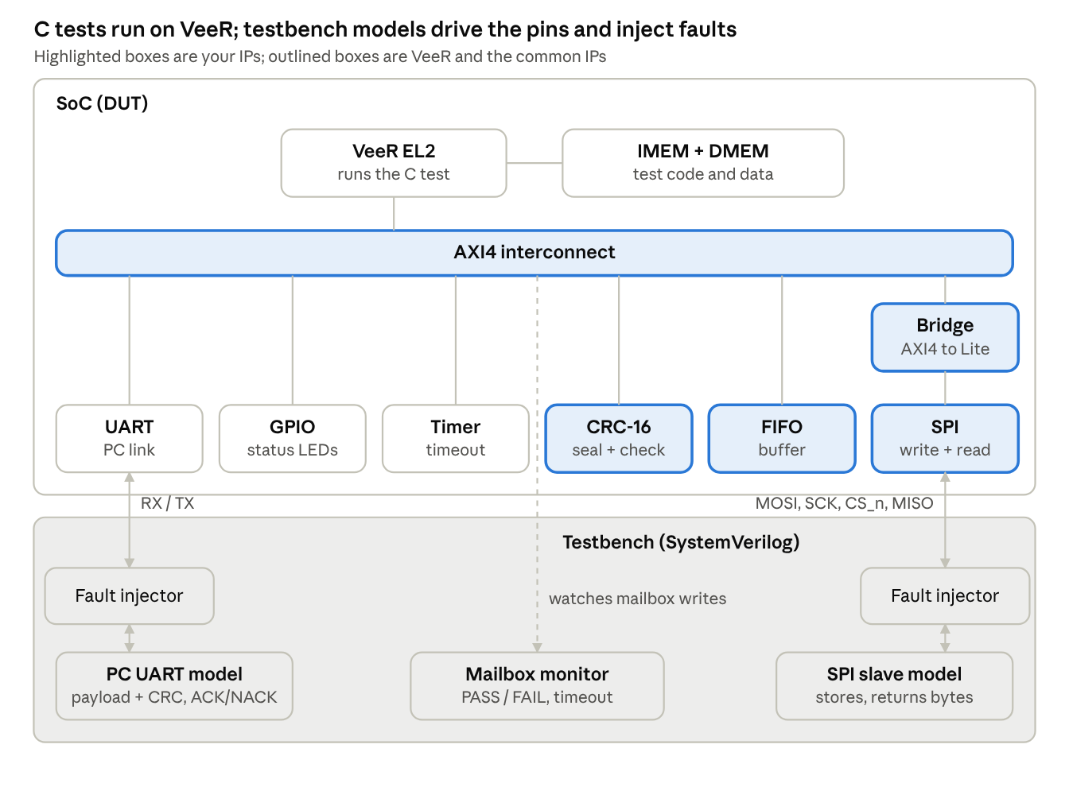
SoC under test and testbench models
Faults are injected between the SoC pins and the models, so the same C test can run clean or with errors.
Interfaces under test
Interface | Between | Protocol
CPU bus | VeeR EL2 and interconnect | AXI4, 64-bit (to confirm from soc_proj_DC/rtl)
Peripheral bus | Bridge and SPI | AXI4-Lite, 32-bit
PC link | UART pins and PC model | 8N1 serial, baud to confirm
SPI link | SPI pins and slave model | SPI mode 0, MSB first
The address map is still open and will be filled in from the interconnect RTL.

Verification strategy
Verification runs bottom up in three levels, and each level starts only when the one below it passes.
Level | What runs | Stimulus | Checker | Done when
L1 IP unit | Each IP alone in its own testbench | Bus BFM (AXI4-Lite or the interconnect's protocol) + pin drivers | Self-checking scoreboard, reference model | All IP test cases pass
L2 Integration | Interconnect + bridge + all IPs, no CPU | AXI4 master BFM in place of VeeR | Register read/write compare, address decode check | Every IP reachable at its address
L3 SoC C tests | Full SoC with VeeR EL2 running C firmware | C test program + testbench models (PC UART model, SPI slave model) | Test writes PASS/FAIL to a mailbox address; testbench ends the sim | All C tests pass, incl. fault injection
Reference models
- CRC-16-CCITT (poly 0x1021, init 0xFFFF) in the testbench and in Python for the PC script
- FIFO: a SystemVerilog queue
- SPI slave: a memory-backed model that stores written bytes and returns them on read
- PC: a UART model that sends payload + CRC and answers ACK/NACK
Pass/fail rule: a test passes only if the scoreboard sees zero mismatches, no X/Z on outputs, no bus error response (SLVERR/DECERR) unless the test expects one, and it finishes before its timeout.
Tools (to confirm): simulator (Verilator, Icarus, Questa or VCS) and the RISC-V GCC toolchain on the lab PC are still open; see Open items.

Features to verify
Each feature below maps to at least one test case in the next two sections.
IP | Features
CRC-16 | CCITT polynomial 0x1021, init 0xFFFF; byte-wise input; result register; clear/restart; back-to-back packets
FIFO | Push/pop in order; full and empty flags; overflow and underflow handling; simultaneous push and pop; reset clears contents
SPI master | Byte transmit on MOSI; full-duplex receive on MISO; chip select low for the whole packet; SCK idle level and sample edge per mode; clock divider; TX ready / RX valid status; done interrupt
UART | RX of 8N1 frames at the chosen baud; TX of ACK (0x06), NACK (0x15) and report text; RX ready flag; framing and overrun flags (if the IP has them)
GPIO | Output write and readback; input read; direction control (if present)
Timer | Count up; compare match; interrupt; used for the retry timeout
Interconnect | Address decode to every slave; DECERR on unmapped address; read and write on all slaves; ID returned unchanged
AXI4 to Lite bridge | ID echo on BID/RID; RLAST = 1; 64 to 32-bit lane select by addr[2]; WSTRB shifted; SLVERR on burst (len > 0)
Firmware flow | CRC check #1 and ACK/NACK; original copy kept until PASS; SPI readback; CRC check #2; retry up to 3; PASS/FAIL report

IP-level test cases (L1 and L2)
There are 38 unit and integration tests; each one is self-checking and runs in its own testbench.
ID | IP | Test | Stimulus | External interface | Expected result
CRC-01 | CRC-16 | Reset values | Read result after reset | Reset | 0xFFFF (init value)
CRC-02 | CRC-16 | Standard check vector | Feed "123456789" | None (internal) | 0x29B1
CRC-03 | CRC-16 | Project vector | Feed 0x48 0x49 ("HI") | None (internal) | 0x4087
CRC-04 | CRC-16 | Single-bit change | Feed 0x48 0x4A | None (internal) | 0x70E4, differs from 0x4087
CRC-05 | CRC-16 | Residue check | Feed 0x48 0x49 0x40 0x87 | None (internal) | 0x0000
CRC-06 | CRC-16 | Clear between packets | Packet A, clear, packet B | None (internal) | B's CRC unaffected by A
CRC-07 | CRC-16 | Random packets | 1,000 random packets, 1 to 64 bytes | None (internal) | Match reference model every time
FIFO-01 | FIFO | Reset | Read flags after reset | Reset | empty = 1, full = 0
FIFO-02 | FIFO | Order | Push 0x48 0x49 0x40 0x87, pop 4 | None (internal) | Same bytes, same order
FIFO-03 | FIFO | Full flag | Push DEPTH items | None (internal) | full = 1 after the last push
FIFO-04 | FIFO | Overflow | Push when full | None (internal) | Data not overwritten; overflow flag if present
FIFO-05 | FIFO | Underflow | Pop when empty | None (internal) | No pointer change; underflow flag if present
FIFO-06 | FIFO | Simultaneous push/pop | Push and pop in the same cycle at half full | None (internal) | Count unchanged, order kept
FIFO-07 | FIFO | Pointer wrap | Push/pop 3 × DEPTH items | None (internal) | No data loss across wrap
SPI-01 | SPI | Reset state | Read pins after reset | SPI (spi_cs_n, spi_sck, spi_mosi), Reset | CS_n = 1, SCK = idle level, MOSI stable
SPI-02 | SPI | Single byte TX | Write 0x49 to TX_DATA | SPI (spi_mosi, spi_sck, spi_cs_n) | Slave model receives 0x49, MSB first
SPI-03 | SPI | Full duplex RX | Slave returns 0xA5 while master sends | SPI (spi_miso, spi_mosi) | RX_DATA = 0xA5
SPI-04 | SPI | Packet with CS held | Send 4 bytes | SPI (spi_cs_n, spi_sck) | CS_n low for all 32 SCK edges, high after
SPI-05 | SPI | Clock divider | Each divider setting | SPI (spi_sck), Clock | SCK period = clk / (2 × CLKS_PER_HALF_BIT)
SPI-06 | SPI | Mode check | Mode 0 (and 1–3 if built) | SPI (spi_sck, spi_mosi, spi_miso) | Data sampled on the correct edge
SPI-07 | SPI | Status and IRQ | One transfer | SPI (all four pins) | busy during, done IRQ once at the end
SPI-08 | SPI | Back-to-back | 16 bytes with no gap | SPI (all four pins) | All received in order
UART-01 | UART | RX one frame | Model sends 0x48 at the set baud | UART (uart_rx) | RX_DATA = 0x48, ready = 1
UART-02 | UART | TX one frame | Write 0x06 (ACK) | UART (uart_tx) | Model receives 0x06
UART-03 | UART | Burst RX | 4 bytes back to back | UART (uart_rx) | No byte lost
UART-04 | UART | Baud mismatch | Model 3% off | UART (uart_rx) | Framing error flag, or the byte is caught later by CRC
GPIO-01 | GPIO | Output | Write 0x0F | GPIO (gpio_out) | Pins = 0x0F, readback 0x0F
GPIO-02 | GPIO | Input | Drive pins 0xA5 | GPIO (gpio_in) | Read = 0xA5
TMR-01 | Timer | Count | Enable, wait N cycles | Clock | Count = N ± 1
TMR-02 | Timer | Compare IRQ | Set compare = 100 | Clock | IRQ at cycle 100
IC-01 | Interconnect | Decode | Write/read every slave base | None (internal) | Each slave sees only its own access
IC-02 | Interconnect | Unmapped | Access a hole in the map | None (internal) | DECERR, no hang
IC-03 | Interconnect | ID return | Accesses with IDs 0 to 15 | None (internal) | BID/RID equal the request ID
IC-04 | Interconnect | Back-to-back masters | IFU and LSU at once (if 2 masters) | None (internal) | Both complete, no deadlock
BR-01 | Bridge | Lower word | Write addr[2] = 0 | None (internal) | WDATA[31:0] reaches the slave
BR-02 | Bridge | Upper word | Write addr[2] = 1 | None (internal) | WDATA[63:32] reaches the slave, WSTRB[7:4] used
BR-03 | Bridge | Read | Read any register | None (internal) | RLAST = 1, RID echoed, data on both halves
BR-04 | Bridge | Burst rejected | AWLEN = 3 | None (internal) | SLVERR, no hang

SoC-level C tests (L3)
There are 10 C programs; each one is compiled for VeeR EL2, loaded into instruction memory, and reports through a mailbox address the testbench watches.
ID | C test | What it does | Pass condition
C-01 | test_boot.c | Reset, run from the reset vector, write PASS | Mailbox = PASS within 10,000 cycles
C-02 | test_gpio.c | Write patterns to GPIO, read back | Pins and readback match
C-03 | test_timer.c | Start timer, poll count, take the timer interrupt | Count grows; ISR runs once
C-04 | test_uart.c | Send "OK" on TX; receive 4 bytes from the PC model | PC model sees "OK"; CPU reads the 4 bytes
C-05 | test_crc.c | Run CRC-01 to CRC-05 vectors through the CRC registers | All 5 results match
C-06 | test_fifo.c | Push 8, pop 8, check full/empty | Order and flags correct
C-07 | test_spi.c | Send 4 bytes, read 4 back from the slave model | Readback = sent bytes
C-08 | test_main_flow.c | Full 15-step flow with "HI": UART RX, CRC #1, ACK, FIFO, SPI write, readback, CRC #2, report | PC model gets ACK then "PASS, attempts 1"; slave holds 48 49 40 87
C-09 | test_arq_nack.c | PC model corrupts the first UART send | CPU sends NACK once, ACK on the resend, then PASS
C-10 | test_spi_retry.c | Testbench flips one MISO bit on the first readback | CRC #2 fails once, retry, then "PASS, attempts 2"
Mailbox convention (proposed): the C test writes 0x1 (PASS) or 0x2 (FAIL) to a reserved address; the testbench prints the result and stops the simulation. A second address can take characters for printf-style debug.

Error injection and negative tests
Every fault below must end in either a recovered PASS or a clean FAIL report, never a false PASS or a hang.
ID | Link | Fault injected (testbench) | Models | Expected result
ERR-01 | UART in | Flip 1 bit in a payload byte | EMI spike | CRC #1 fails, NACK, PC resends, PASS
ERR-02 | UART in | Flip 1 bit in the CRC bytes | EMI spike | NACK, resend, PASS
ERR-03 | UART in | Drop one byte | Loose wire | CRC #1 fails or receive timeout, NACK
ERR-04 | SPI out | Flip 1 MISO bit on readback | Noise on MISO | CRC #2 fails, retry, PASS on attempt 2
ERR-05 | SPI out | Flip 1 MOSI bit on write | Noise on MOSI | Slave stores wrong byte, CRC #2 fails, retry, PASS
ERR-06 | SPI out | Burst of 8 bits flipped | Crosstalk burst | Detected (CRC-16 catches all bursts up to 16 bits)
ERR-07 | SPI out | One extra SCK pulse | Ringing | All bits shifted, CRC #2 fails, retry
ERR-08 | SPI out | MISO stuck at 1 | Open wire | Readback 0xFF, 3 retries fail, FAIL reported
ERR-09 | SPI out | Slave corrupts stored byte | Bad flash cell | Readback differs, retry, PASS or FAIL after 3
ERR-10 | SPI out | Fault on every attempt | Permanent fault | Exactly 3 retries, then FAIL; no infinite loop
NEG-01 | Bus | CPU reads an unmapped address | Firmware bug | DECERR, trap handled, no hang
NEG-02 | FIFO | Firmware pushes past full | Firmware bug | Data protected, error flag
NEG-03 | Timer | Retry timeout expires | Slave not responding | Retry counted, FAIL after limit
How faults are injected: a fault-injector module sits between the SoC pins and the PC or SPI slave model. A plusarg picks the fault, the byte and the bit (for example +ERR=ERR-04 +BYTE=1 +BIT=0), so the same C test runs clean or faulty.

Coverage plan
The sign-off target is 100% functional coverage of the points below and at least 90% line coverage on the project's own RTL (VeeR EL2 excluded).
Functional coverage points
Covergroup | Bins
CRC input | packet length 1, 2–8, 9–32, 33–64 bytes; byte values 0x00, 0xFF, other
FIFO level | empty, 1, half, DEPTH−1, full; push+pop same cycle
SPI transfer | 1 byte, 4 bytes, 16 bytes; each built mode; each divider setting used
UART | ACK sent, NACK sent, report sent; RX bytes 0x00 and 0xFF
ARQ path | CRC #1 pass first try; fail then pass
SPI retry path | attempts = 1, 2, 3; final FAIL
Bus | read and write to every slave; DECERR; SLVERR from the bridge
Fault type | each ERR-01 to ERR-10 hit at least once
Code coverage: line, branch and FSM-state coverage on CRC, FIFO, SPI wrapper, bridge and interconnect. Any line left uncovered must be waived with a reason (for example, unreachable default case).

Test infrastructure
One make command builds a C test, loads it, runs the SoC simulation and prints PASS or FAIL; make regress runs every test.
SoC testbench parts
- tb_soc_top.sv: clock, reset, SoC instance, mailbox monitor, timeout
- pc_uart_model.sv: sends payload + CRC at the set baud, waits for ACK/NACK, resends on NACK
- spi_slave_model.sv: memory-backed slave that stores written bytes and returns them on read
- fault_injector.sv: sits on the UART and SPI pins, applies the fault chosen by plusargs
- soc_assertions.sv: CS_n stays low for a whole packet, no X on the bus, every AXI request gets a response
C test framework
- crt0.S: stack setup, jump to main
- soc.h: base addresses and register offsets for every IP
- test_lib.c: pass(), fail(code), print(str) through the mailbox
- link.ld: places code in instruction memory and data in data memory
Build flow: C source → riscv-gcc -march=rv32imc → ELF → objcopy to hex → $readmemh into instruction memory → simulate.
Directory layout (proposed)
soc_proj_DC/
rtl/ interconnect, bridge, soc_top
IPs/ crc, fifo, spi, uart, gpio, timer
RISC-V-VeeR-EL2/
tb/
unit/ one testbench per IP (L1)
integ/ interconnect + IPs with AXI BFM (L2)
soc/ tb_soc_top and models (L3)
sw/
common/ crt0.S, link.ld, soc.h, test_lib.c
tests/ test_*.c
scripts/ Makefile, regress list, pc_send.py
Regression: a list file names each test and its plusargs; the script runs them all and writes a pass/fail table plus the coverage report.

Entry, exit, risks and open items
Entry criteria (per level)
- L1: the IP's RTL compiles with no lint errors and its register map is written down
- L2: all L1 tests pass; address map frozen
- L3: L2 passes; C toolchain builds test_boot.c; VeeR boots from the reset vector
Exit criteria (sign-off)
- All 38 IP tests, 10 C tests and 13 error and negative tests pass in one regression run
- Functional coverage 100%, line coverage on project RTL at least 90%, waivers listed
- No open bug rated high
Milestones (in order; dates to be set with the guide)
- IPs modified and unit tests passing (CRC, FIFO, SPI)
- Interconnect + bridge integration passing (L2)
- SoC boots and C-01 to C-07 pass
- Main flow C-08 passes
- Fault injection C-09, C-10 and ERR/NEG tests pass
- Coverage closed, report written
Risks
Risk | Effect | Fallback
Interconnect protocol differs from AXI4 | Bridge and SPI wrapper need rework | Read the interconnect RTL first, match the wrapper to it
Existing CRC uses a different polynomial | Vectors and PC script disagree | Fix CRC-16-CCITT (0x1021, 0xFFFF) across RTL, C and Python
No RISC-V toolchain on the lab PC | No L3 tests | Install the prebuilt riscv-gnu-toolchain, or build hex files elsewhere
VeeR EL2 simulation is slow | Long regressions | Keep L3 tests short; do bulk random tests at L1
Simulator lacks SystemVerilog assertions or coverage | No coverage numbers | Use Verilator with coverage, or Questa if available
Open items
- ☐ Confirm the interconnect's bus protocol and address map from soc_proj_DC/rtl
- ☐ Confirm the simulator on the lab PC
- ☐ Confirm the RISC-V GCC toolchain (which riscv64-unknown-elf-gcc)
- ☐ Confirm the CRC IP's polynomial and interface
- ☐ Confirm the FIFO depth and width
- ☐ Pick the mailbox address for PASS/FAIL

