Project Title
Tree Diameter Finder Using Graph Traversal
Project Report submitted for the partial fulfilment of grade for the course

Data Structures and Algorithms -3 (25CS2103E)
in

A.Y. 2026-2027

Submitted by
Lohith Sanapala (2520030023)
Saahas Vaddi (2520030256)
Rithwik Rapaka (2520030427)
Team Number: 16
Section: 4

Under the guidance of

Dr J Yamini Devi
Professor in CSE, Department of CSE
Hyderabad-500090, Telangana, India.

K L (Deemed to be) University
DEPARTMENT OF COMPUTER SCIENCE AND ENGINEERING



DECLARATION

We, Lohith Sanapala (2520030023), Saahas Vaddi (2520030256), and Rithwik Rapaka (2520030427), declare that the mini project report entitled “Tree Diameter Finder Using Graph Traversal” records our project work submitted for Data Structures and Algorithms -3 (25CS2103E), in partial fulfilment of the requirements of the B.Tech programme in Computer Science and Engineering at K L (Deemed to be) University during A.Y. 2026-2027. The sources used for the algorithm and background are acknowledged in the references.

Lohith Sanapala (2520030023)
Saahas Vaddi (2520030256)
Rithwik Rapaka (2520030427) ___________________________

K L (Deemed to be) University
DEPARTMENT OF COMPUTER SCIENCE AND ENGINEERING
CERTIFICATE

This is to certify that the mini project report entitled “Tree Diameter Finder Using Graph Traversal” is the project work submitted by Lohith Sanapala (2520030023), Saahas Vaddi (2520030256), and Rithwik Rapaka (2520030427) in partial fulfilment of the requirements for the BACHELOR OF TECHNOLOGY in Computer Science and Engineering at K L (Deemed to be) University during the academic year 2026-2027, for the course Data Structures and Algorithms -3 (25CS2103E).

Signature of the Supervisor
Dr J Yamini Devi
Professor in CSE

Signature of the HOD Signature of the External Examiner

ACKNOWLEDGEMENT

We thank everyone who supported the completion of our mini project, Tree Diameter Finder Using Graph Traversal, for the course Data Structures and Algorithms -3.

We express our sincere thanks to our guide, Dr J Yamini Devi, Professor in CSE, Department of Computer Science and Engineering, for guidance and support during the project.

We thank the Head of the Department and the Department of Computer Science and Engineering at K L (Deemed to be) University for the opportunity to undertake this project.

We also thank the teaching and non-teaching staff, our classmates, friends, and families for their encouragement. The references in this report acknowledge the resources used to understand graph traversal and tree diameter.

Lohith Sanapala (2520030023)
Saahas Vaddi (2520030256)
Rithwik Rapaka (2520030427)

TABLE OF CONTENTS

S.No. | Contents | Page no.
1 | Abstract | 6
2 | Introduction | 7
3 | Literature survey | 8
4 | Problem Statement and Objectives | 9
5 | Hardware and Software Requirements | 10
6 | Implementation | 11
7 | Results and Discussion | 17
8 | Conclusion and Future Scope | 19
9 | References | 20
A | Case study — Longest Road Path Analysis | 21

1 ABSTRACT
Tree Diameter Finder Using Graph Traversal computes the longest path in a connected, undirected, unweighted tree. The program accepts the number of nodes and their connecting edges, represents the network with adjacency lists, and reports the diameter length, its endpoints, and the complete path. It uses two breadth-first searches. The first search begins at node 0 and identifies a farthest node A. The second search begins at A and identifies a farthest node B. The distance from A to B is the diameter, while parent links recover the path.
The implementation uses Java collections and runs in O(V + E) time with O(V + E) storage, which becomes O(V) for a tree. Verification against all-source BFS passed for all 1,442 labelled trees with one to six nodes and for 100 additional random trees. A rural-road case study with ten junctions produced a diameter of five road segments. The current program checks the node count and endpoint range, but its tree-validation helper is not invoked. Correctness therefore assumes a valid tree as input. The project demonstrates efficient graph traversal and path reconstruction, with an application to measuring separation in a branching network.

Team details
Member | Roll number
Lohith Sanapala | 2520030023
Saahas Vaddi | 2520030256
Rithwik Rapaka | 2520030427

Team 16 Section 4
Guide: Dr J Yamini Devi, Professor in CSE, Department of CSE

2 INTRODUCTION
A tree is a connected graph with no cycles. Between any two nodes, exactly one simple path exists. For a tree with V nodes, the number of edges is V - 1. This structure appears in branching networks and hierarchical data, where the maximum separation between two nodes can be useful.
The diameter is the largest distance between any pair of nodes. This project measures distance in edges, so a path containing six nodes has length five. The output includes both the length and the sequence of nodes, making the result easier to inspect than a distance alone.

Motivation
Running a separate traversal from every node would find the diameter, but it repeats much of the same work. In a tree, two carefully chosen traversals are sufficient. This reduces the time from O(V²) for all-source traversal to O(V) and keeps the implementation easy to follow.

Project approach
The Java program reads an edge list, stores each undirected edge in both directions, and performs BFS using a queue. Distance entries begin at -1, which also marks undiscovered nodes. Parent entries record how each node was reached. The second traversal supplies the diameter distance and the parent chain used to print the path.

Scope and application
The system is a console application for a single static, unweighted tree. Nodes are numbered 0 through n - 1. The rural-road example treats each road segment as one unit. Its diameter measures the maximum number of segments between junctions; it does not estimate kilometres or travel time without additional data.
This report reviews related approaches, states the input assumptions, explains four implementation modules, presents executed tests, and concludes with extensions. Appendix A includes the supplied case study with its inconsistent edge count corrected.

3 LITERATURE SURVEY

3 1 MIT two traversal solution
The MIT Introduction to Algorithms problem-set solution describes finding a tree diameter through two BFS traversals. A first search locates a peripheral vertex, and a second search obtains the maximum distance from that vertex. Its correctness argument uses the unique paths in a tree. This is the theoretical basis for the two-pass method implemented in the project [1].

3 2 CSES Tree Diameter problem
The CSES Tree Diameter task provides a closely related programming problem: read a tree and print its maximum distance. It supplies an edge-list input format and a sample result. This project extends that output by printing endpoints and the actual path. CSES uses one-based node labels, while this implementation uses zero-based labels [2].

3 3 Princeton BreadthFirstPaths
Princeton’s algs4 implementation shows queue-based BFS for an undirected graph. It stores distances and predecessor information so that shortest paths can be recovered. These are the same core data requirements used by this project. The local implementation uses Java standard collections and calls its traversal twice for the tree-diameter problem [3].

3 4 NetworkX exact graph diameter
NetworkX defines diameter as the maximum eccentricity, where eccentricity is a node’s greatest distance to another node. Its exact diameter interface applies to broader graph inputs and offers weight support. This provides a comparison with the project’s narrower unweighted-tree contract. The all-source BFS verification follows the same maximum-distance definition [4].

3 5 NetworkX two sweep approximation
NetworkX also documents a two-sweep diameter approximation for undirected graphs. For general graphs, the procedure supplies a lower bound rather than a universal exact answer. This distinction explains why the project must retain its tree assumption. Applying the same Java code to an arbitrary cyclic graph does not establish that graph’s exact diameter [5].

4 PROBLEM STATEMENT AND OBJECTIVES

Problem statement
Given a connected, undirected, unweighted tree, determine its diameter in edges and print the corresponding endpoints and path.

Problem description
The input contains n nodes and n - 1 undirected edges. The system must identify the most widely separated pair without running a separate search from every node.

Objectives
1. Represent the input efficiently with adjacency lists.
2. Use BFS to locate a farthest node from a chosen start.
3. Repeat BFS from that node to obtain the diameter.
4. Reconstruct the path using parent links.
5. Handle a single node and reject out-of-range indices.
6. Verify results against an all-source BFS reference.

Input and output contract
Item | Definition
Node count | Integer n ≥ 1
Node labels | 0 through n - 1
Edges | Exactly n - 1 pairs u v; undirected and unweighted
Precondition | A connected, acyclic tree
Output | Two endpoints, diameter in edges, and ordered path

For valid input, consecutive path nodes must be adjacent, and the path edge count must equal the maximum distance. Different endpoint pairs can be correct when several longest paths tie. The existing main method does not enforce the full tree precondition.

5 HARDWARE AND SOFTWARE REQUIREMENTS

Hardware requirements
A general-purpose computer capable of running a Java Development Kit is sufficient for the coursework examples. The supplied slides suggest an Intel i3 or AMD Ryzen 3 processor, 4 GB RAM, and 500 MB free storage as a classroom baseline. These are planning figures, not measured minimum requirements; the Java installation and input size determine actual resource needs.

Software requirements
Component | Requirement or use
Language | Java
Compiler and runtime | JDK with javac and java
Operating system | Windows, Linux, or macOS with a compatible JDK
Editor | Any Java-capable editor or IDE
Dependencies | Java standard library only
Interface | Console or redirected text input

Build and execution
javac TreeDiameter.java
java TreeDiameter
Save the source as TreeDiameter.java. Enter n first, followed by n - 1 pairs of integers. Whitespace separates values, so edges can be supplied on separate lines. Verification for this report used the installed JDK 25 on Windows.

Implementation alignment
The submitted program is Java and uses BFS. Python, C++, and DFS mentioned in the presentation are possible alternatives and are not part of this source. No external graph library, database, internet connection, or graphical interface is required to run the program.

6 IMPLEMENTATION

6 1 Overall design
The bfs method receives the adjacency list, a start node, and reusable distance and parent arrays. The main method builds the graph, invokes BFS twice, and prints the result. A separate isValidTree helper exists in the source but is not called by main.

Execution flow
Read n → reject n ≤ 0 → allocate adjacency lists → handle n = 1 → read n - 1 edges and check bounds → BFS from 0 → BFS from A → reconstruct the path from B → reverse and print.

Core pseudocode
A = BFS(adjacency, 0, distance, parent)
B = BFS(adjacency, A, distance, parent)
diameter = distance[B]
path = empty list
current = B
while current != -1:
append current to path
current = parent[current]
reverse(path)
print A, B, diameter, path

Data structures
Structure | Role
List<List<Integer>> adj | Stores neighbours of each node
Queue<Integer> | Processes nodes in BFS discovery order
int[] dist | Edge distances; -1 means undiscovered
int[] parent | Predecessor from the current BFS
List<Integer> path | Reconstructed diameter path

Each bfs call resets both arrays. Parents used for reconstruction therefore belong to the second traversal. The following four modules are excerpts from the supplied source, with line wrapping adjusted for readability.

6 2 INPUT AND GRAPH CONSTRUCTION
Module 1 reads n and the n - 1 edges, checks node counts and endpoint bounds, and stores each edge in both directions. It returns early for a single node. This excerpt is inside main.
Scanner sc = new Scanner(System.in);

System.out.print("Enter number of nodes: ");
int n = sc.nextInt();

if (n <= 0) {
System.out.println("A tree must have at least 1 node.");
sc.close();
return;
}

List<List<Integer>> adj = new ArrayList<>();
for (int i = 0; i < n; i++) {
adj.add(new ArrayList<>());
}

if (n == 1) {
System.out.println("\nEndpoints : 0 and 0");
System.out.println("Diameter : 0 edges");
System.out.println("Path : [0]");
sc.close();
return;
}

System.out.println("Enter " + (n - 1)
+ " edges (u v), nodes numbered 0 to " + (n - 1) + ":");
for (int i = 0; i < n - 1; i++) {
int u = sc.nextInt();
int v = sc.nextInt();

if (u < 0 || u >= n || v < 0 || v >= n) {
System.out.println(
"Invalid node index. Please use numbers between 0 and "
+ (n - 1) + ".");
sc.close();
return;
}

adj.get(u).add(v);
adj.get(v).add(u);
}

6 3 BREADTH FIRST SEARCH
Module 2 resets distance and parent arrays, then uses a queue to visit reachable nodes. A node is enqueued only once because its distance changes from -1 on discovery.
static int bfs(List<List<Integer>> adj, int start, int[] dist, int[] parent) {
Arrays.fill(dist, -1);
Arrays.fill(parent, -1);

Queue<Integer> queue = new LinkedList<>();
queue.add(start);
dist[start] = 0;
int farthest = start;

while (!queue.isEmpty()) {
int u = queue.poll();
if (dist[u] > dist[farthest]) {
farthest = u;
}

for (int v : adj.get(u)) {
if (dist[v] == -1) {
dist[v] = dist[u] + 1;
parent[v] = u;
queue.add(v);
}
}
}

return farthest;
}

6 4 DIAMETER AND PATH RECONSTRUCTION
Module 3 calls BFS twice, follows parent links from the second endpoint, reverses the path, and prints the result. This excerpt completes main.
int[] dist = new int[n];
int[] parent = new int[n];
int a = bfs(adj, 0, dist, parent);
int b = bfs(adj, a, dist, parent);

int diameter = dist[b];
List<Integer> path = new ArrayList<>();
for (int cur = b; cur != -1; cur = parent[cur]) {
path.add(cur);
}
Collections.reverse(path);

System.out.println("\nEndpoints : " + a + " and " + b);
System.out.println("Diameter : " + diameter + " edges");
System.out.println("Path : " + path);
sc.close();

6 5 TREE VALIDATION HELPER
Module 4 is defined in the supplied source but is never called by main. It attempts to check self-loops, cycles, and connectivity. Integrating and reviewing validation is future work; it is not an active safeguard in this submission.
static boolean isValidTree(List<List<Integer>> adj, int n) {
boolean[] visited = new boolean[n];
int[] parent = new int[n];
Arrays.fill(parent, -1);

Queue<Integer> queue = new LinkedList<>();
queue.add(0);
visited[0] = true;

int visitedCount = 0;
while (!queue.isEmpty()) {
int u = queue.poll();
visitedCount++;

for (int v : adj.get(u)) {
if (v == u) {
return false;
}
if (parent[u] != v && visited[v]) {
if (parent[v] != u) {
return false;
}
}
if (!visited[v]) {
visited[v] = true;
parent[v] = u;
queue.add(v);
}
}
}

return visitedCount == n;
}

6 6 CORRECTNESS AND COMPLEXITY

Why two traversals work
BFS visits nodes in increasing distance from its start. In an unweighted tree, that distance is the number of edges on the unique path to each node. A farthest node A from an arbitrary start is an endpoint of some diameter. A second BFS from A therefore reaches an opposite endpoint B at the maximum distance. This is the tree-specific property described in [1].
For every discovered node v, parent[v] is a neighbour one level closer to the BFS start. Following these links from B reaches A without a cycle. Reversing the sequence yields the path from A to B, whose edge count equals dist[B].

Endpoint ties
The farthest node changes only when a strictly greater distance is found. Equal-distance ties retain the node removed from the queue first. The adjacency lists preserve input order, so changing edge order can change the printed endpoints while leaving the diameter unchanged.

Resource analysis
Operation | Time | Storage
Build adjacency lists | O(V + E) | O(V + E)
Two BFS traversals | O(V + E) | O(V) auxiliary
Recover and reverse path | O(V) | O(V)
Complete algorithm on a tree | O(V) | O(V)

Each undirected edge occupies two adjacency entries. A complete BFS queues every node once and examines every adjacency entry once. With E = V - 1, total work and storage are linear in V. These are analytical bounds, not measured execution-time claims.

Comparison
All-source BFS takes O(V²) on a tree. A DFS method combining the two largest downward depths at each node can also run in O(V), but needs different state and path reconstruction logic. Two-pass BFS is iterative and directly produces parent links.

7 RESULTS AND DISCUSSION
The supplied Java file was compiled and executed without changing its algorithm. These figures reproduce captured console text, with input and output separated for readability.

7 1 Balanced tree
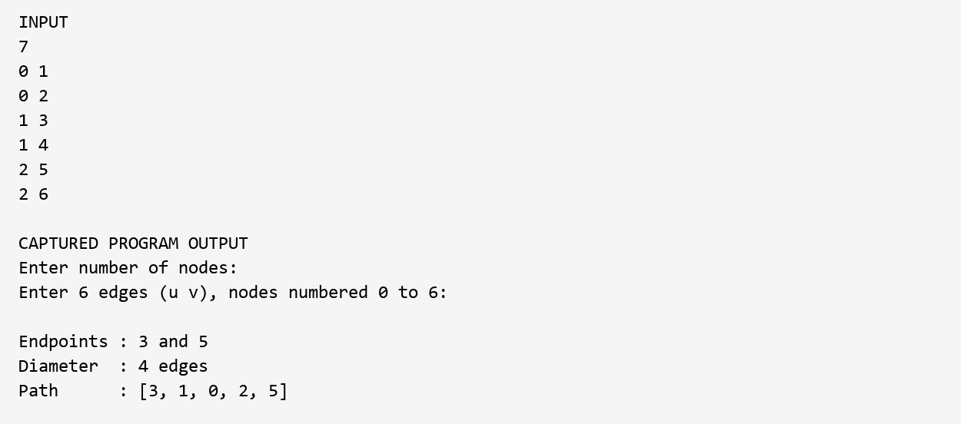
Figure 1. For seven nodes, the program reports endpoints 3 and 5 and a diameter of four edges. The path [3, 1, 0, 2, 5] contains five nodes.

7 2 Single node
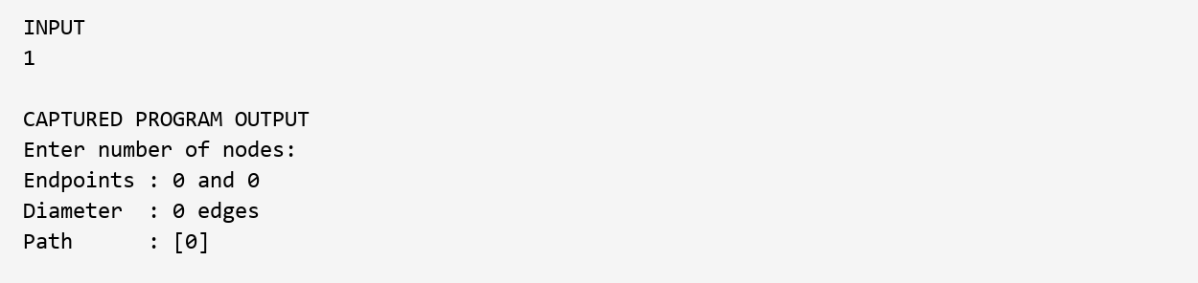
Figure 2. A one-node tree returns endpoints 0 and 0, diameter zero, and path [0]. No edge input is required.

7 3 TEST SUMMARY
Test | Expected | Observed
Single node | Diameter 0 | 0; endpoints 0 and 0
Two nodes | Diameter 1 | 1; endpoints 1 and 0
Five-node chain | Diameter 4 | 4; endpoints 4 and 0
Five-node star | Diameter 2 | 2; endpoints 1 and 2
Balanced tree | Diameter 4 | 4; endpoints 3 and 5
Road network | Diameter 5 | 5; endpoints 7 and 0
n = 0 | Reject | Rejection message
Invalid node index | Reject | Rejection message

Reference verification
A separate harness called the submitted bfs method twice and compared the result with BFS from every possible source. Prüfer sequences generated every labelled tree with two through six nodes; the single-node tree was added separately. All 1,442 cases passed. A further 100 trees, generated with random seed 9 and sizes from 7 to 100, also passed. Reconstructed paths were checked for adjacency and agreement with the computed distance.

Invalid input observations
Input condition | Current behaviour
Cycle with an isolated node | Prints a result for the reachable component
Self-loop with an isolated node | Prints a result instead of rejecting
Duplicate edge with an isolated node | Prints a result instead of rejecting
Nonnumeric node count | Throws InputMismatchException

These cases expose input-validation gaps. The valid-tree proof assumes connectivity and acyclicity. The helper isValidTree is present but unused, and Scanner input errors are not handled.

8 CONCLUSION AND FUTURE SCOPE

Conclusion
The project identifies the diameter endpoints, length, and complete path of a valid unweighted tree using two BFS traversals. Adjacency lists, a queue, and reusable arrays keep the algorithm linear in the number of nodes. Exhaustive small-tree checks and additional random-tree checks agreed with an all-source BFS reference.
The rural-road case study has a diameter of five segments. Multiple endpoint pairs attain this value. The program chooses one according to traversal order, so a different longest path can still be correct.
The main remaining limitation is input validation. Node counts and bounds are checked, but main does not call the tree-validation helper. Correctness claims therefore apply to valid tree input.

Near term improvements
Invoke and review tree validation before the diameter traversals. Reject self-loops and duplicate edges explicitly, check connectivity, and give clear messages for missing or nonnumeric input. Add file input and a repeat-run option.

Further development
For nonnegative weighted trees, store edge weights and accumulate path distances using an appropriate numeric type. Add a display of both BFS passes and highlight the diameter path. A road-planning version needs measured lengths or travel times to support physical-distance conclusions.

Longer term scope
Dynamic trees require dedicated methods to update the diameter after changes. Networks with cycles require an appropriate graph-diameter algorithm. The diameter of a spanning tree describes that selected tree and is not necessarily the exact diameter of the original network.

9 REFERENCES
[1] MIT 6.046J/18.410J. Problem Set 9 Solutions, Handout 32, Exercise 9-1. 21 November 2001.
https:/​/​courses.​csail.​mit.​edu/​6.​046/​fall01/​handouts/​ps9sol.​pdf
[2] CSES Problem Set. Tree Diameter, task 1131.
https:/​/​cses.​fi/​problemset/​task/​1131
[3] Robert Sedgewick and Kevin Wayne. algs4 BreadthFirstPaths.java. Official source repository.
https:/​/​github.​com/​kevin-wayne/​algs4/​blob/​master/​src/​main/​java/​edu/​princeton/​cs/​algs4/​BreadthFirstPaths.​java
[4] NetworkX documentation. Exact diameter and maximum eccentricity.
https:/​/​networkx.​org/​documentation/​stable/​reference/​algorithms/​generated/​networkx.​algorithms.​distance_measures.​diameter.​html
[5] NetworkX documentation. Approximation diameter using two sweeps.
https:/​/​networkx.​org/​documentation/​stable/​reference/​algorithms/​generated/​networkx.​algorithms.​approximation.​distance_measures.​diameter.​html
Online references accessed 12 October 2026.

Project materials
The report also uses the submitted Java code, presentation, abstract, DSA-3 template, and Longest Road Path Analysis case study. The code is the authority for implementation details. Appendix A retains the case-study dataset and corrects the inconsistent diameter value.

APPENDIX A LONGEST ROAD PATH ANALYSIS
Case study using the tree diameter algorithm

A 1 Problem statement
A branching road network can be modelled as a tree when all junctions are connected and there are no cycles. This case study finds the largest number of road segments between two junctions. The ten-junction dataset is the supplied example; it is not identified as a surveyed geographic network.
Application | Use within this model
Emergency services | Assess maximum segment count between junctions
Transport planning | Identify a longest route
Logistics | Compare delivery separation by segment count
Infrastructure planning | Locate long routes for further investigation

A 2 Dataset
Junctions are numbered 0 through 9. Each pair below is an undirected road. All ten junctions are connected by nine edges, with no cycle.
10
0 1
1 2
2 3
3 4
2 5
5 6
6 7
5 8
8 9

A 3 Road network structure
0 -- 1 -- 2 -- 3 -- 4
|
5 -- 6 -- 7
|
8 -- 9

APPENDIX A TRAVERSAL AND RESULT

A 4 Traversal trace
For the given edge order, BFS from 0 reaches both 7 and 9 at distance five. Node 7 is processed first, so A = 7. The second BFS starts at 7 and reaches 0 and 4 at distance five. Node 0 is processed first, so B = 0.
Node | Distance from 0 | Distance from 7
0 | 0 | 5
1 | 1 | 4
2 | 2 | 3
3 | 3 | 4
4 | 4 | 5
5 | 3 | 2
6 | 4 | 1
7 | 5 | 0
8 | 4 | 3
9 | 5 | 4

A 5 Verified diameter
Measure | Result
Program endpoints | 7 and 0
Diameter | 5 edges
Program path | [7, 6, 5, 2, 1, 0]
Junctions on the path | 6
Alternate path from the study | [4, 3, 2, 5, 8, 9]

Correction to the supplied study: the path from 4 to 9 contains six junctions and five edges. The original six-edge value is inconsistent with the dataset. Both displayed paths are diameters of length five; the endpoints are not unique.

APPENDIX A OUTPUT AND ANALYSIS

A 6 Captured program result
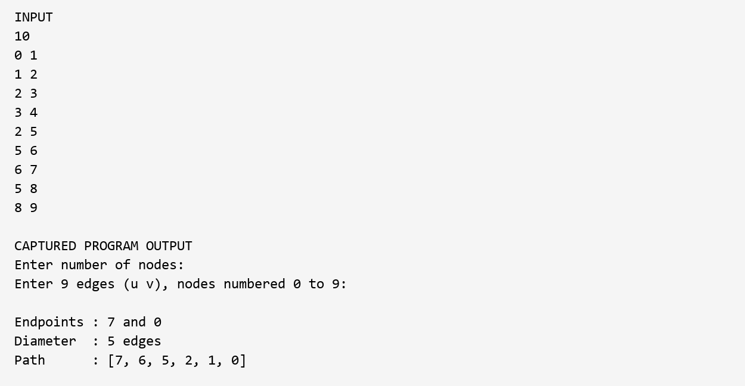
Figure 3. Running the unchanged Java program on the case-study input gives endpoints 7 and 0, diameter 5 edges, and path [7, 6, 5, 2, 1, 0].

A 7 Interpretation and limitations
At most five road segments separate any two junctions in this model. This can help compare branching layouts or identify routes for closer study. Unequal lengths, traffic, road quality, and speed are not represented, so the result alone does not measure maximum travel distance or response time.
Adding shortcuts can reduce shortest-path distances but may introduce cycles. The two-BFS guarantee would then no longer apply to the full network. A revised model and a suitable graph algorithm would be needed.

A 8 Conclusion
The example illustrates tree diameter in a branching network. The verified answer is five segments, and several longest routes exist. Parent-based reconstruction makes the route explicit and allows its edge count to be checked.

