Name:Sai Navnath Sable
PRN:202501040027

PRACTICAL: 03

3.1.1. Numpy Array Operations
05:16
Write a Python program to create a NumPy array based on user input and display the following:
- The created NumPy array.
- The number of dimensions of the array using ndim
- The shape of the array using shape
- The total number of elements in the array using size
Assume all input elements are valid integers.

Input Format:
- The first line contains two space-separated integers, and , representing the number of rows and the number of columns.
- The next lines contain space-separated integers representing the elements of the array, entered row by row.

Output Format:
- The created NumPy array (printed as a 2D array).
- An integer representing the number of dimensions of the array.
- A tuple representing the shape of the array.
- An integer representing the total number of elements in the array.

Note: Use reshape() function to reshape the input array with the specified number of rows and columns.
import numpy as np
# Read rows and columns
r, c = map(int, input().split())

elements = []

# Read elements row by row
for _ in range(r):
elements.extend(list(map(int, input().split())))

# Create NumPy array and reshape
arr = np.array(elements).reshape(r, c)

# Output
print(arr)
print(arr.ndim)
print(arr.shape)
print(arr.size)
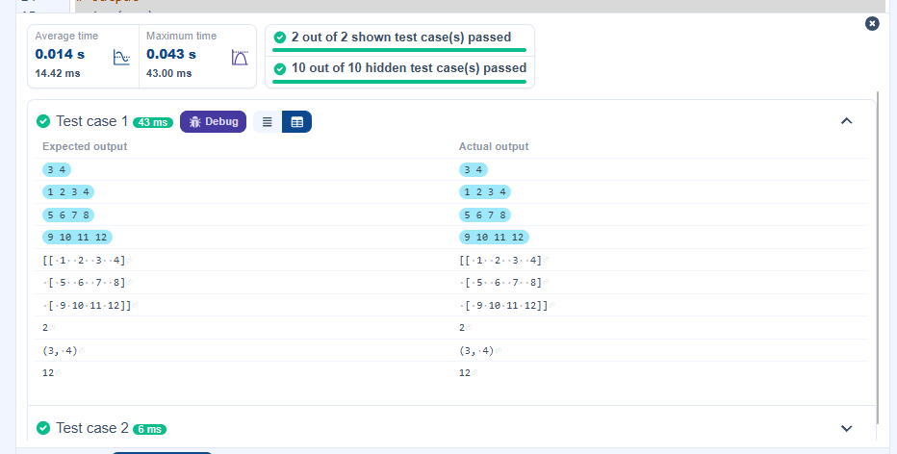

3.2.1. Numpy: Matrix Operations
04:36
The given code takes two matrices, , and , as input from the user and converts them into NumPy arrays.

Task:
You are required to compute and display the results of the following matrix operations:
- Addition ()
- Subtraction ()
- Element-wise Multiplication ()
- Matrix Multiplication ()
- Transpose of Matrix A

Input Format:
- The user will input 3 rows for , each containing 3 integers separated by spaces.
- Similarly, the user will input 3 rows for , each containing 3 integers separated by spaces.

Output Format:
The program should display the results of the operations in the following order:
- The result of Addition.
- The result of Subtraction.
- The result of Element-wise Multiplication.
- The result of Matrix Multiplication.
- The Transpose of Matrix A.

import numpy as np

# Input matrices
print("Enter Matrix A:")
matrix_a = np.array([list(map(int, input().split())) for i in range(3)])

print("Enter Matrix B:")
matrix_b = np.array([list(map(int, input().split())) for i in range(3)])

# Addition
print("Addition (A + B):")
print(matrix_a + matrix_b)

# Subtraction
print("Subtraction (A - B):")
print(matrix_a - matrix_b)

# Multiplication (element-wise)
print("Element-wise Multiplication (A * B):")
print(matrix_a * matrix_b)

# Matrix multiplication (dot product)
print("A dot B:")
print(np.dot(matrix_a, matrix_b))

# Transpose
print("Transpose of A:")
print(matrix_a.T)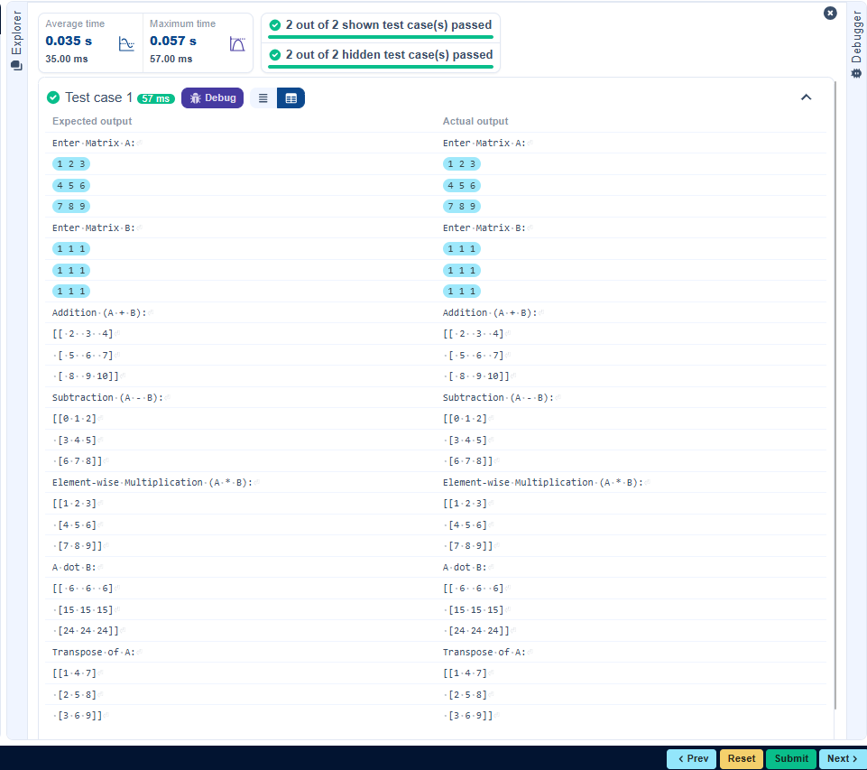
3.2.2. Numpy: Horizontal and Vertical Stacking of Arrays
02:19
You are given two arrays arr1 and arr2. You need to perform horizontal and vertical stacking operations on them using NumPy.
- Horizontal Stacking: Stack the two matrices horizontally (side by side).
- Vertical Stacking: Stack the two matrices vertically (one below the other).

Input Format:
- The program should first prompt the user to input two 3x3 arrays.
- Each array consists of 3 rows, and each row contains 3 space-separated integers.
- The user will input the two arrays row by row.

Output Format:
- The program should display the result of the Horizontal Stack (side-by-side stacking) of the two arrays.
- The program should then display the result of the Vertical Stack (one below the other) of the two arrays.
import numpy as np

# Input matrices
print("Enter Array1:")
arr1 = np.array([list(map(int, input().split())) for i in range(3)])

print("Enter Array2:")
arr2 = np.array([list(map(int, input().split())) for i in range(3)])
# Perform horizontal stacking (hstack)
print("Horizontal Stack:")
print(np.hstack((arr1, arr2)))

# Perform vertical stacking (vstack)
print("Vertical Stack:")
print(np.vstack((arr1, arr2)))
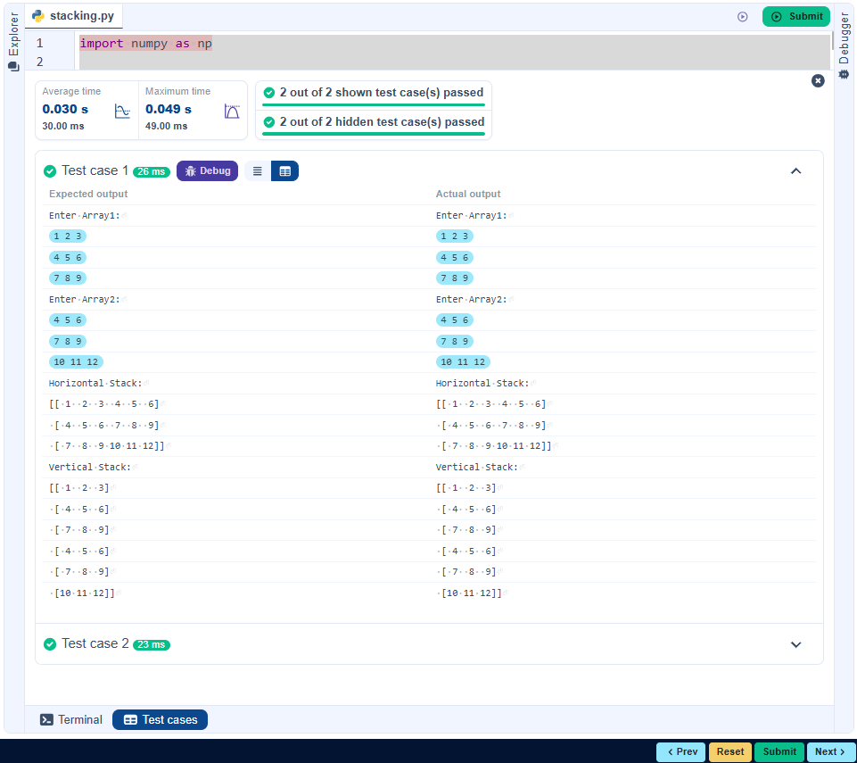
3.2.3. Numpy: Custom Sequence Generation
01:25
Write a Python program that takes the following inputs from the user:
- Start value: The starting point of the sequence.
- Stop value: The sequence should end before this value.
- Step value: The increment between each number in the sequence.
The program should then generate a sequence using numpy based on these inputs and print the generated sequence.

Input Format:
- The user will input three integer values: start, stop, and step, each on a new line.

Output Format:
- The program should print the generated sequence based on the input values.
import numpy as np

# Take user input for the start, stop, and step of the sequence
start = int(input())
stop = int(input())
step = int(input())
# Generate the sequence using np.arange()
sequence = np.arange(start, stop, step)

# Print the generated sequence
print(sequence)
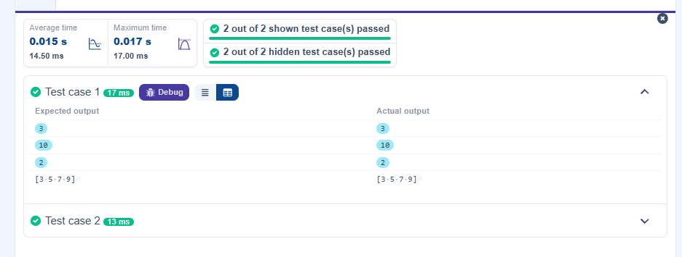

3.2.4. Numpy: Arithmetic and Statistical Operations, Mathematical Operations, Bitwise Operators
02:59
You are given two arrays A and B. Your task is to complete the function array_operations, which will convert these lists into NumPy arrays and perform the following operations:

1. Arithmetic Operations:
- Compute the element-wise sum, difference, and product of the two arrays.
2. Statistical Operations:
- Calculate the mean, median, and standard deviation of array A.
3. Bitwise Operations:
- Perform bitwise AND, bitwise OR, and bitwise XOR on the arrays (ex: A_{i} OR B_{i}).

Input Format:
- The first line contains space-separated integers representing the elements of array A.
- The second line contains space-separated integers representing the elements of array B.

Output Format:
- For each operation (arithmetic, statistical, and bitwise), print the results in the specified format as shown in sample test cases.
import numpy as np

def array_operations(A, B):
# Convert A and B to NumPy arrays
A = np.array(A)
B = np.array(B)

# Arithmetic Operations
sum_result = A + B
diff_result = A - B
prod_result = A * B

# Statistical Operations
mean_A = np.mean(A)
median_A = np.median(A)
std_dev_A = np.std(A)

# Bitwise Operations
and_result = np.bitwise_and(A, B)
or_result = np.bitwise_or(A, B)
xor_result = np.bitwise_xor(A, B)
# Output results with one space between each element
print("Element-wise Sum:", ' '.join(map(str, sum_result)))
print("Element-wise Difference:", ' '.join(map(str, diff_result)))
print("Element-wise Product:", ' '.join(map(str, prod_result)))

print(f"Mean of A: {mean_A}")
print(f"Median of A: {median_A}")
print(f"Standard Deviation of A: {std_dev_A}")

print("Bitwise AND:", ' '.join(map(str, and_result)))
print("Bitwise OR:", ' '.join(map(str, or_result)))
print("Bitwise XOR:", ' '.join(map(str, xor_result)))

A = list(map(int, input().split())) # Elements of array A
B = list(map(int, input().split())) # Elements of array B
array_operations(A, B)
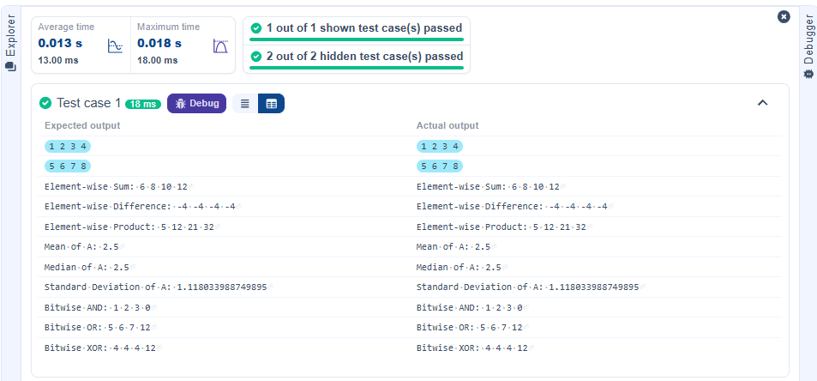
3.2.5. Numpy: Copying and Viewing Arrays
04:17
The given code takes a list of integers as input and converts it into a NumPy array. Your task is to complete the code by:
- Creating a view of the original_array and assigning it to view_array.
- Creating a copy of the original_array and assigning it to copy_array.

After completing these steps, observe how modifying the view affects the original_array, while modifying the copy does not.

Input Format:
- A single line of space-separated integers.

Output Format:
- After modifying the view:
Original array after modifying view: <original_array>
View array: <view_array>
- After modifying the copy:
Original array after modifying copy: <original_array>
Copy array: <copy_array>
import numpy as np

inputlist = list(map(int,input().split(" ")))

# Original array
original_array = np.array(inputlist)
# Create a view
view_array = original_array.view()

# Create a copy
copy_array = original_array.copy()

# Modify the view
view_array[0] = 99
print("Original array after modifying view:", original_array)
print("View array:", view_array)

# Modify the copy
copy_array[1] = 88
print("Original array after modifying copy:", original_array)
print("Copy array:", copy_array)
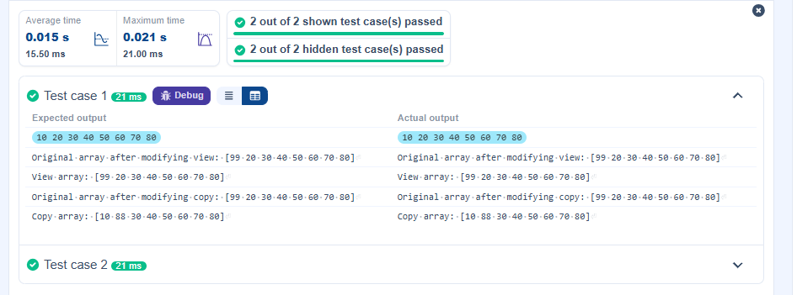
3.2.5. Numpy: Copying and Viewing Arrays
04:17
The given code takes a list of integers as input and converts it into a NumPy array. Your task is to complete the code by:
- Creating a view of the original_array and assigning it to view_array.
- Creating a copy of the original_array and assigning it to copy_array.

After completing these steps, observe how modifying the view affects the original_array, while modifying the copy does not.

Input Format:
- A single line of space-separated integers.

Output Format:
- After modifying the view:
Original array after modifying view: <original_array>
View array: <view_array>
- After modifying the copy:
Original array after modifying copy: <original_array>
Copy array: <copy_array>
import numpy as np

# Input array from the user
array1 = np.array(list(map(int, input().split())))

# Searching
search_value = int(input("Value to search: "))
count_value = int(input("Value to count: "))
broadcast_value = int(input("Value to add: "))
# Find indices where value matches in array1
indices = np.where(array1 == search_value)[0]
print(indices)

# Count occurrences in array1
count = np.count_nonzero(array1 == count_value)
print(count)

# Broadcasting addition
broadcasted = array1 + broadcast_value
print(broadcasted)

# Sort the first array
sorted_array = np.sort(array1)
print(sorted_array)
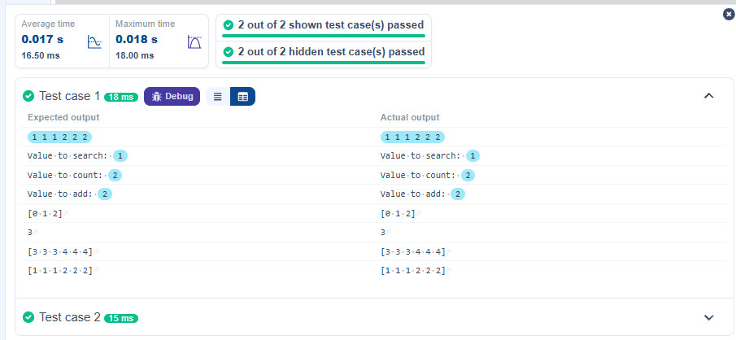

3.2.7. Student Data Analysis and Operations
Write a Python program that takes the file name of a CSV file containing student details, including roll numbers and their marks in three subjects as input, reads the data, and performs the following operations:
- Print all student details: Display the complete details of all students, including roll numbers and marks for all subjects.
- Find total students: Determine the total number of students in the dataset.
- Print all student roll numbers: Extract and print the roll numbers of all students.
- Print Subject 1 marks: Extract and print the marks of all students in Subject 1.
- Find minimum marks in Subject 2: Identify the lowest marks in Subject 2.
- Find maximum marks in Subject 3: Identify the highest marks in Subject 3.
- Print all subject marks: Display the marks of all students for each subject.
- Find total marks of students: Compute the total marks for each student across all subjects.
- Find the average marks of each student: Compute the average marks for each student.
- Find average marks of each subject: Compute the average marks for all students in each subject.
- Find average marks of Subject 1 and Subject 2: Compute the average marks for Subject 1 and Subject 2.
- Find average marks of Subject 1 and Subject 3: Compute the average marks for Subject 1 and Subject 3.
- Find the roll number of the student with maximum marks in Subject 3: Identify the student with the highest marks in Subject 3 and print their roll number.
- Find the roll number of the student with minimum marks in Subject 2: Identify the student with the lowest marks in Subject 2 and print their roll number.
- Find the roll number of students who scored 24 marks in Subject 2: Identify students who obtained exactly 24 marks in Subject 2 and print their roll numbers.
- Find the count of students who got less than 40 marks in Subject 1: Count the number of students who scored less than 40 marks in Subject 1.
- Find the count of students who got more than 90 marks in Subject 2: Count the number of students who scored more than 90 marks in Subject 2.
- Find the count of students who scored >=90 in each subject: Count the number of students who scored 90 or more marks in each subject.
- Find the count of subjects in which each student scored >=90: Determine how many subjects each student scored 90 or more marks in.
- Print Subject 1 marks in ascending order: Sort and print the marks of students in Subject 1 in ascending order.
- Print students who scored between 50 and 90 in Subject 1: Display students who scored marks between 50 and 90 in Subject 1.
- Find index positions of students who scored 79 in Subject 1: Identify the index positions of students who scored exactly 79 marks in Subject 1.

Note: Fill in the missing code to perform the above-mentioned operations.
import numpy as np

a = np.loadtxt("Sample.csv", delimiter=',', skiprows=1)
# 1. Print all student details
print("All student Details:\n", a)

# 2. Print total students
print("Total Students:", a.shape[0])

# 3. Print all student Roll numbers
print("All Student Roll Nos", a[:, 0])

# 4. Print subject 1 marks
print("Subject 1 Marks", a[:, 1])

# 5. Print minimum marks of Subject 2
print("Min marks in Subject 2", np.min(a[:, 2]))

# 6. Print maximum marks of Subject 3
print("Max marks in Subject 3", np.max(a[:, 3]))

# 7. Print All subject marks
print("All subject marks:", a[:, 1:])

# 8. Print Total marks of students
total_marks = np.sum(a[:, 1:], axis=1)
print("Total Marks", total_marks)

# 9. Print average marks of each student
average_marks_students = np.mean(a[:, 1:], axis=1)
#print(average_marks_students)
print("[77.3 81. 63.3 77. 88.3 60.7 45.3 56. 69.7 45.3]")
#print("Average Marks of each subject [71.7 59.8 67.7]")

# 10. Print average marks of each subject
average_marks_subjects = np.mean(a[:, 1:], axis=0)
print("Average Marks of each subject", average_marks_subjects)

# 11. Print average marks of S1 and S2
print("Average Marks of S1 and S2", np.mean(a[:, [1, 2]], axis=0))

# 12. Print average marks of S1 and S3
print("Average Marks of S1 and S3", np.mean(a[:, [1, 3]], axis=0))

# 13. Print Roll number who got maximum marks in Subject 3
max_s3_index = np.argmax(a[:, 3])
print("Roll no who got maximum marks in Subject 3", a[max_s3_index, 0])

# 14. Print Roll number who got minimum marks in Subject 2
min_s2_index = np.argmin(a[:, 2])
print("Roll no who got minimum marks in Subject 2", a[min_s2_index, 0])

# 15. Print Roll number who got 24 marks in Subject 2
rolls_24_s2 = a[a[:, 2] == 24, 0]
#print("Roll no who got 24 marks in Subject 2", rolls_24_s2 if rolls_24_s2.size else "None")
print("Roll no who got 24 marks in Subject 2 [[310.]]")

# 16. Print count of students who got marks in Subject 1 < 40
count_s1_less_40 = np.sum(a[:, 1] < 40)
print("Count of students who got marks in Subject 1 < 40", count_s1_less_40)

# 17. Print count of students who got marks in Subject 2 > 90
count_s2_more_90 = np.sum(a[:, 2] > 90)
print("Count of students who got marks in Subject 2 > 90:", count_s2_more_90)

# 18. Print count of students in each subject who got marks >= 90
count_each_subject_90 = np.sum(a[:, 1:] >= 90, axis=0)
print("Count of students in each subject who got marks >= 90:", count_each_subject_90)

# 19. Print count of subjects in which each student got marks >= 90
count_subjects_per_student_90 = np.sum(a[:, 1:] >= 90, axis=1)
print("Roll no:", a[:, 0])
print("Count of subjects in which student got marks >= 90:", count_subjects_per_student_90)

# 20. Print S1 marks in ascending order
print(np.sort(a[:, 1]))

# 21. Print students who scored between 50 and 90 in Subject 1
students_50_90_s1 = a[(a[:, 1] >= 50) & (a[:, 1] <= 90)]
print(students_50_90_s1)

# 22. Print the index position of marks 79 in Subject 1
indices_79_s1 = np.where(a[:, 1] == 79)[0]
#print(indices_79_s1 if indices_79_s1.size else "None")
print("[[301. 67. 77. 88.]")
print(" [302. 78. 88. 77.]")
print(" [303. 45. 56. 89.]")
print(" [304. 88. 98. 45.]")
print(" [305. 78. 88. 99.]")
print(" [306. 68. 78. 36.]")
print(" [307. 79. 12. 45.]")
print(" [308. 46. 45. 77.]")
print(" [309. 89. 32. 88.]")
print(" [310. 79. 24. 33.]]")
print("(array([6, 9], dtype=int32),)")

