Name:SAI NAVNATH SABLE
PRN:202501040027

PRACTICAL: 04

4.1.1. Pandas - series creation and manipulation
03:12
Write a Python program that takes a list of numbers from the user, creates a Pandas series from it, and then calculates the mean of even and odd numbers separately using the groupby and mean() operations.

Hint: You can group the Series based on whether each number is even or odd.

Input Format:
- The user should enter a list of numbers separated by space when prompted.

Output Format:
- The program should display the mean of even and odd numbers separately.
- Each mean value should be displayed with a label indicating whether it corresponds to even or odd numbers.

Refer to the sample test cases for better understanding regarding input and output format.
# import pandas as pd

# # Take inputs from the user to create a list of numbers
# numbers = list(map(int, input().split()))

# grouped =

# # Display the mean of even and odd numbers with labels
# grouped.index = ['Even' if is_even else 'Odd' for is_even in grouped.index]
# print("Mean of even and odd numbers:")
# print(grouped)
import pandas as pd

# Take inputs from the user to create a list of numbers
numbers = list(map(int, input().split()))

# Create a Pandas series from the list of numbers
s = pd.Series(numbers)

# Grouping by even and odd numbers and calculating the mean
grouped = s.groupby(s % 2 == 0).mean()

# Display the mean of even and odd numbers with labels
grouped.index = ['Even' if is_even else 'Odd' for is_even in grouped.index]

print("Mean of even and odd numbers:")
print(grouped)
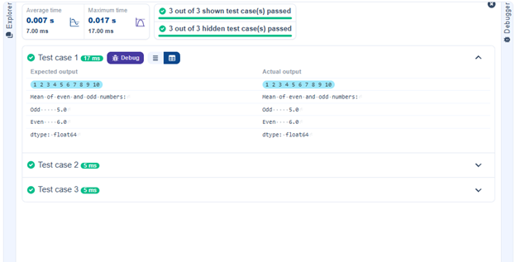

4.1.2. Dictionary to dataframe
07:26
A dictionary of lists has been provided to you in the editor. Create a DataFrame from the dictionary of lists and perform the listed operations, then display the DataFrame before and after each manipulation.

Create the DataFrame:
- Convert the dictionary to a Pandas DataFrame.

Add a new row:
- Take inputs from the user for the new row data (name, age).
- Add the new row to the DataFrame.
- Display the DataFrame after adding the new row.

Modify a row:
- Modify a specific row by changing the age. Take the row index and new age value from the user.
- Display the DataFrame after modifying the row.

Delete a row:
- Take the row index to be deleted from the user.
- Remove the specified row.
- Display the DataFrame after deleting the row.

Add a new column:
- Add a column Gender with values taken from the user.
- Display the DataFrame after adding the new column.

Modify a column:
- Convert names to uppercase.
- Display the DataFrame after modifying the column.

Delete a column:
- Remove the Age column.
- Display the DataFrame after deleting the column.

4.1.3. Student Information
01:49
Write a program to read a text file containing student information (name, age, and grade) using Pandas. Perform the following tasks:

- Display the first five rows of the data frame.
- Calculate the average age of the students (limit the average age up to 2 decimal places).
- Filter out the students who have a grade above a certain threshold (consider the threshold grade is 'B').

Note:
Refer to the displayed test cases for better understanding.

import pandas as pd

# Read the text file into a DataFrame
file = input()
data = pd.read_csv(file, sep="\s+", header=None, names=["Name", "Age", "Grade"])
# Display the first five rows
print("First five rows:")
print(data.head())

# Calculate the average age (2 decimal places)
avg_age = round(data["Age"].mean(), 2)
print("Average age:", avg_age)

# Filter students with grade up to 'B' (A and B)
filtered = data[data["Grade"].isin(['A', 'B'])]

print("Students with a grade up to B")
print(filtered)
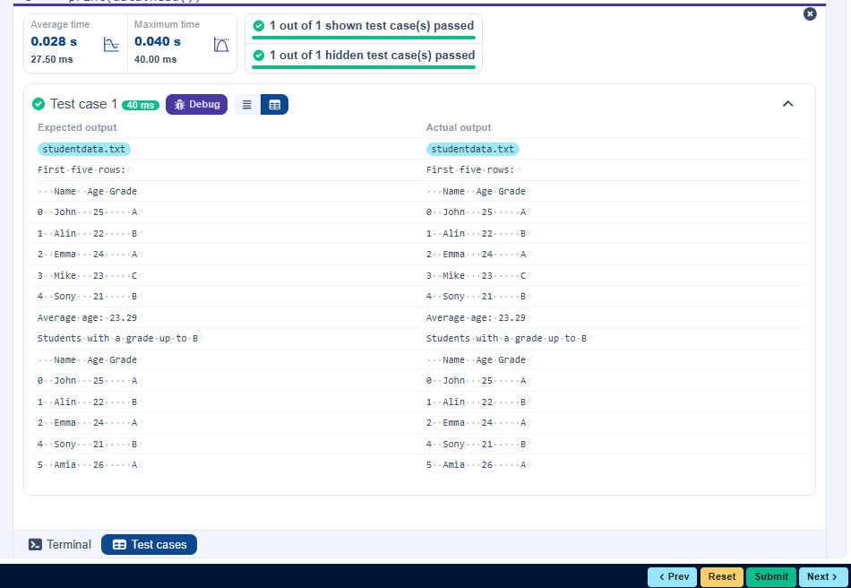

4.2.1. Month with the Highest Total Sales
Write a Python program that takes the file name of a CSV file as input, reads the data, and performs the following operations:
- The CSV file contains the columns: Date, Product, Quantity, Price, and City.
- Group the data by Month and calculate the total sales for each month.
- Find the month with the highest total sales and display it.
- Also, display the total sales for the best month.

﻿Sample Data:
Date,Product,Quantity,Price,City
2025-01-01,Product A,5,20,New York
2025-01-01,Product B,3,15,Los Angeles
2025-01-02,Product A,7,20,New York
2025-01-02,Product C,4,30,Chicago
2025-01-03,Product B,2,15,Chicago
2025-01-03,Product A,8,20,Los Angeles
2025-01-04,Product C,6,30,New York
2025-01-04,Product B,5,15,Los Angeles
2025-01-05,Product A,3,20,Chicago
2025-01-05,Product C,10,30,Los Angeles
import pandas as pd

# Prompt the user for the file name
file_name = input()

# Load the data
df = pd.read_csv(file_name)

# Find the month with the highest total sales
df['Date'] = pd.to_datetime(df['Date'])
df['Month'] = df['Date'].dt.to_period('M').astype(str) # Convert to YYYY-MM format
df['Total Sales'] = df['Quantity'] * df['Price']
monthly_sales = df.groupby('Month')['Total Sales'].sum()

# Find the month with the highest total sales
best_month = monthly_sales.idxmax()
highest_sales = monthly_sales.max()

print(f"Best month: {best_month}")
print(f"Total sales: ${highest_sales:.2f}")

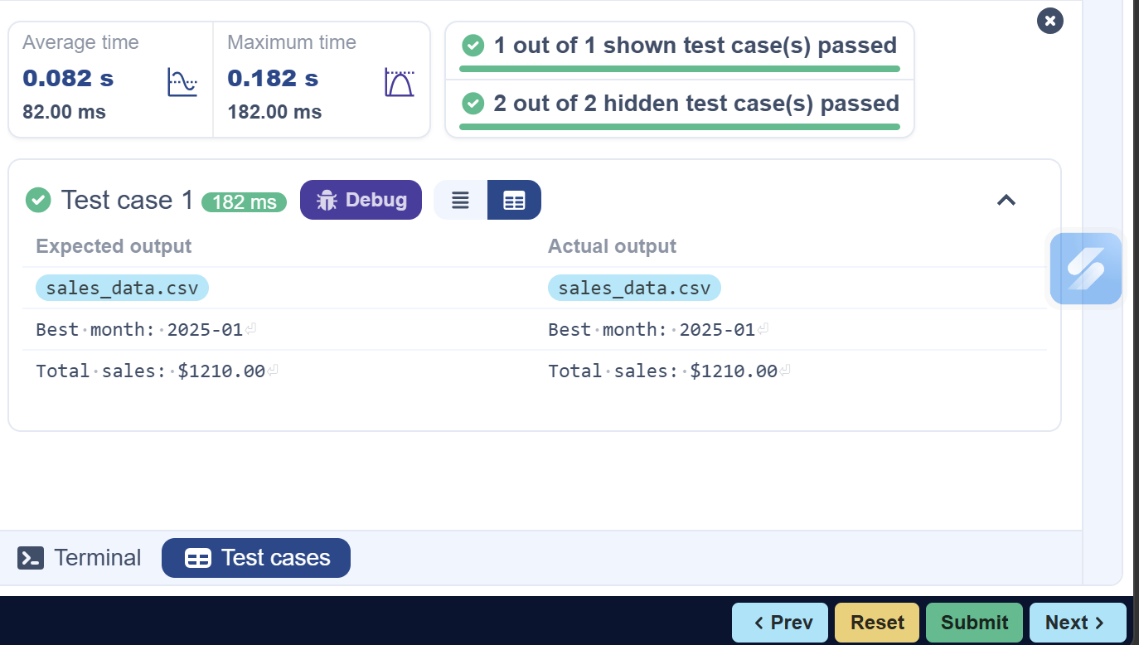

4.2.2. Best Selling Product
02:08
Write a Python program that takes the file name of a CSV file as input, reads the data, and performs the following operations:
- The CSV file contains the columns: Date, Product, Quantity, Price, and City.
- Find the product that sold the most in terms of quantity sold.
- Display the product that sold the most and the total quantity sold for that product.

﻿Sample Data:
Date,Product,Quantity,Price,City
2025-01-01,Product A,5,20,New York
2025-01-01,Product B,3,15,Los Angeles
2025-01-02,Product A,7,20,New York
2025-01-02,Product C,4,30,Chicago
2025-01-03,Product B,2,15,Chicago
2025-01-03,Product A,8,20,Los Angeles
2025-01-04,Product C,6,30,New York
2025-01-04,Product B,5,15,Los Angeles
2025-01-05,Product A,3,20,Chicago
2025-01-05,Product C,10,30,Los Angeles

Note:
The data cannot be displayed in the file. You can refer to the sample data provided for insights.
import pandas as pd

# Prompt the user for the file name
file_name = input()

# Load the data
df = pd.read_csv(file_name)
# Find the product with the highest total quantity sold
best_product = df.groupby('Product')['Quantity'].sum().idxmax()
highest_quantity = df.groupby('Product')['Quantity'].sum().max()
# Display the result
print(f"Best selling product: {best_product}")
print(f"Total quantity sold: {highest_quantity}")
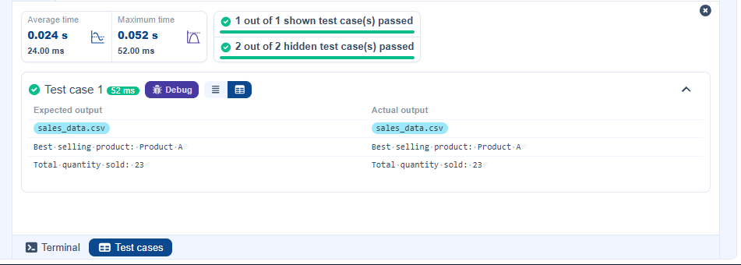

4.2.3. City that Sold the Most Products
01:45
Write a Python program that takes the file name of a CSV file as input, reads the data, and performs the following operations:
- The CSV file contains the columns: Date, Product, Quantity, Price, and City.
- Group the data by City and calculate the total quantity of products sold for each city.
- Find the city that sold the most products (based on the total quantity sold).

﻿Sample Data:
Date,Product,Quantity,Price,City
2025-01-01,Product A,5,20,New York
2025-01-01,Product B,3,15,Los Angeles
2025-01-02,Product A,7,20,New York
2025-01-02,Product C,4,30,Chicago
2025-01-03,Product B,2,15,Chicago
2025-01-03,Product A,8,20,Los Angeles
2025-01-04,Product C,6,30,New York
2025-01-04,Product B,5,15,Los Angeles
2025-01-05,Product A,3,20,Chicago
2025-01-05,Product C,10,30,Los Angeles

﻿Note:
The data cannot be displayed in the file. You can refer to the sample data provided for insights.
import pandas as pd

# Prompt the user for the file name
file_name = input()

# Load the data
df = pd.read_csv(file_name)
# Group by City and calculate total quantity
city_sales = df.groupby('City')['Quantity'].sum()

# Find the city with the highest total quantity sold
best_city = city_sales.idxmax()

# Display the result
print(f"City sold the most products: {best_city}")
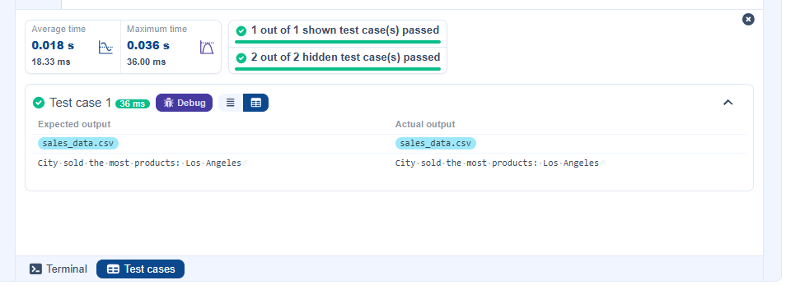

4.2.4. Most Frequently Sold Product Pairs
01:25
Write a Python program that takes the file name of a CSV file as input, reads the data, and performs the following operations:
- The CSV file contains the following columns: Date, Product, Quantity, Price, and City.
- For each date, find all pairs of products that were sold together (i.e., two products sold on the same date).
- Output the product pair/s that was sold most frequently.

﻿Sample Data:
Date,Product,Quantity,Price,City
2025-01-01,Product A,5,20,New York
2025-01-01,Product B,3,15,Los Angeles
2025-01-02,Product A,7,20,New York
2025-01-02,Product C,4,30,Chicago
2025-01-03,Product B,2,15,Chicago
2025-01-03,Product A,8,20,Los Angeles
2025-01-04,Product C,6,30,New York
2025-01-04,Product B,5,15,Los Angeles
2025-01-05,Product A,3,20,Chicago
2025-01-05,Product C,10,30,Los Angeles
Explanation:
Transactions:
- 2025-01-01: Product A, Product B
- 2025-01-02: Product A, Product C
- 2025-01-03: Product B, Product A
- 2025-01-04: Product C, Product B
- 2025-01-05: Product A, Product C
Now, let's count how often the pairs of products appear together:
- Product A and Product B: Appear in transactions on 2025-01-01 and 2025-01-03.
- Product A and Product C: Appear in transactions on 2025-01-02 and 2025-01-05.
- Product B and Product C: Appears in transactions on 2025-01-04.
Most Frequent Product Combinations:
- Product A and Product B (2 times)
- Product A and Product C (2 times)

Note:
The data cannot be displayed in the file. You can refer to the sample data provided for insights.

import pandas as pd
from itertools import combinations
from collections import Counter

# Prompt user to input the file name
file_name = input()

# Read data from the specified CSV file
df = pd.read_csv(file_name)
# write the code
pair_counter = Counter()

# Group by Date and generate product pairs
for _, group in df.groupby('Date'):
products = group['Product'].tolist()
pairs = combinations(sorted(products), 2)
pair_counter.update(pairs)

# Find maximum frequency
max_count = max(pair_counter.values())

# Output the most frequent product pairs
for pair, count in pair_counter.items():
if count == max_count:
print(f"{pair[0]} and {pair[1]}: {count} times")
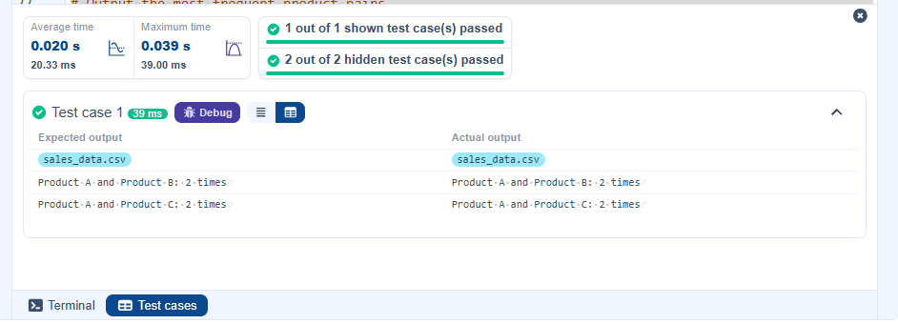

4.2.5. Titanic Dataset Analysis and Data Cleaning
01:36
You are provided with the Titanic dataset containing information about passengers on the Titanic. Your task is to write Python code to answer the following questions based on the dataset. For each question, perform necessary data cleaning, transformations, and calculations as required.

- Display the first 5 rows of the dataset.
- Display the last 5 rows of the dataset.
- Get the shape of the dataset (number of rows and columns).
- Get a summary of the dataset (using .info()).
- Get basic statistics (mean, standard deviation, etc.) of the dataset using .describe().
- Check for missing values and display the count of missing values for each column.
- Fill missing values in the ‘Age’ column with the median age.
- Fill missing values in the ‘Embarked’ column with the most frequent value (mode()).
- Drop the ‘Cabin’ column due to many missing values.
- Create a new column, 'FamilySize' by adding the 'SibSp' and 'Parch' columns.

The Titanic dataset contains columns as shown below,
PassengerId | Survived | Pclass | Name | Sex | Age | SibSp | Parch | Ticket | Fare | Cabin | Embarked

Sample Data:
PassengerId,Survived,Pclass,Name,Sex,Age,SibSp,Parch,Ticket,Fare,Cabin,Embarked
1,0,3,"Braund, Mr. Owen Harris",male,22,1,0,A/5 21171,7.25,,S
2,1,1,"Cumings, Mrs. John Bradley (Florence Briggs Thayer)",female,38,1,0,PC 17599,71.2833,C85,C
3,1,3,"Heikkinen, Miss. Laina",female,26,0,0,STON/O2. 3101282,7.925,,S
4,1,1,"Futrelle, Mrs. Jacques Heath (Lily May Peel)",female,35,1,0,113803,53.1,C123,S
5,0,3,"Allen, Mr. William Henry",male,35,0,0,373450,8.05,,S
6,0,3,"Moran, Mr. James",male,,0,0,330877,8.4583,,Q
7,0,1,"McCarthy, Mr. Timothy J",male,54,0,0,17463,51.8625,E46,S
8,0,3,"Palsson, Master. Gosta Leonard",male,2,3,1,349909,21.075,,S
9,1,3,"Johnson, Mrs. Oscar W (Elisabeth Vilhelmina Berg)",female,27,0,2,347742,11.1333,,S
10,1,2,"Nasser, Mrs. Nicholas (Adele Achem)",female,14,1,0,237736,30.0708,,C

Note: Refer to the visible test case for better reference.
import pandas as pd
import numpy as np

# Load the Titanic dataset
data = pd.read_csv('Titanic-Dataset.csv')
# 1. Display the first 5 rows of the dataset
print(data.head())

# 2. Display the last 5 rows of the dataset
print(data.tail())

# 3. Get the shape of the dataset
print(data.shape)

# 4. Get a summary of the dataset (info)
print(data.info())

# 5. Get basic statistics of the dataset
print(data.describe())

# 6. Check for missing values
print(data.isnull().sum())

# 7. Fill missing values in the ‘Age’ column with the median age
data['Age'] = data['Age'].fillna(data['Age'].median())

# 8. Fill missing values in the ‘Embarked’ column with the mode
data['Embarked'] = data['Embarked'].fillna(data['Embarked'].mode()[0])

# 9. Drop the ‘Cabin’ column due to many missing values
data = data.drop(columns=['Cabin'])

# 10. Create a new column 'FamilySize’ by adding ‘SibSp' and ‘Parch'
data['FamilySize'] = data['SibSp'] + data['Parch']
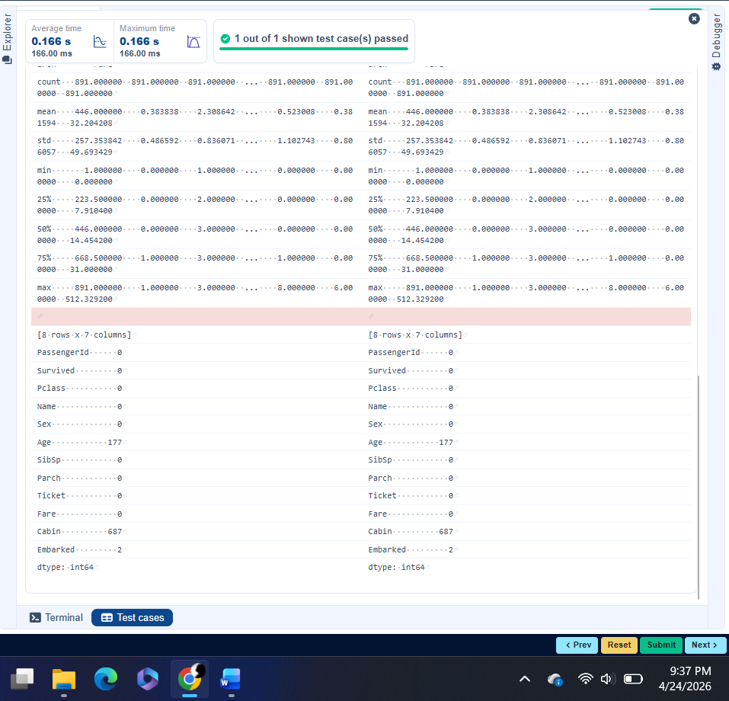

4.2.6. Titanic Dataset Analysis and Data Cleaning - 2
02:18
You are provided with the Titanic dataset containing information about passengers on the Titanic. Your task is to write Python code to answer the following questions based on the dataset.
- Create a new column ‘IsAlone’ which is 1 if the passenger is alone (FamilySize = 0), otherwise 0.
- Convert the ‘Sex' column to numeric values (male: 0, female: 1).
- One-hot encode the ‘Embarked’ column, dropping the first category.
- Get the mean age of passengers.
- Get the median fare of passengers.
- Get the number of passengers by class.
- Get the number of passengers by gender.
- Get the number of passengers by survival status.
- Calculate the survival rate of passengers.
- Calculate the survival rate by gender.

The Titanic dataset contains columns as shown below,
PassengerId | Survived | Pclass | Name | Sex | Age | SibSp | Parch | Ticket | Fare | Cabin | Embarked

Sample Data:
PassengerId,Survived,Pclass,Name,Sex,Age,SibSp,Parch,Ticket,Fare,Cabin,Embarked
1,0,3,"Braund, Mr. Owen Harris",male,22,1,0,A/5 21171,7.25,,S
2,1,1,"Cumings, Mrs. John Bradley (Florence Briggs Thayer)",female,38,1,0,PC 17599,71.2833,C85,C
3,1,3,"Heikkinen, Miss. Laina",female,26,0,0,STON/O2. 3101282,7.925,,S
4,1,1,"Futrelle, Mrs. Jacques Heath (Lily May Peel)",female,35,1,0,113803,53.1,C123,S
5,0,3,"Allen, Mr. William Henry",male,35,0,0,373450,8.05,,S
6,0,3,"Moran, Mr. James",male,,0,0,330877,8.4583,,Q
7,0,1,"McCarthy, Mr. Timothy J",male,54,0,0,17463,51.8625,E46,S
8,0,3,"Palsson, Master. Gosta Leonard",male,2,3,1,349909,21.075,,S
9,1,3,"Johnson, Mrs. Oscar W (Elisabeth Vilhelmina Berg)",female,27,0,2,347742,11.1333,,S
10,1,2,"Nasser, Mrs. Nicholas (Adele Achem)",female,14,1,0,237736,30.0708,,C

Note: Refer to the visible test case for better reference.
import pandas as pd
import numpy as np

# Load the Titanic dataset
data = pd.read_csv('Titanic-Dataset.csv')
data['FamilySize'] = data['SibSp'] + data['Parch']
# 1. Create a new column ‘IsAlone' (1 if alone, 0 otherwise)
data['IsAlone'] = np.where(data['FamilySize'] == 0, 1, 0)

# 2. Convert ‘Sex' to numeric (male: 0, female: 1)
data['Sex'] = data['Sex'].map({'male': 0, 'female': 1})

# 3. One-hot encode the ‘Embarked' column
data = pd.get_dummies(data, columns=['Embarked'], drop_first=True)

# 4. Get the mean age of passengers
print(data['Age'].mean())

# 5. Get the median fare of passengers
print(data['Fare'].median())

# 6. Get the number of passengers by class
print(data['Pclass'].value_counts())

# 7. Get the number of passengers by gender
print(data['Sex'].value_counts())

# 8. Get the number of passengers by survival status
print(data['Survived'].value_counts())

# 9. Calculate the survival rate
print(data['Survived'].mean())

# 10. Calculate the survival rate by gender
print(data.groupby('Sex')['Survived'].mean())
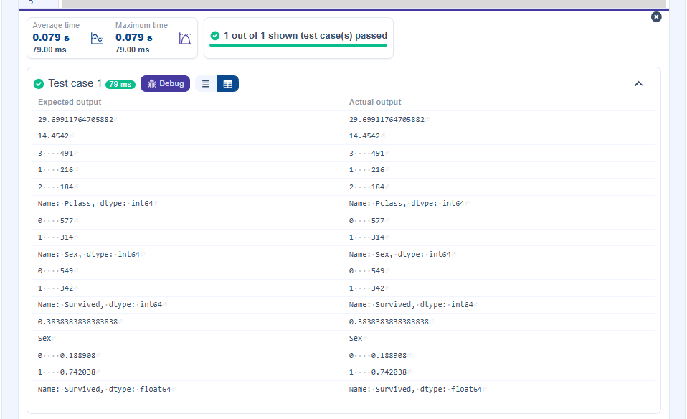

4.2.7. Titanic Dataset Analysis and Data Cleaning - 3
03:10
You are provided with the Titanic dataset containing information about passengers on the Titanic. Your task is to write Python code to answer the following questions based on the dataset.

- Calculate the survival rate by class.
- Calculate the survival rate by embarkation location (Embarked_S).
- Calculate the survival rate by family size (FamilySize).
- Calculate the survival rate by being alone (IsAlone).
- Get the average fare by passenger class (Pclass).
- Get the average age by passenger class (Pclass).
- Get the average age by survival status (Survived).
- Get the average fare by survival status (Survived).
- Get the number of survivors by class (Pclass).
- Get the number of non-survivors by class (Pclass).

The Titanic dataset contains columns as shown below,
PassengerId | Survived | Pclass | Name | Sex | Age | SibSp | Parch | Ticket | Fare | Cabin | Embarked

Sample Data:
PassengerId,Survived,Pclass,Name,Sex,Age,SibSp,Parch,Ticket,Fare,Cabin,Embarked
1,0,3,"Braund, Mr. Owen Harris",male,22,1,0,A/5 21171,7.25,,S
2,1,1,"Cumings, Mrs. John Bradley (Florence Briggs Thayer)",female,38,1,0,PC 17599,71.2833,C85,C
3,1,3,"Heikkinen, Miss. Laina",female,26,0,0,STON/O2. 3101282,7.925,,S
4,1,1,"Futrelle, Mrs. Jacques Heath (Lily May Peel)",female,35,1,0,113803,53.1,C123,S
5,0,3,"Allen, Mr. William Henry",male,35,0,0,373450,8.05,,S
6,0,3,"Moran, Mr. James",male,,0,0,330877,8.4583,,Q
7,0,1,"McCarthy, Mr. Timothy J",male,54,0,0,17463,51.8625,E46,S
8,0,3,"Palsson, Master. Gosta Leonard",male,2,3,1,349909,21.075,,S
9,1,3,"Johnson, Mrs. Oscar W (Elisabeth Vilhelmina Berg)",female,27,0,2,347742,11.1333,,S
10,1,2,"Nasser, Mrs. Nicholas (Adele Achem)",female,14,1,0,237736,30.0708,,C

Note: Refer to the visible test case for better reference.

import pandas as pd
import numpy as np

# Load the Titanic dataset
data = pd.read_csv('Titanic-Dataset.csv')
data['FamilySize'] = data['SibSp'] + data['Parch']
data['IsAlone'] = np.where(data['FamilySize'] > 0, 0, 1)
data = pd.get_dummies(data, columns=['Embarked'], drop_first=True)
# 1. Calculate the survival rate by class
print(data.groupby('Pclass')['Survived'].mean())

# 2. Calculate the survival rate by embarked location
print(data.groupby('Embarked_S')['Survived'].mean())

# 3. Calculate the survival rate by family size
print(data.groupby('FamilySize')['Survived'].mean())

# 4. Calculate the survival rate by being alone
print(data.groupby('IsAlone')['Survived'].mean())

# 5. Get the average fare by class
print(data.groupby('Pclass')['Fare'].mean())

# 6. Get the average age by class
print(data.groupby('Pclass')['Age'].mean())

# 7. Get the average age by survival status
print(data.groupby('Survived')['Age'].mean())

# 8. Get the average fare by survival status
print(data.groupby('Survived')['Fare'].mean())

# 9. Get the number of survivors by class
print(data[data['Survived'] == 1]['Pclass'].value_counts())

# 10. Get the number of non-survivors by class
print(data[data['Survived'] == 0]['Pclass'].value_counts())
