**My college Results Project – Documentation**

1. Project Overview Project Name: Prakasam Engineering College Results Portal Live Link: https://saisadam.github.io/result/ Purpose: A fast and simple website to check 2025 exam results by roll number.

2. Features

User-friendly design

Roll number-wise result search

Mobile-friendly UI

Lightweight and fast loading

Hosted on GitHub Pages

SEO optimized (verified on Google Search Console)

3. Supported Roll Numbers The portal currently supports roll numbers from: 23F91A05F1 → 23F91A05J8 (Started with less number of students)

4. Tech Stack

Frontend: HTML, CSS, JavaScript

Hosting: GitHub Pages

SEO Tools: Meta description, Sitemap.xml

5. Project Structure result/ │── index.html # Main website │── style.css # CSS file │── script.js # JavaScript file (if added) │── sitemap.xml # Sitemap for search engines │── verify.html # Google Search Console verification │── README.md # Documentation

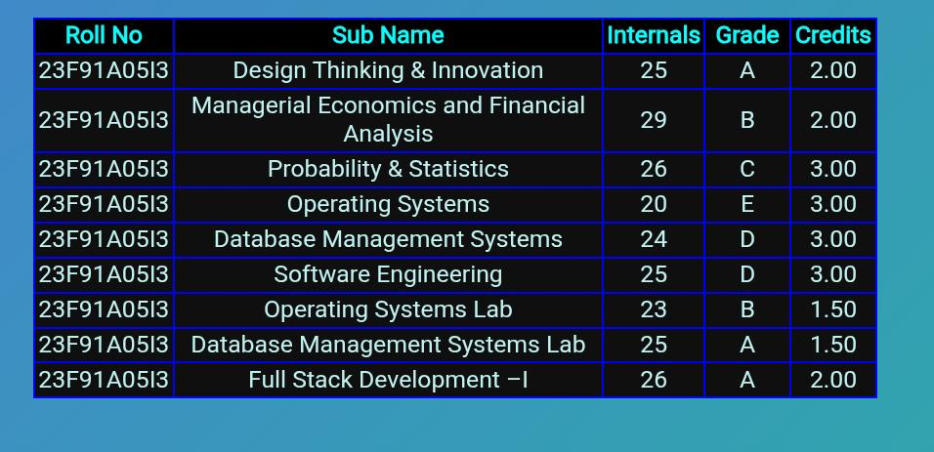

6. Screenshots of result site Roll Number Search Result:

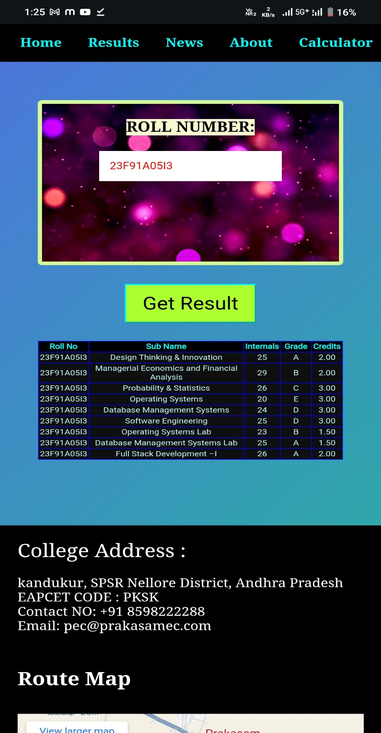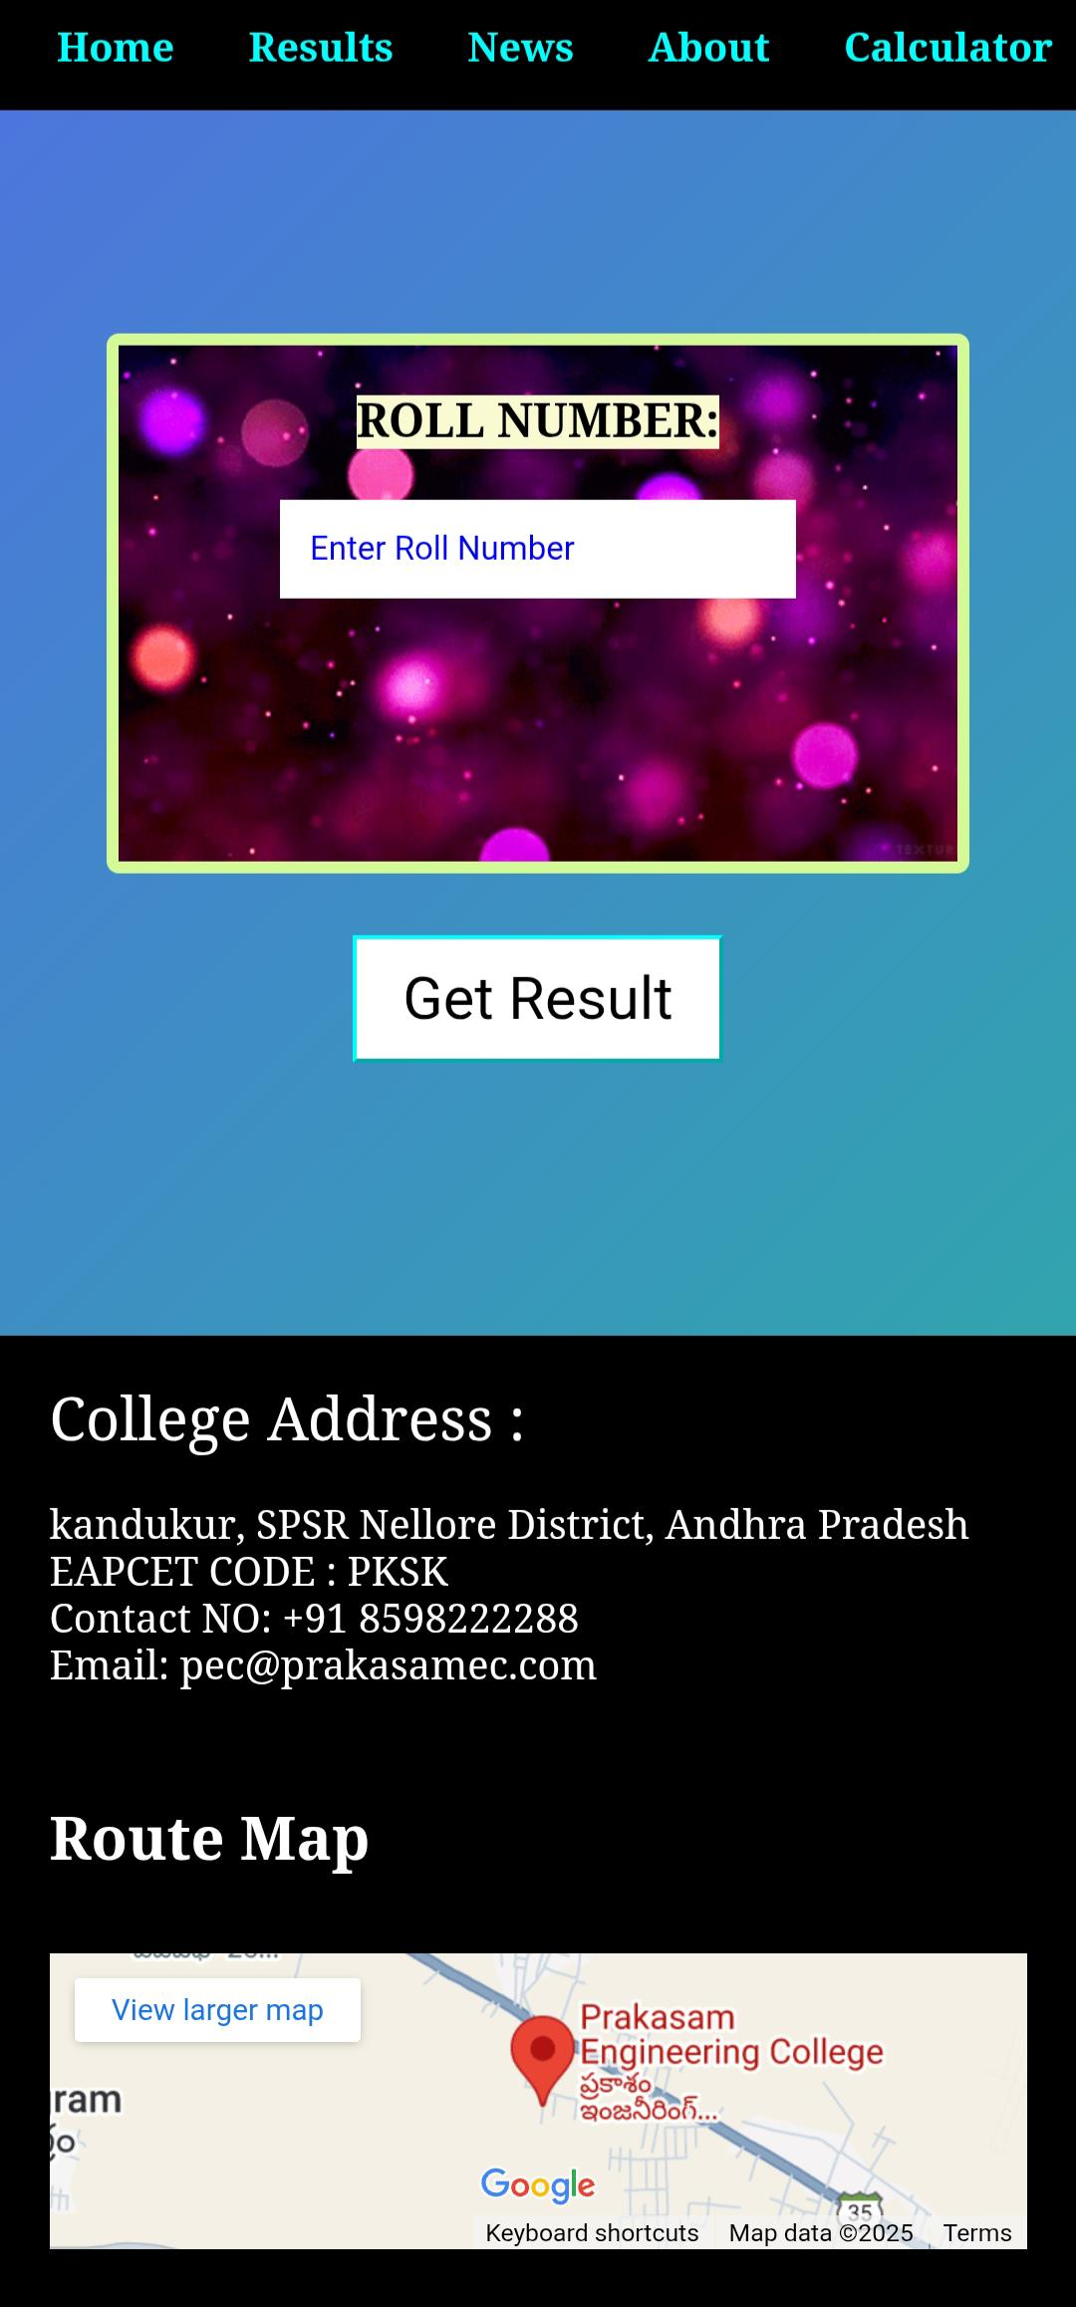

7. SEO & Indexing

Verified on Google Search Console

Sitemap submitted for faster indexing

Optimized meta description for better search ranking

8. Contributing If you want to contribute:

9. Fork the repository

10. Make changes

11. Submit a pull request

12. Contact

Author: Sai Sadam

GitHub: https://github.com/saisadam

Live Project: https://saisadam.github.io/result/

Do Follow For More Thanks for Reading