SCHOOL OF COMPUTER SCIENCE AND ARTIFICIAL INTELLIGENCE |  |  |  |  | DEPARTMENT OF COMPUTER SCIENCE ENGINEERING
Program Name: B. Tech |  |  |  | Assignment Type: Lab |  |  | Academic Year:2025-2026
Course Coordinator Name |  |  |  | Venkataramana Veeramsetty
Instructor(s) Name
  Dr. V. Venkataramana (Co-ordinator)
  Dr. T. Sampath Kumar
  Dr. Pramoda Patro
  Dr. Brij Kishor Tiwari
  Dr.J.Ravichander
  Dr. Mohammand Ali Shaik
  Dr. Anirodh Kumar
  Mr. S.Naresh Kumar
  Dr. RAJESH VELPULA
  Mr. Kundhan Kumar
  Ms. Ch.Rajitha
  Mr. M Prakash
  Mr. B.Raju
  Intern 1 (Dharma teja)
  Intern 2 (Sai Prasad)
  Intern 3 (Sowmya)
  NS_2 ( Mounika)
Course Code |  |  | 24CS002PC215 | Course Title |  | AI Assisted Coding
Year/Sem |  |  | II/I | Regulation |  | R24
Date and Day  of Assignment |  |  | Week8 - Monday | Time(s)
Duration |  |  | 2 Hours | Applicable to  Batches
AssignmentNumber:15.1(Present assignment number)/24(Total number of assignments)
 | Q.No. | Question |  |  |  |  |  | Expected Time  to complete
 | 1 | Lab 15 – Backend API Development: Creating RESTful services with AI  Lab Objectives:  - Understand the fundamentals of RESTful API design.  - Use AI-assisted coding tools to generate backend services.  - Implement CRUD (Create, Read, Update, Delete) operations.  - Document endpoints with comments and auto-generated documentation.  Task 1 – Student Records API  Task:  Use AI to build a RESTful API for managing student records.  Instructions:  - Endpoints required:  - GET /students → List all students  - POST /students → Add a new student  - PUT /students/{id} → Update student details  - DELETE /students/{id} → Delete a student record  - Use an in-memory data structure (list or dictionary) to store records.  - Ensure API responses are in JSON format.  Expected Output:  - Working API with CRUD functionality for student records.  Prompt:  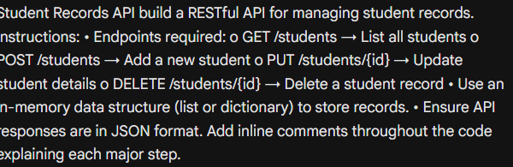  Code:  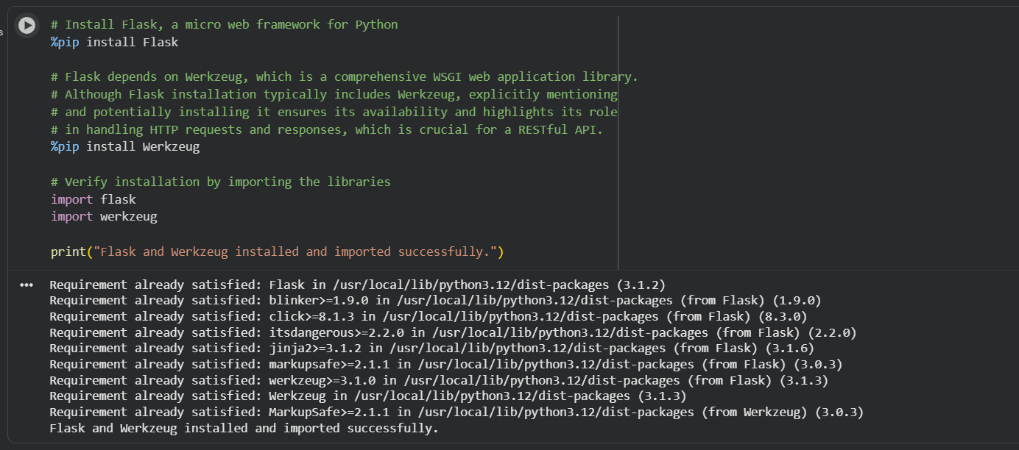  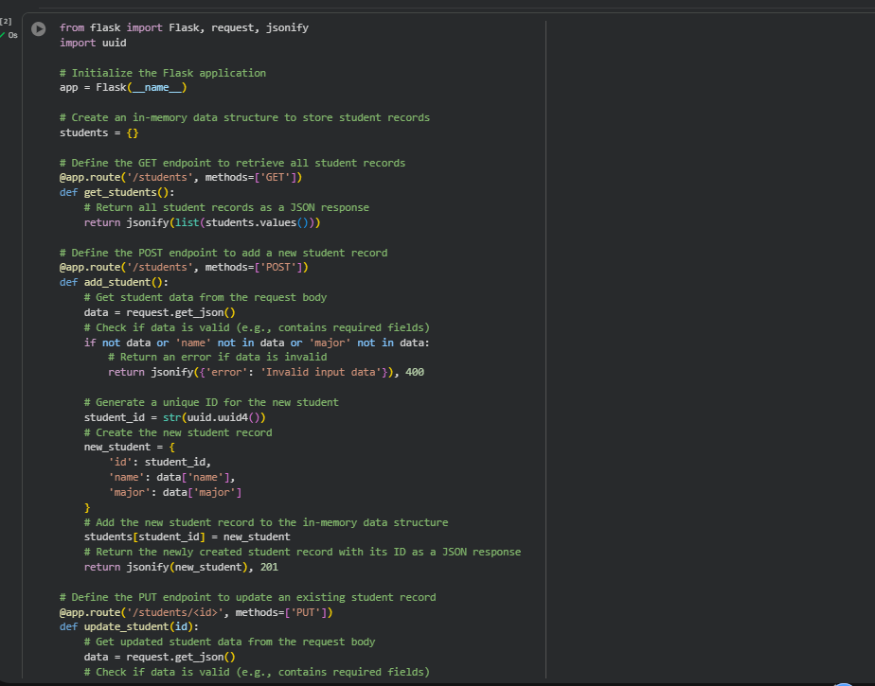  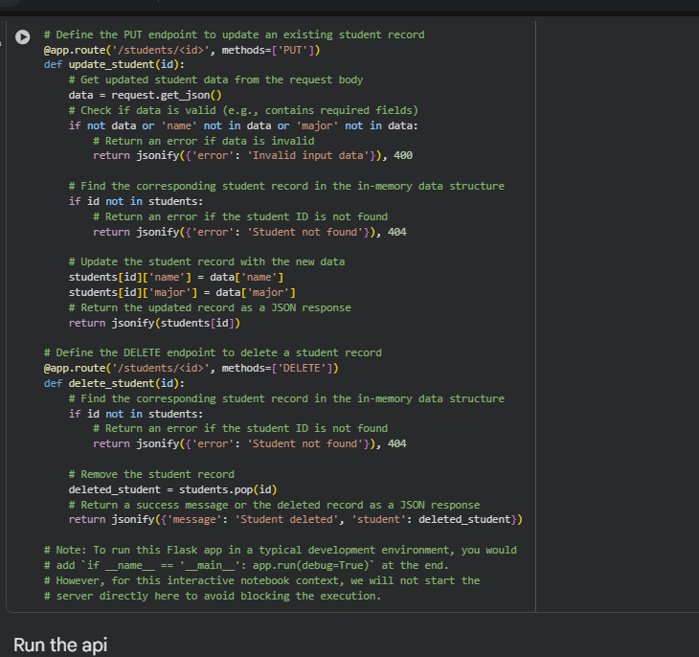  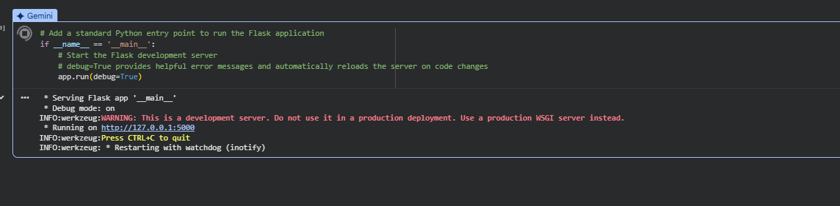  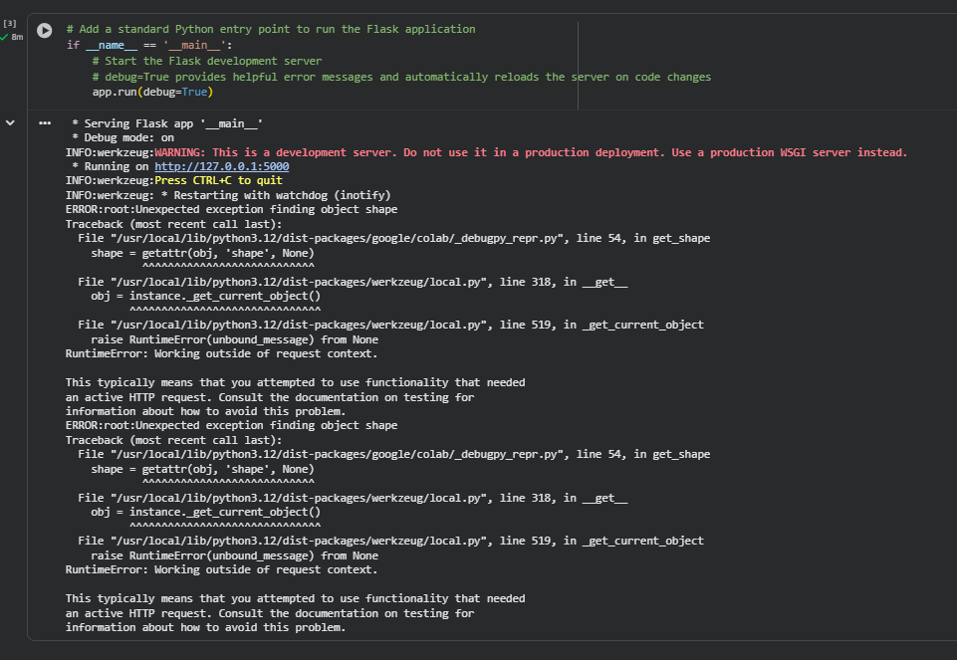  Task 2 – Library Book Management API  Task:  Develop a RESTful API to handle library books.  Instructions:  - Endpoints required:  - GET /books → Retrieve all books  - POST /books → Add a new book  - GET /books/{id} → Get details of a specific book  - PATCH /books/{id} → Update partial book details (e.g., availability)  - DELETE /books/{id} → Remove a book  - Implement error handling for invalid requests.  Expected Output:  - Functional API with CRUD + partial updates.  Prompt:  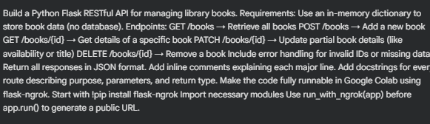  Code:  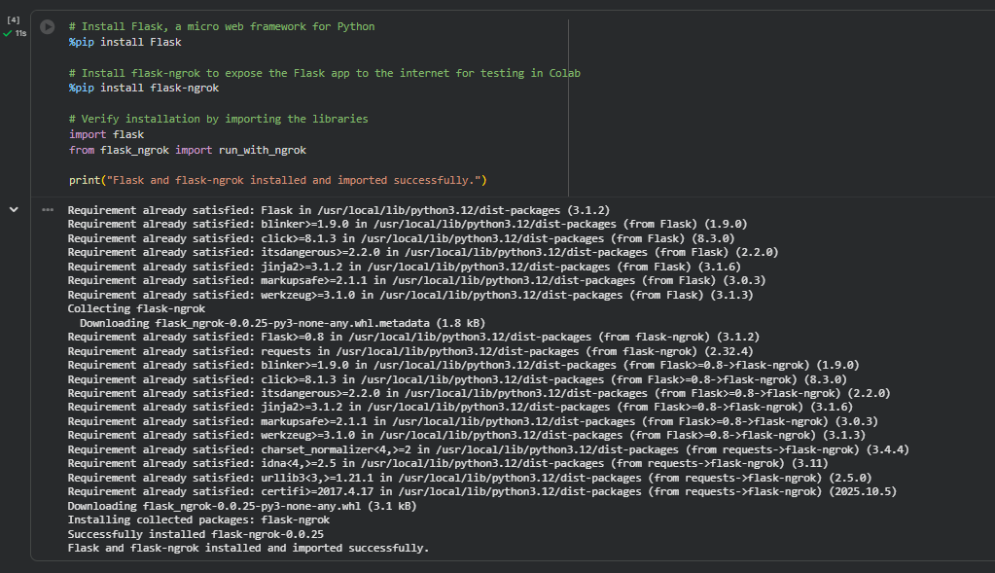  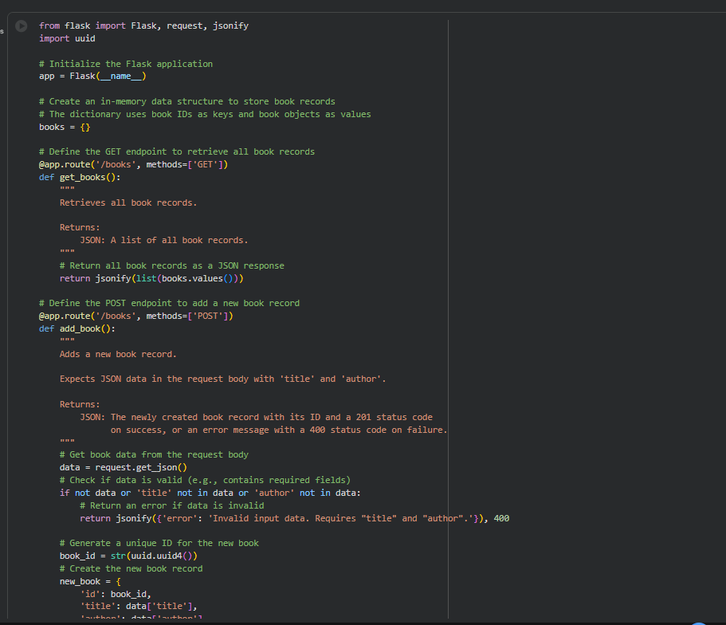  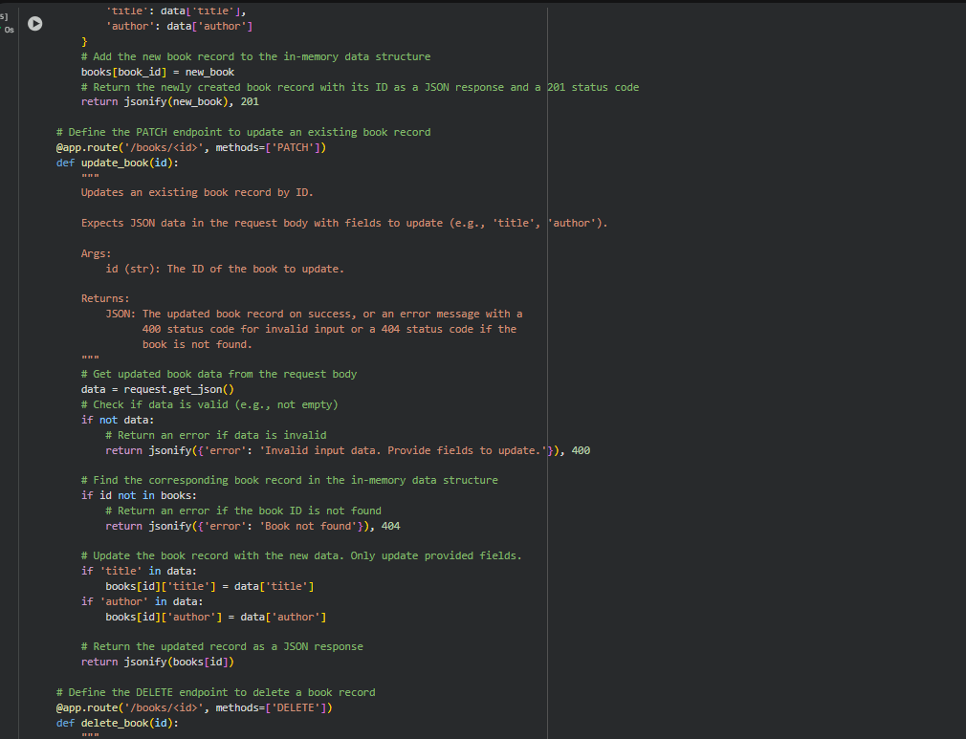  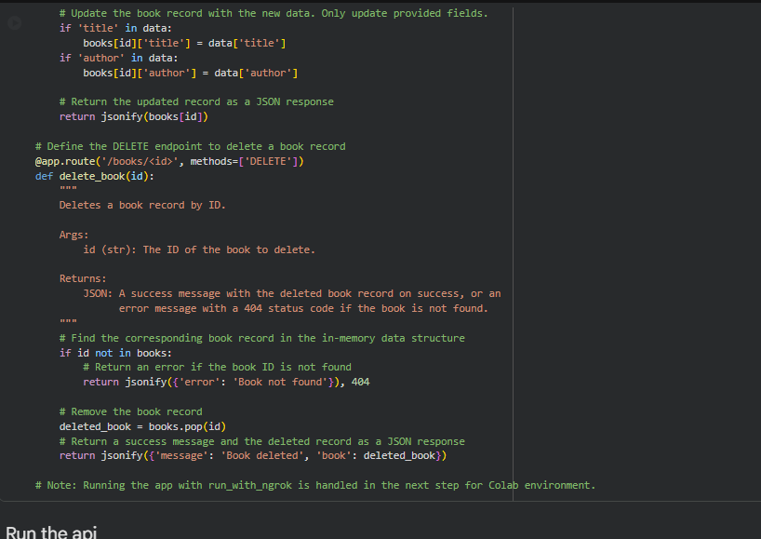  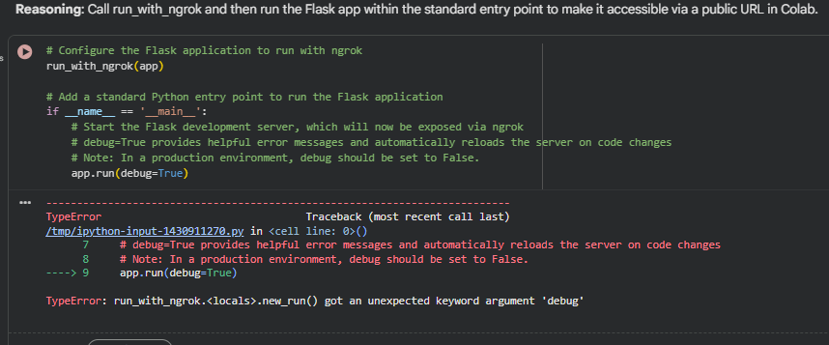  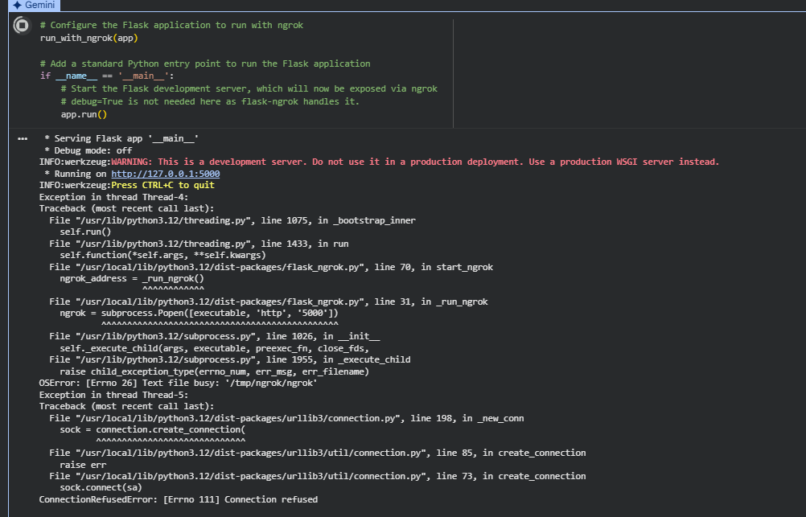  Task 3 – Employee Payroll API  Task:  Create an API for managing employees and their salaries.  Instructions:  - Endpoints required:  - GET /employees → List all employees  - POST /employees → Add a new employee with salary details  - PUT /employees/{id}/salary → Update salary of an employee  - DELETE /employees/{id} → Remove employee from system  - Use AI to:  - Suggest data model structure.  - Add comments/docstrings for all endpoints.  Expected Output:  - API supporting salary management with clear documentation.  Prompt:  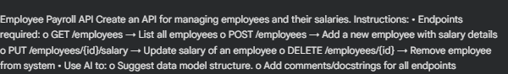  Code:  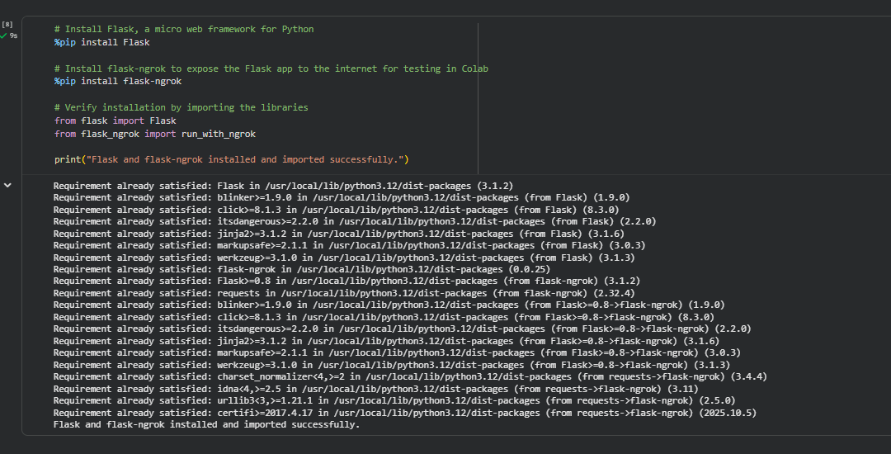  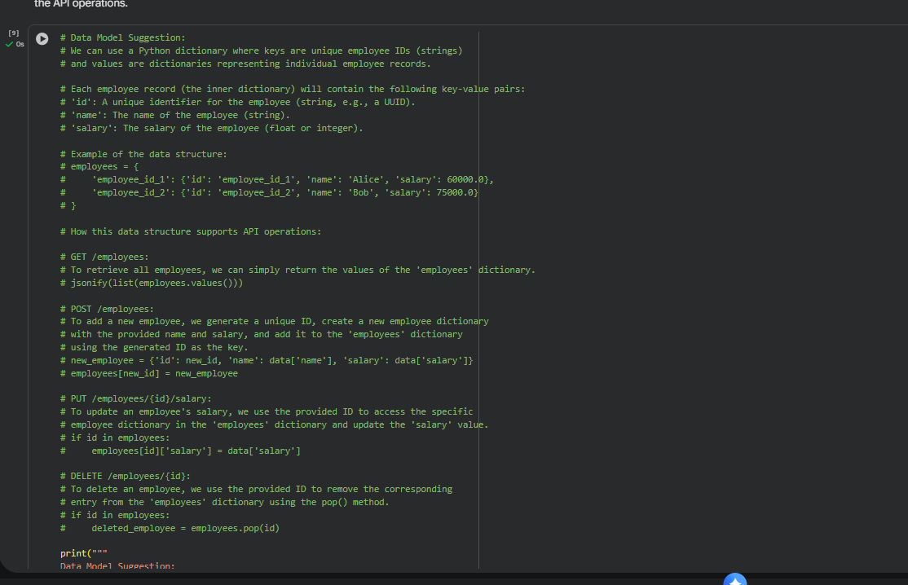  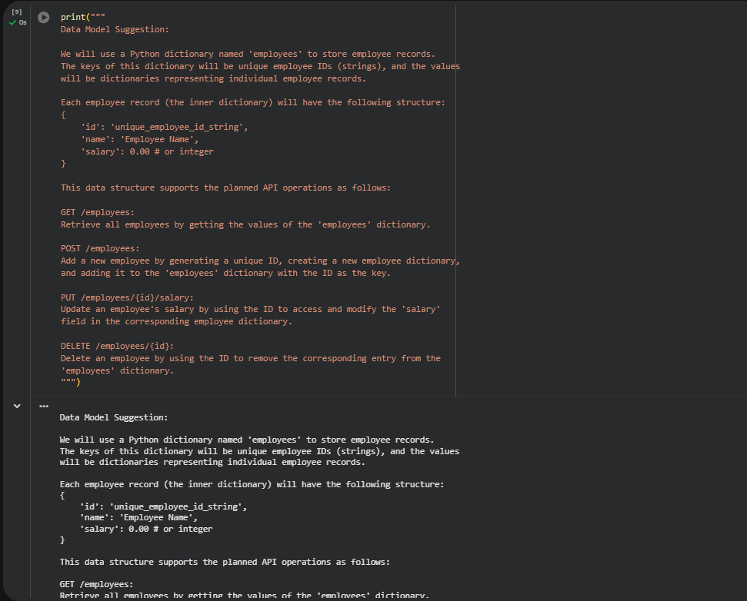  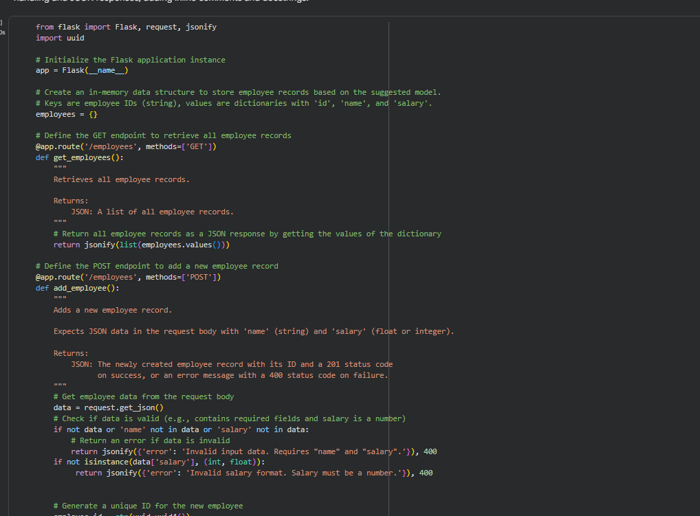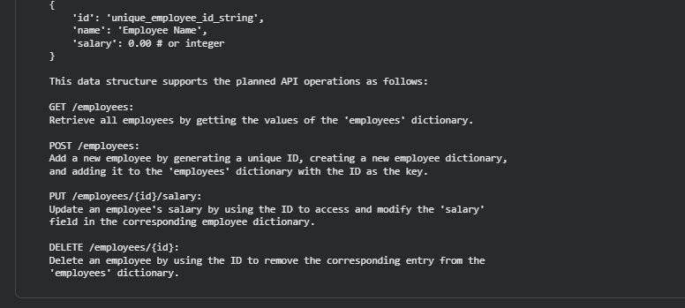  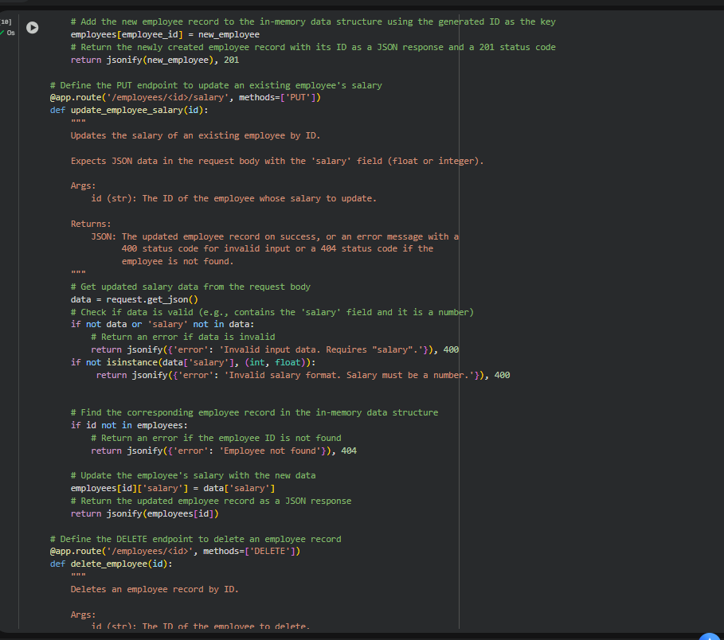  Task 4 – Real-Time Application: Online Food Ordering API  Scenario:  Design a simple API for an online food ordering system.  Requirements:  - Endpoints required:  - GET /menu → List available dishes  - POST /order → Place a new order  - GET /order/{id} → Track order status  - PUT /order/{id} → Update an existing order (e.g., change items)  - DELETE /order/{id} → Cancel an order  - AI should generate:  - REST API code  - Suggested improvements (like authentication, pagination)  Expected Output:  - Fully working API simulating a food ordering backend.  Prompt:  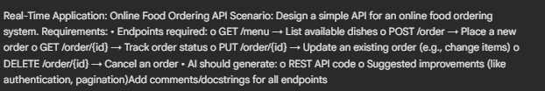  Cpde:  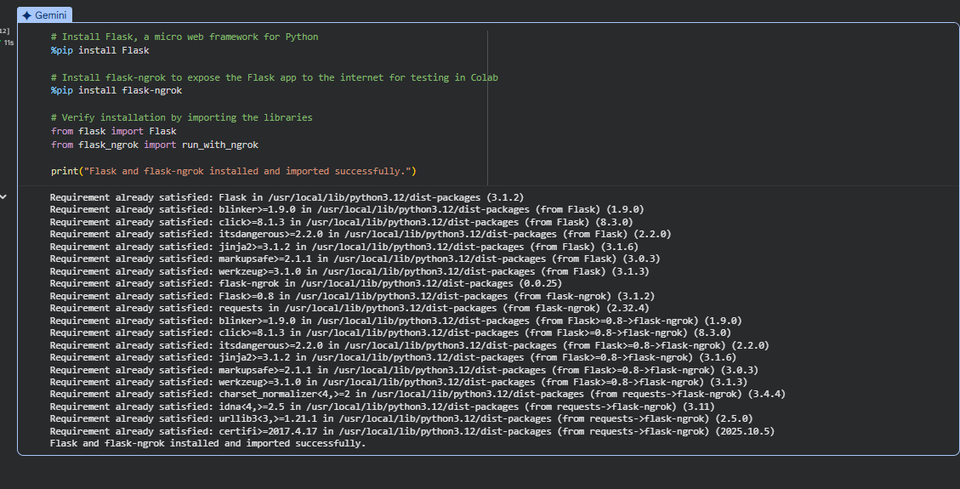  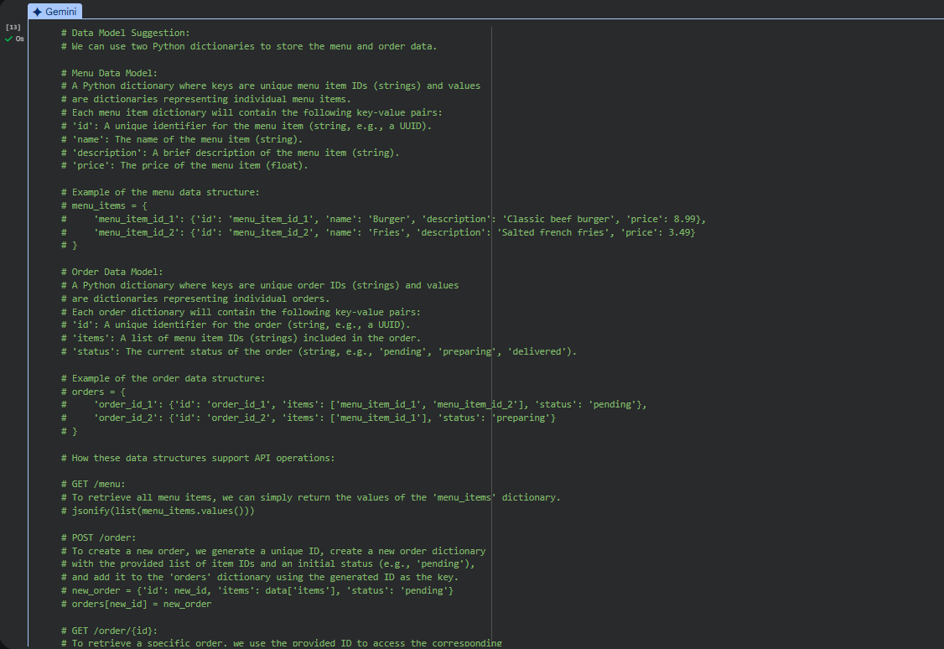  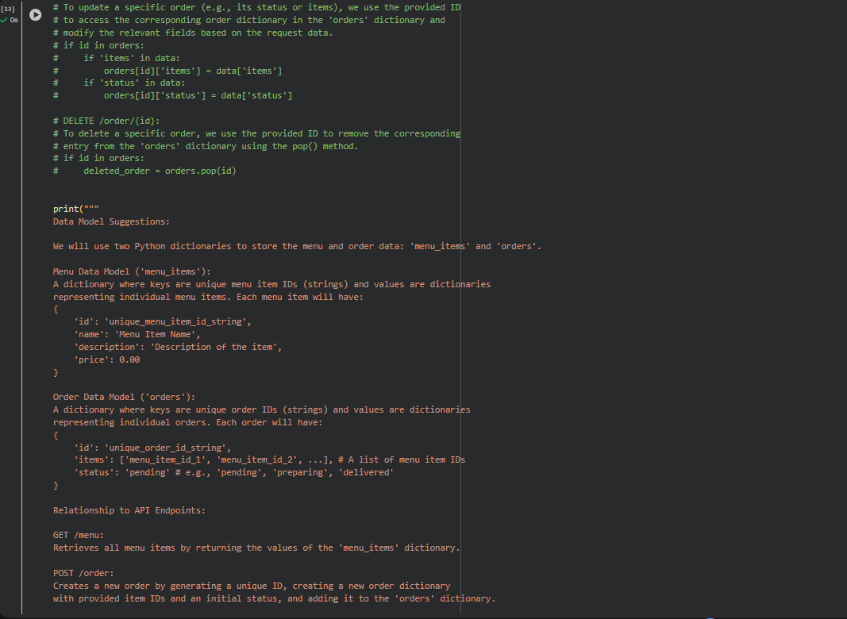  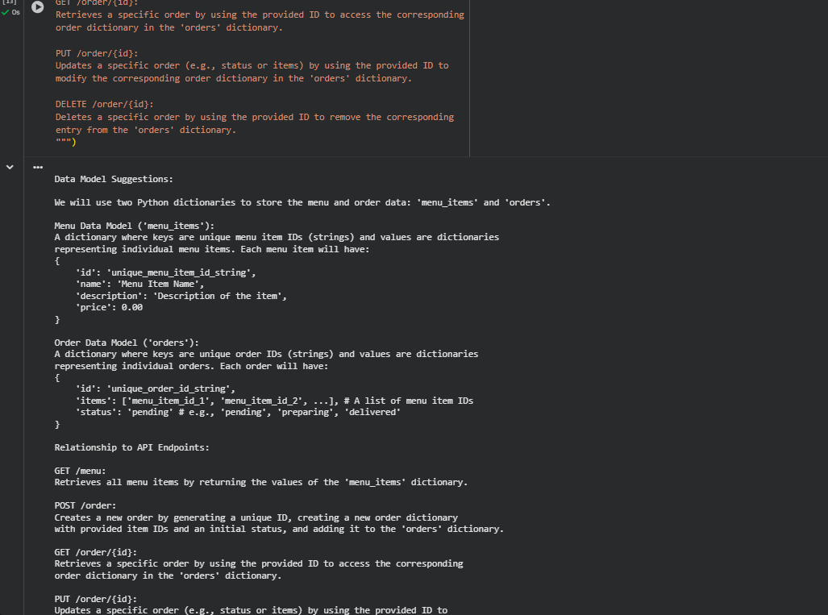  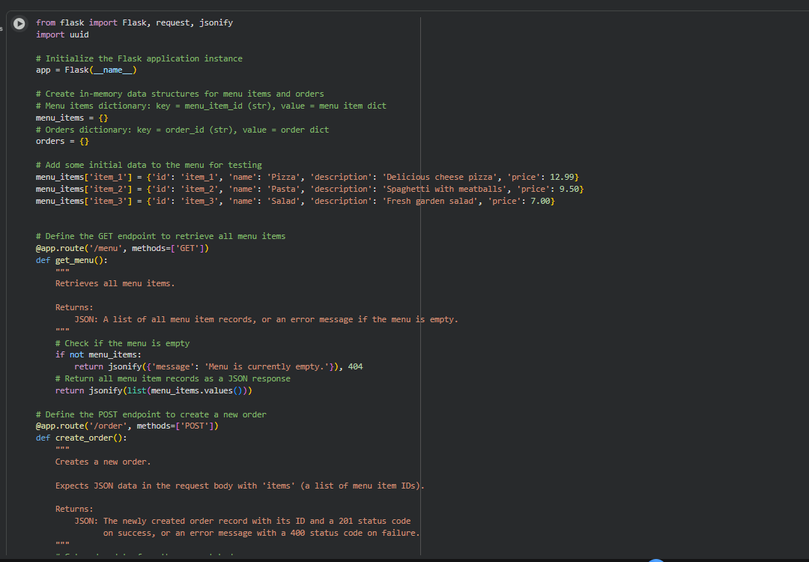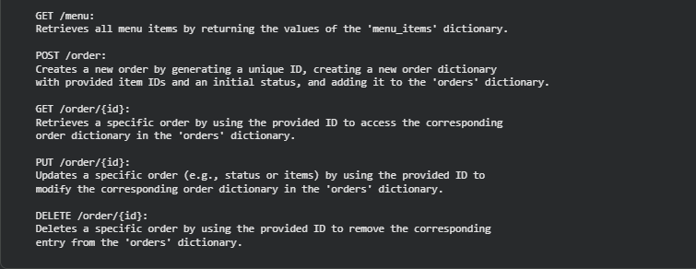  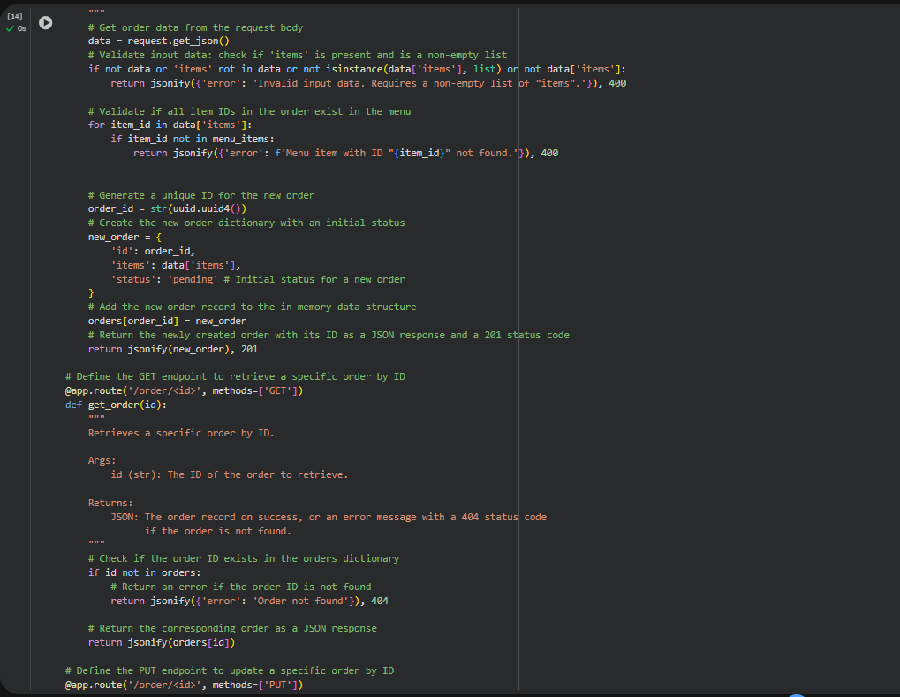  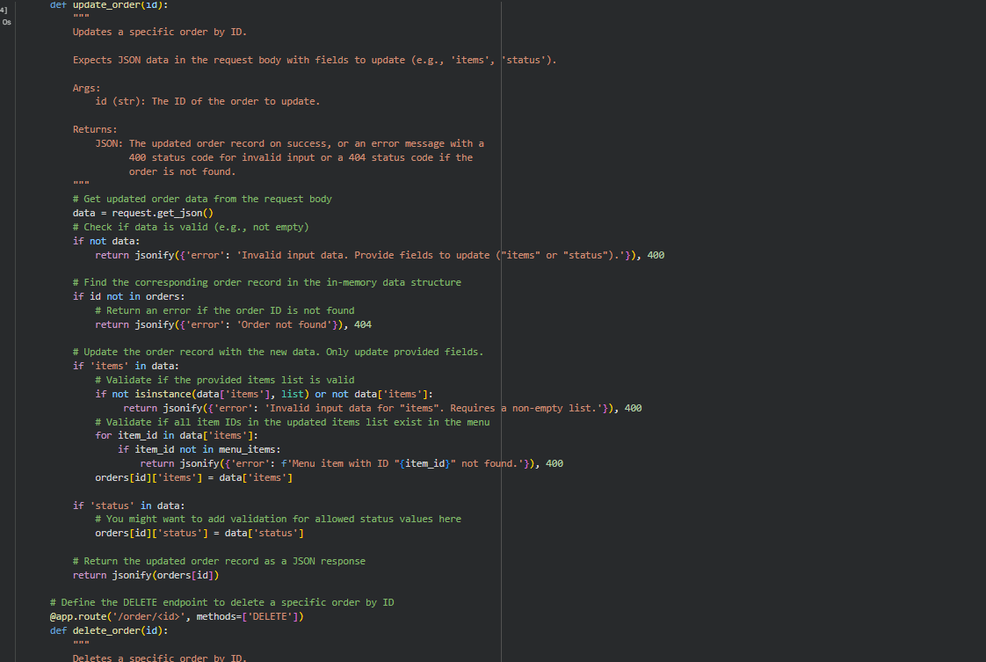  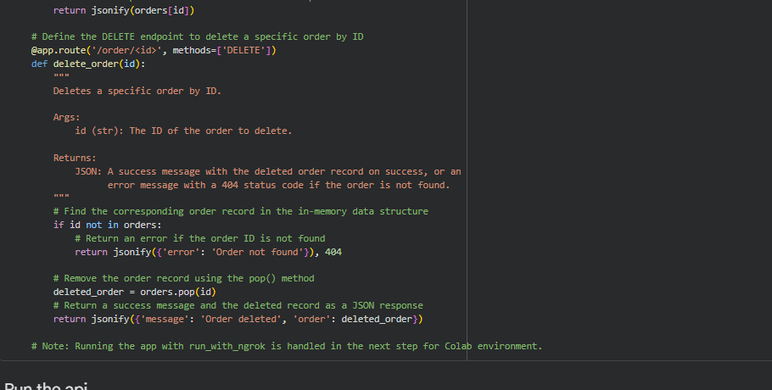  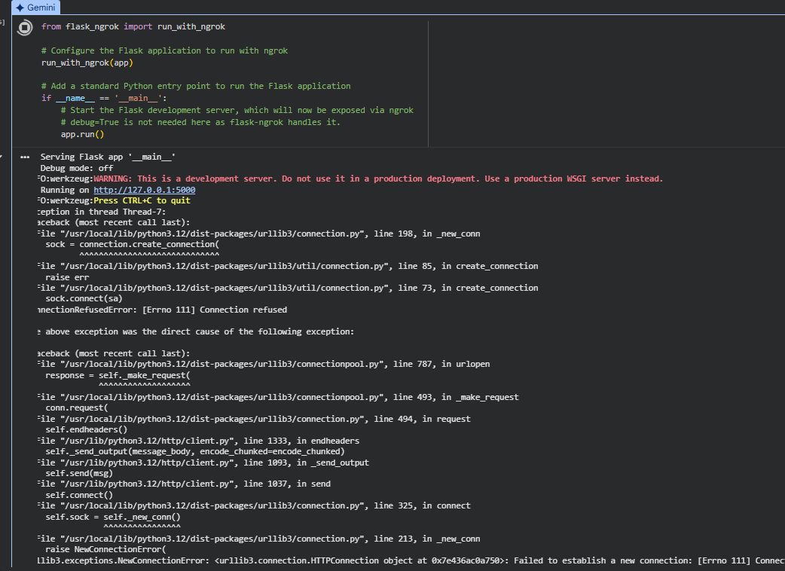  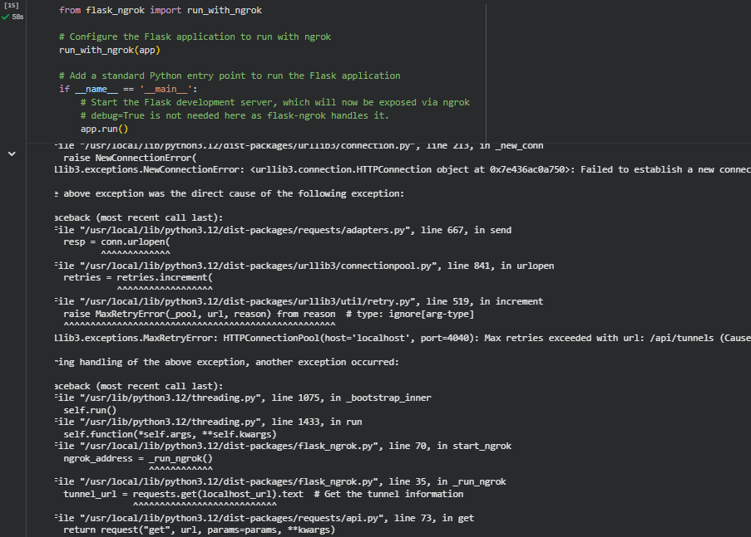  ✅ Deliverables (For All Tasks)  - AI-generated prompts for code and test case generation.  - At least 3 assert test cases for each task.  - AI-generated initial code and execution screenshots.  - Analysis of whether code passes all tests.  - Improved final version with inline comments and explanation.  - Compiled report (Word/PDF) with prompts, test cases, assertions, code, and output. |  |  |  |  |  | Week8 - Monday

