**RA1911003010783**

PIPES EXP-10

* **CREATING A PIPE (HALF DUPLEX):**

Code:

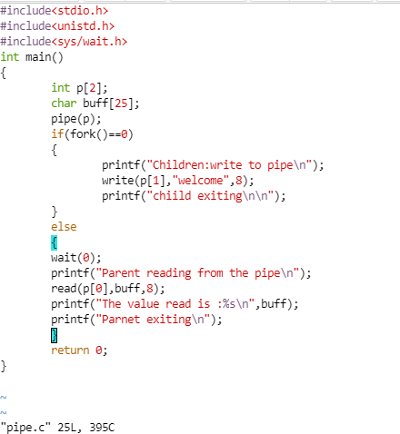

**OUTPUT:**

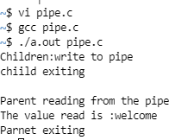

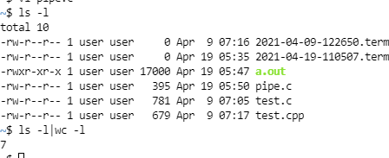

* Alternative method OF CREATING PIPE(HALF-DUPLEX)

CODE:

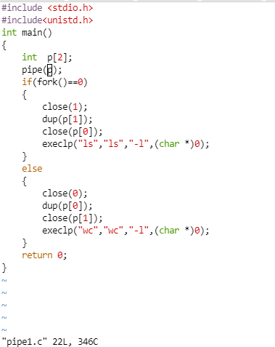

OUTPUT:

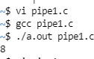

* CREATING A PIPE(FULL-DUPLEX): CODE:

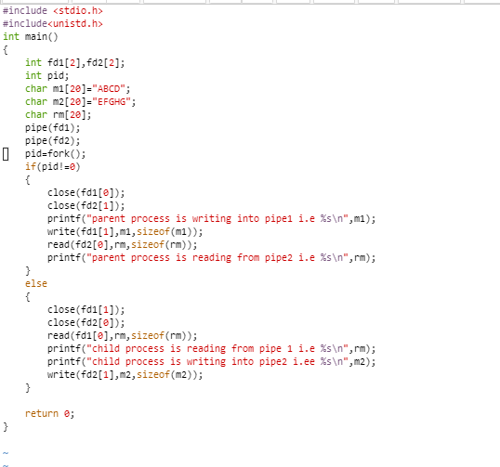

OUTPUT:

