MA 374 (2021) Financial Engineering Lab Lab 01

**Name:** Udandarao Sai Sandeep

**Roll Number:** 180123063

**Dept.:** Mathematics and Computing

**Q1.** Using the values of the parameters (given in the question), the up factor (**u**) and down factor **(d)** was calculated for each value of M by using the below formulas:







The up probability (**p**) was calculated as follows:

$$p=\frac{e^{r∆t}-d}{u-d}$$

The Option Price (at t = 0) was calculated as follows:

$$H\left(0\right)= \frac{1}{e^{rT}}\sum_{k=0}^{M}{ \left({M \atop k}\right)} p^{k}{\left(1-p\right)}^{M-k} f\left( S\left(0\right)u^{k}d^{M-k} \right)$$

$$where f represents Payoff of the option$$

$$for European call option:f\left(x\right)=max⁡(x-K,0)$$

$$for European put option: f\left(x\right)=max⁡(K-x,0)$$

The Option Prices for various values of M is as follows:

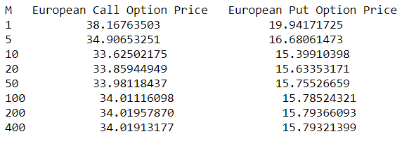

**Q2.**

Two sets of input arrays (containing various values of M) were used.

The **first array** contained the values from **1 to 200** varying **M** in **steps of 1**.

The **second array** contained the values from **1 to 200** varying **M** in **steps of 5**.

|  |  |
| --- | --- |
| **M** | **European Call Option Price Vs M (Binomial Model Framework)** |
| M with 1 Step Increments |  |
| M with 5 Step Increments |  |

|  |  |
| --- | --- |
| **M** | **European Put Option Price Vs M (Binomial Model Framework)** |
| M with 1 Step Increments |  |
| M with 5 Step Increments |  |

**Observations:**

Both the Call option prices and the Put option prices (at t=0) seem to oscillate about a central value. If we only consider even values of M separately, the corresponding option prices form a gradually increasing sequence **(0<M<200)** converging to the central value from the bottom. Similarly, if we consider only odd values of M separately, the corresponding option prices form a gradually decreasing sequence **(0<M<200)** converging to the central value from the above.

The absolute difference between consecutive values of option prices decreases as M increases. The difference reaches zero as M reaches higher values **(0<M<200)**. The European Call Option price seems to converge to the point **34.01** and the European Call Option price converges to **15.78**.

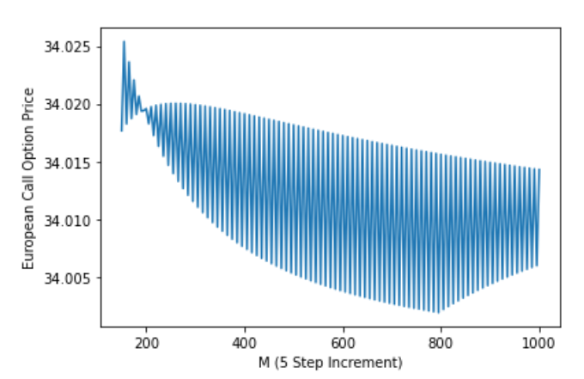**Note:** The graph matches theoretical conclusions when M remains below 200. When M surpasses 200, the option prices graph shows some irregularity, which may be explained through accumulating errors, or computational discrepancies. However, for higher values of M (~1800), these irregularities decrease and the option price converges to the expected values.

**Q3.**

The value of M has been set to **20**.

For each value of t, the number of remaining time intervals and the number of time intervals that have already occurred were calculated.

All possible case scenarios till time **t** were taken into consideration.

For each possible case, the number of ups and the number of downs that have already occurred have been noted. Then, the stock price at the current time (**t**) was calculated. Considering this as the initial stock price, the option price was calculated (for the remaining time period).

The results obtained are given in the next page.

Given below are all the European Call Option Prices at different times (for all scenarios).

**UPS** representsthe number of ups that have already occurred.

**DOWNS** represents the number of downs that have already occurred.

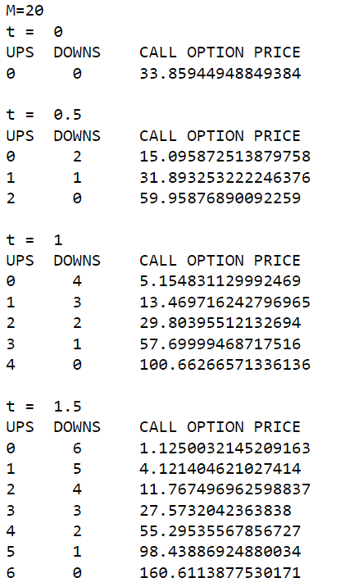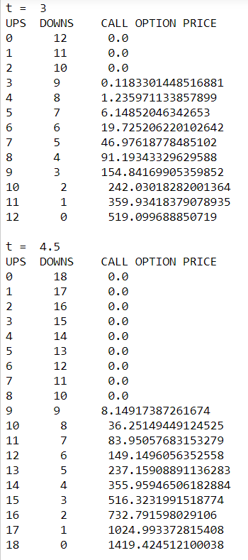

Given below are all the European Put Option Prices at different times (for all scenarios).

**UPS** representsthe number of ups that have already occurred.

**DOWNS** represents the number of downs that have already occurred.

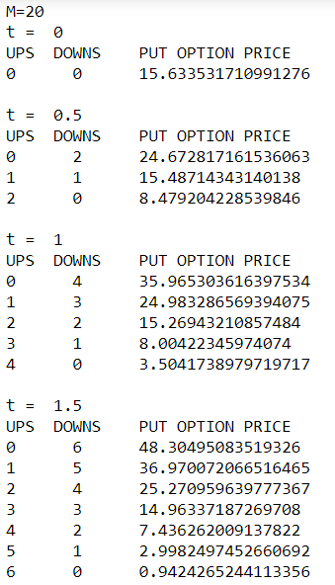 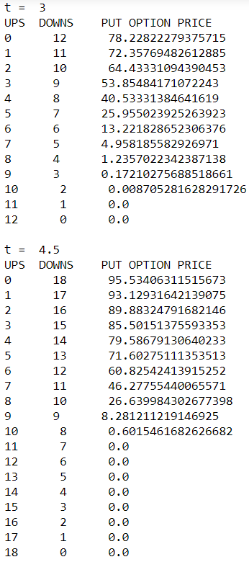

**Note:** For every question and every subcase, the program initially checks for **No Arbitrage Condition** before proceeding further. The following check is carries out:

No Arbitrage Condition: $d< e^{\frac{rT}{m}}<u$