MA 374 (2021) Financial Engineering Lab Lab 10

**Name:** Udandarao Sai Sandeep

**Roll Number:** 180123063

**Dept.:** Mathematics and Computing

**Q1.**

The following parameters have been set (as given in question):

* **Stock** **Price** for **ten** different simulations (using **risk** **neutral** GBM equation):



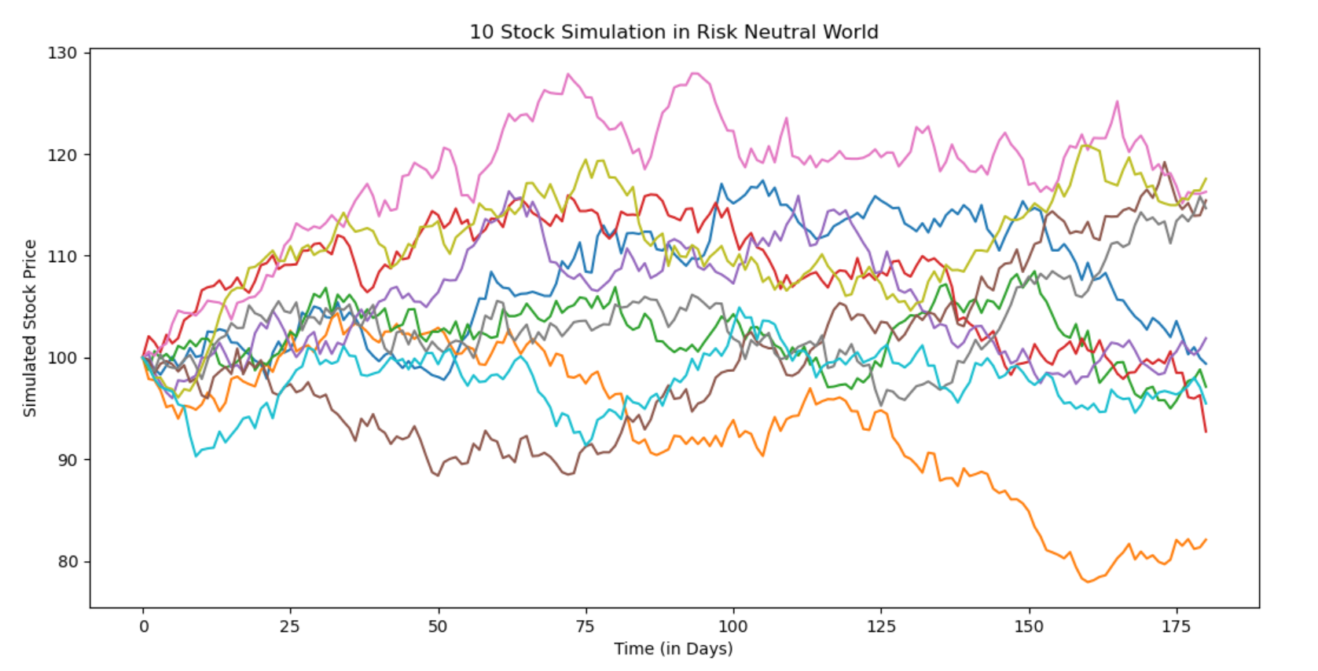

* Stock Price for ten different simulations (using real world GBM equation):



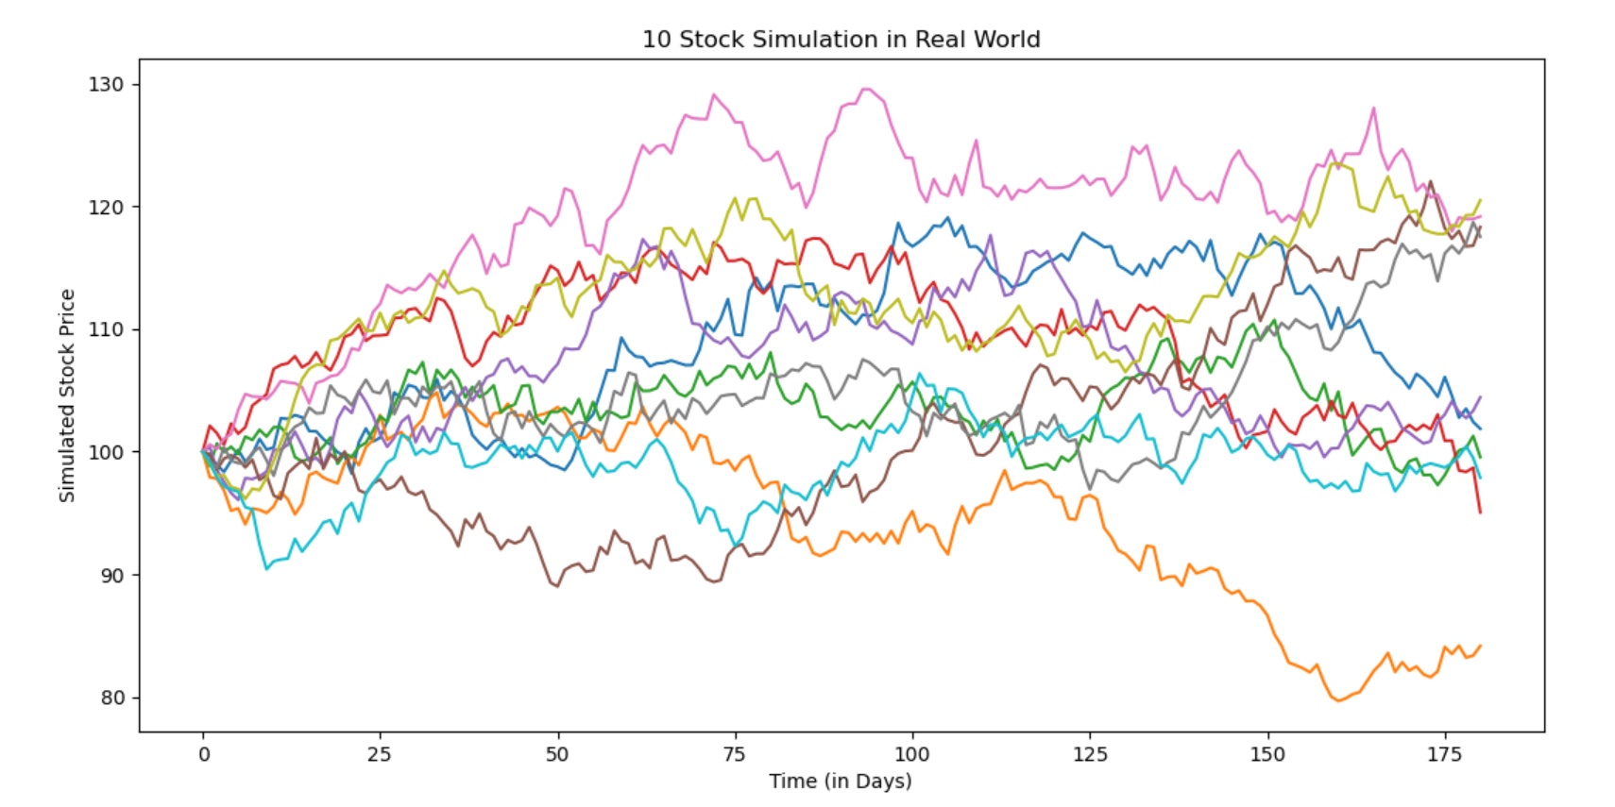

Here, we have compared the stock price values for risk neutral and real-world scenarios for one of the simulations.

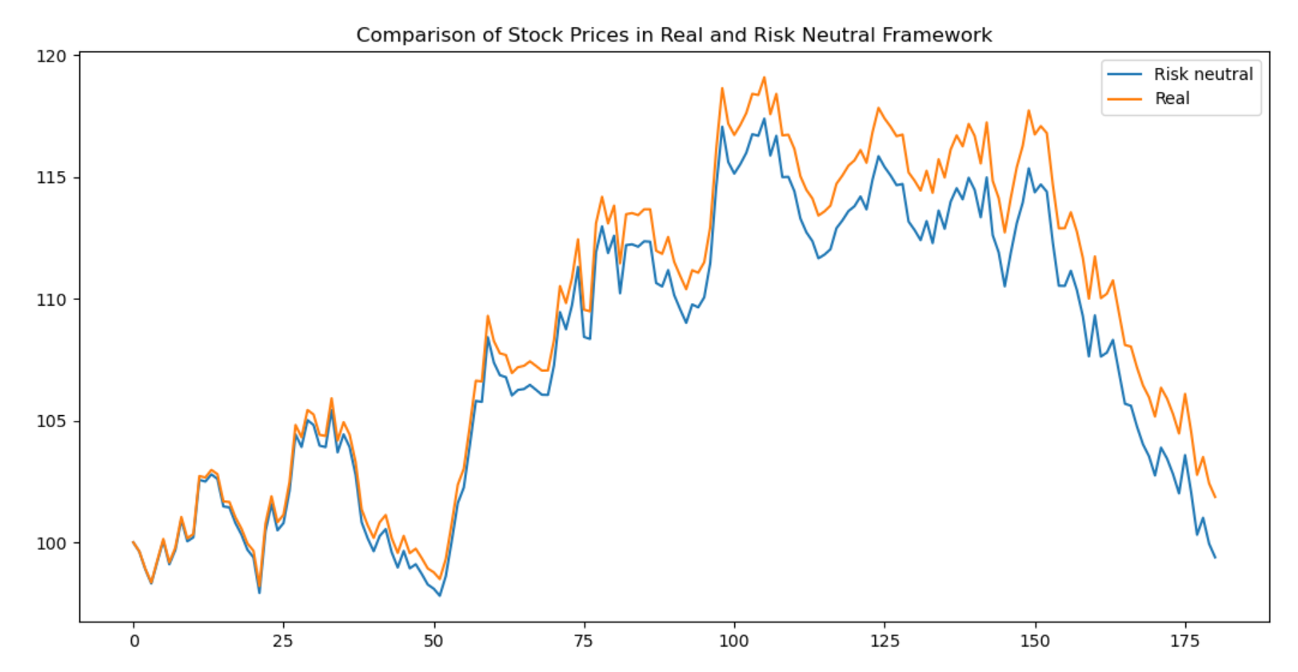

Six month fixed-strike Asian Option Price was calculated for Strike prices 90,105 and 110. To calculate the Asian Option Payoff, arithmetic mean (of the strike prices in the 6-month period) was used. The option price was calculated as follows:

The graphical plots of the Option Prices vs Number of Simulations are as follows:

Average Call option price for K = 90 is 11.32566

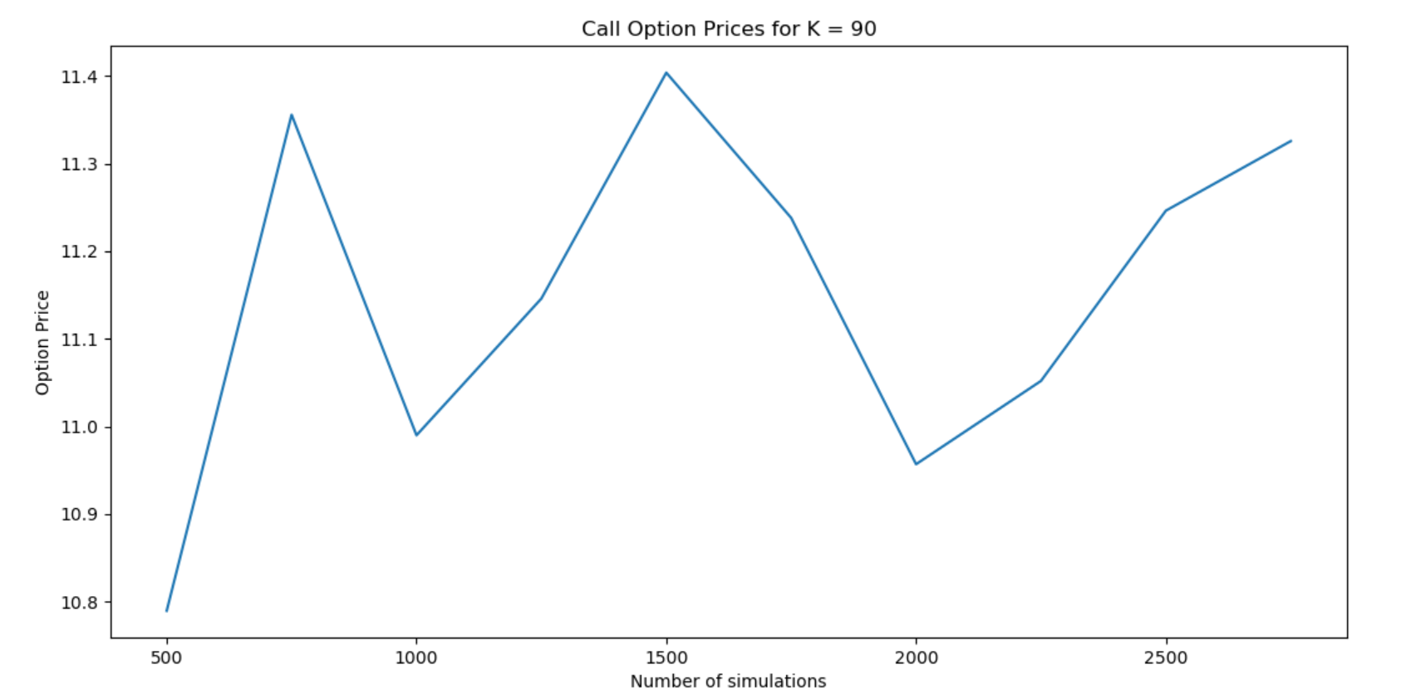

Average Call option price for K = 105 is 1.76843

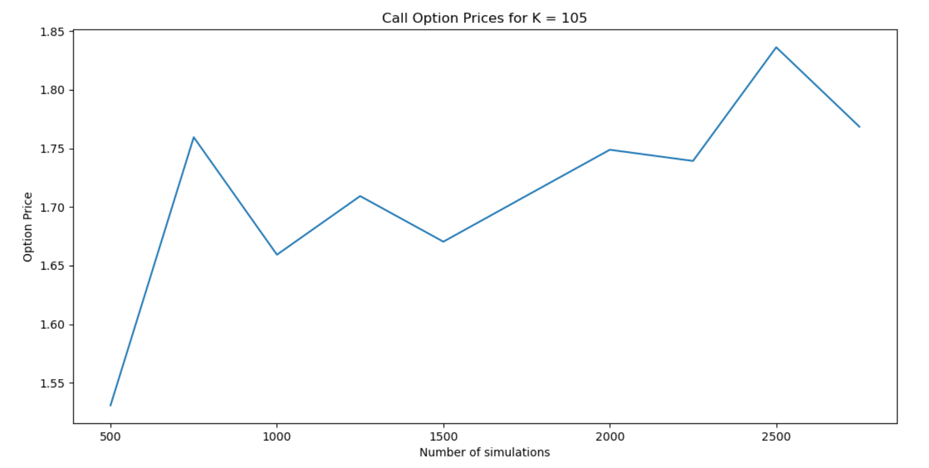

Average Call option price for K = 110 is 0.69037

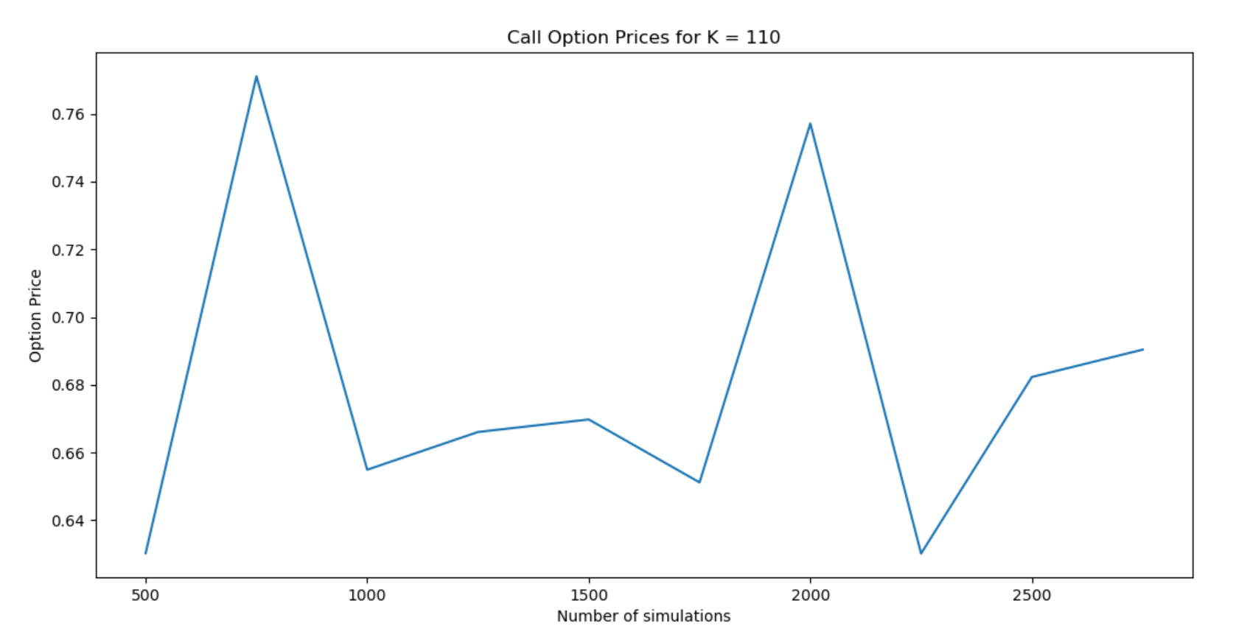

Average Put option price for K = 90 is 0.23942

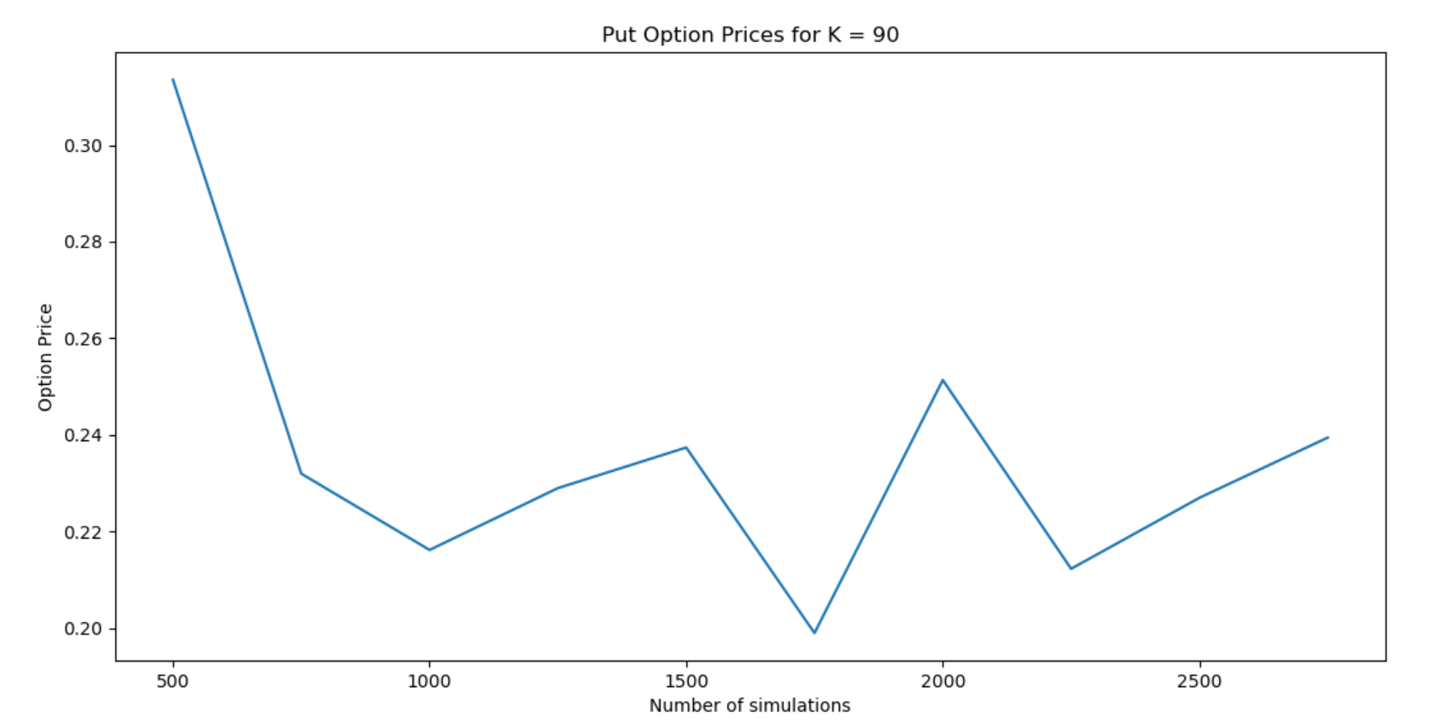

Average Put option price for K = 105 is 5.43707

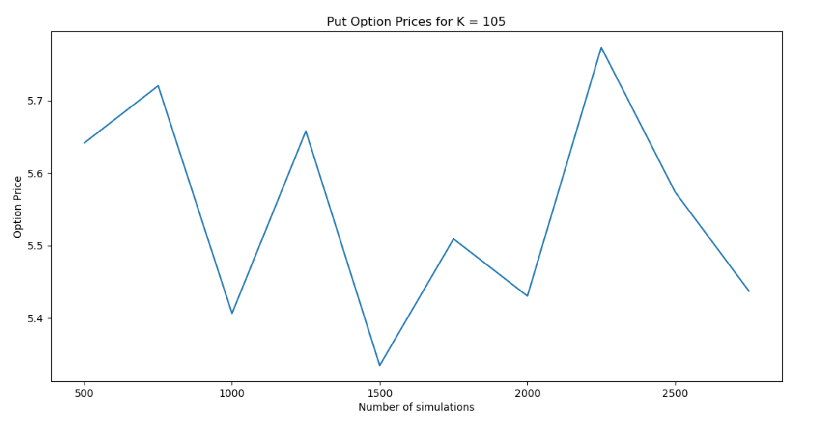

Average Put option price for K = 110 is 9.37288

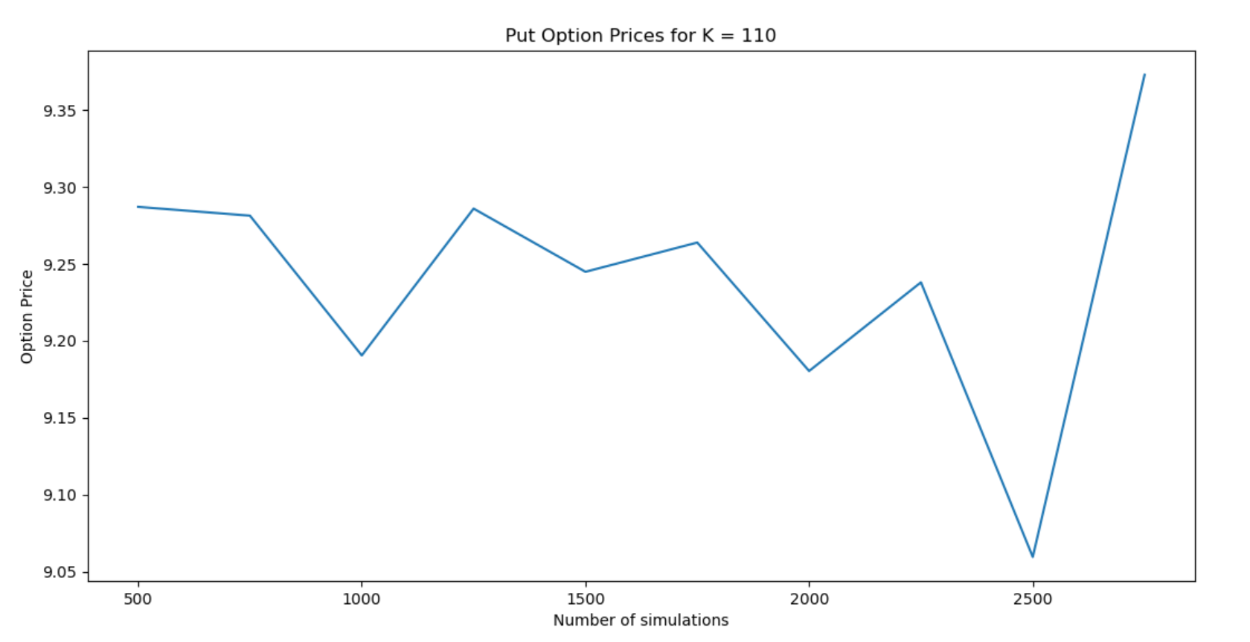

Sensitivity analysis of the option prices was done (on the model parameters T, K, r, sigma).

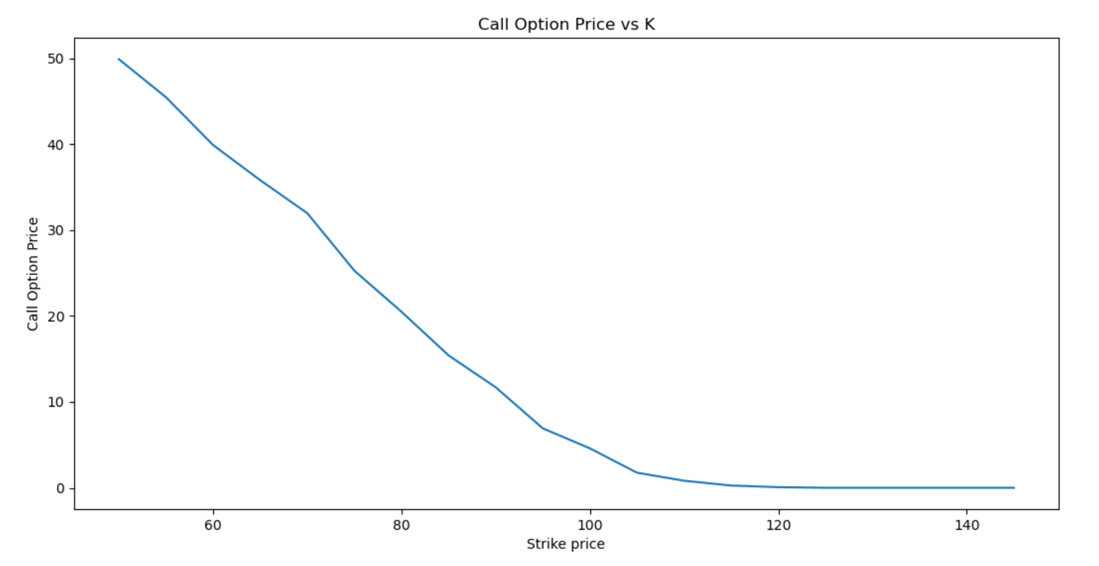

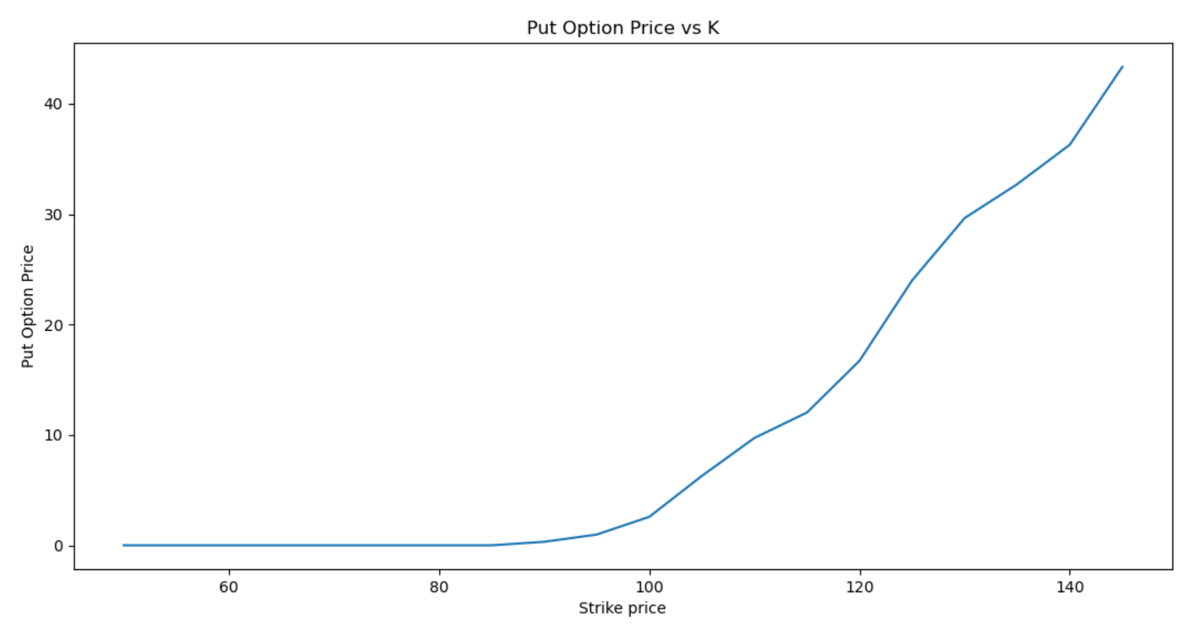

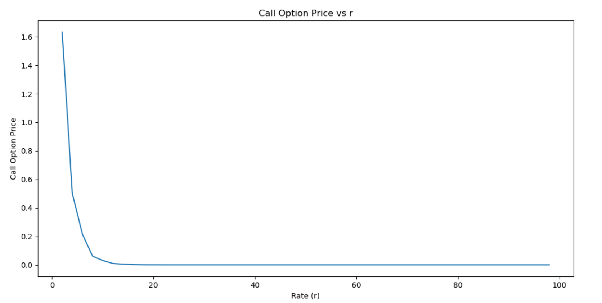

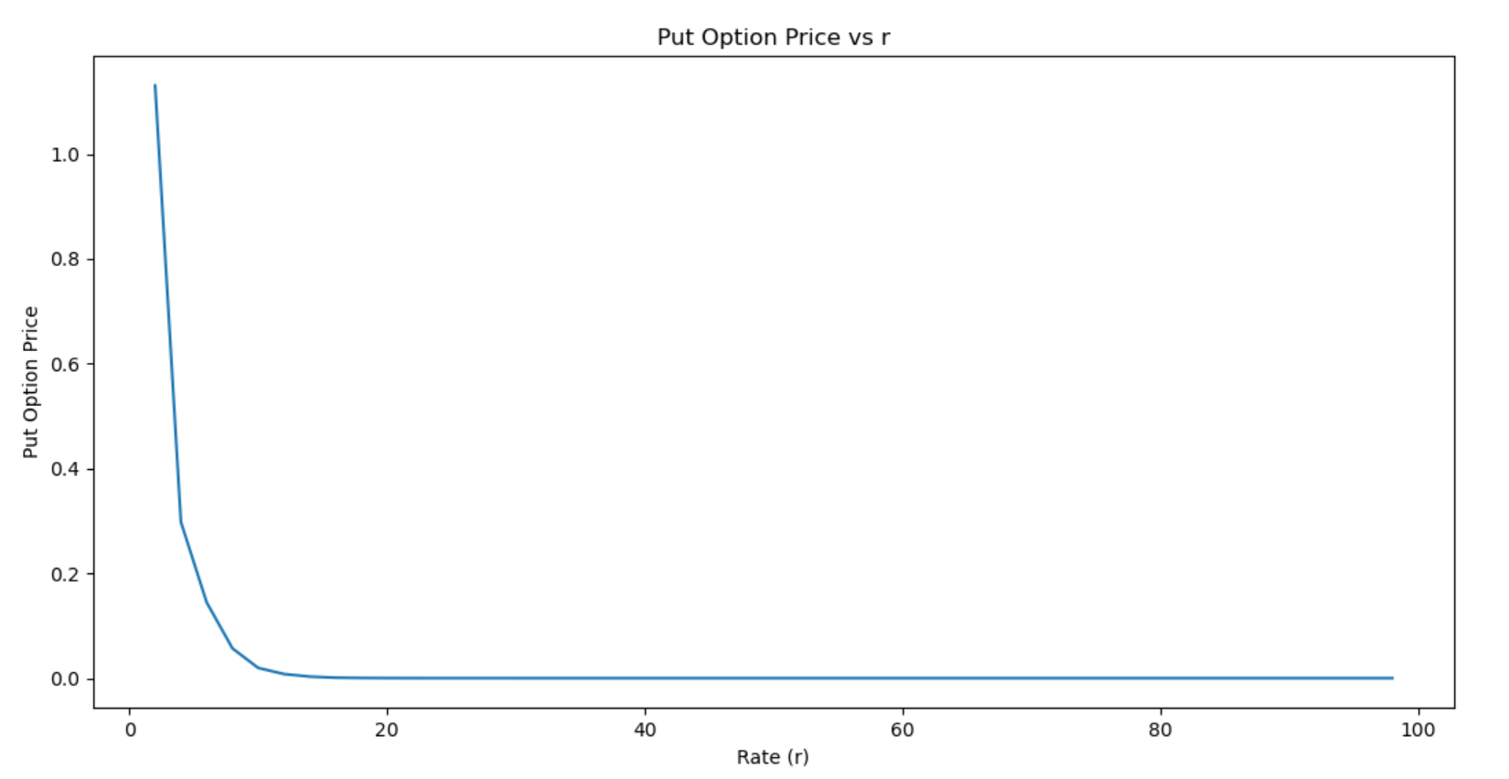

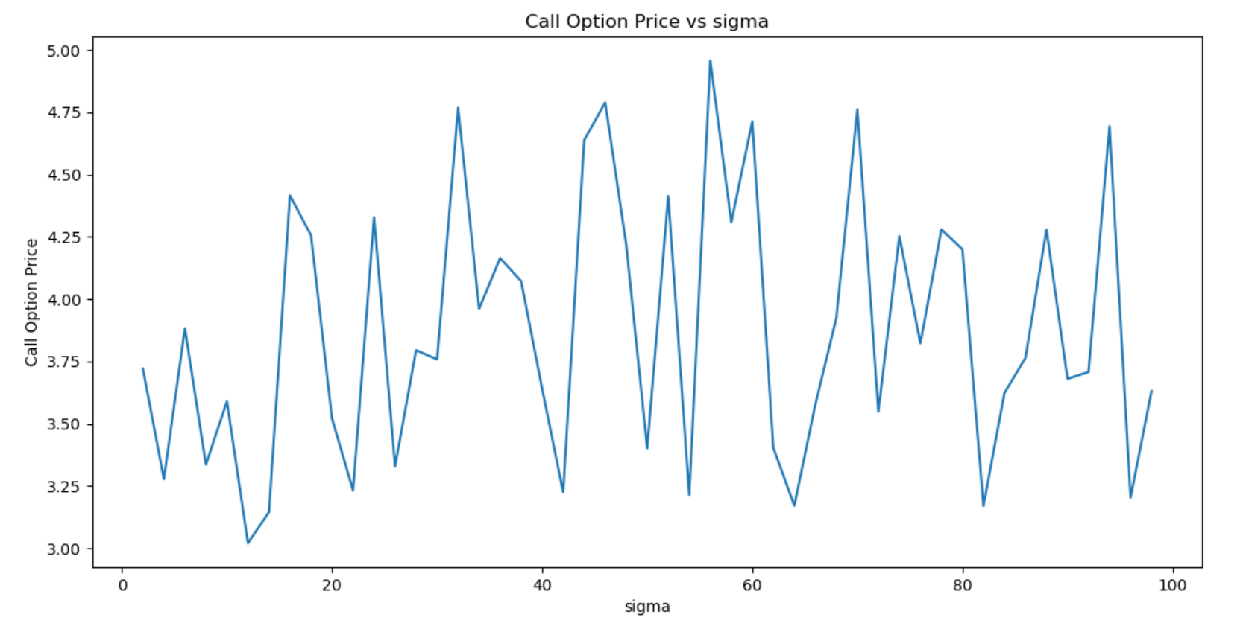

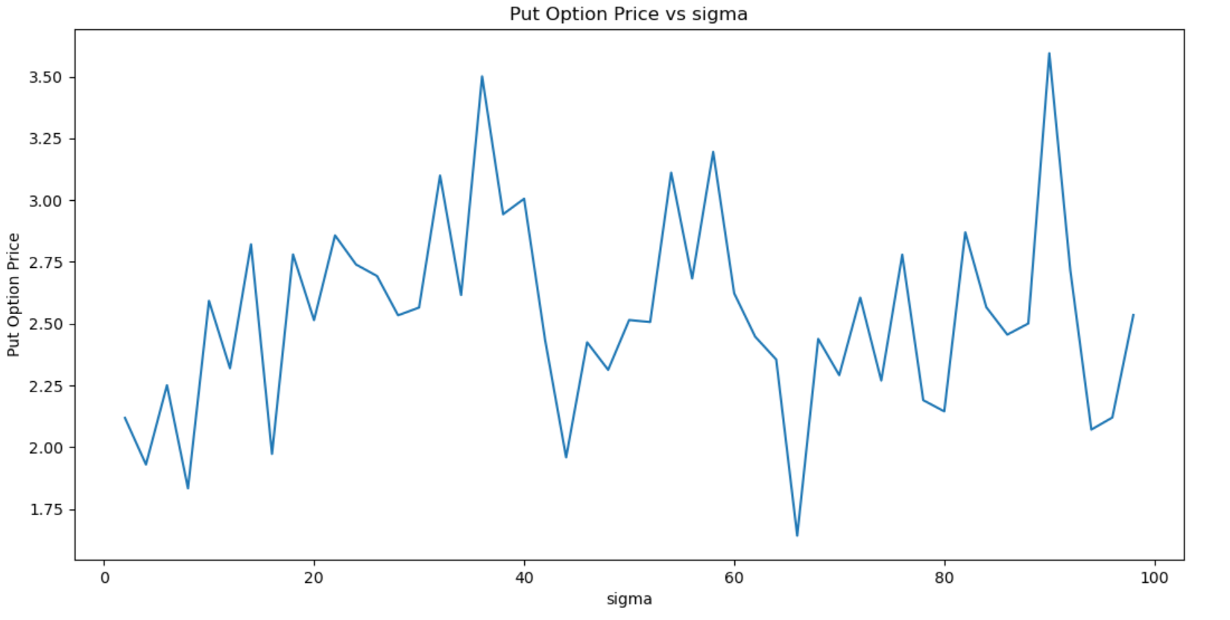

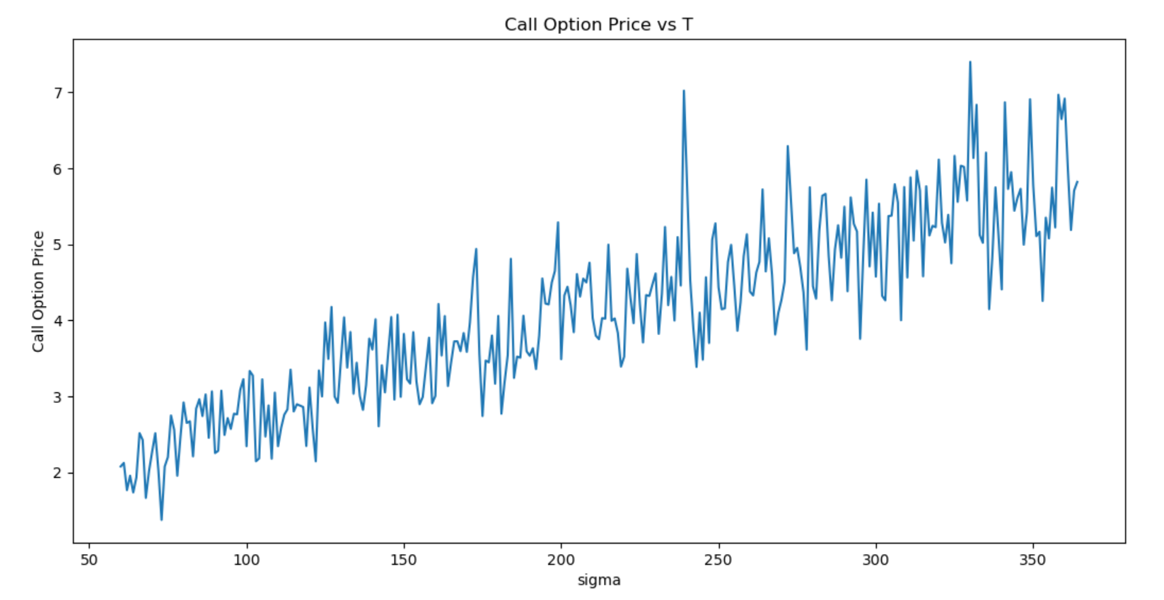

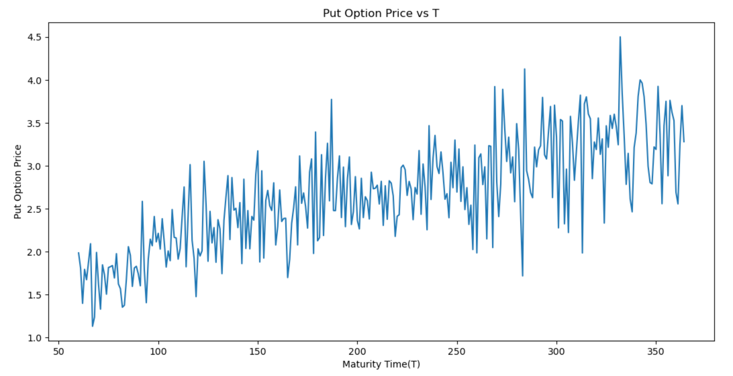

Q2:

Variance reduction techniques was done using **antithetic** **variables**. (In this technique, the variance is reduced using an antithetic variable (negative value for every corresponding positive value.))The reduction in variance is evident from the following graphs:

Variance of Call option price without variance reduction for K = 90 is **0.0465**

Variance of Call option price with variance reduction for K = 90 is **0.0025**

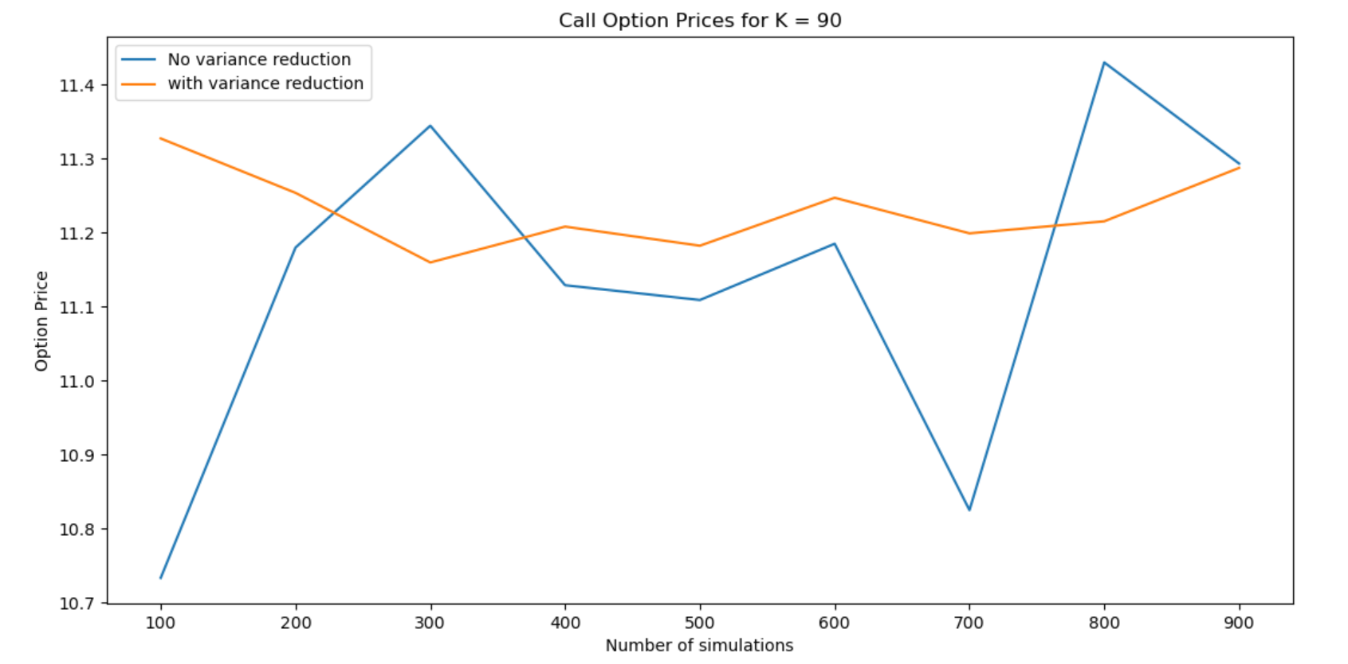

Variance of Call option price without variance reduction for K = 105 is **0.01992**

Variance of Call option price with variance reduction for K = 105 is **0.02815**

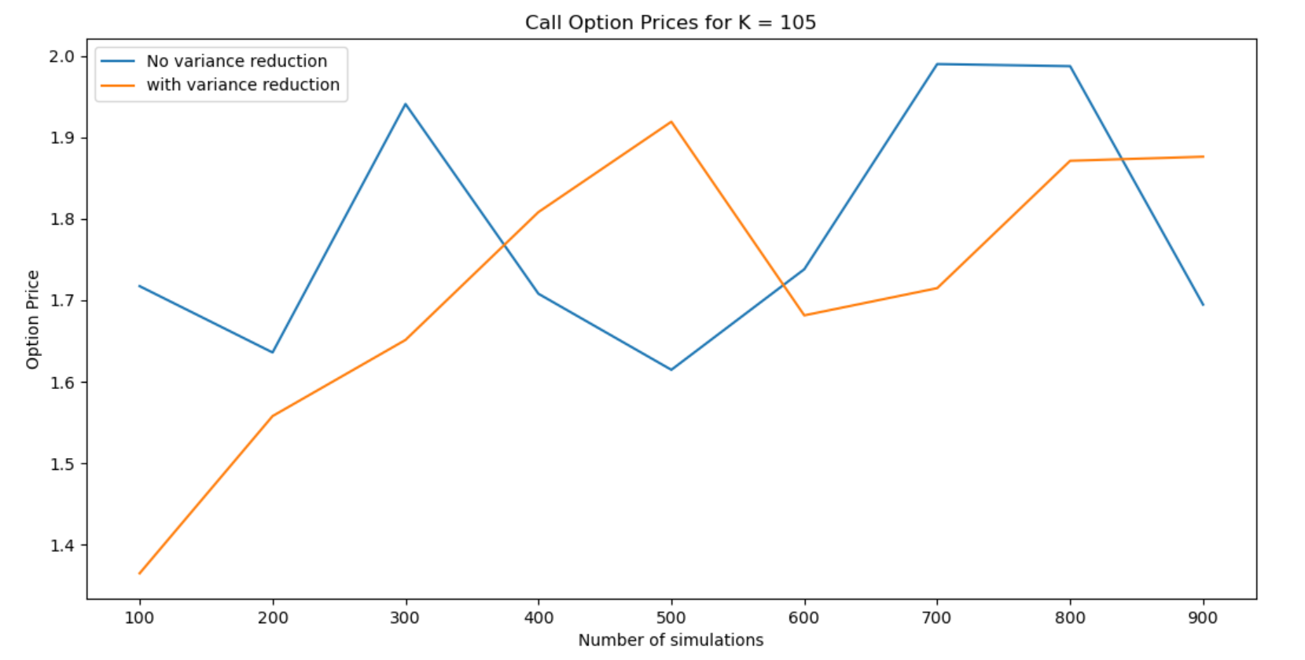

Variance of Call option price without variance reduction for K = 110 is **0.00487**

Variance of Call option price with variance reduction for K = 110 is **0.01234**

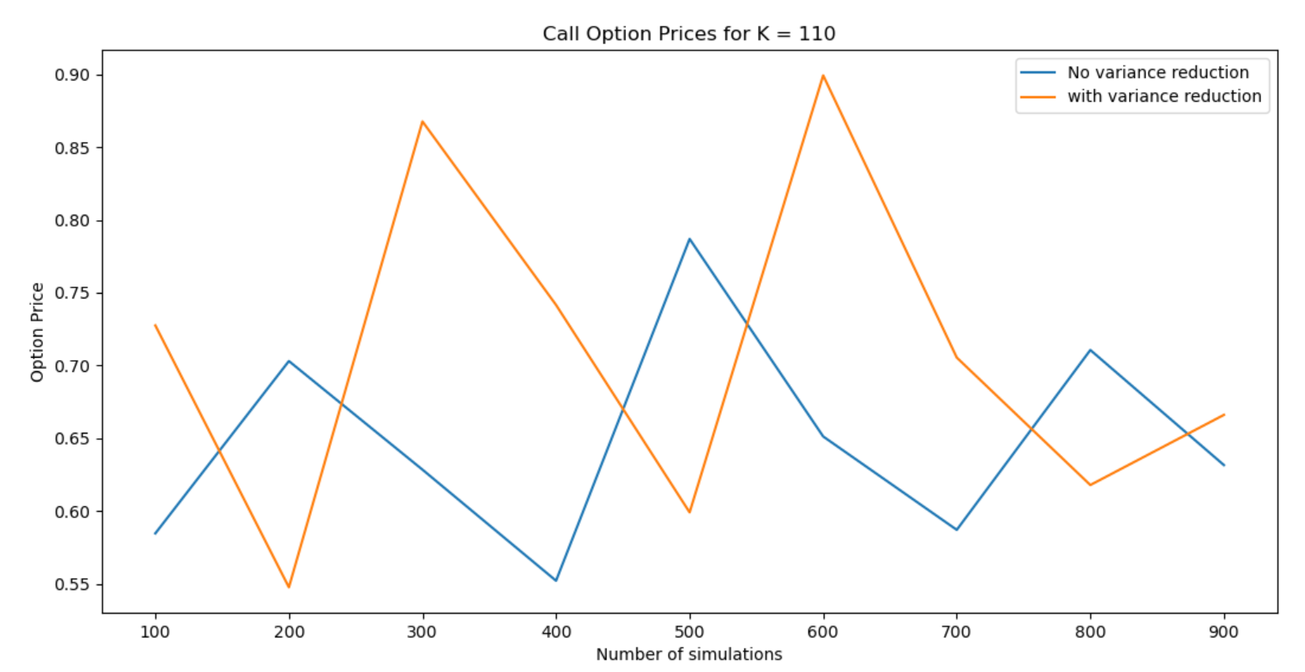

Variance of Put option price without variance reduction for K = 90 is **0.00298**

Variance of Put option price with variance reduction for K = 90 is **0.00066**

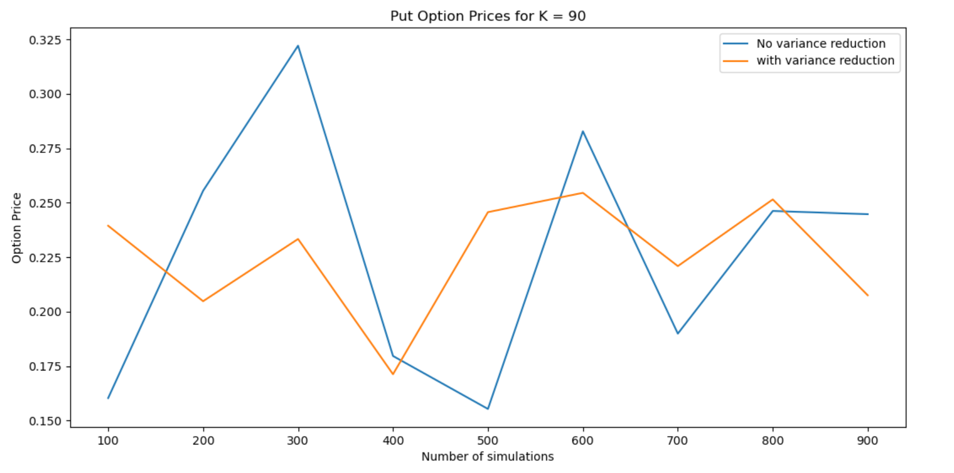

Variance of Put option price without variance reduction for K = 105 is **0.0619**

Variance of Put option price with variance reduction for K = 105 is **0.01016**

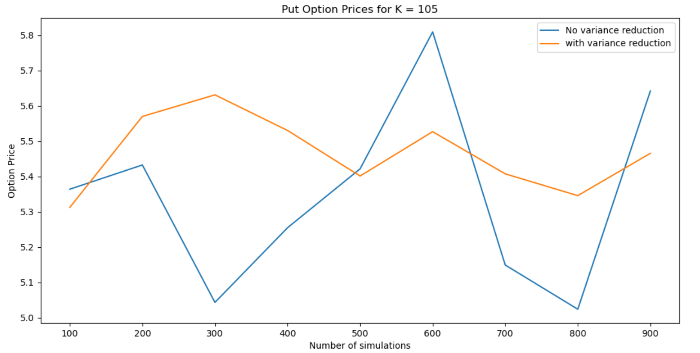

Variance of Put option price without variance reduction for K = 110 is **0.09944**

Variance of Put option price with variance reduction for K = 110 is **0.00177**

