MA 374 (2021) Financial Engineering Lab Lab 11

**Name:** Udandarao Sai Sandeep

**Roll Number:** 180123063

**Dept.:** Mathematics and Computing

**Q1.**

The **Vasicek model** is as follows:



Plot Yield vs Maturity Time for **3 parameter sets [5.9,0.2,0.3,0.1], [3.9,0.1,0.3,0.2],** and **[0.1,0.4,0.11,0.1]**:

**Term Structure:**

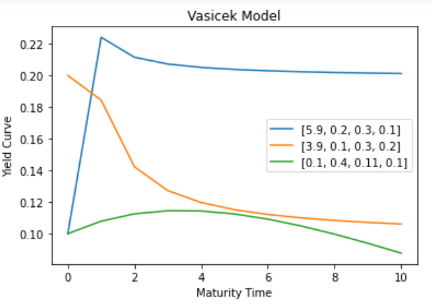

Now, **10** different values of **r (from 0.1 to 1)** were chosen. Then, the **Yield Curve vs Maturity Time** was plotted out for each of the parameter sets (with **500** units).

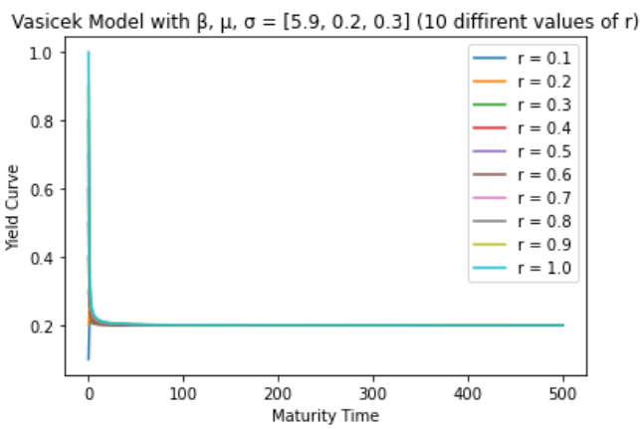

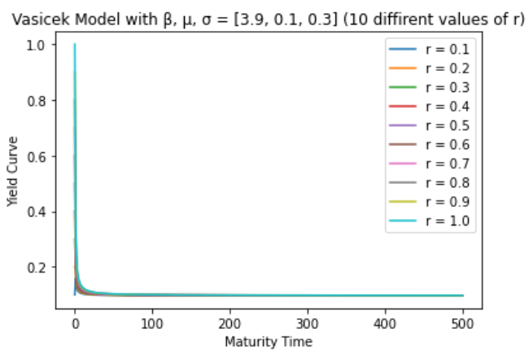

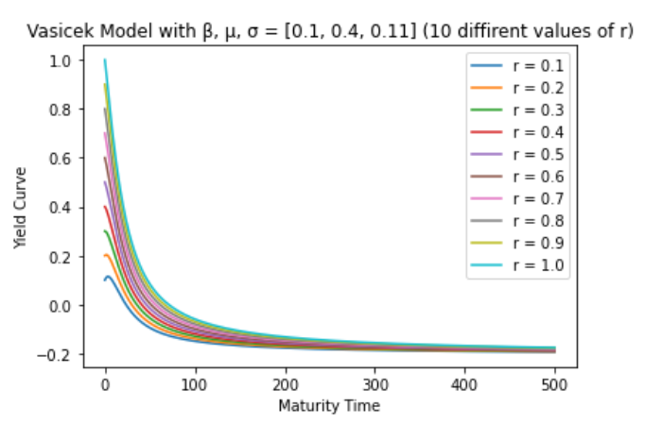

**Q2.** The **CIR** **Model** is as follows:



**Plot Yield vs Maturity Time** for **3** parameter sets **[0.02,0.7,0.02,0.1], [0.7,0.1,0.3,0.2],** and **[0.06,0.09,0.5,0.02]:** 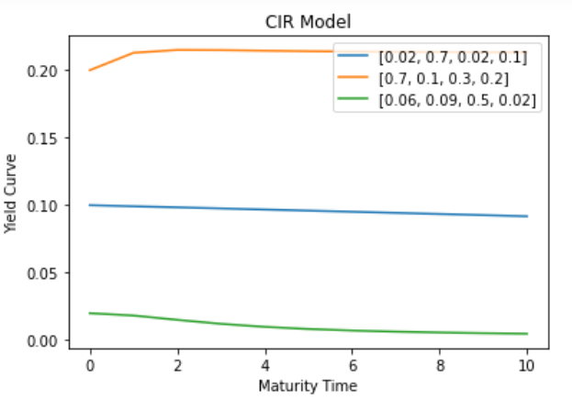

Now, **10 different values** of **r** **(from 0.1 to 1)** were chosen. Then, the **Yield Curve vs Maturity Time** was plotted out for the parameter set **[0.02,0.7,0.02, r]** (with **600** units).

