MA 374 (2021) Financial Engineering Lab Lab 04

**Name:** Udandarao Sai Sandeep

**Roll Number:** 180123063

**Dept.:** Mathematics and Computing

**Q1.**

As given in the question, the mean vector and sigma covariance matrix is as follows:

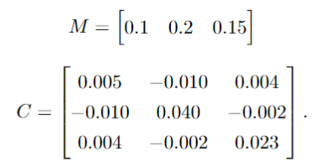

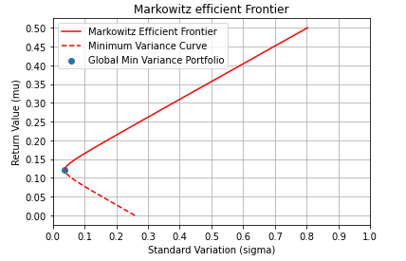**(a)** Firstly, a sample of “Expected Return Value” was chosen. For each value of **µ** in the sample, the minimum variance portfolio for that particular value of **µ** was constructed. All the minimum variance portfolios were stored, and then plotted out. The results are as follows:

**(b)** Weights, Expected Return and Risk of certain portfolios:

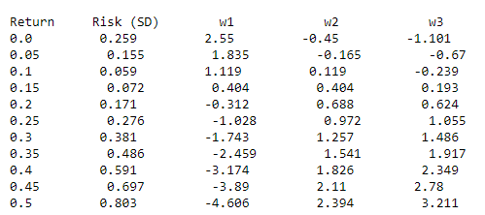

**(c)**

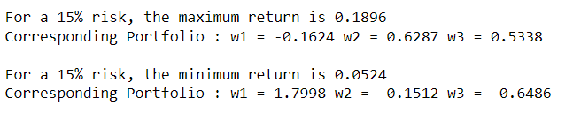

**(d)**



**(e)**

**µrf** (Risk Free Return) **= 0.1**

Using the risk-free return, the corresponding portfolio on the minimum variance curve was identified. Then, by joining the points **(0, µrf)** and **(σM, µM)**, the **Capital Market Line** was plotted out.

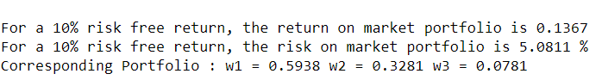

The plot of the **CML** is as follows:

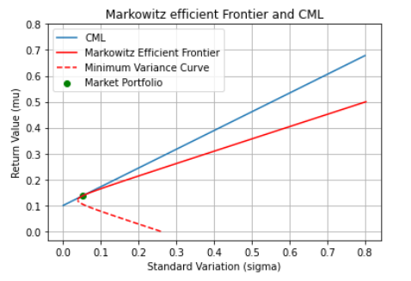

**(f)**

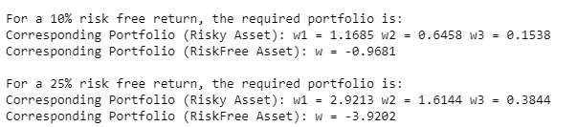

**Q2.**

For this question, before accepting the values of the variance (of the Minimum Variance Portfolios for a particular µ), it was first checked if any of the weights was negative. This was done to avoid short selling. The following sub-part of the main efficient Frontier was obtained:

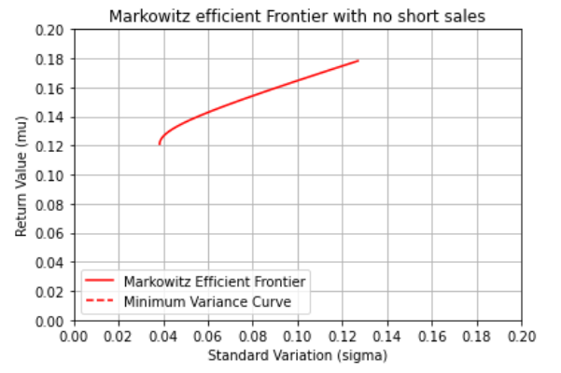

Then, the securities were considered 2 out of 3 at a time. The mean and sigma covariance variances were reconstructed. All the Minimum Covariance Curves were plotted out on the same graph. It can be seen that all the **MVCs** (green, blue and yellow) tangentially touches the original red **MVC**. The feasible region consists of all the portfolios that can be constructed with no short sales. So, by choosing **2000** random values of portfolios with positive weights, the **feasible set** was plotted out. Each **black** marker denotes a portfolio with **positive weights**. From the below graph, the feasible set can be easily identified.

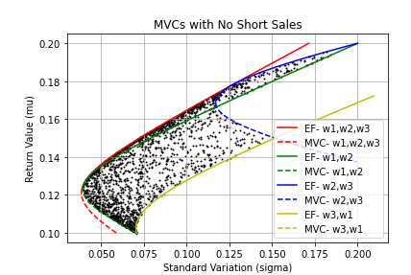

Then, the weights corresponding to the efficient Markowitz frontier (original) were plotted out in a 3D graph (green). Along with the points, the **plane w1 + w2 + w3 =1** was also plotted in the same graph (blue plane). Since the weights follow this plane equation, all these points lie on the plane (as visible from the below diagram).

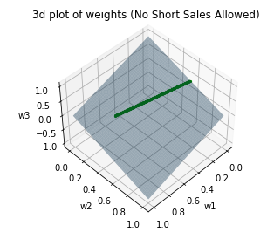It can be seen from the this graph that the points lie on a **straight line**, which itself lies on the plane w1+w2+w3=1**.**

Equations followed by the weights:

1. $u{.w}^{T}=1$ where $u$ = [1,1,1]
2. As per **Capinski**, every point on the efficient frontier (except for the portfolio with the least variance) follows the following equation:



With the values of $w$ (weights), the values of **γ** and **µ** were calculated.



If we consider only 2 securities at a time, the following graph is obtained:

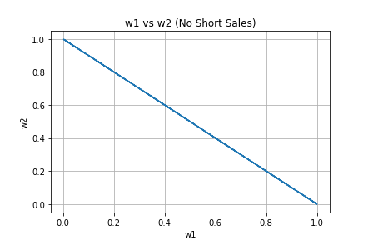

**Note:** If you consider only two securities at a time, it will always create the straight line **(x + y = 1)** in all cases.

**Q3.**

Initially, 10 famous companies were chosen. For each company, the **monthly closing stock prices** from **1st Feb 2016** till **1st Feb 2021** were collected into a **csv file, (titled ‘Price_Data.csv’)** with the help of online website **Yahoo Finance**. For each company, **60** monthly stock prices were recorded. Stock Prices of certain companies showed high variance, whereas some displayed somewhat constant prices. The 10 companies are as follows:

Google, Microsoft, Apple, Amazon, Facebook

Walmart, GameStop, Sony, Tesla, Intel

After calculating the mean vector and the sigma-covariance matrix of the returns (S[j+1]-S[j]bhai ), similar procedure was followed as in question 1 to construct an efficient Frontier.

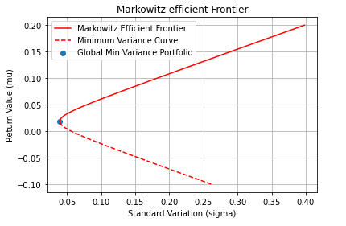

1. **µrf = 0.05.** Similar to Q1(e), we have the following result:

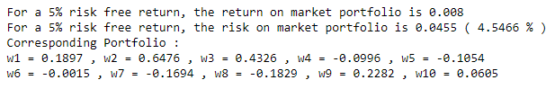



Using the risk-free return, the corresponding portfolio on the minimum variance curve was identified. Then, by joining the points **(0, µrf)** and **(σM, µM)**, the **Capital Market Line** was plotted out.

The **CML** is as follows:

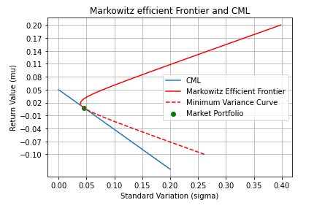



1. Using the below formula, **µV** vs **βV** (Beta Coefficient) for each company was plotted out.



βV was varied between -2 to 2.

µM = Mean of the corresponding Stock Price

The plot of Security Market Lines are as follows:

