MA 374 (2021) Financial Engineering Lab Lab 05

**Name:** Udandarao Sai Sandeep

**Roll Number:** 180123063

**Dept.:** Mathematics and Computing

**Q1.**

Firstly, all the required data was collected.

**Monthly stock/index prices** for the period from **January 1, 2014** to **December 31, 2018** was considered. So, each **stock/index data** would have **60 time points**.

Monthly Index Prices for **SENSEX 30** for the above period was stored in the file **bse_index.csv**

Monthly Index Prices for **NIFTY 50** for the above period was stored in the file **nse_index.csv**

Monthly Stock Prices of **Ten Stocks** included in the **SENSEX** was stored in the file **bsedata1.csv**

Monthly Stock Prices of **Ten Stocks** included in the **NIFTY** was stored in the file **nsedata1.csv**

Monthly Stock Prices of **Ten Stocks** not included in the **SENSEX** (but still listed in **BSE**) was stored in the file **bse_non_index_data1.csv**

Monthly Stock Prices of **Ten Stocks** included in the **NIFTY** (but still listed in the **NSE**) was stored in the file **nse_non_index_data1.csv**

**Note:** Using the stock/index prices, the **corresponding returns** were calculated. (They were also converted from **monthly** to **yearly** format).

The Data was collected from **Yahoo Finance** website.

After data collection, the **mean return (yearly)** and the **Standard Deviation (Risk (yearly))** of the given index values for **NIFTY** and **SENSEX** was calculated. They are as follows:

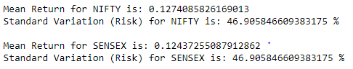

Now, for **each csv data file**, procedure used in **Question3** of **Lab4** was repeated.

The **Markowitz Efficient Frontiers** (and the **Minimum Variance Curves**) are as follows:

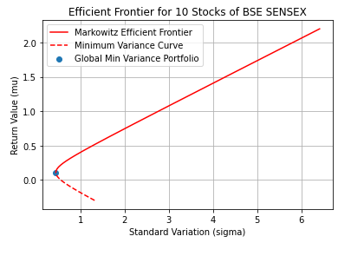

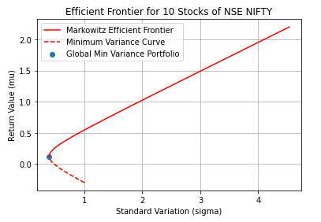

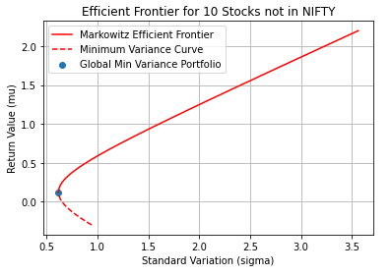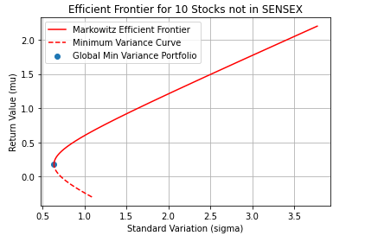

For Constructing the **CML**, same procedure was followed as in **Q3** of **Lab4**. The **risk-free** rate was considered to be **0.05 (per annum)**. The corresponding **Market Portfolio** was found using the **risk-free rate**. Subsequently, the CML was plotted out.

Also, the Market portfolio corresponding to the index (NIFTY/SENSEX) value was also marked. It is important to note that index Market Portfolio **may not lie on/inside the Efficient Frontier**, **as the index and the 10 Stocks do not represent same set of companies.**

The **CMLs** are as follows:

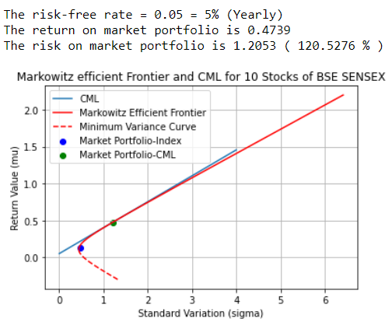

**(SENSEX)**

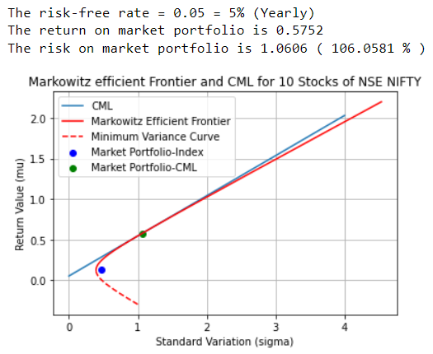

**(NIFTY)**

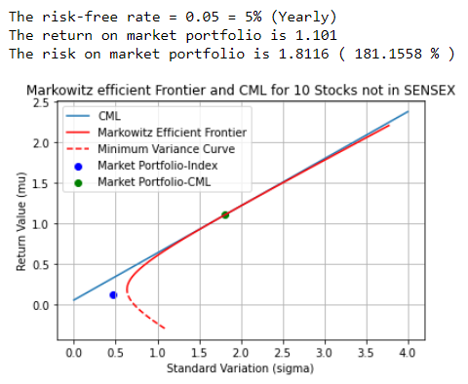

BSE NON_INDEX

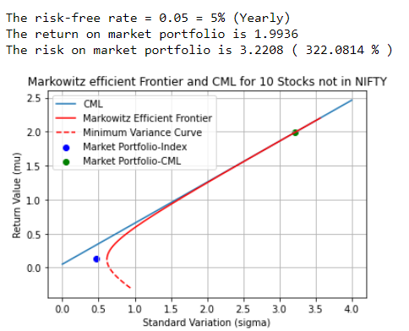

NSE NON_INDEX

Using the below formula, **µV** vs **βV** (Beta Coefficient) for each index was plotted out.



**βV**was varied between **-2 to 2**.

**µM** = Mean of the **corresponding index return value**

The plot of **Security Market Lines** (for **NIFTY** and **SENSEX**) are as follows:

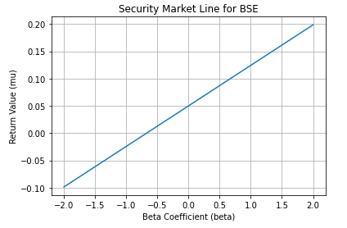

(Sensex)

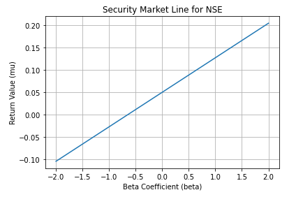

(Nifty)

It can be seen that **SMLs** for **NSE** **(NIFTY)** and **BSE** **(SENSEX)** are almost the same, with **insignificant diffirence**. Since the **SMLs** have **positive** slopes in both cases, this implies that the market return is **greater** than the **risk free rate**.

**Q2.**

In this question, **beta values** for each stock were calculated (Procedure explained in Q3). Using these **calculated values of beta** (**risk premium**), the actual values of returns were calculated for each stock, using the below formula.



where **µM**is the **mean stock return**, **βV** is the **calculated beta value**, **rF** is the **risk-free rate (0.05)**

Here, **µV**is the **actual return**.

This **actual return** value was then compared with the corresponding **CAPM** return value (using **mean market index** return as **µM**) to determine whether the stock is **overvalued**, or **undervalued**. All stocks whose values **lie above the security market line are undervalued** (as they give **more** returns relative to market, represented as green), and stocks which **lie below the security market line are overvalued**, (as they give **less** return relative to market, represented as red).

Stocks in Sensex (BSE):

|  |  |  |  |  |
| --- | --- | --- | --- | --- |
| Stock Name | Calculated Beta | Actual Return | Expected (CAPM) Return | Quality |
| SBI | **1.687** | **0.40283** | **0.12544** | Undervalued |
| Titan | **0.861** | **0.25372** | **0.06405** | Undervalued |
| Reliance | **1.189** | **0.10478** | **0.08842** | Undervalued |
| ICICI | **1.465** | **0.26526** | **0.10893** | Undervalued |
| Axis | **1.419** | **0.23439** | **0.10556** | Undervalued |
| L&T | **1.4** | **0.23669** | **0.10414** | Undervalued |
| Ultratech | **1.456** | **0.23699** | **0.10829** | Undervalued |
| ITC | **0.808** | **-0.00078** | **0.06008** | Overvalued |
| ONGC | **1.111** | **0.12787** | **0.08265** | Undervalued |
| Infosys | **0.603** | **0.02706** | **0.04488** | Overvalued |

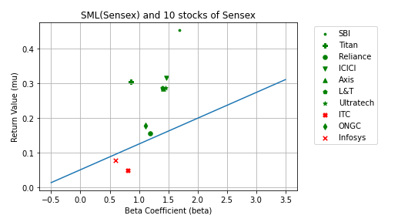

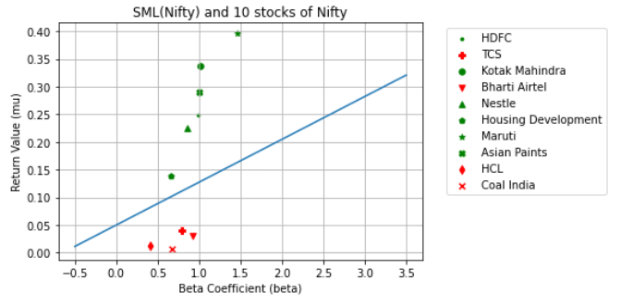Stocks in NIFTY (NSE):

|  |  |  |  |  |
| --- | --- | --- | --- | --- |
| Stock Name | Calculated Beta | Actual Return | Expected (CAPM) Return | Quality |
| HDFC | **0.983** | **0.19847** | **0.07607** | Undervalued |
| TCS | **0.793** | **-0.00972** | **0.06137** | Overvalued |
| Kotak Mahindra | **1.018** | **0.28784** | **0.07879** | Undervalued |
| Bharti Airtel | **0.916** | **-0.0198** | **0.07093** | Overvalued |
| Nestle | **0.859** | **0.174523** | **0.06646** | Undervalued |
| Housing Dev. | **0.655** | **0.08934** | **0.0507** | Undervalued |
| Maruti Suzuki | **1.466** | **0.34586** | **0.11351** | Undervalued |
| Asian Paints | **1.005** | **0.23975** | **0.0778** | Undervalued |
| HCL | **0.414** | **-0.03813** | **0.03205** | Overvalued |
| Coal India | **0.673** | **-0.04314** | **0.05206** | Overvalued |

Stocks not included in Nifty (but still listed in NSE):

|  |  |  |  |  |
| --- | --- | --- | --- | --- |
| Stock Name | Calculated Beta | Actual Return | Expected (CAPM) Return | Quality |
| Suzlon | **1.86** | **0.19682** | **0.14396** | Undervalued |
| Godfrey Phillips | **0.873** | **0.06875** | **0.06756** | Undervalued |
| Engineers India | **1.544** | **0.45488** | **0.11955** | Undervalued |
| Maharashtra Scooters | **1.159** | **0.91401** | **0.08968** | Undervalued |
| KEI Industries | **1.091** | **0.81944** | **0.08443** | Undervalued |
| Sun Pharmaceuticals | **0.204** | **-0.07513** | **0.01575** | Overvalued |
| Travancore Fertilizers | **1.574** | **0.74502** | **0.12180** | Undervalued |
| Responsive Industries | **1.449** | **0.16315** | **0.11218** | Undervalued |
| Heide-core Cement | **1.809** | **0.58655** | **0.14005** | Undervalued |
| VST Industries | **0.565** | **0.11118** | **0.04377** | Undervalued |

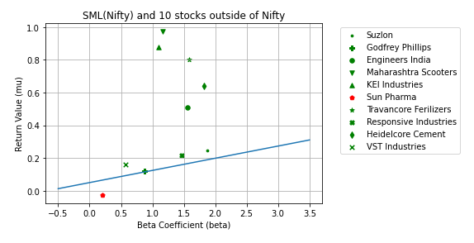Stocks not included in Sensex (but still listed in BSE):

|  |  |  |  |  |
| --- | --- | --- | --- | --- |
| Stock Name | Calculated Beta | Actual Return | Expected (CAPM) Return | Quality |
| Suzlon | **1.785** | **0.20238** | **0.13272** | Undervalued |
| Godfrey Phillips | **0.861** | **0.06725** | **0.06406** | Undervalued |
| Engineers India | **1.466** | **0.44888** | **0.10902** | Undervalued |
| Maharashtra Scooters | **1.117** | **0.91143** | **0.08311** | Undervalued |
| KEI Industries | **1.060** | **0.80622** | **0.07880** | Undervalued |
| Sun Pharmaceuticals | **0.205** | **-0.07532** | **0.01525** | Overvalued |
| Travancore Fertilizers | **1.465** | **0.81612** | **0.10899** | Undervalued |
| Responsive Industries | **1.579** | **0.17292** | **0.11743** | Undervalued |
| Gujrat Raffia | **0.765** | **0.56936** | **0.05690** | Undervalued |
| VST Industries | **0.508** | **0.10843** | **0.03775** | Undervalued |

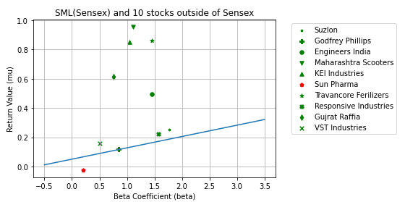

**Q3.**

First, the **beta values** of each stock were calculated using the below formula.

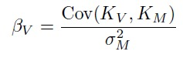

Here, the **KV** and **KM** represents the **returns of that particular stock** and **the mean return of the corresponding index portfolio (NIFTY/SENSEX)**. **σM**represents the **SD (risk)** of the **corresponding index portfolio (NIFTY/SENSEX)**.

Also, the **long-term beta** values **(actual value)** for the stocks were also collected from online sources ([www.topstockresearch.com](http://www.topstockresearch.com)). The data has been stored in 4 files, **bse_beta.csv, nse_beta.csv, non_bse_beta.csv, and non_nse_beta.csv**.

The comparison between **actual** and **calculated** **beta** values are as follows:

Stocks included in **Sensex (BSE)**

|  |  |  |
| --- | --- | --- |
| Stock Name | Calculated Beta | Actual Beta |
| SBI | **1.687** | **1.75** |
| Titan | **0.861** | **1.10** |
| Reliance | **1.189** | **0.95** |
| ICICI | **1.465** | **1.7** |
| Axis | **1.419** | **1.42** |
| L&T | **1.4** | **1.34** |
| Ultratech | **1.456** | **1.57** |
| ITC | **0.808** | **1.01** |
| ONGC | **1.111** | **1.04** |
| Infosys | **0.603** | **0.62** |

Stocks included in **NIFTY (NSE):**

|  |  |  |
| --- | --- | --- |
| Stock Name | Calculated Beta | Actual Beta |
| HDFC | **0.983** | **0.85** |
| TCS | **0.793** | **0.69** |
| Kotak Mahindra | **1.018** | **0.799** |
| Bharti Airtel | **0.916** | **0.972** |
| Nestle | **0.859** | **0.742** |
| Housing Dev. | **0.655** | **0.84** |
| Maruti Suzuki | **1.466** | **1.01** |
| Asian Paints | **1.005** | **0.728** |
| HCL | **0.414** | **0.7** |
| Coal India | **0.673** | **0.875** |

Stocks **not included in** **Sensex (but still listed in the BSE):**

|  |  |  |
| --- | --- | --- |
| Stock Name | Calculated Beta | Actual Beta |
| Suzlon | **1.785** | **1.28** |
| Godfrey Phillips | **0.861** | **0.55** |
| Engineers India | **1.466** | **0.936** |
| Maharashtra Scooters | **1.117** | **0.99** |
| KEI Industries | **1.060** | **1.61** |
| Sun Pharmaceuticals | **0.205** | **0.349** |
| Travancore Fertilizers | **1.465** | **1.34** |
| Responsive Industries | **1.579** | **N/A** |
| Gujrat Raffia | **0.765** | **N/A** |
| VST Industries | **0.508** | **0.47** |

Stocks **not included in Nifty (but still listed in the NSE):**

|  |  |  |
| --- | --- | --- |
| Stock Name | Calculated Beta | Actual Beta |
| Suzlon | **1.86** | **1.28** |
| Godfrey Phillips | **0.873** | **0.55** |
| Engineers India | **1.544** | **0.936** |
| Maharashtra Scooters | **1.159** | **0.99** |
| KEI Industries | **1.091** | **1.61** |
| Sun Pharmaceuticals | **0.204** | **0.349** |
| Travancore Fertilizers | **1.574** | **1.34** |
| Responsive Industries | **1.449** | **N/A** |
| Heidelcore Cement | **1.809** | **1.87** |
| VST Industries | **0.565** | **0.47** |

We can say that the calculated beta values and the actual beta values are **similar**. The **similarity** is much stronger in case of Stocks included in **Nifty/Sensex**, (because large companies have **credible** (and **stable**) datasets of beta values). **Actual** Beta values for **smaller** companies vary very **large** (due to high volatility), and hence the similarity between the actual and calculated beta values is **less** **strong**.

**Beta Value:**

The **Market Portfolio** has **beta value** as **1**.

If the **Beta value is above 1**, it implies that the particular stock is **highly** **correlated** with the market, and **moves according to the market volatility**.

If the **Beta value is below 1**, it implies that the particular stock is **lowly** **correlated** with the market, and moves with **small** **magnitude** **in response to the market volatility.**

A **Beta** **value** of **0** represents **zero** **correlation** with the market, and occurs when the **stock** **return** **equals the risk-free return.**

A **negative Beta value** suggests that the stock moves in **opposite** direction to the market flow, and is **negatively** **correlated**.