MA 374 (2021) Financial Engineering Lab Lab 07

**Name:** Udandarao Sai Sandeep

**Roll Number:** 180123063

**Dept.:** Mathematics and Computing

**Note:** The following modules would be required to run the programs:

pip install **numpy**, pip install **matplotlib**, pip install **scipy**, pip install **prettytable**

**Q1.**In order to estimate the value of the Call/Put Option Price, **classical** **BSM** **framework** was used. The formula used to calculate **Call** **option** **price** is as follows:





Then, the **put**-**call** **parity** was then employed to calculate the corresponding put option price.



The implementation of the functions (in python) is as follows:

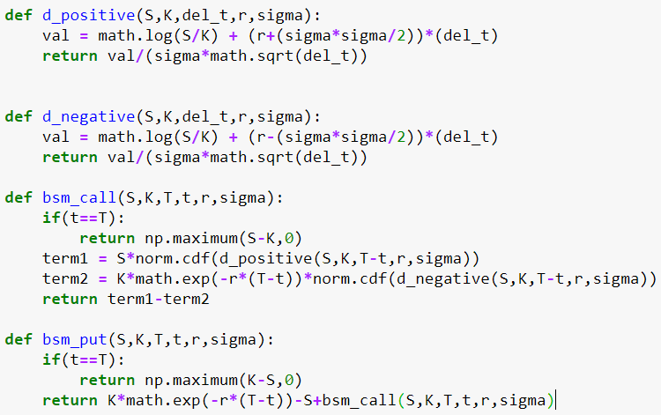

**Q2. Call Option** Prices (green) and **Put Option** Prices (blue) (as a function of x alone) have been calculated for the given **six** different values of t (as given in the assignment). The Stock Price has been varied from **0.1 to 2.1**. The plots are as follows:

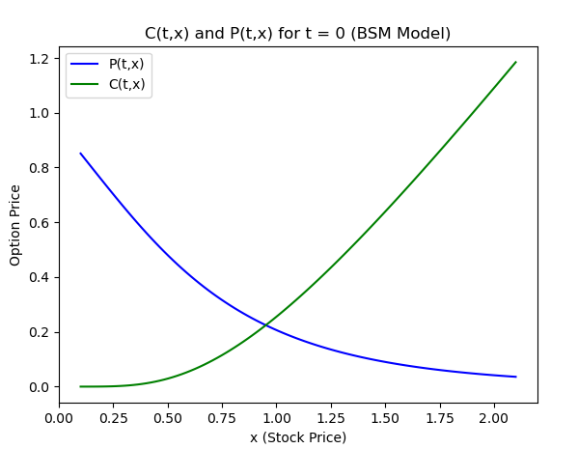

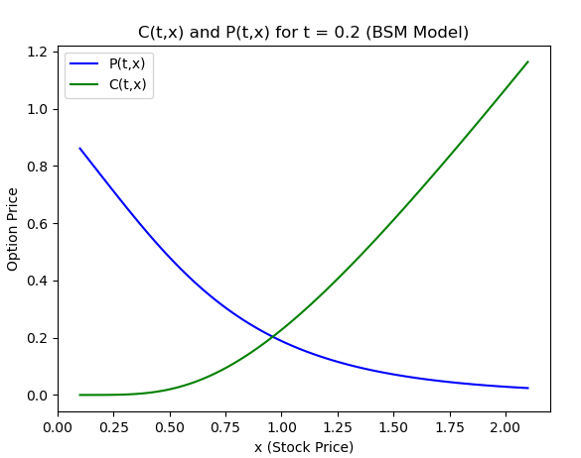

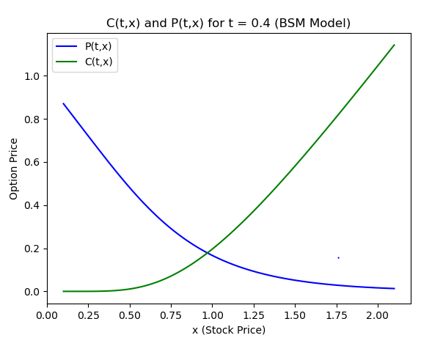

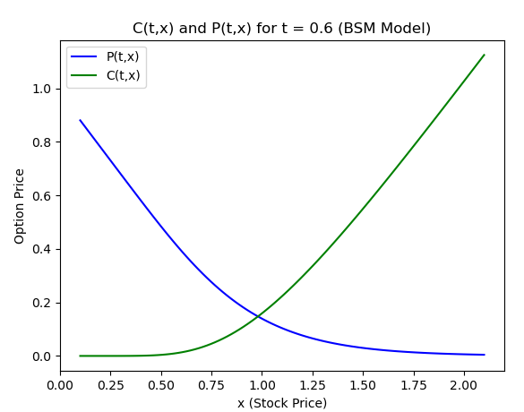

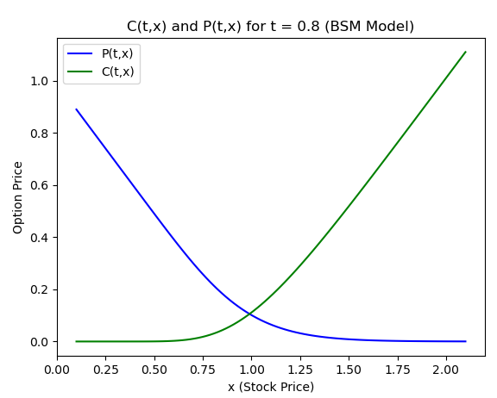

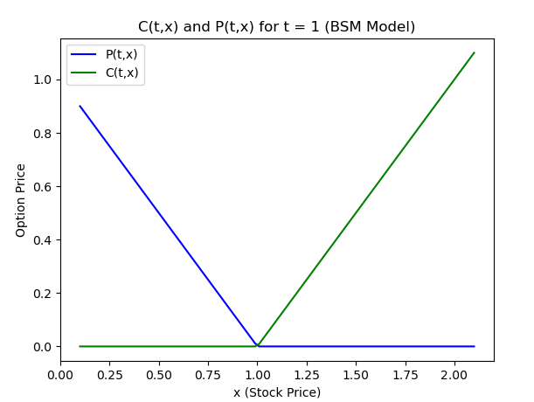

As expected, **the call option price increases with increase in stock price**, and **the put option price decreases with increase in stock price**. Now, the same information has been displayed in **3-D** format as follows (the edge lines have been emphasized with darker edge colors):

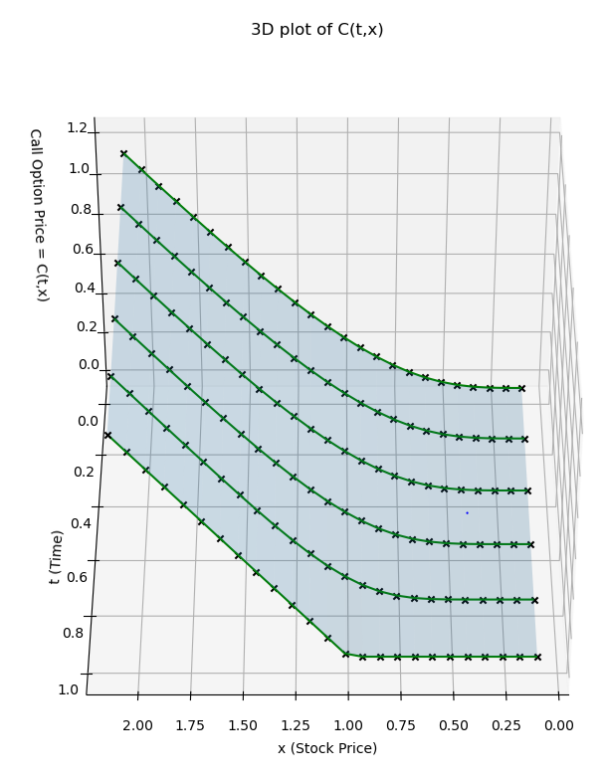

In both the plots taken, the **black** **X marker** represents the points **(x, t)** that have been taken to plot the graphs.   
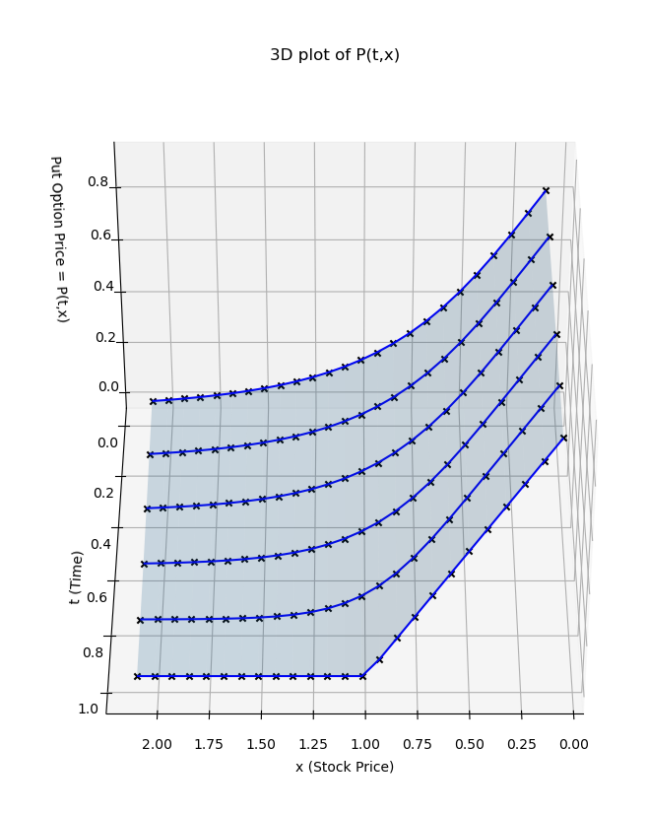

**Q3.**

Now, by using more input values of t and x, smooth 3D plots have been made.

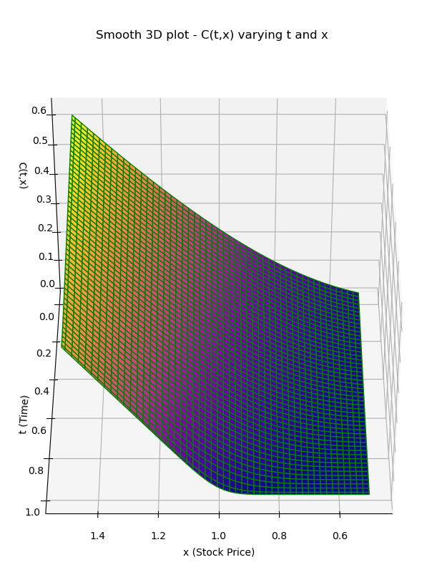

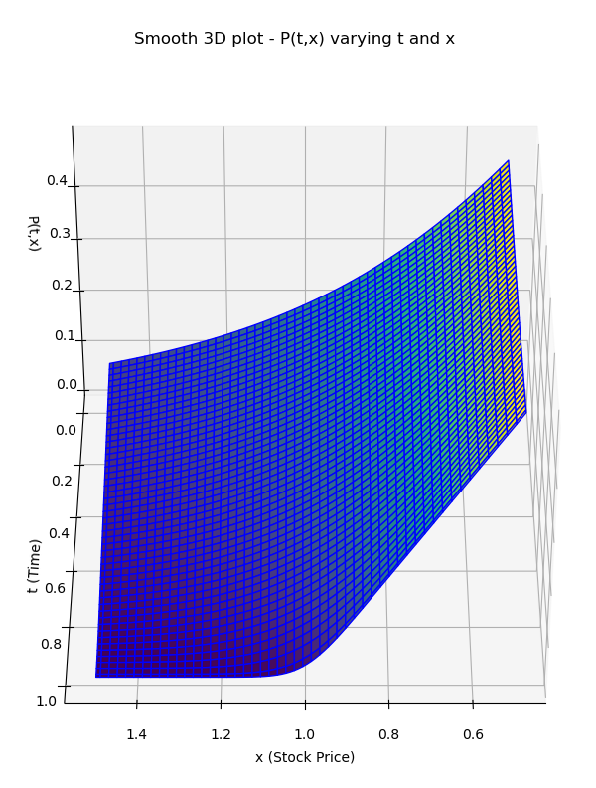

**Q4.** Sensitivity analysis of both the call and put option price on the basis of Model parameters (**Strike Price (K), sigma(σ), rate (r) and Final Time (T)**) has been done.

**Note: x** and **t** have been fixed to **1** and **0.5** respectively.

**2-D graphs** (varying one variable)

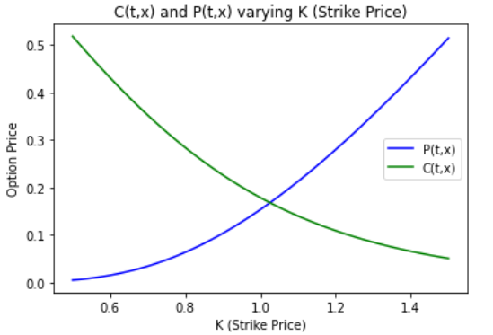

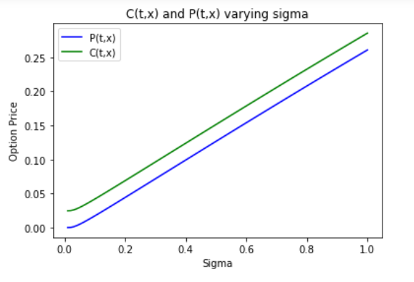

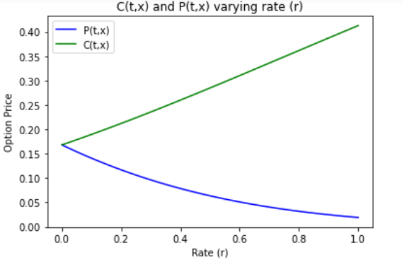

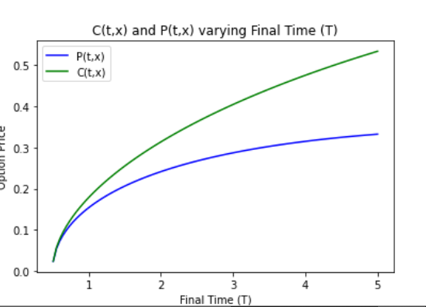  
**3-D graphs** (varying 2 parameters)

|  |  |  |
| --- | --- | --- |
| Parameters | Call Option Price | Put Option Price |
| K and sigma |  |  |
| K and r |  |  |
| K and T |  |  |
| r and T |  |  |
| r and sigma |  |  |
| T and sigma |  |  |

Tables (for different combinations (**2D Graphs**)):

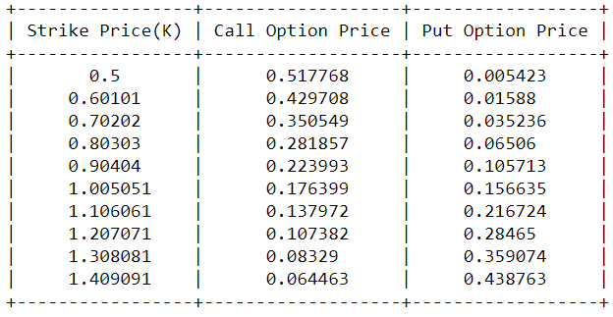

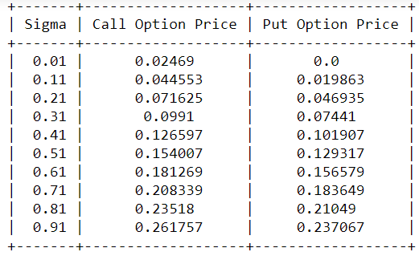

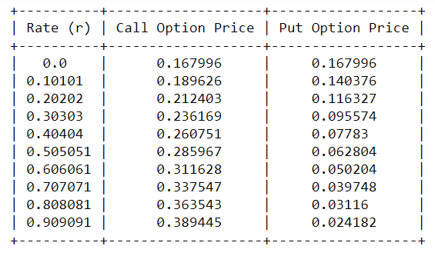

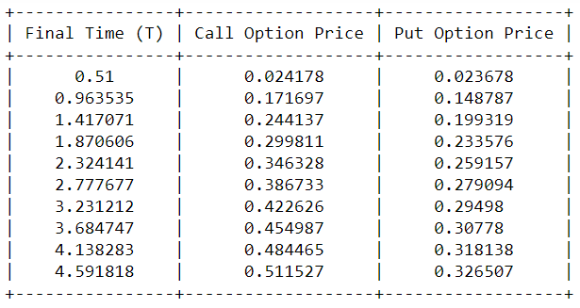

Tables for **3D graphs**:

