MA 374 (2021) Financial Engineering Lab Lab 08

**Name:** Udandarao Sai Sandeep

**Roll Number:** 180123063

**Dept.:** Mathematics and Computing

**Q1.**

Based on last month data **(21 days)** in **nsedata1(daily)** and **bsedata1(daily)**, the **corresponding** **return** **values** were calculated, and subsequently the **sigma** **value** corresponding to the return was then calculated. Then, **annualized** **sigma** was calculated by multiplying it with a factor of . The results are as follows:

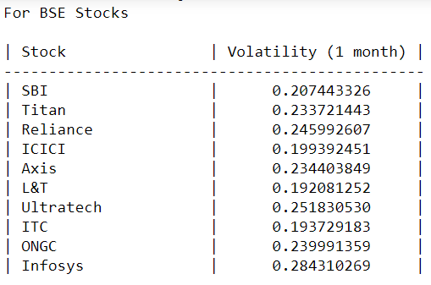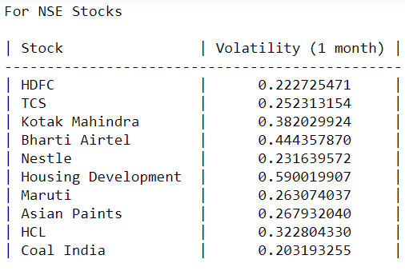For Stocks:

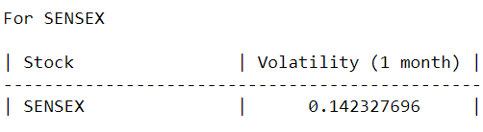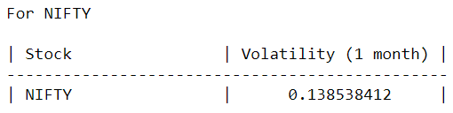For the market index values, the annualized sigma values are as folllows:

**Q2**.

Setting final price of the stock values as the starting value, and **T = 0.5** (half year), we have:

**BSE STOCKS:**

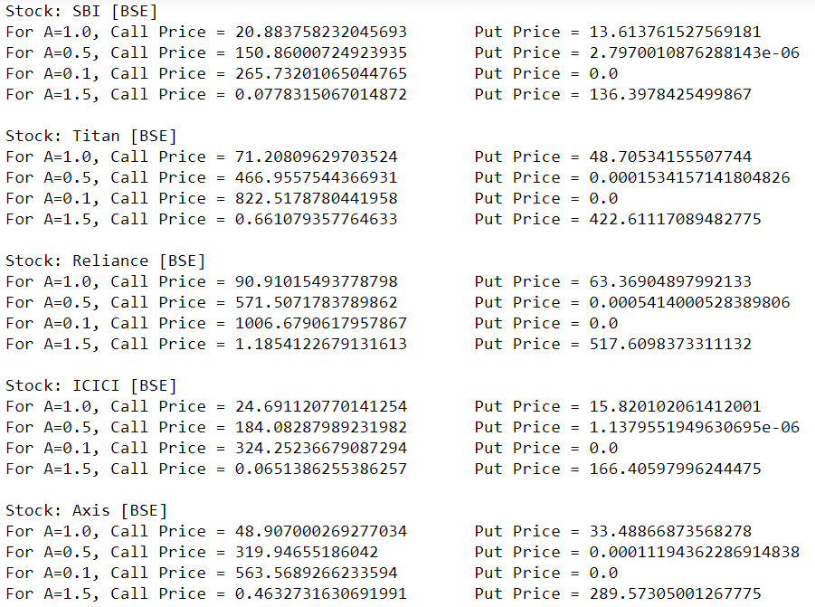

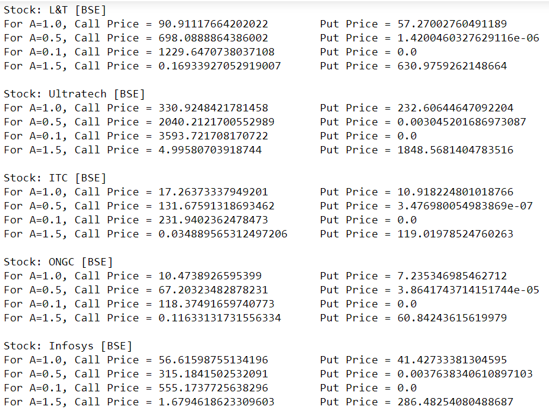

**NSE STOCKS:**

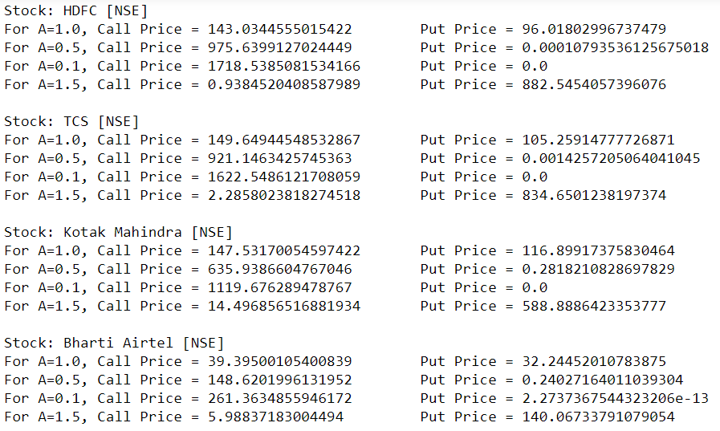

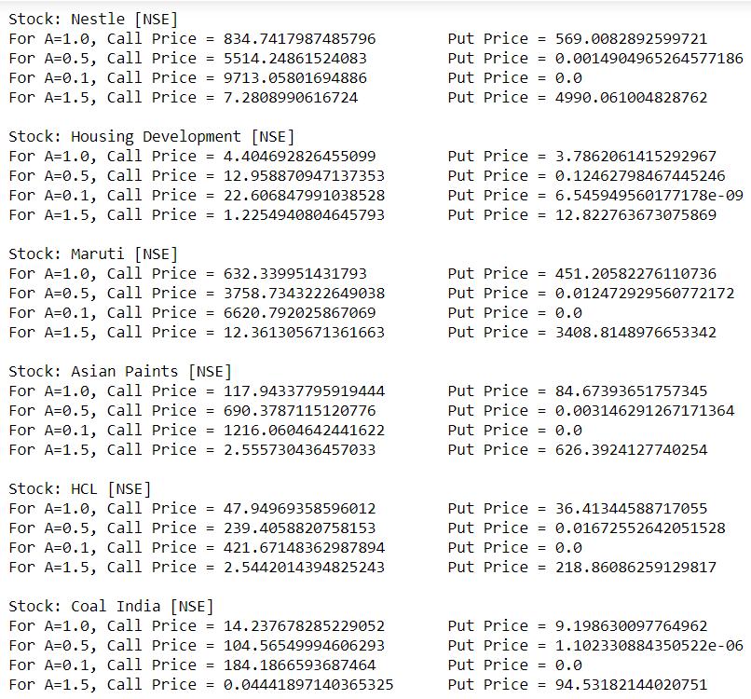

**SENSEX AND NIFTY**

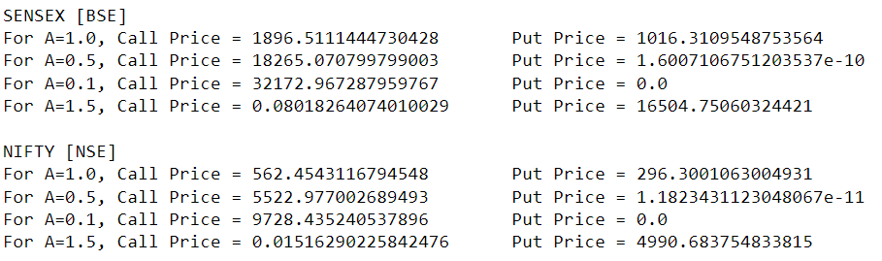

**Q3.** Going **one month back (21 days) at a time** (for **1** year), **Volatility vs Time** was plotted out.

|  |  |
| --- | --- |
| Stock Name | Volatility vs Time |
| SBI (BSE) |  |
| Titan (BSE) |  |
| Reliance (BSE) |  |
| ICICI (BSE) |  |
| Axis (BSE) |  |
| L&T (BSE) |  |
| Ultratech (BSE) |  |
| ITC (BSE) |  |
| ONGC (BSE) |  |
| Infosys (BSE) |  |
| HDFC (NSE) |  |
| TCS (NSE) |  |
| Kotak (NSE) |  |
| Bharti Airtel (NSE) |  |
| Nestle (NSE) |  |
| Housing Development (NSE) |  |
| Maruti (NSE) |  |
| Asian Paints (NSE) |  |
| HCL (NSE) |  |
| Coal India (NSE) |  |
| SENSEX |  |
| NIFTY |  |

The **put** and **call** option prices (for various values of **A**) are as follows:

|  |  |  |
| --- | --- | --- |
| Stock Name | Call Option Prices | Put Option Prices |
| SBI (BSE) |  |  |
| Titan (BSE) |  |  |
| Reliance (BSE) |  |  |
| ICICI (BSE) |  |  |
| Axis (BSE) |  |  |
| L&T (BSE) |  |  |
| Ultratech (BSE) |  |  |
| ITC (BSE) |  |  |
| ONGC (BSE) |  |  |
| Infosys (BSE) |  |  |
| HDFC (NSE) |  |  |
| TCS (NSE) |  |  |
| Kotak (NSE) |  |  |
| Bharti Airtel (NSE) |  |  |
| Nestle (NSE) |  |  |
| Housing Development (NSE) |  |  |
| Maruti (NSE) |  |  |
| Asian Paints (NSE) |  |  |
| HCL (NSE) |  |  |
| Coal India (NSE) |  |  |
| SENSEX |  |  |
| NIFTY |  |  |

**Q4. Submitted as a CSV file.**