MA 374 (2021) Financial Engineering Lab Lab 09

**Name:** Udandarao Sai Sandeep

**Roll Number:** 180123063

**Dept.:** Mathematics and Computing

**Q1.**

Data has been collected from site **nseindia.com**. Put and Call option prices of **NTPC**, **HERO MOTOCORP**, and **GRASIM** industries have been collected (listed in **NSE**). **NIFTY** option data has also been obtained from the same site. They have been put in the folder named **stockoptiondata**.

**Q2.**

For Nifty Option Data (3D Graphs):

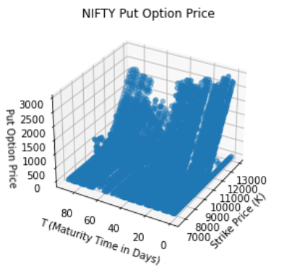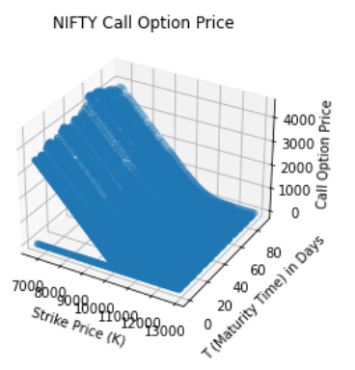

For Nifty Option Data (2D Graphs):

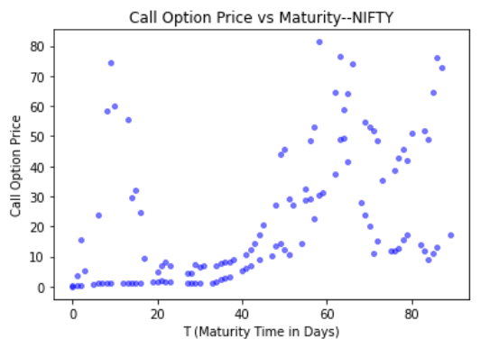

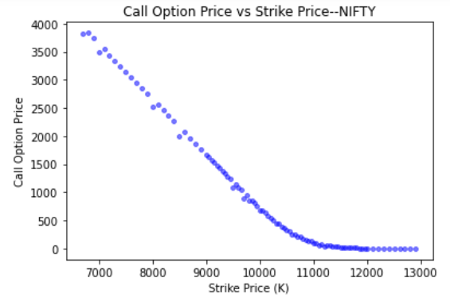

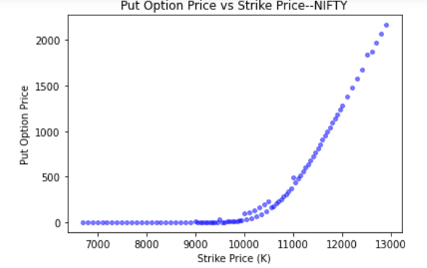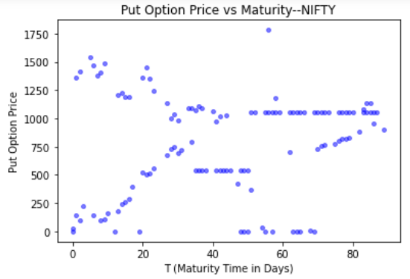

|  |  |  |
| --- | --- | --- |
| Stock Name | Call Option | Put Option |
| Coal India |  |  |
| Coal India |  |  |
| Coal India |  |  |
| Grasim |  |  |
| Grasim |  |  |
| Grasim |  |  |
| NTPC |  |  |
| NTPC |  |  |
| NTPC |  |  |

We can see that the graph of **Option Price vs Strike Price** resembles the theoretical graph with great similarity. But **Option Price vs Maturity** is somewhat a straight line (In real world scenarios, Option Price is somewhat kept constant with T). Also, the 3D graphs also seem to be matching theoretical graphs as well.

**Q3.**

Fixing the other parameters, and also considering the option prices collected from internet, **implied** **volatility** was found using the **bisection** (**binary**) **method**. We can see that the 3D plots match with the theoretical plots. We can see that in the 2D plots, volatility is small (<0.5), and is mostly located near the x-axis.

|  |  |  |
| --- | --- | --- |
| Stock Name | Graphs | Graphs |
| Coal India |  |  |
| Coal India |  |  |
| Grasim |  |  |
| Grasim |  |  |
| NTPC |  |  |
| NTPC |  |  |

**Q4.** The historical volatility has been estimated for the previous 2 months. The graphs are as follows:

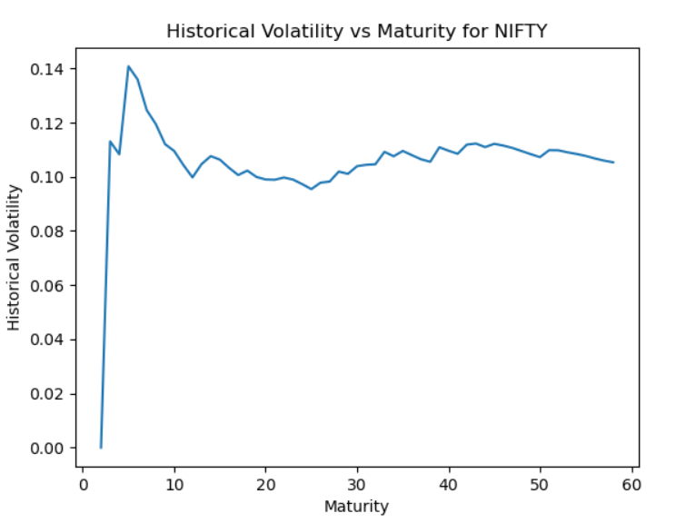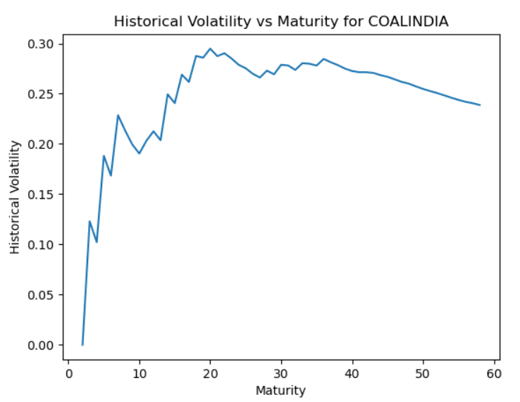

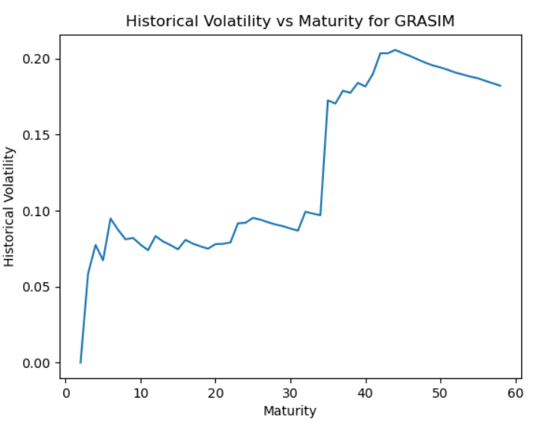

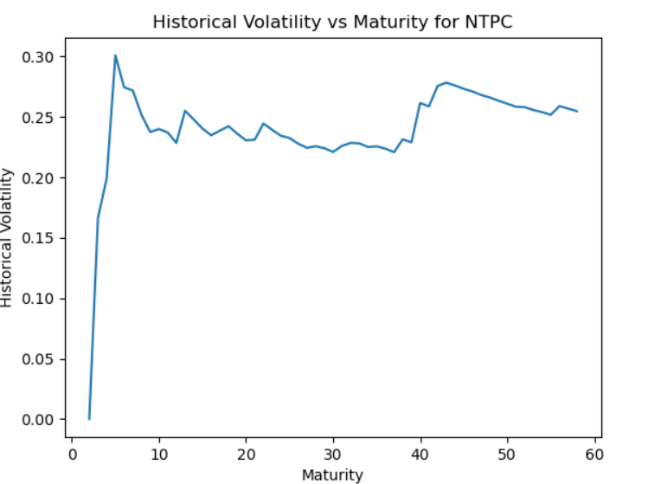

Implied volatility accounts for expectations for future volatility, which are expressed in options premiums, while historical volatility measures past trading ranges of underlying securities and indexes. Since **option** **premiums** are **overvalued**, hence, it can be observed that **implied** **volatility** is **higher** than as **compared** to **historical** **volatility**.