**WEEK-3 HANDS-ON**

**Spring Core_Maven:  
  
Exercise 1: Configuring a Basic Spring Application:**

**BookService.java:**

package com.library.service;

import com.library.repository.BookRepository;

public class BookService {

private BookRepository bookRepository;

public void setBookRepository(BookRepository bookRepository) {

this.bookRepository = bookRepository;

}

public void displayBooks() {

bookRepository.printBooks();

}

}

**BookRepository.java:**

package com.library.repository;

public class BookRepository {

public void printBooks() {

System.out.println("Listing books from repository...");

}

}

**applicationContext.xml:**

<?xml version="1.0" encoding="UTF-8"?>

<beans xmlns="http://www.springframework.org/schema/beans"

xmlns:xsi="http://www.w3.org/2001/XMLSchema-instance"

xsi:schemaLocation="http://www.springframework.org/schema/beans

http://www.springframework.org/schema/beans/spring-beans.xsd">

<!-- Repository Bean -->

<bean id="bookRepository" class="com.library.repository.BookRepository"/>

<!-- Service Bean with Dependency Injection -->

<bean id="bookService" class="com.library.service.BookService">

<property name="bookRepository" ref="bookRepository"/>

</bean>

</beans>

**MainApp.java:**

package com.library;

import org.springframework.context.ApplicationContext;

import org.springframework.context.support.ClassPathXmlApplicationContext;

import com.library.service.BookService;

public class MainApp {

public static void main(String[] args) {

ApplicationContext context =

new ClassPathXmlApplicationContext("applicationContext.xml");

BookService bookService = (BookService) context.getBean("bookService");

bookService.displayBooks();

}

}

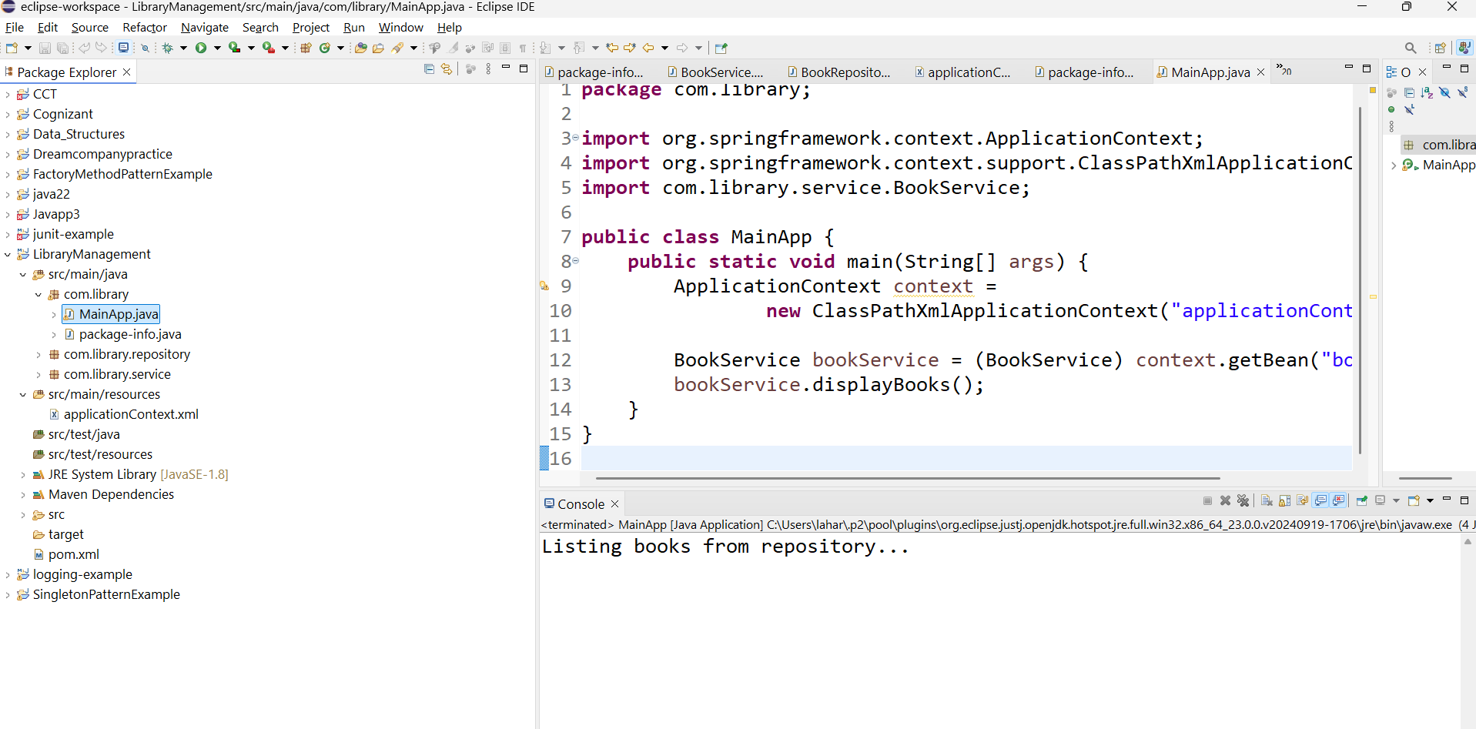**Output:**

**Exercise 2: Implementing Dependency Injection:**

**applicationContext.xml :**

<?xml version="1.0" encoding="UTF-8"?>

<beans xmlns="http://www.springframework.org/schema/beans"

xmlns:xsi="http://www.w3.org/2001/XMLSchema-instance"

xsi:schemaLocation="

http://www.springframework.org/schema/beans

http://www.springframework.org/schema/beans/spring-beans.xsd">

<!-- BookRepository Bean -->

<bean id="bookRepository" class="com.library.repository.BookRepository"/>

<!-- BookService Bean with Dependency Injection -->

<bean id="bookService" class="com.library.service.BookService">

<property name="bookRepository" ref="bookRepository"/>

</bean>

</beans>

**BookService.java :**

package com.library.service;

import org.springframework.beans.factory.annotation.Autowired;

import org.springframework.stereotype.Service;

import com.library.repository.BookRepository;

*@Service*

public class BookService {

private final BookRepository bookRepository;

*@Autowired* // constructor injection

public BookService(BookRepository bookRepository) {

this.bookRepository = bookRepository;

}

public String displayService() {

return "BookService: Service is working...\n" + bookRepository.displayRepo();

}

}

**BookRepository.java :**

package com.library.repository;

import org.springframework.stereotype.Repository;

*@Repository*

public class BookRepository {

public String displayRepo() {

return "BookRepository: Fetching book data...";

}

}

**LibraryManagementApplication,java :**

package com.library;

import org.springframework.boot.SpringApplication;

import org.springframework.boot.autoconfigure.SpringBootApplication;

*@SpringBootApplication*

public class LibraryManagementApplication {

public static void main(String[] args) {

SpringApplication.*run*(LibraryManagementApplication.class, args)

}

}

**OUTPUT:**



**Exercise 4: Creating and Configuring a Maven Project:**

**Program:**

<project xmlns="http://maven.apache.org/POM/4.0.0"

xmlns:xsi="http://www.w3.org/2001/XMLSchema-instance"

xsi:schemaLocation="http://maven.apache.org/POM/4.0.0

http://maven.apache.org/xsd/maven-4.0.0.xsd">

<modelVersion>4.0.0</modelVersion>

<groupId>com.smartlibrary</groupId>

<artifactId>BookManagementSystem</artifactId>

<version>1.0-SNAPSHOT</version>

<packaging>jar</packaging>

<name>BookManagementSystem</name>

<description>Spring-based Library Management Maven Project</description>

<dependencies>

<!-- Spring Context (Core) -->

<dependency>

<groupId>org.springframework</groupId>

<artifactId>spring-context</artifactId>

<version>5.3.30</version>

</dependency>

<!-- Spring AOP -->

<dependency>

<groupId>org.springframework</groupId>

<artifactId>spring-aop</artifactId>

<version>5.3.30</version>

</dependency>

<!-- Spring Web MVC -->

<dependency>

<groupId>org.springframework</groupId>

<artifactId>spring-webmvc</artifactId>

<version>5.3.30</version>

</dependency>

</dependencies>

<!-- Build section with Java version 1.8 -->

<build>

<plugins>

<plugin>

<groupId>org.apache.maven.plugins</groupId>

<artifactId>maven-compiler-plugin</artifactId>

<version>3.8.1</version>

<configuration>

<source>1.8</source>

<target>1.8</target>

</configuration>

</plugin>

</plugins>

</build>

</project>

**Output:**

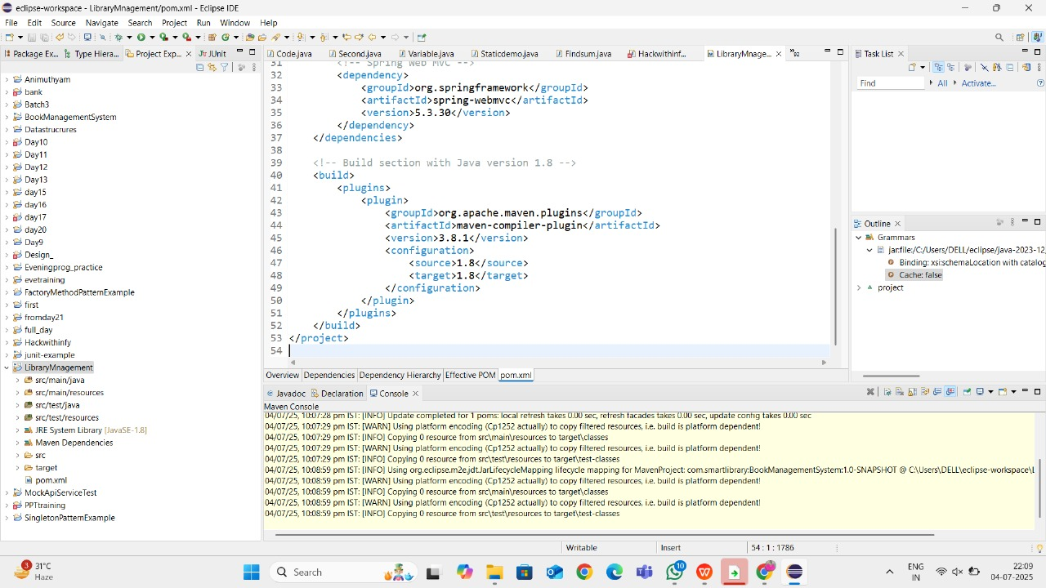

**spring-data-jpa-handson:**

**Spring Data JPA - Quick Example:**

**src/main/resources/application.properties:**

spring.datasource.url=jdbc:mysql://localhost:3306/ormlearn

spring.datasource.username=root

spring.datasource.password=root

spring.datasource.driver-class-name=com.mysql.cj.jdbc.Driver

spring.jpa.hibernate.ddl-auto=validate

spring.jpa.properties.hibernate.dialect=org.hibernate.dialect.MySQL5Dialect

logging.level.org.hibernate.SQL=trace

logging.level.org.hibernate.type.descriptor.sql=trace

**MySQL:**

CREATE TABLE country (

co_code VARCHAR(2) PRIMARY KEY,

co_name VARCHAR(50)

);

INSERT INTO country VALUES ('IN', 'India');

INSERT INTO country VALUES ('US', 'United States of America');

**Java class:**

package com.cognizant.ormlearn.model;

import javax.persistence.*;

@Entity

@Table(name = "country")

public class Country {

@Id

@Column(name = "co_code")

private String code;

@Column(name = "co_name")

private String name;

public String getCode() { return code; }

public void setCode(String code) { this.code = code; }

public String getName() { return name; }

public void setName(String name) { this.name = name; }

@Override

public String toString() {

return "Country [code=" + code + ", name=" + name + "]";

}

}

**CountryRepository:**

package com.cognizant.ormlearn.repository;

import org.springframework.data.jpa.repository.JpaRepository;

import org.springframework.stereotype.Repository;

import com.cognizant.ormlearn.model.Country;

@Repository

public interface CountryRepository extends JpaRepository<Country, String> {

}

**CountryService:**

package com.cognizant.ormlearn.service;

import java.util.List;

import javax.transaction.Transactional;

import org.springframework.beans.factory.annotation.Autowired;

import org.springframework.stereotype.Service;

import com.cognizant.ormlearn.model.Country;

import com.cognizant.ormlearn.repository.CountryRepository;

@Service

public class CountryService {

@Autowired

private CountryRepository countryRepository;

@Transactional

public List<Country> getAllCountries() {

return countryRepository.findAll();

}

}

**OrmLearnApplication.java:**

package com.cognizant.ormlearn;

import java.util.List;

import org.slf4j.Logger;

import org.slf4j.LoggerFactory;

import org.springframework.boot.SpringApplication;

import org.springframework.boot.autoconfigure.SpringBootApplication;

import org.springframework.context.ApplicationContext;

import com.cognizant.ormlearn.model.Country;

import com.cognizant.ormlearn.service.CountryService;

@SpringBootApplication

public class OrmLearnApplication {

private static final Logger LOGGER = LoggerFactory.getLogger(OrmLearnApplication.class);

private static CountryService countryService;

public static void main(String[] args) {

ApplicationContext context = SpringApplication.run(OrmLearnApplication.class, args);

LOGGER.info("Inside main");

countryService = context.getBean(CountryService.class);

testGetAllCountries();

}

private static void testGetAllCountries() {

LOGGER.info("Start");

List<Country> countries = countryService.getAllCountries();

LOGGER.debug("countries={}", countries);

LOGGER.info("End");

}

}

**Output:**



