**WEEK – 7**

**Date:03-08-2025**

**9. ReactJS-HOL**

**IndianPlayers**

import React from 'react';

const IndianPlayers = () => {

const team = ['Virat', 'Rohit', 'Gill', 'Rahul', 'Iyer', 'Pant'];

const [odd1, even1, odd2, even2, odd3, even3] = team;

const oddTeam = [odd1, odd2, odd3];

const evenTeam = [even1, even2, even3];

const T20players = ['Hardik', 'Surya', 'Bumrah'];

const RanjiPlayers = ['Jaiswal', 'Unadkat', 'Sarfaraz'];

const mergedTeam = [...T20players, ...RanjiPlayers];

return (

<div>

<h2>Odd Team Players</h2>

{oddTeam.map((player, index) => (

<p key={index}>{player}</p>

))}

<h2>Even Team Players</h2>

{evenTeam.map((player, index) => (

<p key={index}>{player}</p>

))}

<h2>Merged Players (T20 + Ranji)</h2>

{mergedTeam.map((player, index) => (

<p key={index}>{player}</p>

))}

</div>

);

};

export default IndianPlayers;

**ListofPlayers**

import React from 'react';

const ListofPlayers = () => {

const players = [

{ name: 'Virat', score: 95 },

{ name: 'Rohit', score: 88 },

{ name: 'Gill', score: 65 },

{ name: 'Rahul', score: 50 },

{ name: 'Iyer', score: 76 },

{ name: 'Pant', score: 68 },

{ name: 'Jadeja', score: 92 },

{ name: 'Hardik', score: 81 },

{ name: 'Bumrah', score: 44 },

{ name: 'Shami', score: 56 },

{ name: 'Kuldeep', score: 73 }

];

const lowScorers = players.filter(player => player.score < 70);

return (

<div>

<h2>All Players</h2>

{players.map((player, index) => (

<p key={index}>{player.name} - {player.score}</p>

))}

<h2>Players with score below 70</h2>

{lowScorers.map((player, index) => (

<p key={index}>{player.name} - {player.score}</p>

))}

</div>

);

};

export default ListofPlayers;

**App.js**

import React from 'react';

import ListofPlayers from './components/ListofPlayers';

import IndianPlayers from './components/IndianPlayers';

function App() {

const flag = false;

return (

<div className="App">

<h1>Cricket App</h1>

{flag ? <ListofPlayers /> : <IndianPlayers />}

</div>

);

}export default App;

**OUTPUT:**

**When Flag=True**

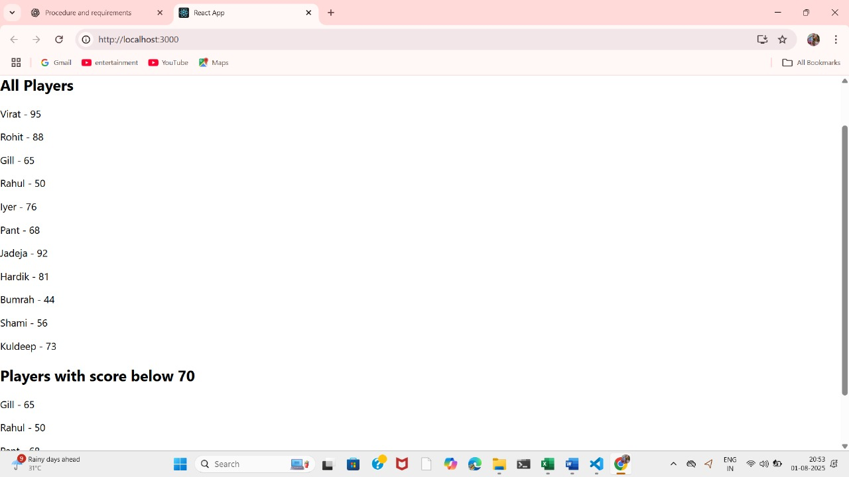

**When Flag=false**

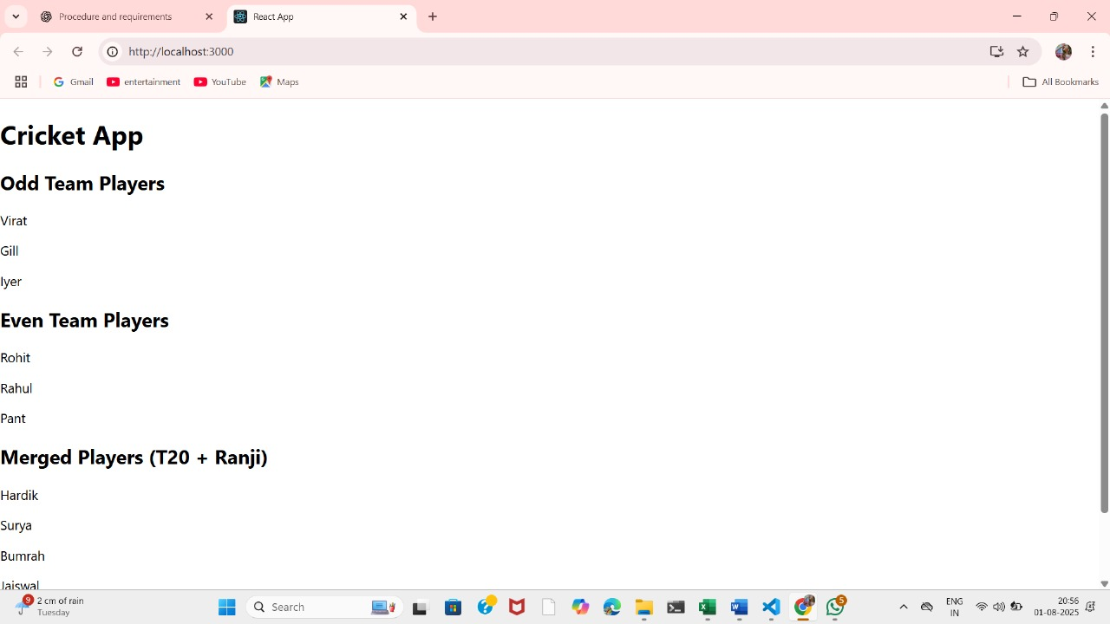

**10. ReactJS-HOL**

**App.css**

.App {

text-align: center;

font-family: Arial, sans-serif;

}

.App-logo {

height: 40vmin;

pointer-events: none;

}

@media (prefers-reduced-motion: no-preference) {

.App-logo {

animation: App-logo-spin infinite 20s linear;

}

}

.App-header {

background-color: #282c34;

min-height: 100vh;

display: flex;

flex-direction: column;

align-items: center;

justify-content: center;

font-size: calc(10px + 2vmin);

color: white;

}

.App-link {

color: #61dafb;

}

@keyframes App-logo-spin {

from {

transform: rotate(0deg);

}

to {

transform: rotate(360deg);

}

}

**App.js**

import React from 'react';

import './App.css';

function App() {

const offices = [

{

name: 'Regus Office',

rent: 55000,

address: '123, MG Road, Bangalore',

image: 'https://images.unsplash.com/photo-1600585154340-be6161a56a0c?auto=format&fit=crop&w=400&q=80'

},

{

name: 'WeWork',

rent: 65000,

address: '456, Cyber City, Gurgaon',

image: 'https://images.unsplash.com/photo-1560448204-e02f11c3d0e2?auto=format&fit=crop&w=400&q=80'

},

{

name: 'SmartSpace',

rent: 45000,

address: '789, Banjara Hills, Hyderabad',

image: 'https://images.unsplash.com/photo-1600585154340-be6161a56a0c?auto=format&fit=crop&w=400&q=80'

}

];

return (

<div className="App">

<h1>Office Space Rental</h1>

{offices.map((office, index) => (

<div key={index} style={{ border: '1px solid black', margin: '10px', padding: '10px' }}>

<img src={office.image} alt={office.name} width="200" />

<h2>{office.name}</h2>

<p>{office.address}</p>

<p style={{ color: office.rent < 60000 ? 'red' : 'green' }}>

Rent: ₹{office.rent}

</p>

</div>

))}

</div>

);

}

export default App;

**OUTPUT:**

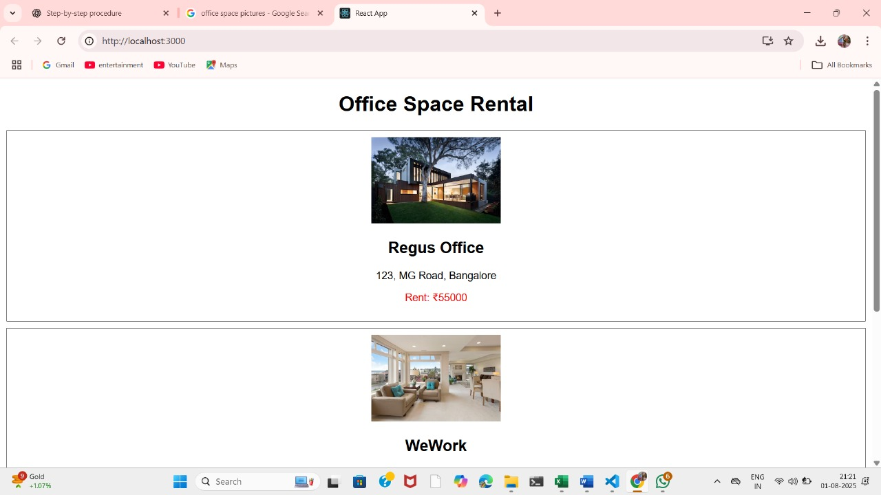

**11. ReactJS-HOL**

**Counter.js**

import React, { useState } from 'react';

function Counter() {

const [count, setCount] = useState(0);

const increment = () => {

setCount(prev => prev + 1);

sayHello();

displayMessage();

};

const decrement = () => {

setCount(prev => prev - 1);

};

const sayHello = () => {

console.log("Hello");

};

const displayMessage = () => {

console.log("Static Message: Count updated!");

};

return (

<div>

<h2>Counter: {count}</h2>

<button onClick={increment}>Increment</button>

<button onClick={decrement}>Decrement</button>

</div>

);

}

export default Counter;

**CurrencyConvertor.js**

import React, { useState } from 'react';

function CurrencyConvertor() {

const [rupees, setRupees] = useState('');

const [euros, setEuros] = useState('');

const handleSubmit = (e) => {

e.preventDefault();

const converted = (parseFloat(rupees) / 88.0).toFixed(2); // Example rate

setEuros(converted);

};

return (

<div>

<h3>Currency Convertor</h3>

<form onSubmit={handleSubmit}>

<input

type="number"

placeholder="Enter amount in INR"

value={rupees}

onChange={(e) => setRupees(e.target.value)}

/>

<button type="submit">Convert</button>

</form>

{euros && <p>Euros: €{euros}</p>}

</div>

);

}

export default CurrencyConvertor;

**SayWelcom.js**

import React from 'react';

function SayWelcome() {

const sayMessage = (msg) => {

alert(msg);

};

return (

<button onClick={() => sayMessage("Welcome!")}>Say Welcome</button>

);

}

export default SayWelcome;

**SyntheticEventButton.js**

import React from 'react';

function SyntheticEventButton() {

const handleClick = (event) => {

event.preventDefault(); // synthetic event

alert("I was clicked");

};

return (

<button onClick={handleClick}>Click Me</button>

);

}

export default SyntheticEventButton;

**App.js**

import React from 'react';

import Counter from './components/Counter';

import SayWelcome from './components/SayWelcome';

import SyntheticEventButton from './components/SyntheticEventButton';

import CurrencyConvertor from './components/CurrencyConvertor';

function App() {

return (

<div className="App">

<h1>Event Examples App</h1>

<Counter />

<SayWelcome />

<SyntheticEventButton />

<CurrencyConvertor />

</div>

);

}

export default App;

**App.css**

.App {

text-align: center;

}

.App-logo {

height: 40vmin;

pointer-events: none;

}

@media (prefers-reduced-motion: no-preference) {

.App-logo {

animation: App-logo-spin infinite 20s linear;

}

}

.App-header {

background-color: #282c34;

min-height: 100vh;

display: flex;

flex-direction: column;

align-items: center;

justify-content: center;

font-size: calc(10px + 2vmin);

color: white;

}

.App-link {

color: #61dafb;

}

@keyframes App-logo-spin {

from {

transform: rotate(0deg);

}

to {

transform: rotate(360deg);

}

}

**OUTPUT:**

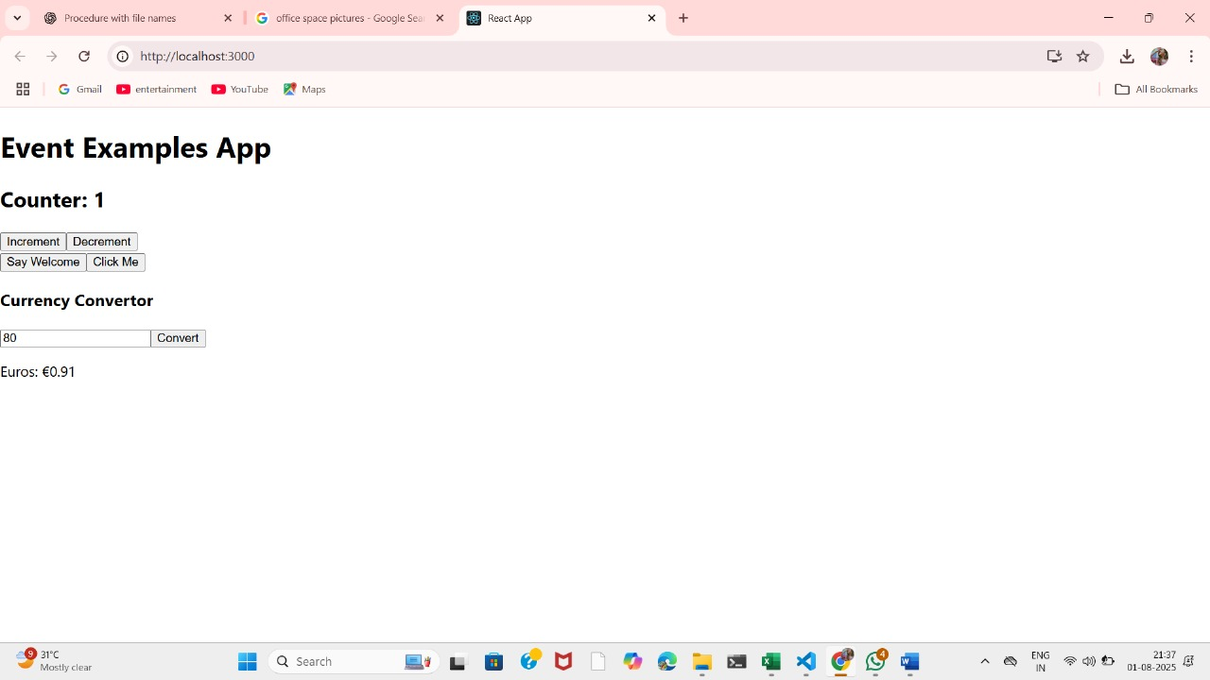

**12. ReactJS-HOL**

**Blogdetails.js:**

import React from 'react';

const blogs = [

{

title: "React Learning",

author: "Stephen Biz",

content: "Welcome to learning React!",

install: "You can install React from npm.",

lib: "Schwzedneier"

}

];

const BlogDetails = () => {

return (

<div className="card">

<h2>Blog Details</h2>

{blogs.map((blog, index) => (

<div key={index}>

<h3>{blog.title}</h3>

<h4>{blog.author}</h4>

<p>{blog.content}</p>

<h5>Installation</h5>

<h4>{blog.lib}</h4>

<p>{blog.install}</p>

</div>

))}

</div>

);

};

export default BlogDetails;

**BookDetails.js:**

import React from 'react';

const books = [

{ id: 1, bname: "Master React", price: 500 },

{ id: 2, bname: "Deep Dive into Angular 11", price: 650 },

{ id: 3, bname: "Mongo Essentials", price: 900 }

];

const BookDetails = () => {

return (

<div className="card">

<h2>Book Details</h2>

{books.map(book => (

<div key={book.id}>

<h3>{book.bname}</h3>

<h4>{book.price}</h4>

</div>

))}

</div>

);

};

export default BookDetails;

**CourseDetails.js:**

import React from 'react';

const courses = [

{ name: "Angular", date: "3/6/20" },

{ name: "React", date: "7/9/21" }

];

const CourseDetails = () => {

return (

<div className="card">

<h2>Course Details</h2>

{courses.map((course, index) => (

<div key={index}>

<h3>{course.name}</h3>

<h4>{course.date}</h4>

</div>

))}

</div>

);

};

export default CourseDetails**;**

**Output:**

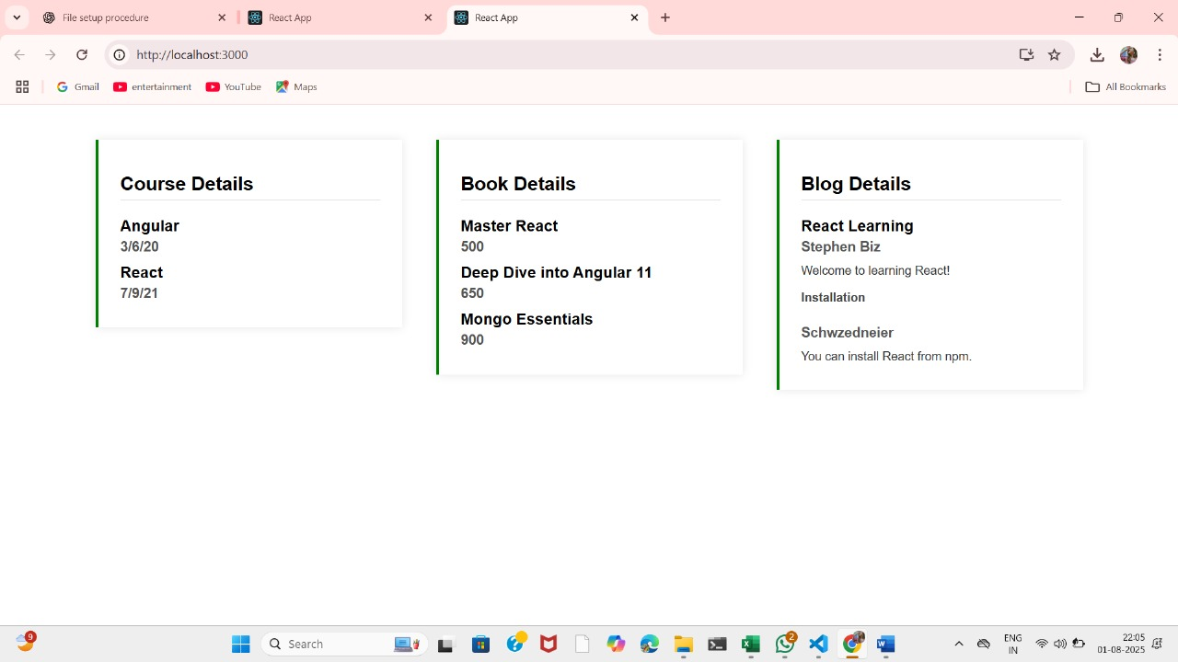

**13. ReactJS-HOL**

**FlightDetails.js:**

import React from 'react';

const FlightDetails = () => {

return (

<div>

<h3>Flight Details</h3>

<ul>

<li>Flight: AI202</li>

<li>From: Delhi</li>

<li>To: Chennai</li>

<li>Time: 10:00 AM</li>

</ul>

</div>

);

};

export default FlightDetails;

**GuestPage.js:**

import React from 'react';

const GuestPage = () => {

return (

<div>

<h2>Welcome Guest</h2>

<p>Please log in to book tickets.</p>

</div>

);

};

export default GuestPage;

**UserPage.js:**

import React from 'react';

const UserPage = () => {

return (

<div>

<h2>Welcome Back!</h2>

<p>You can now book your flight tickets.</p>

</div>

);

};

export default UserPage;

**Output:**

