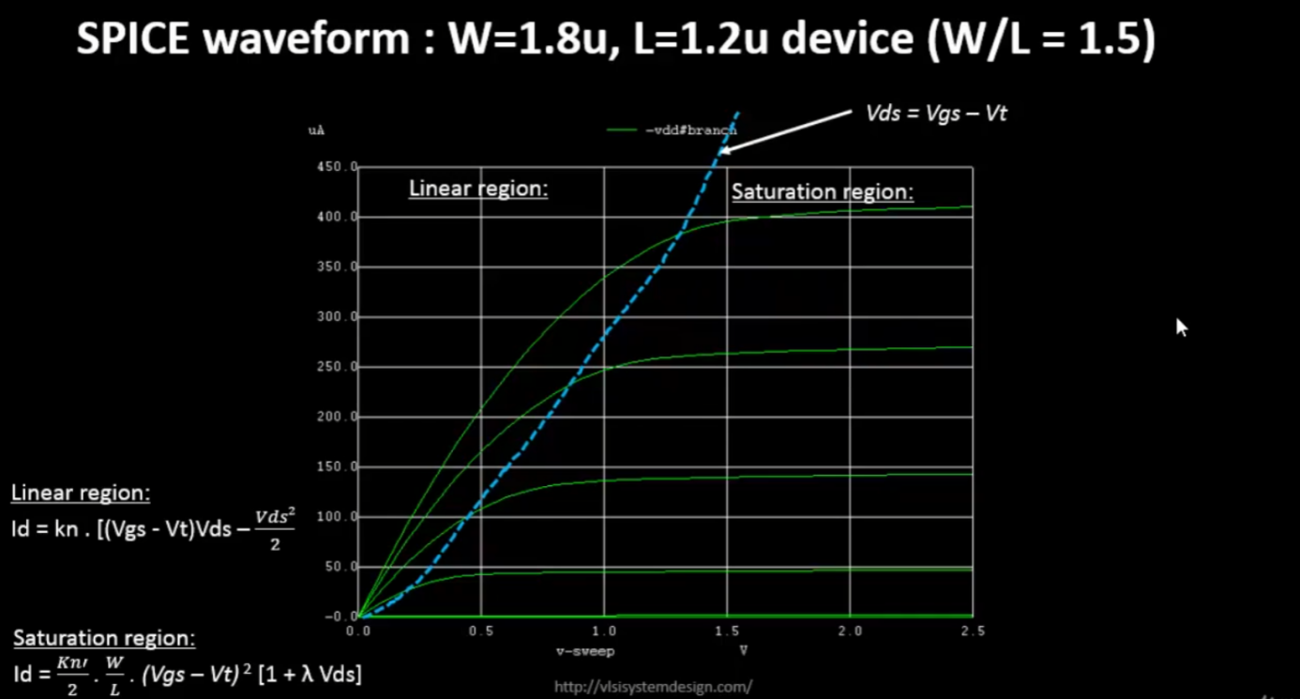
Not shown in the above picture but there is also another region called cutoff region which is when Vgs < Vt I.e. the device did not yet got into inversion
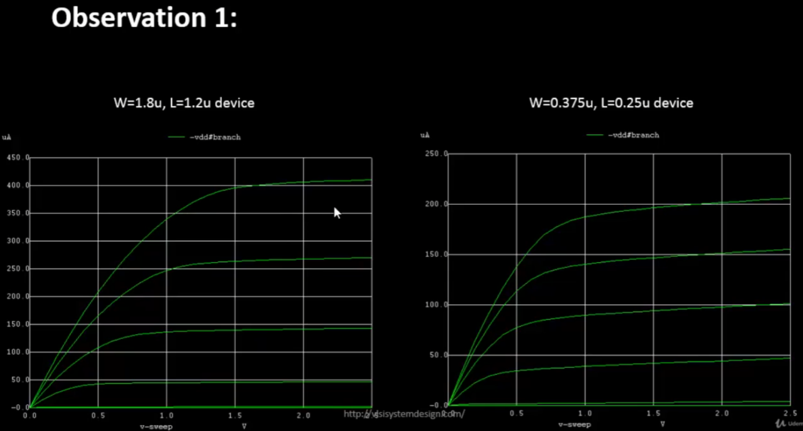
In general anything < 250nm is considered short channel

In the long channel devices, we can clearly see a quadratic relattionship between the vgs and id. But in the short channel devices, this quadratic relationship disappears after small vgs values. For bigger vgs values the relationship becomes linear apparently
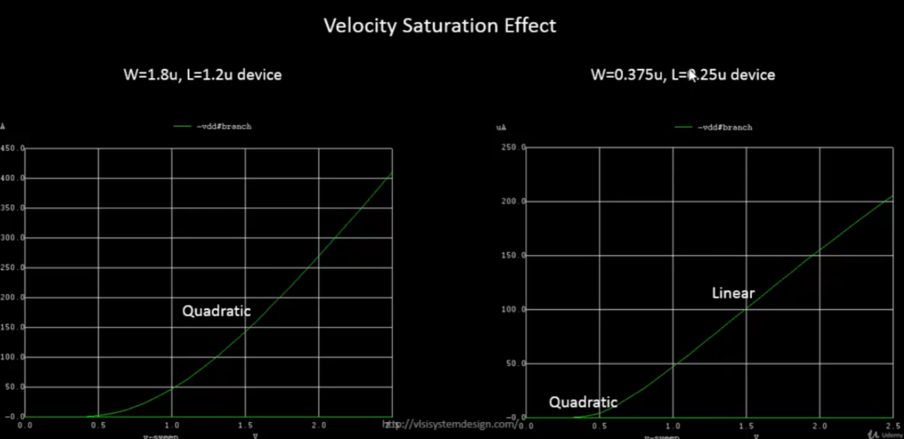

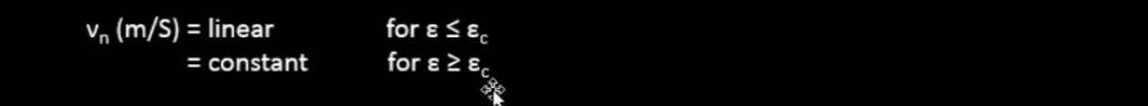
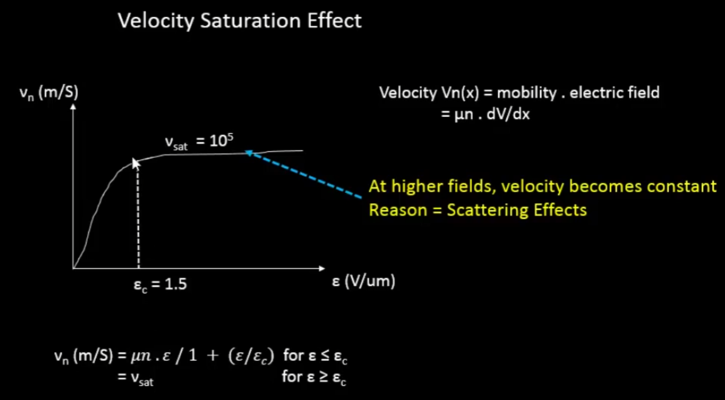
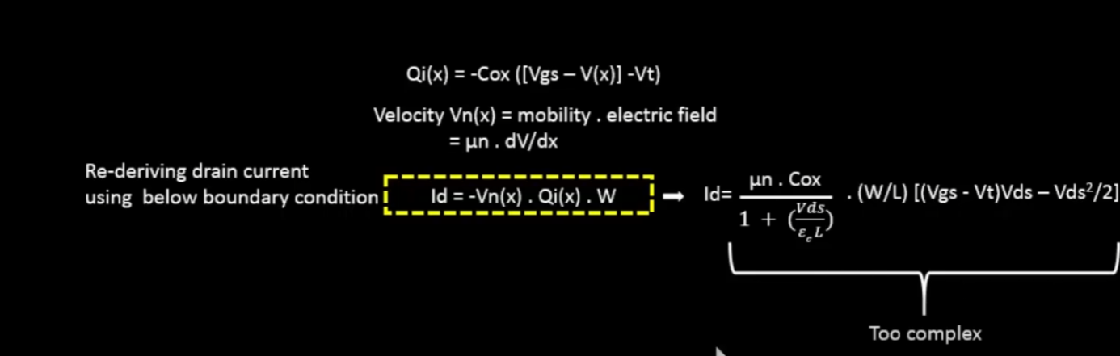
It seems like the derivation is incorrect for this. Unless $\frac{u∗E}{1+\frac{E}{Ec}}$, the denominator E is considered to be a constant while integrating
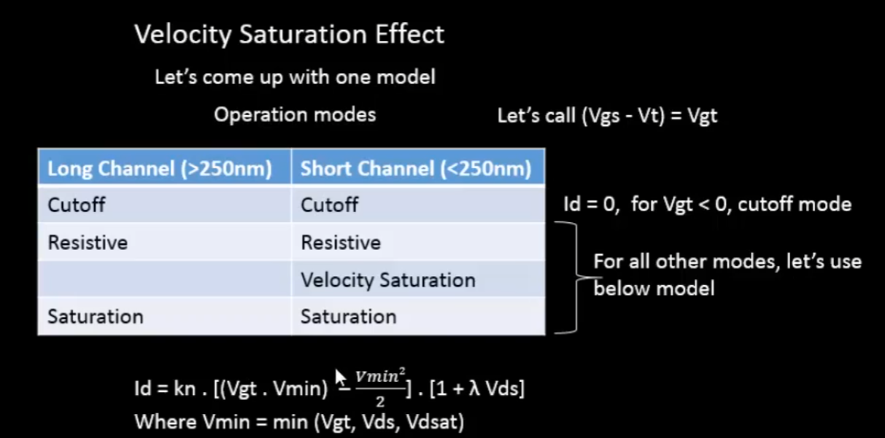
Saturation region:Vdsat > Vds > Vgt Resistive/Linear region:Vgt>Vdsat>Vds VSat region: Vds>Vgt>Vdsat
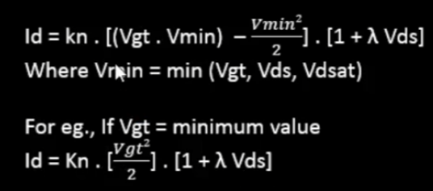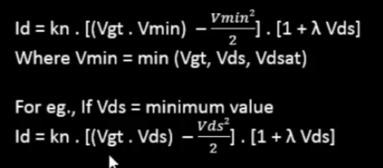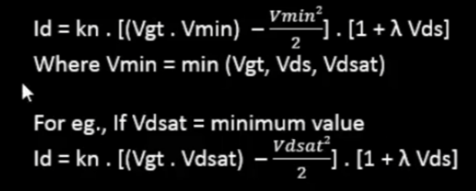
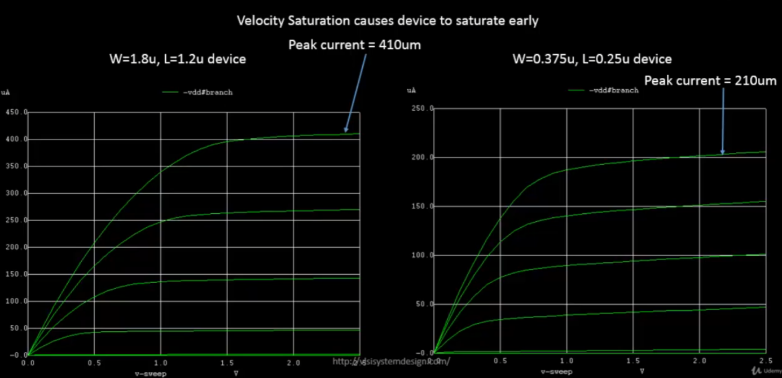
As seen above, the peak currents reduce due to velocity saturationeven though W/L and other params are the same
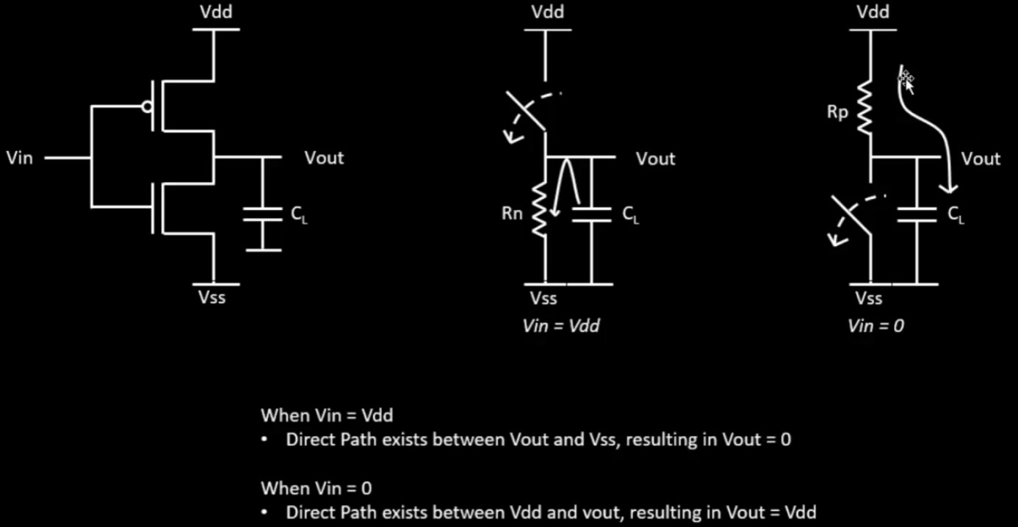

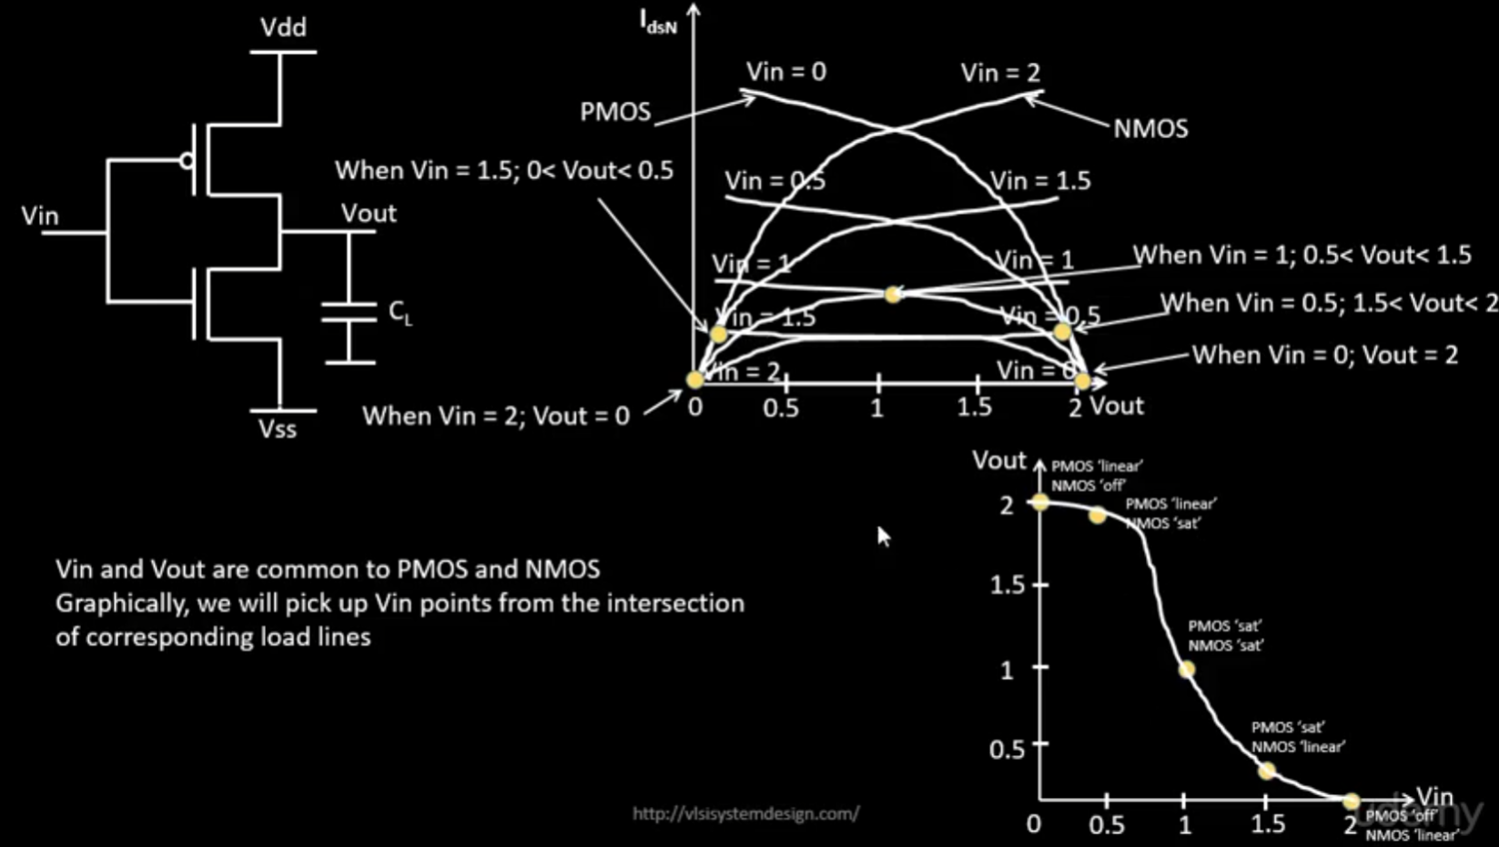
Now in the above graph of the intersected PMOS and NMOS load curves we might wonder about the y-axis label being IdsN. It is actually -IdsP since in this case IdsN = -Idsp

