Ideally you size your PMOS a little bit bigger than your NMOS to compensate for the lower mobility of the holes. Normally W/L of the PMOS will be around 2 to 4 times of that of NMOS
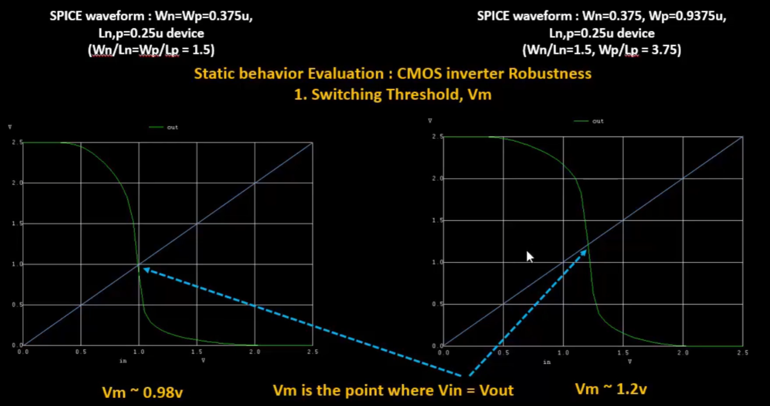
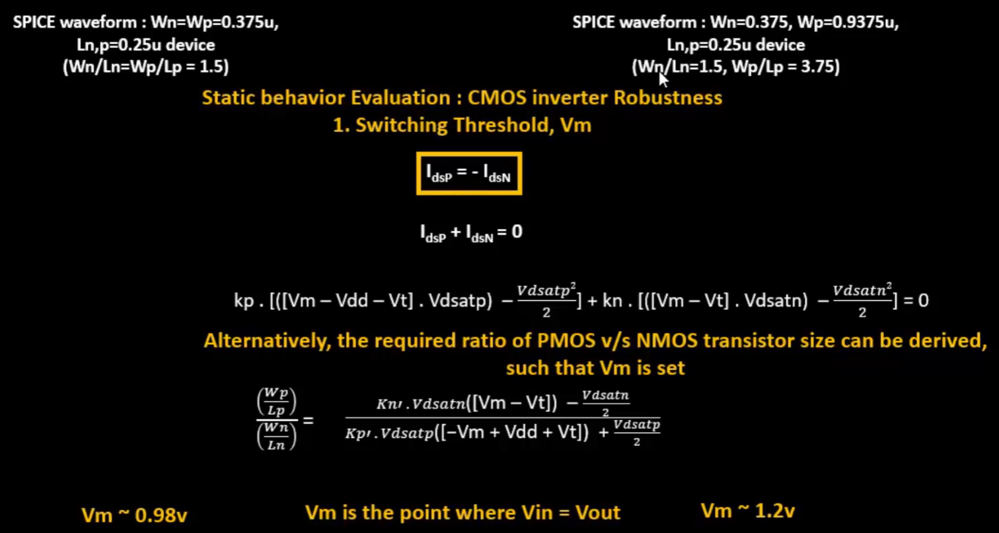
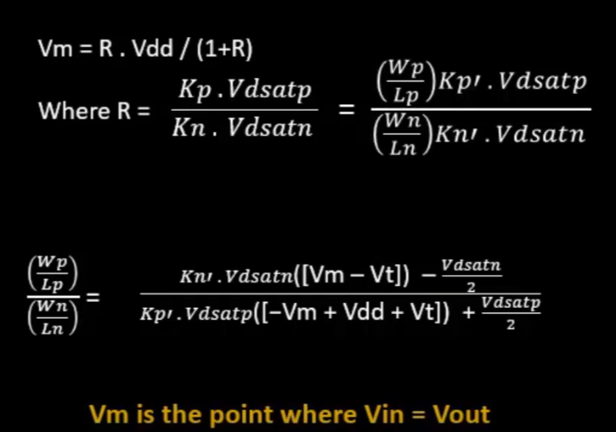
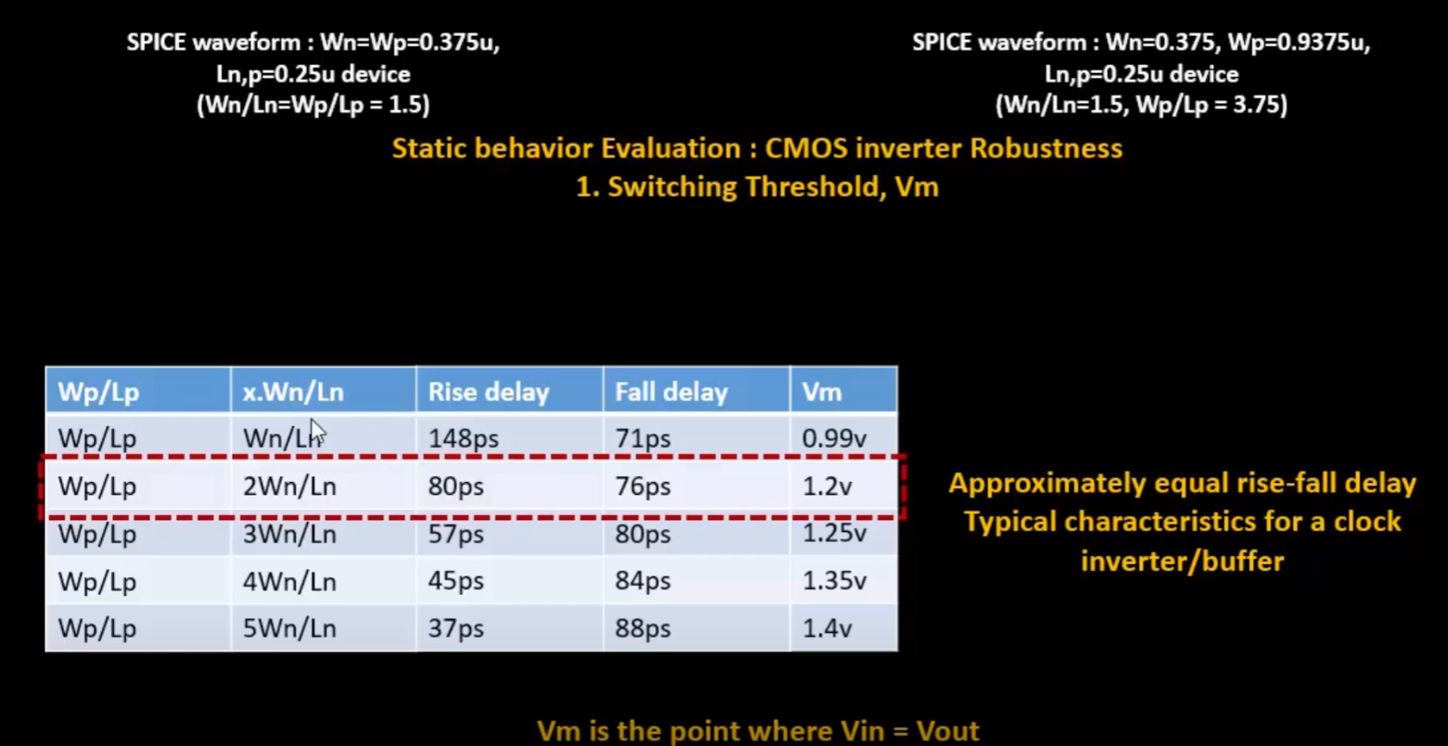
As seen above, the switching threshold varies only by a little when the size changes by a lot=> inverter is robust
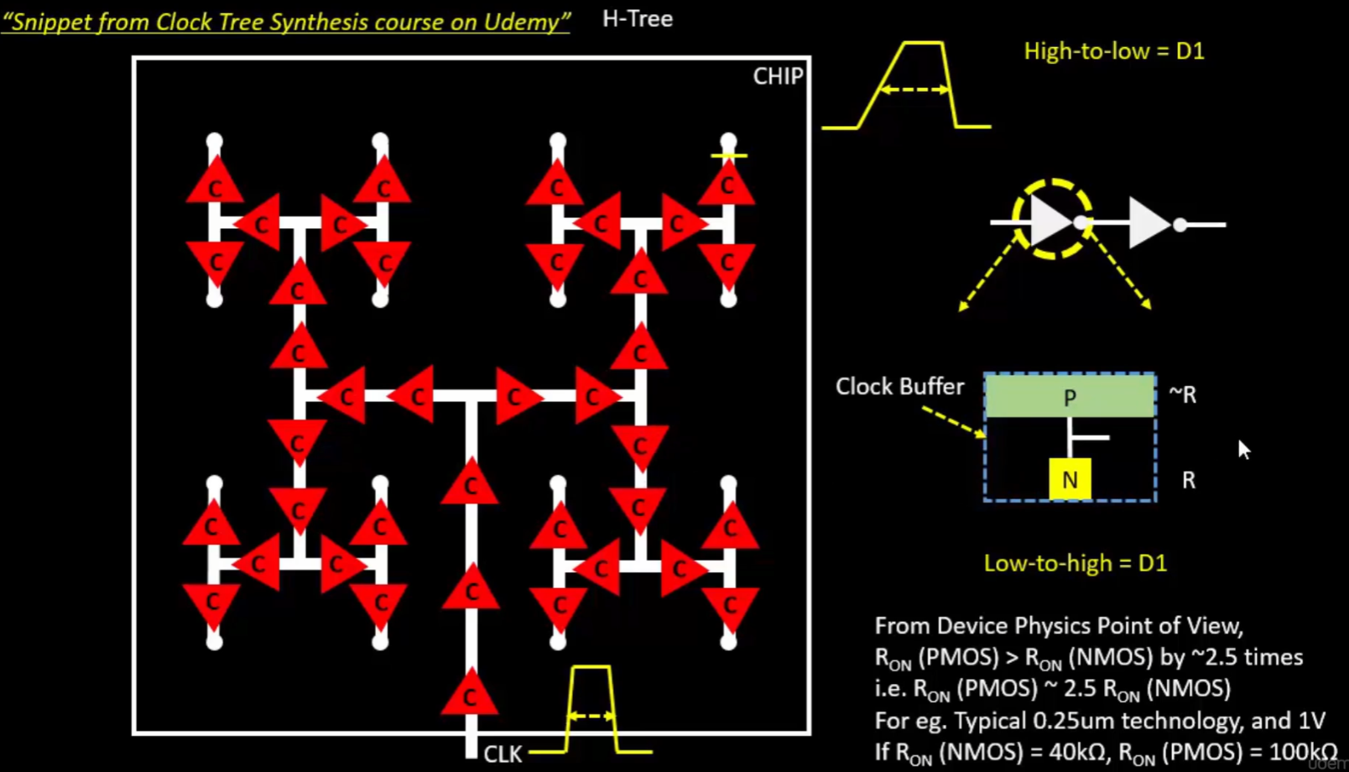
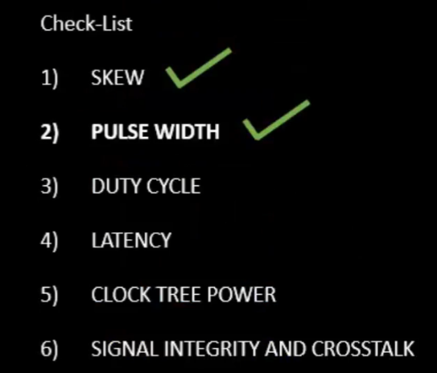 The other sizes can also be used based on our requirements:
