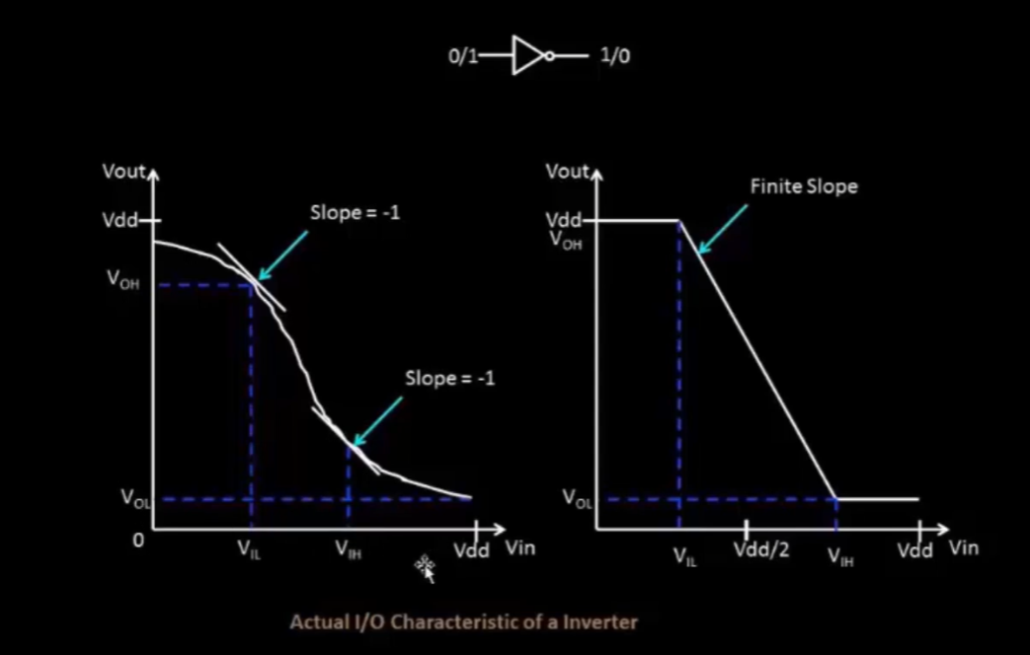
VOH should be > VIH so that the next stage will recognize it as a logic high
VOL should be < VIL so the next stage will recognize it as a logic low
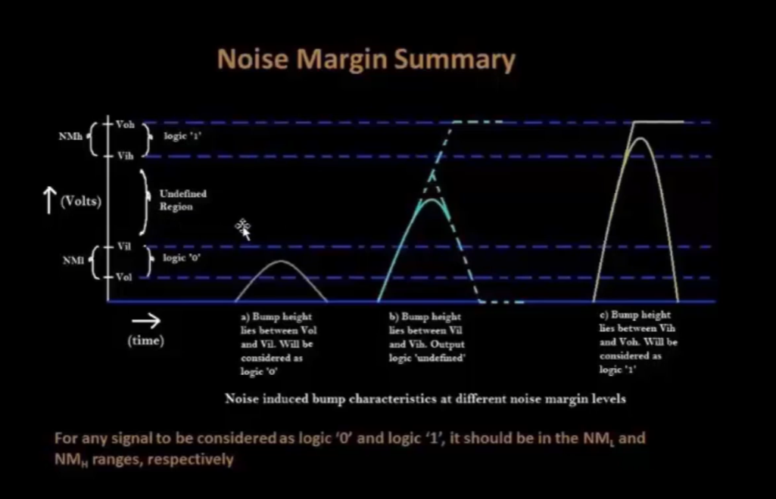
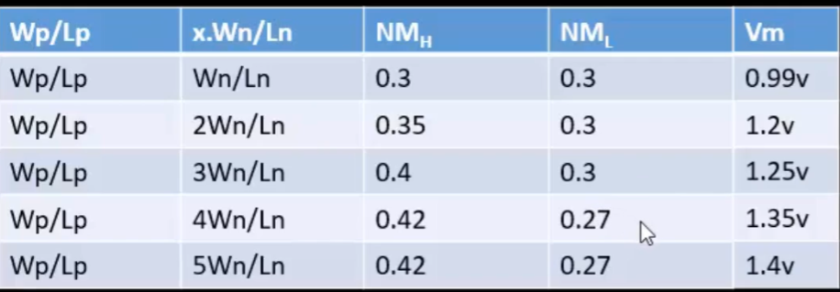
VOL
VOH

