Spice scripting
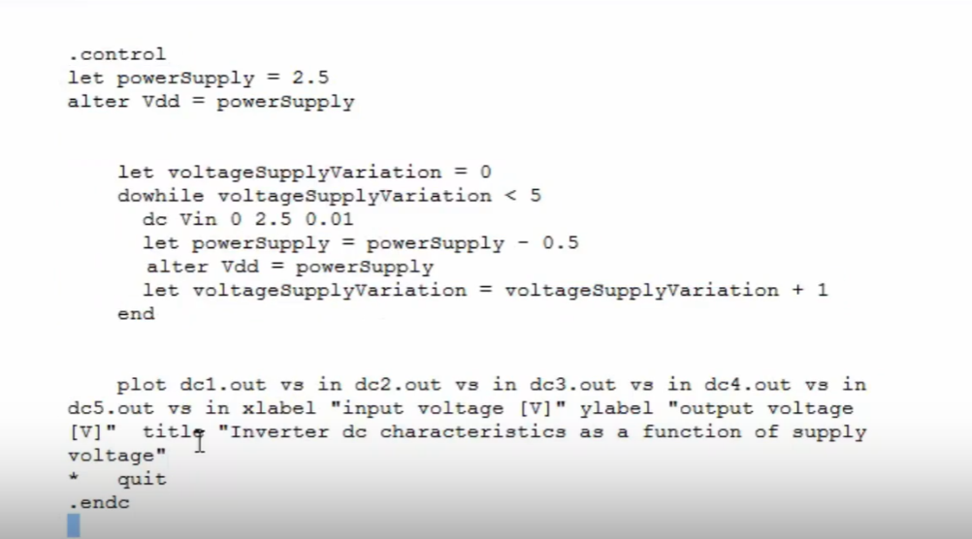
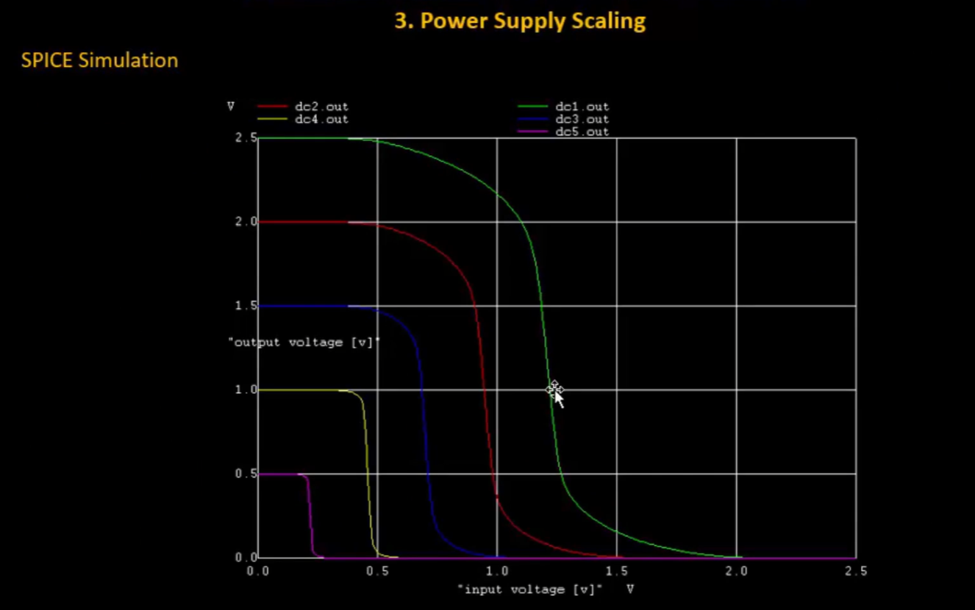

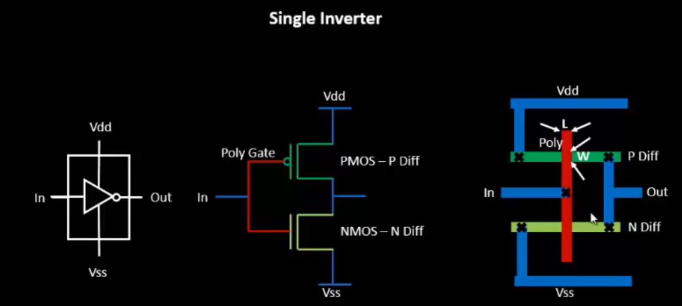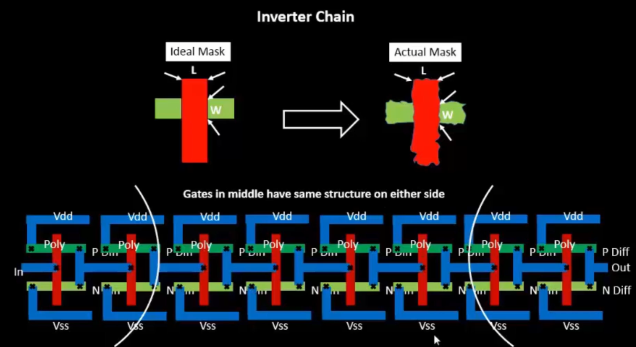
When the similar devices are close to each other then those devices might not see a lot of variations. However, if the devices adjacent are made from different mask then the variations causing the defects/distortion can have a greater impact because the adjacent devices’s distortion will in turn cause distortions in the device
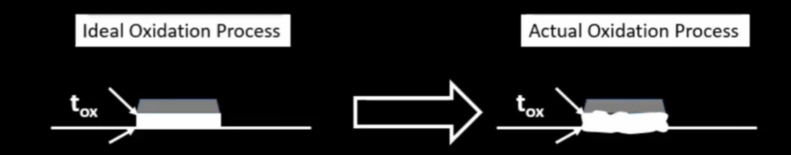
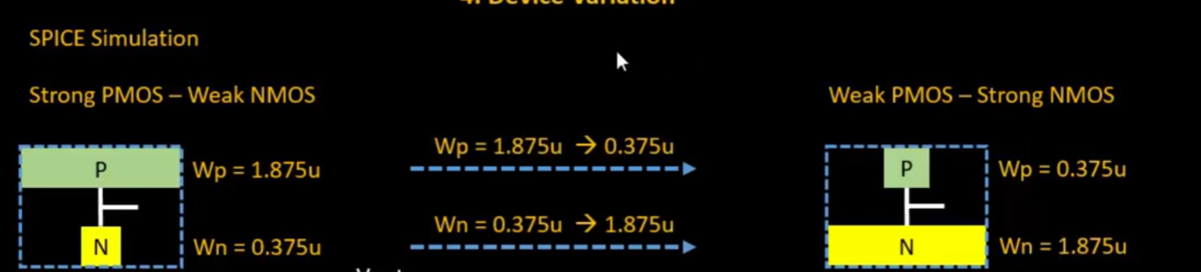
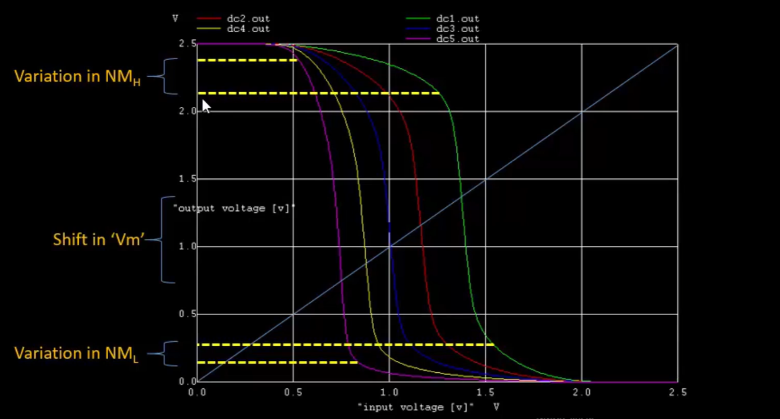
A CMOS inverter’s function always stays intact even with the variations in W, L or supply voltage

