Database Design Project

CS 6360.002

Project Title: Indoor Playground

Names of the students in team:

1. Sai Sandeep Vaddi – SXV160830
2. Sandeep Avula – SXA165930

Step 1: Data Requirements

Indoor Playground has to has to maintain the data regarding the following to maintain successful business

* 1. Playground Branches
  2. Games
  3. Game equipment
  4. Employees
  5. Customers
  6. Billing
  7. Other shopping like toy shops

## **Branches**

Location details of the indoor playground like the following

1. Details of manager of branch
2. Branch working times
3. Branch area, ground type details
4. Address

## **Games**

1. Playground should have following details about games it hosts:
   1. Game names
   2. Game types like single player, multi-player etc
   3. Age limits for each game
   4. Each game price

## **Equipment**

1. Equipment details of each game
2. Available units of each game according to branches
3. Timings of occupancy on the equipment

## **Employees**

1. Employee name, ssn, sex, salary details
2. Employee’s manager details
3. Employee address details

## **Customers**

1. Contact details
2. Games customers played
3. Their payment details
4. Their membership details

## **Other shops like toy shops**

1. Maintain toys details like which customer is buying which toy etc.

## **Billing details**

1. Which games each customer played
2. How much time they spent on each game
3. Bill date
4. Total amount
5. Final bill with the discount if they have membership

## **Membership**

1. Maintain membership types (Platinum, Gold, Silver)
2. Membership validity
3. Discount available with each membership

Step 2: ER Diagrams

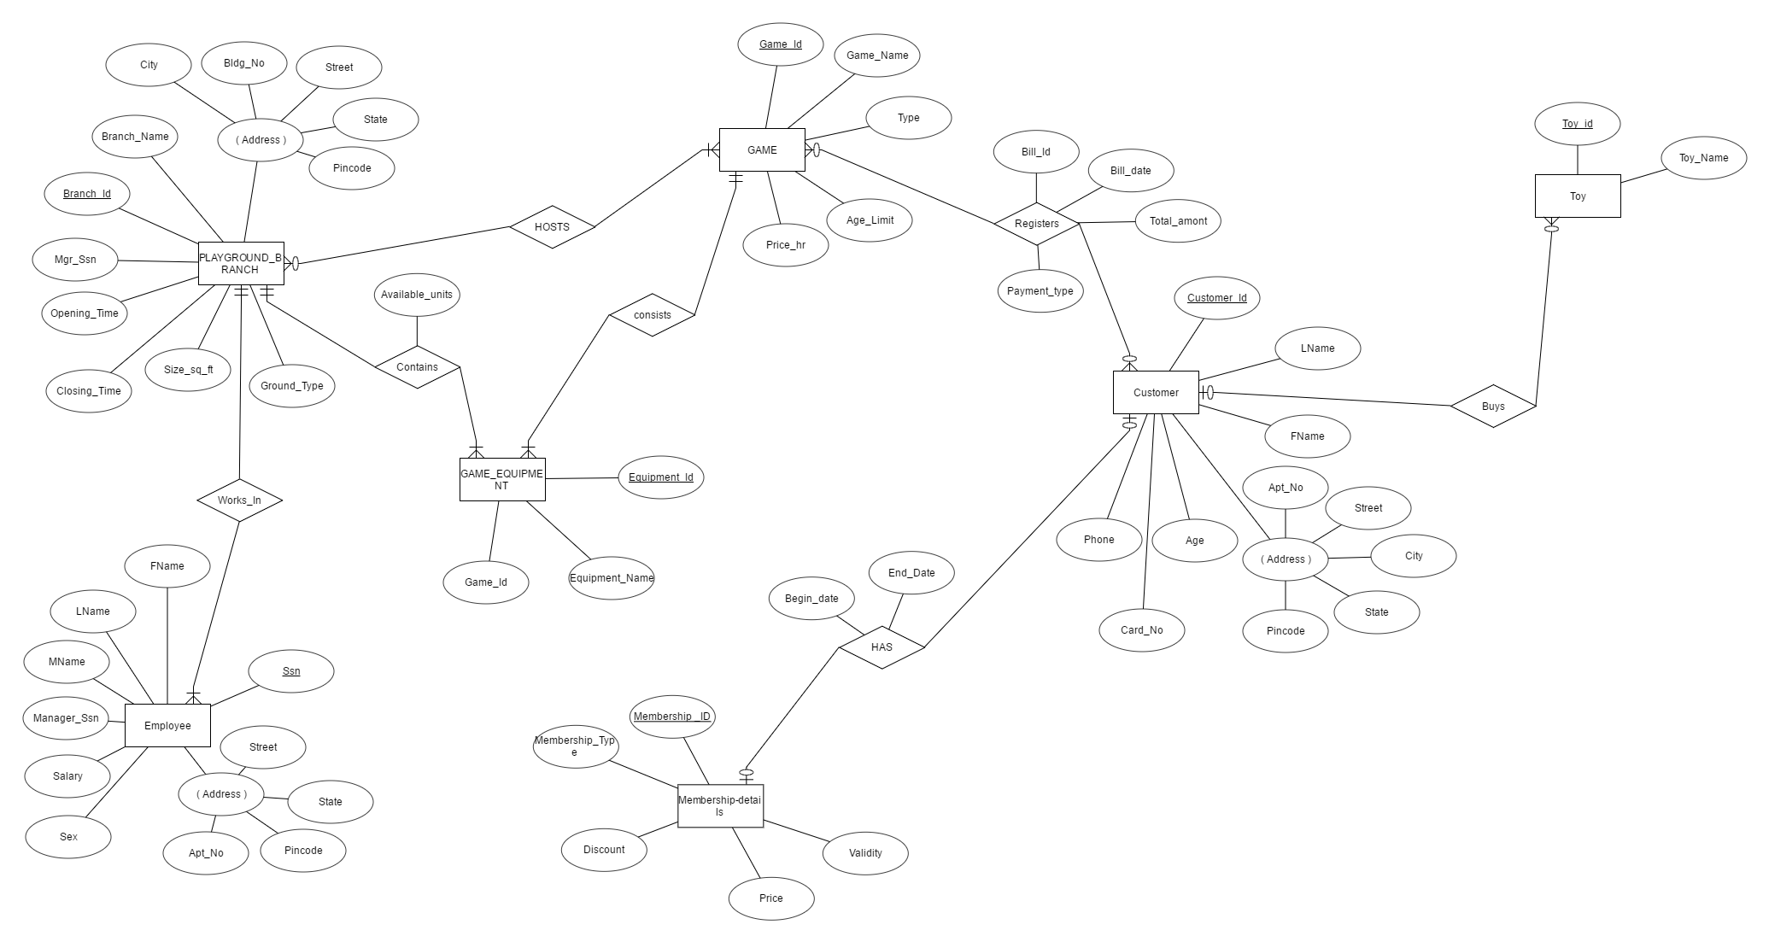

Step 3: ER to Relational Schema

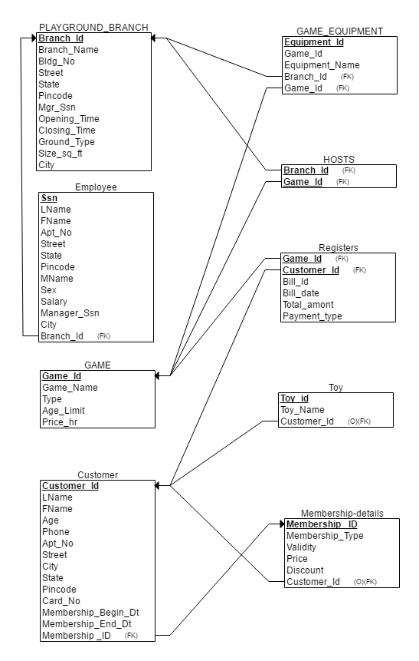

Step 4: Normalization

1)

In PLAYGROUND_BRANCH, EMPLOYEE, CUSTOMER

City -> State violates 3NF

2)

In CUSTOMER Table, the following FDs violate 3NF

Customer_Id -> Membership_Id , Membership_Begin_Dt , Membership_End_Dt

Membership_Id , Membership_Begin_Dt -> Membership_End_Dt

3)

In GAME_EQUIPMENT table, the following FDs violate 3NF

Equipment_id -> Equipment_Name, Game_Id

Equipment_Name -> Game_Id

4)

In PLAYGROUND_BRANCH table, the following FDs violate 3NF

Branch_Id -> Mgr_SSN, Branch_Name

Mgr_SSN -> Branch_Name

Branch_Name -> Mgr_Ssn

Step 5: Final relational schema after normalization

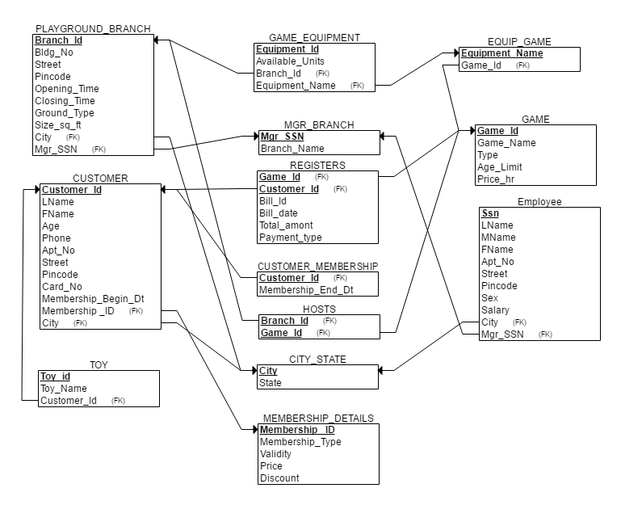

Step 6: Table creation queries

-- 1.

CREATE TABLE GAME (

Game_Id INT NOT NULL,

Game_Name VARCHAR(20) NOT NULL,

Type VARCHAR(20),

Age_Limit INT,

Price_Hr DECIMAL(5,2),

PRIMARY KEY (Game_Id)

);

-- 2.

CREATE TABLE MEMBERSHIP_DETAILS(

Membership_Id INT NOT NULL,

Membership_Type VARCHAR(20) NOT NULL,

Validity INT,

Price DECIMAL(5,2),

Discount INT,

PRIMARY KEY (Membership_Id)

);

-- 3.

CREATE TABLE CITY_STATE (

City VARCHAR (20),

State VARCHAR (20),

PRIMARY KEY (City)

);

-- 4.

CREATE TABLE MGR_BRANCH(

Mgr_Ssn VARCHAR(9) NOT NULL,

Branch_Name VARCHAR(20) NOT NULL,

PRIMARY KEY (Mgr_Ssn)

);

-- 5.

CREATE TABLE PLAYGROUND_BRANCH

(

Branch_Id INT NOT NULL,

Mgr_Ssn VARCHAR(9) NOT NULL,

Opening_Time TIMESTAMP,

Closing_Time TIMESTAMP,

Size_Sq_Ft VARCHAR(20),

Ground_Type VARCHAR(20),

Bldg_No VARCHAR(20),

Street VARCHAR(20),

City VARCHAR(20),

Pincode INT,

PRIMARY KEY (Branch_Id),

FOREIGN KEY (City) REFERENCES CITY_STATE (City) ON DELETE SET NULL,

FOREIGN KEY (Mgr_Ssn) REFERENCES MGR_BRANCH (Mgr_Ssn) ON DELETE SET NULL

);

-- 6.

CREATE TABLE HOSTS(

Branch_Id INT NOT NULL,

Game_Id INT NOT NULL,

PRIMARY KEY (Branch_Id, Game_Id),

FOREIGN KEY (Branch_Id) REFERENCES PLAYGROUND_BRANCH (Branch_Id) ON DELETE CASCADE,

FOREIGN KEY (Game_Id) REFERENCES GAME (Game_Id) ON DELETE CASCADE

);

-- 7.

CREATE TABLE CUSTOMER

(

Customer_Id INT NOT NULL,

Lname VARCHAR(20) NOT NULL,

Fname VARCHAR(20) NOT NULL,

Age INT,

Phone VARCHAR(15),

Membership_Id INT,

Membership_Begin_Dt DATE,

-- Membership_Status VARCHAR(20),

-- Membership_End_Dt Date,

Card_No VARCHAR(20),

Apt_No VARCHAR(20),

Street VARCHAR(20),

City VARCHAR(20),

Pincode INT,

PRIMARY KEY (Customer_Id),

FOREIGN KEY (Membership_Id) REFERENCES MEMBERSHIP_DETAILS(Membership_Id) ON DELETE SET NULL,

FOREIGN KEY (City) REFERENCES CITY_STATE (City) ON DELETE SET NULL

);

-- 8.

CREATE TABLE TOY(

Toy_Id INT NOT NULL,

Toy_Name VARCHAR(20),

Customer_Id INT,

PRIMARY KEY (Toy_Id),

FOREIGN KEY (Customer_Id) REFERENCES CUSTOMER(Customer_Id) ON DELETE SET NULL

);

-- 9.

CREATE TABLE EQUIP_GAME (

Equipment_Name VARCHAR(20) NOT NULL,

Game_Id INT NOT NULL,

PRIMARY KEY (Equipment_Name),

FOREIGN KEY (Game_Id) REFERENCES GAME (Game_Id) ON DELETE CASCADE

);

-- 10.

CREATE TABLE GAME_EQUIPMENT (

Equipment_Id INT NOT NULL,

Equipment_Name VARCHAR(20),

Branch_Id INT,

Available_Units INT,

PRIMARY KEY (Equipment_Id),

FOREIGN KEY (Equipment_Name) REFERENCES EQUIP_GAME (Equipment_Name) ON DELETE CASCADE,

FOREIGN KEY (Branch_Id) REFERENCES PLAYGROUND_BRANCH (Branch_Id) ON DELETE SET NULL

);

-- 11.

CREATE TABLE REGISTERS(

Customer_Id INT,

Game_Id INT,

Bill_Id INT,

Bill_Date DATE,

Payment_Type VARCHAR(20),

Total_Amount DECIMAL(10,2),

PRIMARY KEY (Customer_Id, Game_Id),

FOREIGN KEY (Customer_Id) REFERENCES CUSTOMER (Customer_Id) ON DELETE SET NULL,

FOREIGN KEY (Game_Id) REFERENCES GAME (Game_Id) ON DELETE SET NULL

);

-- 12.

CREATE TABLE EMPLOYEE (

SSN VARCHAR(9) NOT NULL,

Lname VARCHAR(20) NOT NULL,

Mname VARCHAR(20) NOT NULL,

FName VARCHAR(20) NOT NULL,

Mgr_Ssn VARCHAR(9),

Salary DECIMAL(10,2),

Sex VARCHAR(20),

Apt_No VARCHAR(20),

Street VARCHAR(20),

City VARCHAR(20),

Pincode VARCHAR(5),

PRIMARY KEY (SSN),

FOREIGN KEY (City) REFERENCES CITY_STATE (City) ON DELETE SET NULL,

FOREIGN KEY (Mgr_Ssn) REFERENCES MGR_BRANCH (Mgr_Ssn) ON DELETE SET NULL

);

-- 13

CREATE TABLE CUSTOMER_MEMBERSHIP (

Customer_Id INT NOT NULL,

Membership_End_Dt DATE,

PRIMARY KEY (Customer_Id),

FOREIGN KEY (Customer_Id) REFERENCES CUSTOMER (Customer_Id)

);

Step 7: Stored Procedures

**1. Stored Procedure to retrieve the customer details whose membership status end by today.**

DROP PROCEDURE Customers_Mem_Curr_Status;

CREATE or replace PROCEDURE Customers_Mem_Curr_Status As

this_c_Id CUSTOMER.CUSTOMER_ID%TYPE;

this_c_FName CUSTOMER.FNAME%TYPE;

this_c_LName CUSTOMER.LNAME%TYPE;

CURSOR RES_SET IS

SELECT C.Customer_Id,C.Fname,C.Lname FROM CUSTOMER C WHERE C.MEMBERSHIP_END_DT <= trunc(SYSDATE) and C.MEMBERSHIP_ID IS NOT NULL

FOR UPDATE;

BEGIN

OPEN RES_SET;

LOOP

FETCH RES_SET INTO this_c_Id, this_c_FName ,this_c_LName;

EXIT WHEN(RES_SET%NOTFOUND);

dbms_output.put_line('Customer_ID = ' || this_c_Id ||

', Customer_Name = ' || this_c_FName || ', First_Name = ' || this_c_LName );

END LOOP;

CLOSE RES_SET;

END;

.

RUN;

BEGIN

Customers_Mem_Curr_Status();

END;

.

RUN;

**2. Stored Procedure for generating Bill for each customer today calculating the changes in the bill amount according to membership discount if they have membership.**

DROP PROCEDURE GENERATE_BILL; COMMIT;

CREATE OR REPLACE PROCEDURE GENERATE_BILL (Customer_Id IN CUSTOMER.Customer_Id%TYPE)

IS

Gid GAME.Game_Id%TYPE;

Customer_Lname CUSTOMER.LNAME%TYPE;

Customer_Fname CUSTOMER.FNAME%TYPE;

Game_Bill NUMBER(10,2);

Bill NUMBER(10,2);

Price_per_hr GAME.Price_Hr%TYPE;

Membership MEMBERSHIP_DETAILS.MEMBERSHIP_TYPE%TYPE;

Discount_Amt MEMBERSHIP_DETAILS.DISCOUNT%TYPE;

GameName GAME.Game_Name%TYPE;

CURSOR REGISTER_DETAILS IS

SELECT R.game_id, R.total_amount FROM REGISTERS R WHERE R.CUSTOMER_ID = Customer_Id AND R.BILL_DATE = trunc(SYSDATE);

BEGIN

DBMS_OUTPUT.PUT_LINE('Bill');

DBMS_OUTPUT.PUT_LINE('==========================');

Bill := 0;

SELECT LNAME, FNAME into Customer_Lname, Customer_Fname FROM CUSTOMER C WHERE C.Customer_Id = Customer_Id;

SELECT DISCOUNT, MEMBERSHIP_TYPE INTO Discount_Amt, Membership FROM MEMBERSHIP_DETAILS WHERE MEMBERSHIP_ID = (SELECT MEMBERSHIP_ID FROM CUSTOMER C WHERE C.CUSTOMER_ID = Customer_Id);

DBMS_OUTPUT.PUT_LINE('Customer Name: '||Customer_Lname||', '||Customer_Fname);

DBMS_OUTPUT.PUT_LINE('Game_Id'||chr(9)||'Game_Name'||chr(9)||'Hrs_Played'||chr(9)||'Bill_by_Game');

DBMS_OUTPUT.PUT_LINE('=================================================================');

OPEN REGISTER_DETAILS;

LOOP

FETCH REGISTER_DETAILS INTO Gid, Game_Bill;

EXIT WHEN REGISTER_DETAILS%NOTFOUND;

SELECT G.Game_Name, G.Price_Hr into GameName, Price_per_hr FROM GAME G WHERE G.Game_Id = Gid;

DBMS_OUTPUT.PUT_LINE(Gid||chr(9)||GameName||chr(9)||(Game_Bill/Price_per_Hr)||chr(9)||Game_Bill);

-- DBMS_OUTPUT.PUT_LINE(Game_Id||' '||Game_Bill);

Bill := Bill + Game_Bill;

END LOOP;

CLOSE REGISTER_DETAILS;

DBMS_OUTPUT.PUT_LINE('=================================================================');

DBMS_OUTPUT.PUT_LINE('Total Amount: '||'$'||Bill);

DBMS_OUTPUT.PUT_LINE('Membership: '||Membership);

Bill := Bill - (Bill * (Discount_Amt/100));

DBMS_OUTPUT.PUT_LINE('Discount %: '||Discount_Amt);

DBMS_OUTPUT.PUT_LINE('Final Bill: '||'$'||Bill);

END GENERATE_BILL; /

-- CALL GENERATE_BILL(1);

Step 8: Rules by using Triggers

**1. Trigger to update the membership end date when the customer changes membership or takes a membership. Remove customer membership details when customer withdraws membership**

DROP TRIGGER END_DATE_TRIGGER; commit;

CREATE OR REPLACE TRIGGER END_DATE_TRIGGER

AFTER INSERT OR UPDATE OF MEMBERSHIP_ID ON CUSTOMER

FOR EACH ROW

DECLARE

validity MEMBERSHIP_DETAILS.VALIDITY%TYPE;

old_date DATE;

end_date DATE;

cid INT;

BEGIN

IF (:NEW.MEMBERSHIP_ID > 0) THEN

-- DBMS_OUTPUT.PUT_LINE(:NEW.MEMBERSHIP_ID);

cid := 0;

old_date := :OLD.Membership_Begin_dt;

-- DBMS_OUTPUT.PUT_LINE(old_date);

SELECT VALIDITY INTO validity FROM MEMBERSHIP_DETAILS WHERE MEMBERSHIP_ID = :NEW.MEMBERSHIP_ID;

SELECT TO_DATE(ADD_MONTHS(:OLD.Membership_Begin_dt,validity)) into end_date FROM DUAL;

SELECT count(*) INTO cid FROM CUSTOMER_MEMBERSHIP WHERE CUSTOMER_ID = :OLD.CUSTOMER_ID;

-- DBMS_OUTPUT.PUT_LINE(cid);

CASE WHEN cid > 0 THEN

UPDATE CUSTOMER_MEMBERSHIP SET Membership_End_Dt = end_date WHERE CUSTOMER_ID = :OLD.CUSTOMER_ID;

DBMS_OUTPUT.PUT_LINE('Membership details updated for '||:OLD.lname||chr(9)||', '||:OLD.fname);

ELSE

INSERT INTO CUSTOMER_MEMBERSHIP (CUSTOMER_ID, Membership_End_Dt) VALUES (:OLD.CUSTOMER_ID, end_date);

DBMS_OUTPUT.PUT_LINE('Membership details updated for '||:OLD.lname||chr(9)||', '||:OLD.fname);

END CASE;

ELSE

DBMS_OUTPUT.PUT_LINE('Deleted Membership for the customer '||:OLD.lname||chr(9)||:OLD.fname);

DELETE FROM CUSTOMER_MEMBERSHIP WHERE CUSTOMER_ID = :OLD.CUSTOMER_ID;

END IF;

END;

/

**2. On update of available units to zero of a game in a branch, trigger should make the game at that particular branch unavailable**

DROP TRIGGER GAME_EQUIPMENT_AVAILABILYT;

CREATE OR REPLACE TRIGGER GAME_EQUIPMENT_AVAILABILYT

AFTER UPDATE OF AVAILABLE_UNITS ON GAME_EQUIPMENT

FOR EACH ROW

DECLARE

AVA_QNTY NUMBER;

B_ID NUMBER;

E_NAME VARCHAR(20);

G_ID NUMBER;

BEGIN

CASE

WHEN UPDATING('AVAILABLE_UNITS')

THEN

IF(:NEW.AVAILABLE_UNITS = 0) THEN

B_ID :=:NEW.BRANCH_ID;

E_NAME := :NEW.EQUIPMENT_NAME;

SELECT S.GAME_ID INTO G_ID FROM EQUIP_GAME S WHERE E_NAME=S.EQUIPMENT_NAME;

DELETE FROM HOSTS L WHERE L.BRANCH_ID= B_ID AND G_ID=L.GAME_ID;

END IF;

UPDATE GAME_EQUIPMENT

SET AVAILABLE_UNITS=0

WHERE BRANCH_ID =1;