MOBILE COMPUTING AND ITS BUSINESS IMPLICATIONS
Sai Jaswanth reddy Sanikommu
Campbellsville University-Louisville, KY

Abstract
The abstract, according to the Publication Manual of the American Psychological Association (American Psychological Association [APA], 2010), “is a brief, comprehensive summary of the contents of the article; it allows readers to survey the contents of an article quickly and, like a title, it enables persons interested in the document to retrieve it from abstracting and indexing databases” (p. 25). It should also indicate the importance of the article—what makes it worth reading. Abstract length depends on the word limit of the journal to which you would like to submit your paper, so APA suggests “a range of 150-250 words” (p. 27). As shown above, the word “Abstract” is centered above the abstract text, and the entire text is double-spaced. Note that the first sentence is not indented, but begins flush left. Remember that key words from the abstract are used as index words for library search programs. The main concerns of this "Getting Started" sample are providing samples of paper basics, demonstrating the best way to set up the two running heads in Microsoft Word, and presenting an overview of the contents of the new edition of APA.
MOBILE COMPUTING AND ITS BUSINESS IMPLICATIONS
In the present never-ending development driven world, the advancement in technology is improving at a good pace. In any case, there is always a need to change a bit for the best advances in the authentic background of development progress in this organizational movement. Mobile computing is one of the innovation in this decade which attracted many sections of customers to follow it. Let’s start with the basics of mobile computing.

What is Mobile device?
Mobile is a non-exclusive term which includes an extensive variety of gadgets that enable individuals to access information and data whenever or wherever and most of those that can fit in your pocket like portable workstations that can enable you to remain associated. They incorporate cell phones and other compact gadgets. Connection to the cell phone helps for making telephone calls, use the Internet and Much more.
Some examples include
- Laptop computers.
- Smartphones.
- Tablets.
- Wearable tech such as Apple watches, Samsung Watch.

What are the benefits of mobile computing?
High Connectivity: Stay connected to any source available at any time.
Social: It is much easier to connect, Contact a person.
Personalization: According to the user needs and requirements devices and apps can be tailored.
Some of the basic wireless technology architectures are as follows
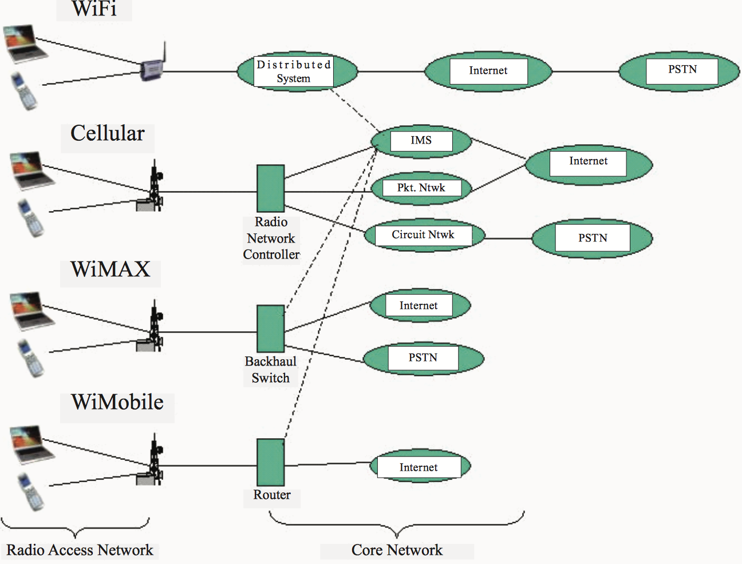
Figure 1. Image showing Architectures of various wireless technologies. Retrieved from irma-international org Database. Copyright © 2007, Idea Group Inc.,

How is the demand for the mobile computing?
Even workers are currently requesting these developments and anticipating that their associations should give something close in ability to what they can get almost for nothing (or very free) all alone gadgets and systems. Directors and officials, though for the most part on the business side, are regularly pushing for
1) benefit conveyance on cutting edge cell phones like the iPad.
2) considerably less demanding to utilize IT arrangements, and
3) access to better, more shared and valuable intranet abilities.
So, to achieve the purpose of the internet or intranet Mobile computing mostly fill all the gaps according to the user needs. And businesses are also benefiting by this involvement.

Business implications of Mobile Computing
Mobile computing truly is in a condition of advancement. We see the assault vectors keep on growing bigger, develop at a quickened pace, and keeping in mind that we're seeing a hefty portion of the malware instruments and the gadget administration and application devices showing signs of improvement and better, they're not continually staying aware of the [pace of change] of the knowledge related with the malfeasants over here who are rifling buyers of their protection, testing gadgets and data around security and proceeding to bring destruction up in numerous ways - similarly we found in the beginning of PCs, and positively we keep on seeing in the realm of the web. In any case, I believe it's truly imperative to acknowledge that each part of the business is going to change or is probably going to change. We have a circumstance, which we have not seen some time recently, where each viewpoint is changing in light of the fact that the measure of information driven particularly by mobile is developing at such an exponential rate, to the point that we can compute it. Mobile has as of now made enormous effect on the principles of business and in truth how we live, work and play, yet I believe it's truly essential to investigate some of these seismic movements that are being made by mobile.

Companies can Improve businesses by using mobile computing for communication:
Mobile technology enables organizations to have a remarkable level of a network between representatives, sellers, or potential clients. Specialists can download applications on their mobile gadgets that enable them to interface with others through online networking, for example, LinkedIn, Facebook and Twitter; or the firm can utilize local or electronic applications to empower coordinate correspondence with these groups of Employee’s in an assortment of ways.

Ongoing correspondence with the workplace will progress for achieving business benefits,
for example
- Proficient utilization of staff time,
- Enhanced client benefit, and
- More noteworthy scope of items and administrations conveyed.

An exponential growth of E-Commerce:
E-Commerce is equally competing with the traditional markets and these are some of the current and noticeable benefits customers are enjoying

What would be an ideal next step?

On the off chance that we anticipate these patterns forward, what will the result be? Is there going to be a last crossroads for buyer and venture innovation, with each side taking a gander at each other through a wandering pair of windows, with insignificant hybrid between the two? Or, on the other hand will the two universes keep on blurring together, as innovation cross-pollinates from the developing mass of advancement originating from the Web and customer innovation world? Given the virality and inescapability of shopper innovation, the last is by a long shot the probably situation.

So what are the key IT patterns of the following half decade? By what method will associations adjust to them? In a discussion I had as of late with the Editor-in-Chief of CIO Magazine, Maryfran Johnson, we talked about what I named the "Enormous Five", the greatest innovation impacts of the following half decade. This incorporates cutting edge versatility, online networking (or all the more particularly social business), distributed computing, consumerization, and huge information. We concurred that these five - of all present tech patterns - are at top of the rundown for what most associations should be getting ready for in their present systems and guides as they refresh and modernize, and also (ideally) out-enhance their rivals.

Beneath I will investigate the methodologies that may break the logjam that is forestalling a significant part of the business world from getting to be as present with the innovation progresses as they should. Be that as it may, first lets investigate each of these innovation patterns with an eye towards the most cutting-edge explanation of the favorable circumstances they can give. I'll likewise give a key new knowledge on beating the difficulties of embracing them all the more adequately and effectively.
By the day's end, organizations must have the capacity to viably serve the business sectors they take into account and doing as such means utilizing an indistinguishable channels and procedures from their exchanging accomplices and clients. Associations must adjust to the developing commercial center to succeed. Luckily, I do accept there are approaches that can yet be received to address this inexorably critical test.

of the Publication Manual of the American Psychological Association (American Psychological Association [APA], 2010) presents a style almost as clunky as those of the preceding editions, but on the plus side, some of its sections (particularly those on grammar) have been reduced, other sections have been reorganized, and new formatting features make it easier to read. This paper provides examples of manuscript title page, abstract page, first text page, running heads, and citation and reference style, as well as an overview of the new APA manual as a whole. It also provides, in the first section, clear-cut instructions for how to deliver proper new APA style when working in Microsoft Word (both pre-2007 and 2007 versions).
Setting Up the Two Running Heads in Word
One important change to APA concerns where to place the two running heads, and, because placing running heads in Word can be tricky, this first section of the paper is dedicated to making that process as painless as possible. You could, of course, simply use this document (the one you're reading now) as a template for your own paper (and save yourself the work of reading through what follows), but you may be better off in the long run, for the sake of your work in other projects, if you read and work through the instructions. (If you do decide to go the template route, be sure to use the Save As/97-2003 option—see number 7, below, for details.)
Setting up the required running heads in Word can be tricky because it involves both left and right alignment on a single line (for title text and page number, respectively), because two running heads are required instead of just one (thanks to the "Running head" that needs to be included in one of them!), and because, perhaps counter-intuitively, the main body running head is set up first, before the actual title-page running head.
To set up the running heads, proceed as follows (the instructions for Word 2007 are given first, with those for pre-2007 versions of Word following in italics):
- In your Word document, click Insert, select Header, and choose Blank (the first option), then, in the left margin, type your running head title (do not include the words "Running head" in this header). For pre-2007 versions of Word: in View, select Header and Footer, and type your title.
- Next, with your cursor still inside your header, and still working within the Design tab, under Header & Footer Tools, click Insert Alignment Tab and then select Right (because the page numbers go on the right margin), and click OK. Then click Page Number, then Current Position, and select the Plain Number window to have the page numbers inserted. You should now have a header with your running head (on left) and page number (on right). For pre-2007 versions of Word: in Insert, select Page Numbers, then, in the alignment window, and select Right (and make sure the "Show number on first page" box is checked).
- At this point you should click somewhere outside the header (get your cursor into the body of your paper) and finish formatting the rest of your title page (your name and institution).
- To set up the second header (for your title page), you should type something (just a few words, for now) on your second page.
- After you have text on your second page, return to your title page and double-click inside the header that you just made.
- In the Header & Footer Tools, in the Design tab, select Different First Page. Your original header and page number will go away, but don't panic. Simply type the words "Running head:" (with the colon, but without the quotation marks) and then add your title. Set up alignment (right alignment) as you did before and enter the page number (as you did in #2 above). Your title page running head is now set (with the words "Running head"), and your second and subsequent pages will also (still) be set (same as the title page running head, but without the words "Running head"!). For pre-2007 versions of Word: in File, select Page Setup and check "Different First Page," then set up running head and page number as before.
- Avoid causing difficulties for others who may be using pre-2007 versions of Word. When you save your document, use the Save As and Word 97-2003 options to get general compatibility. You will need to do this each time you save a new document. If you prefer to make compatibility a default setting, follow these steps: Click the Office button (the multi-colored circle in the upper-left corner of the window), then click Word Options, then, in the option bar, click Save, and finally, in the window bar beside Save files in this format, select Word 97-2003. Then click OK.
Overview of the New Edition
The new sixth edition of the APA guide contains good treatments of the following issues (all of which are easy to find, thanks to a good index and table of contents):
- Genres and standards within the behavioral and social sciences
- Manuscript structure and content (title page, etc.)
- Writing clearly and concisely
- Mechanics of style (i.e., grammar)
- Tables and figures (much improved)
- Crediting sources
- Reference examples
- The publication process

Conclusion
Mobile has as of now made gigantic effect on the tenets of business and in truth how we live, work and play, however I believe it's truly essential to investigate some of these seismic movements that are being made not simply by versatile, but rather [also by] the blend of this thing called the internet of things or the sensorization of everything, combined with cloud computing, big data and additionally an expanding and compelling need for examination.

Within these chapters, issues of particular interest might include the following:
- Capitalization
- Citations (primary, secondary, and presentation in the reference list)
- Style (verb tense, active voice, no personal pronouns, abbreviations, how to write numbers, quotations, plagiarism, presenting the works of others, etc.)
- Citing sources from the Internet
In any case, here's hoping this paper sample, with its guide to running heads, title page abstract, and citation and reference style, will get you off on the right foot!
References
American Psychological Association. (2010). Publication manual of the American Psychological Association (6th ed.). Washington, DC: Author.
Author, A., Author, B. C. E., & Author, D. (2000). Title of chapter in a book. In E. E. Editor (Ed.), Book title (pp. 00-00). City: Publisher.
Author, A., Author, B. C. E., & Author, D. (2000). Title of article. Name of Journal, 3(7), 00-00. Doi:xx.xxxx/xxxxxxxxxxx (for articles with DOI)
Author, A., Author, B. C. E., & Author, D. (2000). Title of article. Name of Journal, 3(7), 00-00. Retrieved from http://www.xxxxxxx (for articles without DOI)

