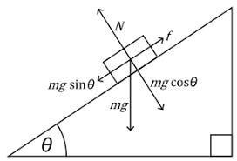

Frictional force= µN=µmgcosƟ

Total force=(mgsinƟ-µmgcosƟ)

ma=(mgsinƟ-µmgcosƟ)

a=(gsinƟ-µgcosƟ)

S=ut+1/2at2

S=ut+1/2(gsinƟ-µgcosƟ)t2

Calculate µ as you know all other quantities.

µ = g sinƟ-a/gcosƟ