Automated Locker Technical Documentation

**1. Safety Information** **1**

**2. Parts List** **2**

**3. Schematic Diagram** **3**

**4. Wiring** **4**

**5. Software** **5**

**6. 3D Printed Locker Plate** **7**

**7. 3D Printed Power Switch Cover** **8**

**8. How to Install in the Locker** **8**

## 1. Safety Information

PRODUCT SAFETY NOTICE: The use of a substitute replacement component which does not meet the same characteristics as the recommended replacement one, shown in the parts list in this Technical Documentation, may create shock, fire, or other hazards.

## 

## 

## 2. Parts List

|  |  |  |
| --- | --- | --- |
| **Section** | **Part** | **Schematic Symbol/Description** |
| **Circuit** | 12V 15.6Wh Li-ion Battery | V1, DeWalt DCB120 |
| 1N4004 Diode | D2 |
| Lock-style Solenoid | Solenoid_Lock, 18Ω Nominal DC Resistance |
| TIP102 BJT | Q1 |
| 2.2kΩ 1/4W Resistor | R1 |
| SPST Toggle Switch | S1, 6A 125VAC Maximum |
| 10uF 50V Capacitor **x 2** | C1, C3 |
| 4.7uF 50V Capacitor | C2 |
| 10uH Inductor | L1 |
| Buck Converter | A1, Recom Power R-78E5.0-0.5 |
| Resettable Fuse | U1, 300mA Hold Current |
| 5.1V Zener Diode | D1 |
| Perf Board | 3” x 4.5” |
| Enclosure | From DeWalt DCB107 Battery Charger |
| **Wiring** | 22AWG VW-1 Wire | Green, Yellow, Black, White, Red, Blue |
|  | 14-22AWG Wire Nut **x 3** | Gray (Color Code Standardized) |
|  | Male Jumper Wire x **3** | 22AWG or thicker |
|  | Cable Sleeving | 0.5” diameter |
| **Touchscreen** | 3.2” Touchscreen | 4D Systems ULCD-32PTU-AR |
|  | Micro SD Card | 2GB suggested |
|  | Screw **x 4** | M1.5 |
| **Mechanical** | U-bolt + 2 nuts | 1.5” * 2+” U-bolt |
|  | Cam lock | ¾” Diameter & 1” Length, 2” Custom-cut Cam |
|  | Grounding bolt & nut | If rightmost locker in bank: >=2” length  Otherwise: any length All: any diameter |
|  | 2 bolts + 2 nuts for mounting enclosure | Flat Phillips Head Bolts; <= ¼” diameter; length same as grounding bolt |

*Figure 1: Parts list*

## 3. Schematic Diagram

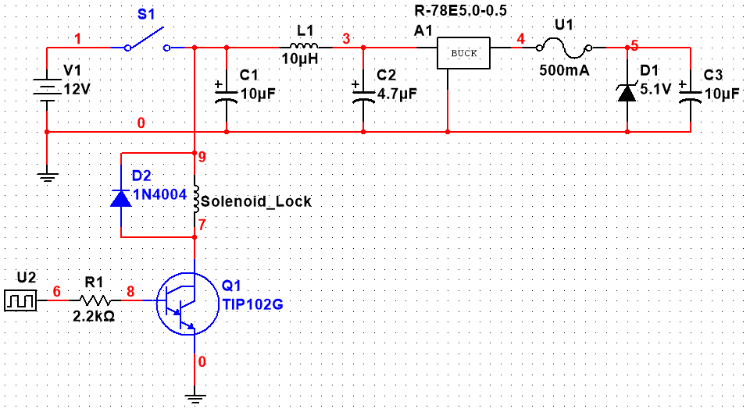

*Figure 2: Circuit Schematic*

Figure 2 above shows the circuit schematic. The 5VDC and GND supply rails for the touchscreen are taken from nodes 5 and 0, respectively. Component U2 represents the digital signal from I/O Pin 1 of the touchscreen.

The circuit is enclosed in a DeWalt DCB107 battery charger case. The contents of the charger were pulled out and discarded, with the exception of the battery connector. This is used to connect the battery to the perf board.

## 

## 

## 4. Wiring

|  |  |
| --- | --- |
| **Wire Color** | **Description** |
| Green | 12VDC |
| Yellow | 5VDC |
| Black | GND |
| White | I/O |
| Red | Solenoid + |
| Blue | Solenoid - |

*Figure 3: Wire Color Code Table*

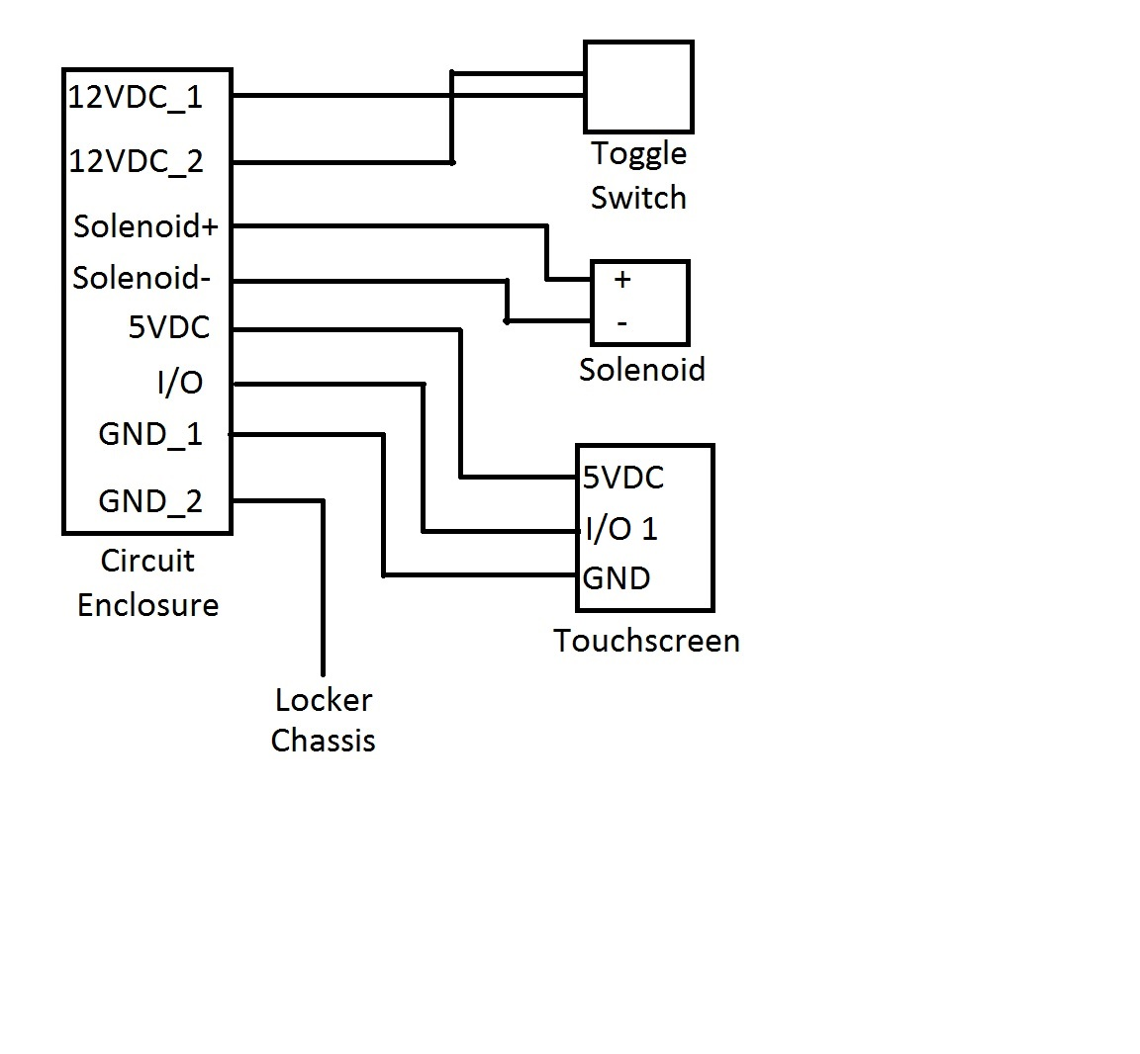

*Figure 4: Wiring Diagram*

## 

## 5. Software

1. 4D systems workshop 4 IDE. Used to write the code and flash the touchscreen.
2. How to flash the board:
   1. Plug the board into your computer with the USB-to-Serial Bridge adapter connected to the screen
   2. Install the 4D systems workshop software from <http://www.4dsystems.com.au/product/4D_Workshop_4_IDE>
   3. Open up the 4D systems workshop software
   4. If the software does not detect the board you may need to install the drivers from <http://www.silabs.com/products/development-tools/software/usb-to-uart-bridge-vcp-drivers>. You can check if the software detects the board by going to the COMMS tab in the IDE.
   5. Open the code named “[FinalTouchScreen.4dg](https://github.com/cooljjkid/AutomatedLocker/blob/master/FinalTouchScreen.4dg)” provided at: <https://github.com/cooljjkid/AutomatedLocker> with the IDE.
   6. Flash the screen by going to the project tab in the IDE. Make sure the proper display is chosen in the dropdown menu (ULCD-32PTU-AR).
   7. Choose to Run RAM as the Destination. The code will be saved to the board’s flash memory, and the program will be run from RAM.
3. Basic program flow: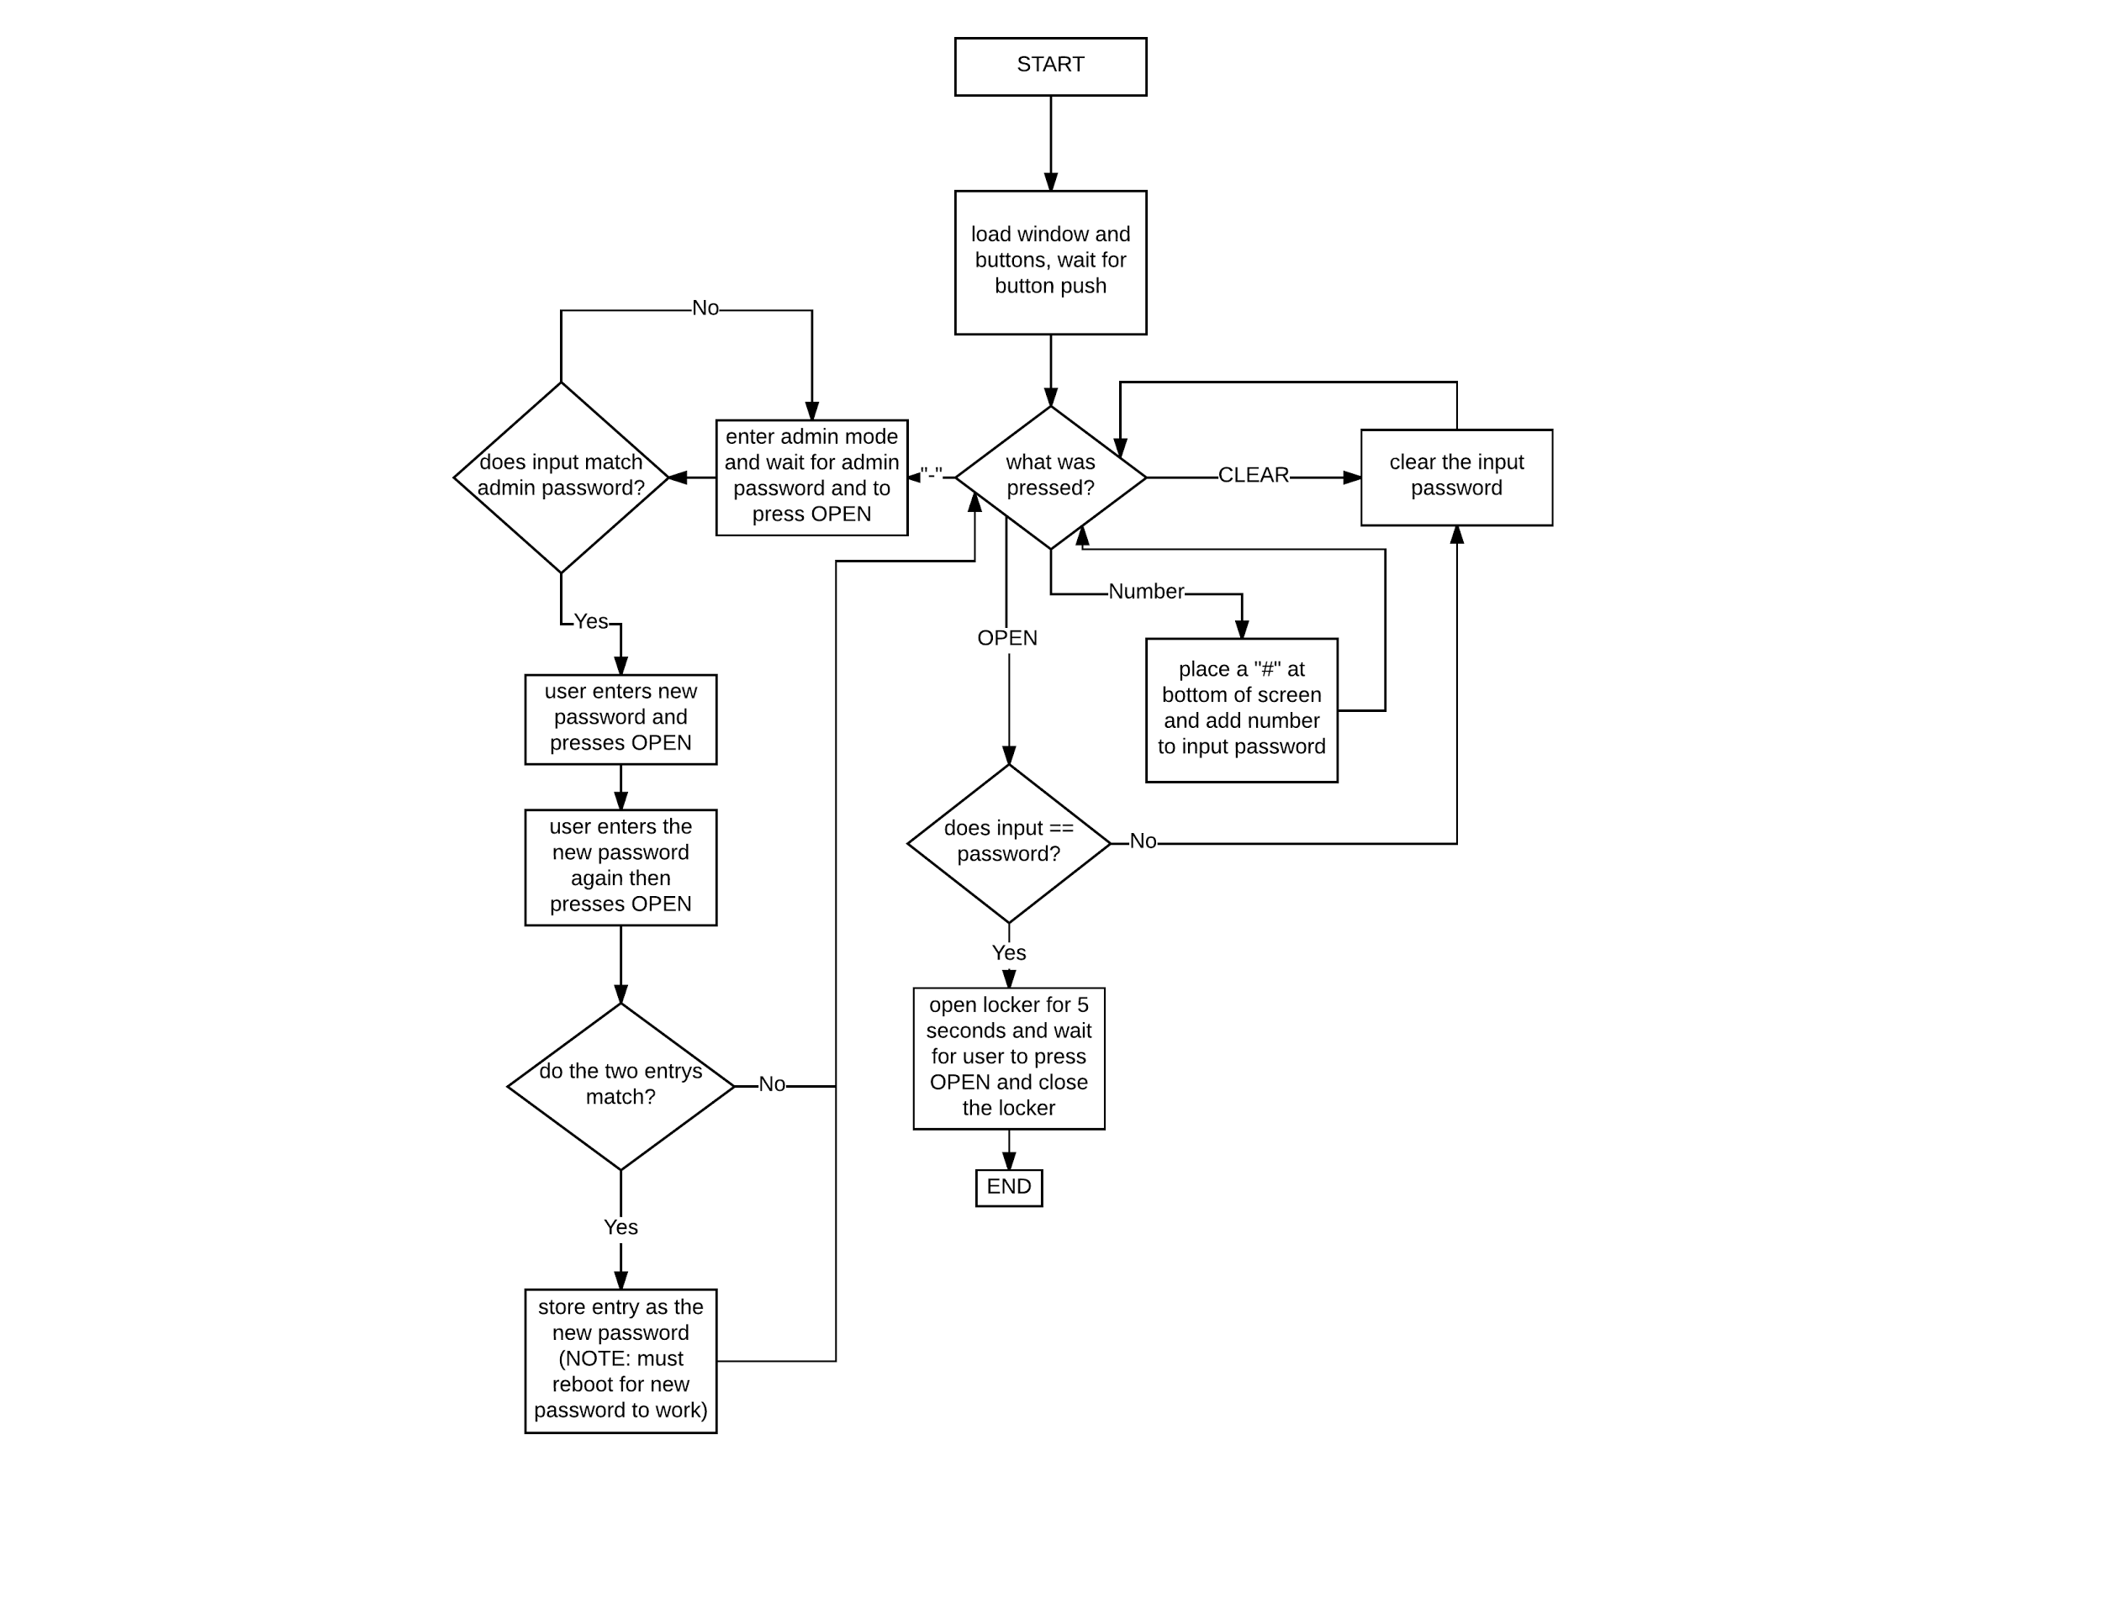

*Figure 5: Program Flow Chart*

## 6. 3D Printed Locker Plate

1. Use the stl file from <https://drive.google.com/open?id=0B5xdRFD_-BjmQXIwWnhReDVSWWM> to 3D print the front plate of the locker.

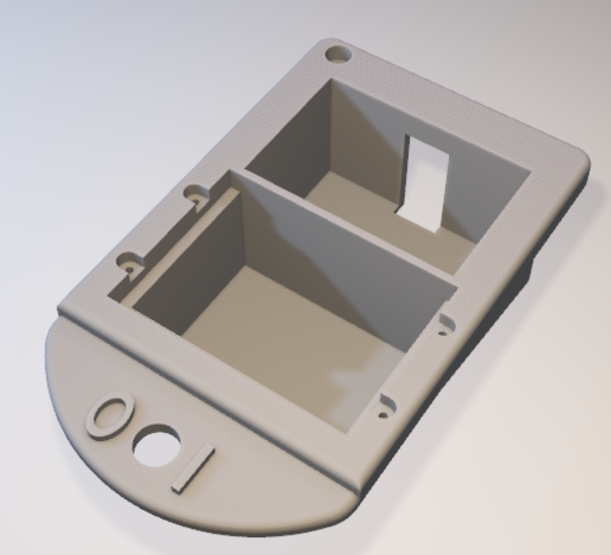

*Figure 6: Locker Plate*

1. Locker Plate dimensions:

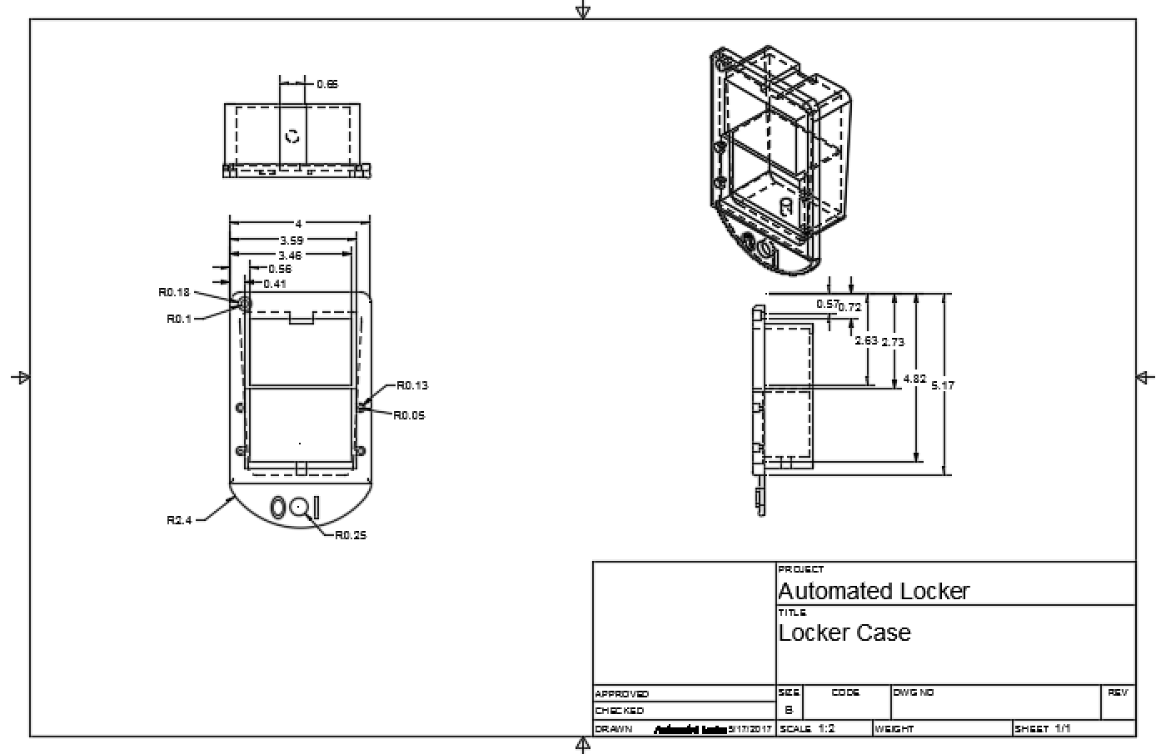

*Figure 7: Locker Plate Dimensions*

## 7. 3D Printed Power Switch Cover

1. 3D print the stl from <https://drive.google.com/open?id=0B5xdRFD_-BjmdUVNdHdacVpOSnc>.

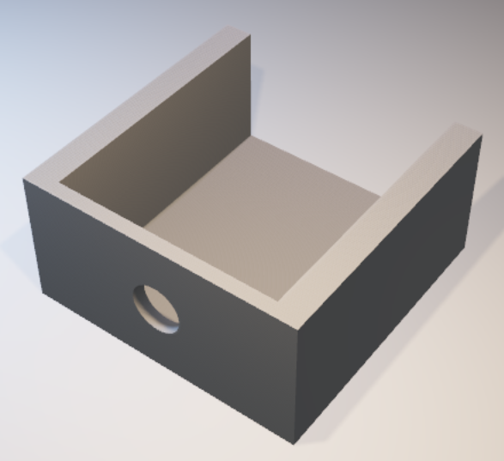

*Figure 8: Power Switch Cover*

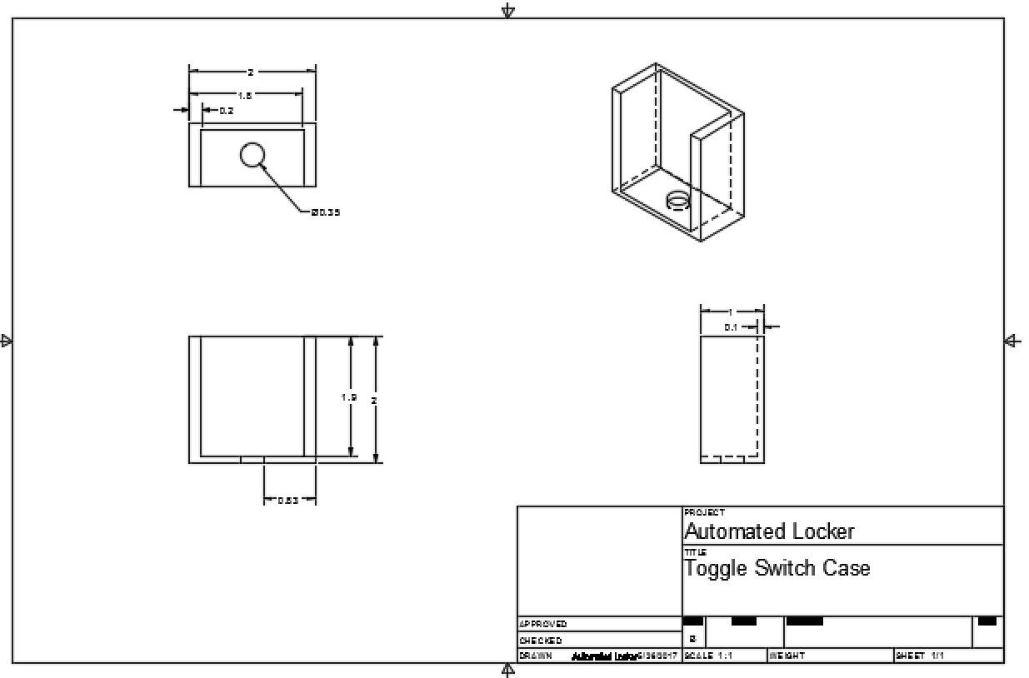

*Figure 9: Power Switch Cover Dimensions*

## 8. How to Install in the Locker

1. Remove the metal front plate of the locker by undoing the nut on the bottom of the plate inside the locker door.
2. Insert the 3D printed plate into the front of the locker where the metal plate was. Mark the outline of the top left hole and the bottom middle hole with a pen or pencil.
3. Cut the upper left hole to a diameter of 5/16 inches and the bottom middle hole to a diameter of about 1/2 inches using a drill. Verify the size of the bottom hole using the toggle switch and testing fit. Adjust as needed.
4. Screw the bolt removed from the metal plate into the top left hole of the new plastic plate and into the locker. Screw the toggle switch into the bottom hole.
5. You will now need access to the right side of the locker, either the locker next to it needs to be opened or the end cap must be accessible. If the locker is on the right end of the set then you will need two 2-inch screws and 2 nuts. If the locker is not on the end then 2 ¼-inch screws and 2 nuts will suffice.
6. On the upper right inside wall choose a place to drill a 5/16 inch hole for mounting the circuit enclosure (re-purposed Dewalt case) and make sure there is enough room in the locker for the case to hang. From that hole use a level and measure 4 inches across the side of the locker, place a mark and drill the second hole. Cut another hole anywhere near the circuit case and mount the grounding screw.
7. Hang the DeWalt case (inside the locker) from the screws used and tighten the nuts so that the case is held in place.
8. Hold the solenoid in the locker so that the locking mechanism is blocking the latch from being lifted like so:

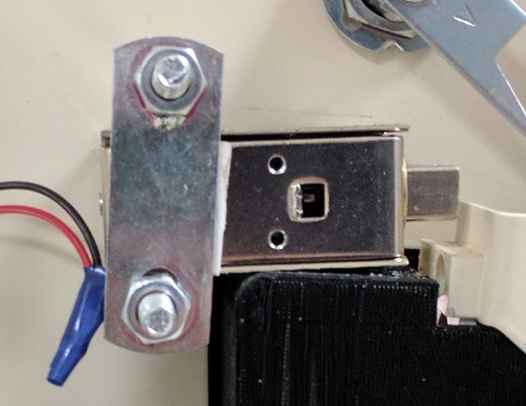

1. If you did not remove the bolt holes on the solenoid then just drill two screws and nuts through the solenoid to hold it to the locker.
2. If you do not have the mounting hardware on the solenoid then you have to use a U-bolt like in the image above. Use a pen to mark the top line of the solenoid in the correct place in the locker. Mark a hole for the U-bolt slightly above the line that was just drawn and out of the way of the locker front plate. Use a tape measure and wrap it around the locker and mark the point to drill from the front making sure that you will not be cutting into the front plate. Use a 5/16 inch drill bit. After that hole is drilled, use the U-bolt to measure and mark where the next hole should be cut; cut below the current hole. After both holes are cut, mount the solenoid using the U-bolt and tighten the clamps.
3. Cut the cam as shown in the picture below. You should be able to open the locker handle while moving the solenoid locking mechanism out of the way.

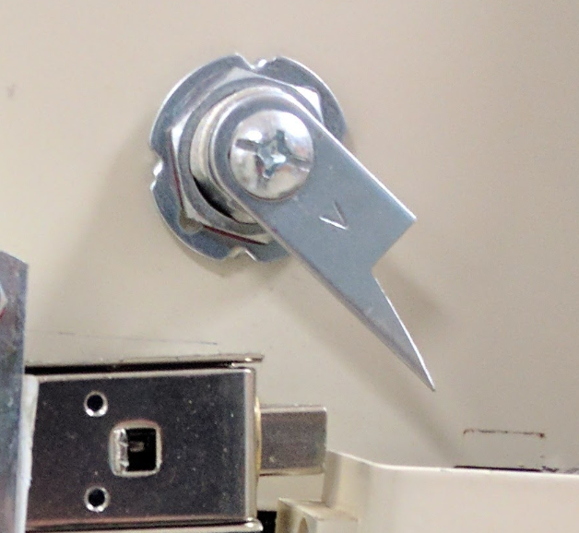

1. Hold the cam lock plate you just cut in place where it would be unlocking the locker and outline the hole at the top with a pen. Drill a ¾ inch hole where you just marked.
2. Insert the cam lock into the hole and tighten, making sure the manual override functionality works properly.
3. Refer to the wiring diagram on page 4 for how the wires should be connected. Make sure the battery is not plugged in during wire installation. Connect one ground wire to the locker grounding screw. Connect the solenoid wires with solder and heat-shrink tubing. Solder the 12VDC wire to the solder lugs of the toggle switch. Inside the front locker case, use wire nuts to attach the touchscreen wires to female jumper wires. Attach these jumper wires to the proper pins on the touchscreen. Test and make sure everything is working, then screw the screen into the front locker plate, glue the power switch cover in place, and glue all screen and switch wires where they exit the power switch cover.