Lab2Q4

## Loading required libraries

library(dplyr)  
library(ggplot2)

## Reading data

data = read.csv("June 10-July 12, 2015 - Gaming, Jobs and Broadband - CSV.csv")

### Removing the variables having more than 65% missing values

dt = data[, colMeans(is.na(data)) <= .65]

## Missing value imputation

We will replace the remaining missing values using Mode imputation

Mode <- function(x, na.rm = FALSE) {  
 if(na.rm){  
 x = x[!is.na(x)]  
 }  
   
 ux <- unique(x)  
 return(ux[which.max(tabulate(match(x, ux)))])  
}  
  
vec = c()  
for(n in names(dt))  
{  
 s = sum(is.na(dt[,n]))  
 if(s >0)  
 {  
 vec = c(vec,n)  
 }  
}  
  
for(var in vec)  
{  
 dt[is.na(dt[,var]),var] <- Mode(dt[,var],na.rm = T)  
}

## Converting selected variables to factor

conames = c("int_date","age","zipcode","weight","standwt","ï..psraid")  
dt[,!colnames(dt) %in% conames] = lapply(dt[,!colnames(dt) %in% conames], as.factor)

# How would you rate your community as a place to live?

Overall, how would you rate your community as a place to live? Would you say it is...

1 Excellent

2 Good

3 Only fair, OR

4 Poor?

8 (VOL.) Don't know

9 (VOL.) Refused

## Creating data frame with useful variables

q1 = select(dt,sample,lang,usr,cregion,state,form,sex,age,race,q1,marital,par,educ2,inc)

We will look at couple of graphs and variables to answer the above question

## Plot 1 : Age Distribution

ggplot(q1, aes(x = age)) + geom_histogram(color = "black", fill = "red")

## `stat_bin()` using `bins = 30`. Pick better value with `binwidth`.

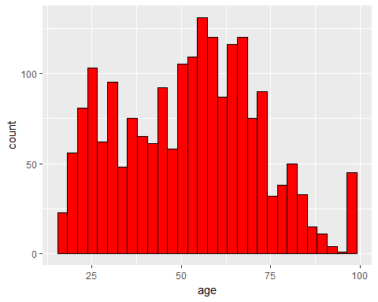

From the above plot, we can observe that most of the people belonging to age group 50-70 participated in survey.

## Plot 2 : q1 vs Race

ggplot(q1,aes(race,fill = race)) +geom_bar()

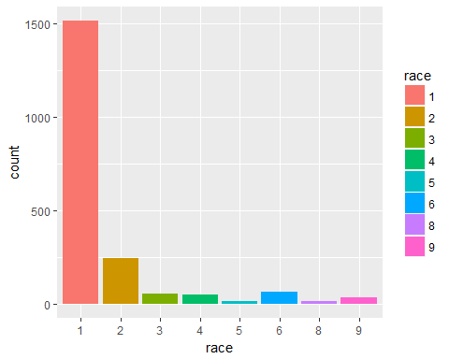

From the frequency curve, we can see that most surveys are from people belonging to race group 1, i.e, White

ggplot(q1,aes(q1,fill = race)) + geom_bar(position = "dodge")

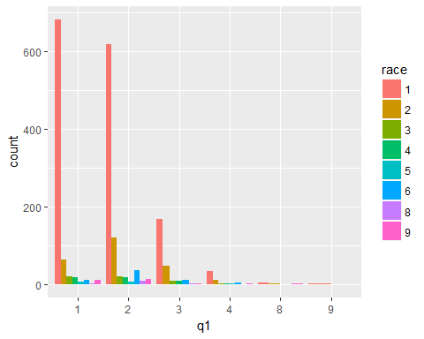

From the above curve we can conclude that ppl belonging to "White"" race have voted the most for Excellent/Good quality of life,while the minority race such as Native American/American Indian have voted the least for Excellent/Good quality of life.

## Plot 3 : q1 vs Sex

ggplot(q1,aes(q1,fill = sex)) + geom_bar(position = "dodge") + scale_fill_discrete(name="Sex",labels=c("Male", "Female"))

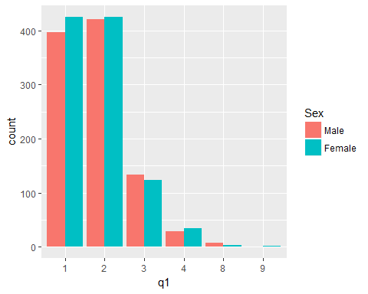

From the above plot,we can observe that more number of females have voted for "Excellent" quality while almost equal number of males and females have voted for "Good" quality.

## Plot 4 : q1 vs PAR

ggplot(q1, aes(x = q1, fill = par)) + geom_bar(position = "dodge") + scale_fill_discrete(name = "parent/guardian of children under age 18", labels = c("Yes","No","Refused"))

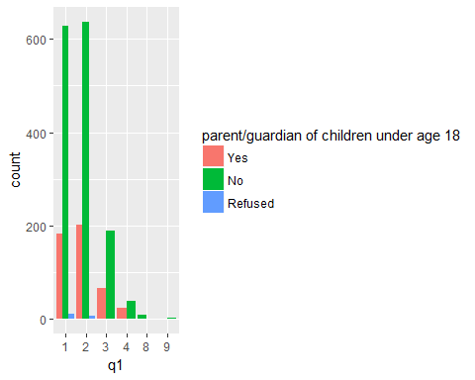

Survey states that people or guardian who doesn't have children under age 18 have rated more to "Excellent/Good" community to live in.

# Q2 Part(a) : Do you ever play video games on a computer, TV, game console, or portable device like a cell phone?

1 Yes

2 No

8 (VOL.) Don't know

9 (VOL.) Refused

Q2 <- select(dt,sample:q1,game1:game4,age,race,marital,par,educ2,inc)  
Q2 <- select(Q2, -(sample:form))  
Q2 <- select(Q2, -q1,-marital)  
levels(Q2$game1)[4] = "8"

## Plot 1: game1 vs Parent

ggplot(Q2, aes(x = game1, fill = par)) + geom_bar(position = "dodge") + scale_fill_discrete(name = "parent/guardian of children under age 18", labels = c("Yes","No","Refused"))

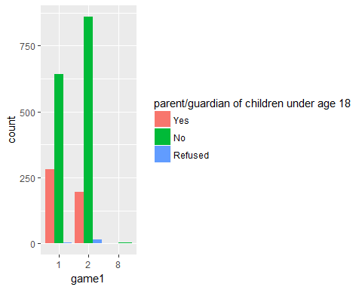

Survey states that people or guardian who doesn't have children under age 18 does not play video games.

# Q2 Part(b) : Video games are a waste of time

## Plot 2: game2b vs income

ggplot(Q2,aes(x = game2b, fill = inc)) + geom_bar() + facet_grid(~inc)

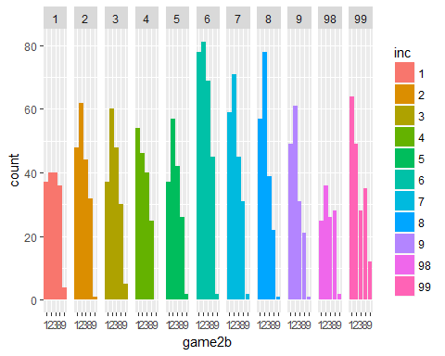

Most of the people believe that video games are waste of time is true for some of the games but not others,whereas people earning(30k-40k) believes that it is true for all games.

# Q2 Part(c) : Most people who play video games are men

## Plot 3: game3a vs sex

ggplot(Q2, aes(x = game3a, fill = sex)) + geom_bar(position = "dodge") + scale_fill_discrete(name = "Sex", labels = c("Male","Female"))

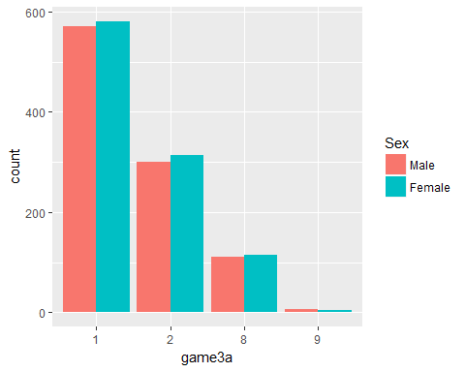

Almost everyone has agreed that most people who play video games are men.

# Q2 Part(d) : People who play violent video games are more likely to be violent themselves

## Plot 4 : game3b vs race

ggplot(Q2, aes(x = game3b, fill = race)) + geom_bar() + facet_grid(~race)

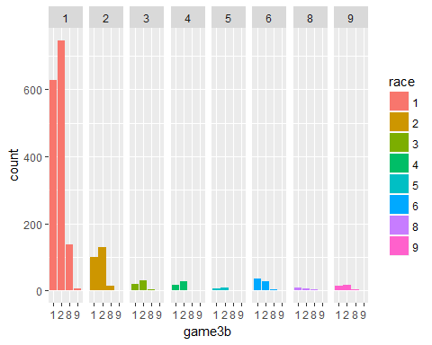

Survey states that a person from any race disagrees with the fact that b. People who play violent video games are more likely to be violent themselves.

# Q3 About how often do you use the internet?

About how often do you use the internet? [READ] {Modified Teens Relationships}

1 Almost constantly

2 Several times a day

3 About once a day

4 Several times a week, OR

5 Less often?

8 (VOL.) Don’t know

9 (VOL.) Refused

## Creating dataframe with useful variables

Q3 = select(dt,sample,lang,usr,cregion,state,sex,par,educ2,race,inc,age,emplnw,intfreq)

We will merge levels of some factors that do not provide much information

levels(Q3$intfreq)[7] = "8"  
levels(Q3$intfreq)

## [1] "1" "2" "3" "4" "5" "8"

levels(Q3$inc)[11] = "98"

We will be looking at couple of plots to draw inferences and relationship between internet frequency and other factors

## Plot 1 : intfreq

table(Q3$intfreq)

##   
## 1 2 3 4 5 8   
## 390 1115 211 137 136 12

ggplot(Q3,aes(intfreq)) + geom_bar(fill = "blue")

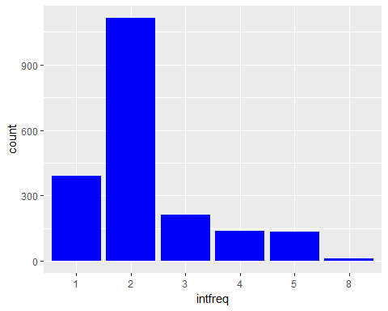

The above frequency tells us that majority of people voted for option 2 i.e. "Several times a day".

## Plot 2 : intfreq vs sex

ggplot(Q3,aes(intfreq,fill = sex)) + geom_bar(position = "dodge") + scale_fill_discrete(name="Sex",labels=c("Male", "Female"))

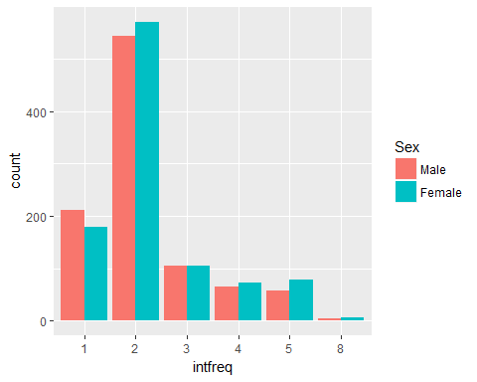

From the above plot, we can see that males tend to spend more time on internet while there are more number of female users than male users.

## Plot 3 : intfreq vs parental

ggplot(Q3,aes(intfreq,fill = par)) + geom_bar(position = "dodge") +scale_fill_discrete(name="Parental Status",labels=c("Yes", "No","Refused"))

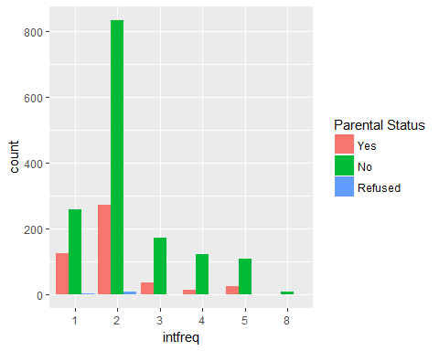

From the above graph, we can observe that the people who are parent of under 18 year age tend to use internet comparatively less.

## Plot 4 :intfreq vs age

ggplot(Q3,aes(y=age,x=intfreq)) + geom_boxplot(aes(fill = intfreq)) + scale_fill_discrete(name="Internet Frequency", labels=c("Constantly", "Several","Once/day","Several times/week","Less Often","Refused"))

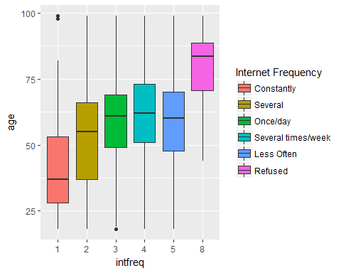

From the above plot,we can conclude that people belonging to younger age group(<40) tend to use internet more oftenly that others.

## Plot 5 : intfreq vs income

levels(Q3$inc)[11] = "98"  
ggplot(Q3,aes(x = intfreq,fill = inc)) + geom_bar() + facet_wrap(~inc)

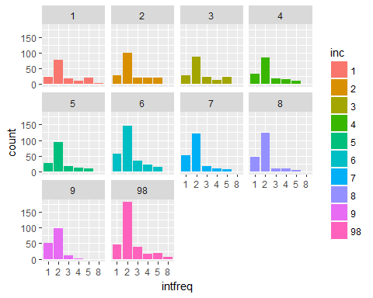

By observing the above plots carefully,we came to know that as income level of people increases they tend to spend more time on internet.