**React.js Component Creation**

**Name :Mounika Thota**

**Roll No :20KT1A05B0**

**College Name** **:Potti Sriramulu Chalavadi Mallikarjunarao College of Engineering & Technology**

**Source code:**

Button. Jsx:

import React from "react";

import './button.css'

/*function Button({ children, onClick, variant }) {

  const buttonClass = `button button-${variant}`;

  return (

    <button className={buttonClass} onClick={onClick}>

      {children}

    </button>

  );

}*/

export const Button = ({buttonClick,show}) => {

  return (

    <button onClick={buttonClick}>

        {show ? 'show less' : 'show more' }

    </button>

  )

}

//export default Button;

Button.css:

button {

    outline: none;

    border: none;

    width: 90%;

    padding: 10px 5px;

    background: aqua;

    border-radius: 5px;

    font-weight: bold;

    margin-inline: auto;

}

button:hover {

    opacity: .6;

}

Card.Jsx:

import React,{useState} from 'react';

import {Button} from '../buttons/Button'

import './card.css'

export const Card = ({card}) => {

    const [show,setshoW] =useState(false)

    function buttonClick(){

        setshoW(!show);

    }

    return (

        <div className={show ? "card show" : "card"}>

            <div className="image">

            <img src={card.url} alt="" />

            </div>

            <h3>{card.title}</h3>

            {

                show && <p>{card.description}</p>

            }

            <Button buttonClick ={buttonClick} show={show}/>

        </div>

    )

}

Card.css:

.card {

    padding: 10px;

    border: 1px solid #000;

    border-radius: 10px;

    flex-shrink: 0;

    flex-grow: 0;

    background-color: #fff;

    width: 300px;

    height: 250px;

    display: flex;

    flex-direction: column;

    align-items: center;

}

.card.show {

    height: 350px;

}

.card .image {

    border-radius: 6px;

    overflow: hidden;

    background: red;

}

.card .image img {

    width: 100%;

    height: 100%;

    object-fit: cover;

}

.card .image img:hover {

    transform: scale(1.2);

}

.card h3 {

    text-align: center;

    margin: 6px;

}

.card p {

    text-align: justify;

    width: 240px;

    padding: 10px 0px;

}

App.css:

* {

    margin: 0;

    padding: 0;

    box-sizing: border-box;

    transition: .3s;

}

::-webkit-scrollbar {

    display: none;

}

.app {

    height: 100vh;

    padding: 20px;

    display: flex;

    justify-content: space-between;

    align-items: center;

    gap: 20px;

    overflow: scroll;

    background: #000;

}

App.js:

import './App.css';

import { Card } from './components/card/Card'; // Assuming Card component is in './components/Card'

import image1 from './images/image1.jpeg'; // Corrected import paths

import image2 from './images/image2.jpeg';

import image3 from './images/image3.jpeg';

import image4 from './images/image4.jpeg';

import image5 from './images/image5.jpeg';

function App() {

    const cards = [{

            url: image1,

            title: "Girl",

            description: "the definition of a sketch drawing artist notes down his preliminary ideas for a work"

        },

        {

            url: image2,

            title: "Flute",

            description: "the definition of a sketch drawing artist notes down his preliminary ideas for a work"

        },

        {

            url: image3,

            title: "Elephant",

            description: "the definition of a sketch drawing artist notes down his preliminary ideas for a work"

        },

        {

            url: image4,

            title: "Krishna",

            description: "the definition of a sketch drawing artist notes down his preliminary ideas for a work"

        },

        {

            url: image5,

            title: "Father&Daughter",

            description: "the definition of a sketch drawing artist notes down his preliminary ideas for a work"

        },

    ]

    return ( <

            div className = "app" > {

                cards.map((card, index) => < Card key = { index }

                    card = { card }

                    />)}</div >

                );

            }

            export default App;

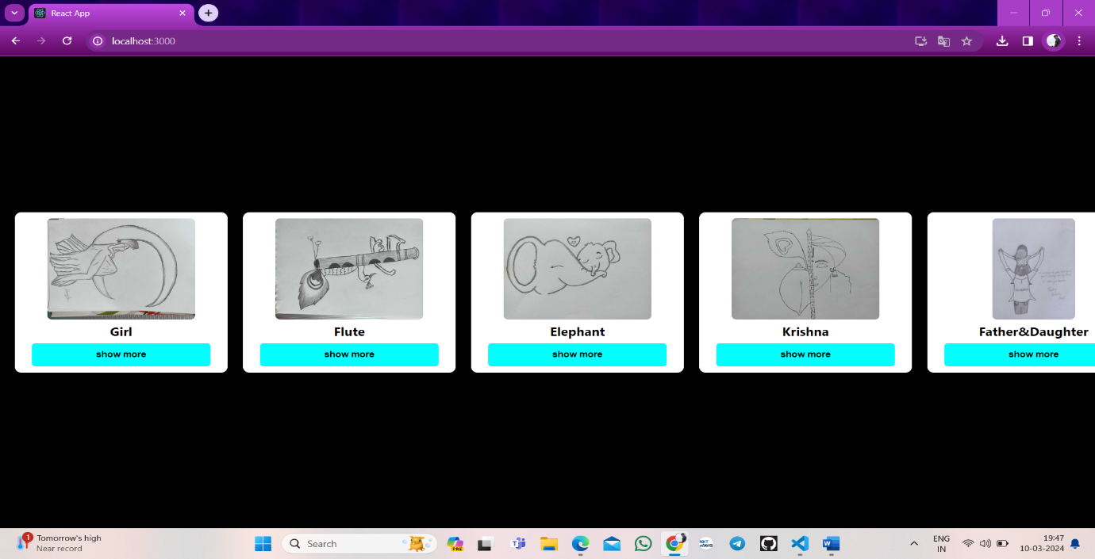**OUTPUTS:**

