Ex:8 Designing User Interface (UI) Wireframes for an E-commerce Mobile Application(Balsamiq)

Aim
To design and document the sequential user flow of a mobile e-commerce application, focusing on the journey from product discovery to successful order placement.
Procedure
The design process followed a standard 6-stage user flow:
- Home Screen Design: Created a landing page featuring a search bar, a grid layout for featured products/categories, and a bottom navigation bar for easy access to Home, Categories, Cart, and Profile.
- Category Selection: Developed a "Categories" page organized by gender (Men, Women) and product types (Pants, Shirts, Sarees, etc.) to help users narrow their search.
- Product Listing: Designed a results page that displays product thumbnails, search functionality, and star ratings to assist in user decision-making.
- Product Detail View: Created a dedicated page for a specific item (e.g., "Pants") showing price (₹599), product descriptions, ratings, and primary call-to-action buttons like "Add to Cart" and "Buy Now."
- Checkout & Payment: Developed a checkout interface listing various payment methods, including Debit Card, Credit Card, UPI, and Cash on Delivery (COD), with a final "Place Order" button.
- Confirmation Screen: Designed a final success state featuring a visual confirmation (green checkmark), an "Order Placed Successfully" message, and options to "Track Order" or return "Back" to the home screen.

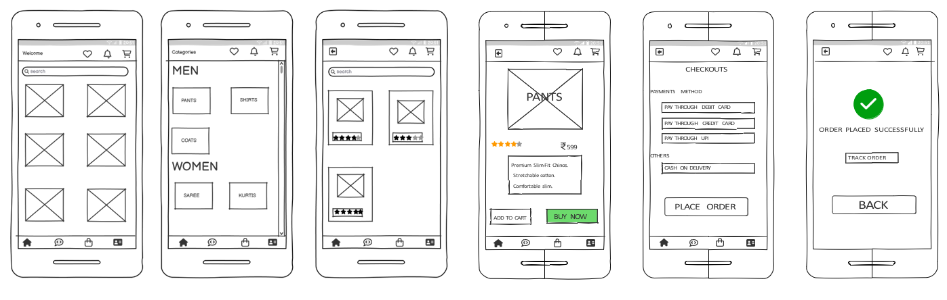

Results
The wireframes successfully illustrate a logical and intuitive User Experience (UX).

