PYTHON ACTIVITY-BASED LEARNING
CASE STUDY 11
Examination Result and Grace-Mark Validation
B.Tech First Year – CSE | Python Programming

1. Problem Statement
Process marks across multiple subjects, apply subject-wise pass criteria and a specified grace-mark policy, and generate final classifications without exceeding maximum marks.

2. Objectives
- Calculate total and percentage from subject marks.
- Check subject-wise pass marks.
- Apply a limited grace-mark rule where permitted.
- Display final result and classification.

3. Assumptions
- There are 3 subjects, each out of 100.
- Pass mark is 40 in each subject.
- At most 5 grace marks may be added to one failed subject.
- Grace marks cannot make a subject exceed 100.
- Classification is Distinction at 75% or above, First Class at 60% or above, otherwise Pass.

4. Algorithm
1. Start
2. Read marks for three subjects
3. For each subject, if it is below 40 by at most 5, add required grace marks
4. Calculate total and percentage
5. Determine pass/fail and classification
6. Display final marks and result
7. Stop

5. Flowchart
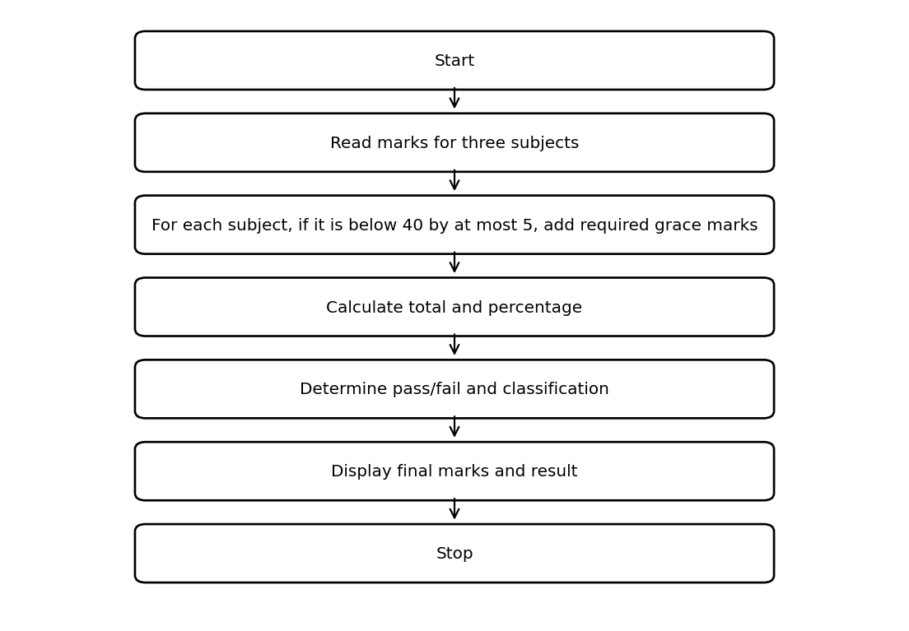

6. Pseudocode
START
INPUT marks[0], marks[1], marks[2]
FOR each mark
IF mark < 40 AND (40 - mark) <= 5 THEN mark = 40
END FOR
total = SUM(marks)
percentage = total / 3
IF any mark < 40: result = Fail
ELSE classify percentage
OUTPUT marks, total, percentage, result
STOP

7. Python Source Code
marks = [int(input("Enter marks for subject 1: ")),
int(input("Enter marks for subject 2: ")),
int(input("Enter marks for subject 3: "))]
pass_mark = 40
grace_limit = 5
grace_used = 0
for i in range(len(marks)):
if marks[i] < pass_mark and pass_mark - marks[i] <= grace_limit:
marks[i] = pass_mark
grace_used += pass_mark - (marks[i] - (pass_mark - marks[i]))
total = sum(marks)
percentage = total / len(marks)
if min(marks) < pass_mark:
result = "Fail"
elif percentage >= 75:
result = "Distinction"
elif percentage >= 60:
result = "First Class"
else:
result = "Pass"
print("Final marks:", marks)
print("Total:", total)
print("Percentage:", percentage)
print("Result:", result)

8. Test Cases
Test | Input / Scenario | Expected Result
1 | Subject 1: 42, Subject 2: 38, Subject 3: 66 | Matches sample output below
2 | Invalid / boundary values as applicable | Program handles conditions using stated rules

9. Output Screenshot
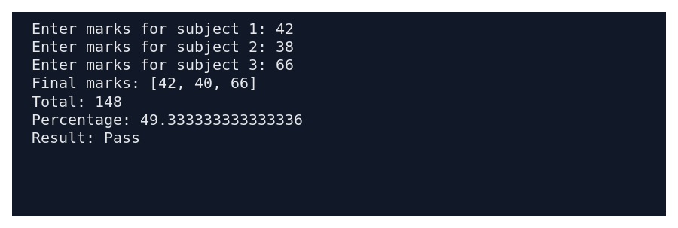

10. Sample Output
Enter marks for subject 1: 42
Enter marks for subject 2: 38
Enter marks for subject 3: 66
Final marks: [42, 40, 66]
Total: 148
Percentage: 49.333333333333336
Result: Pass

11. Conclusion
This case study demonstrates how basic Python concepts can be used to solve the problem of examination result and grace-mark validation. The program uses simple data structures, conditions, loops, and calculations to produce the required result.
Submitted by: ____________________ Roll No.: ____________________

