PYTHON ACTIVITY-BASED LEARNING
CASE STUDY 17
Student Performance Trend Analysis
B.Tech First Year – CSE | Python Programming

1. Problem Statement
Compare assessment scores across multiple examinations, calculate improvements and declines, identify consistently weak subjects, and classify students according to defined criteria.

2. Objectives
- Store scores from two exams.
- Calculate subject-wise changes.
- Identify improvement or decline.
- Find the lowest-scoring subject.

3. Assumptions
- Three subjects are considered.
- Each subject has marks out of 100.
- A change of 5 marks or more is reported as a notable trend.

4. Algorithm
1. Start
2. Store subject names and two exam score lists
3. Loop through subjects
4. Calculate exam 2 minus exam 1
5. Print trend
6. Find minimum score in exam 2
7. Print weakest subject
8. Stop

5. Flowchart
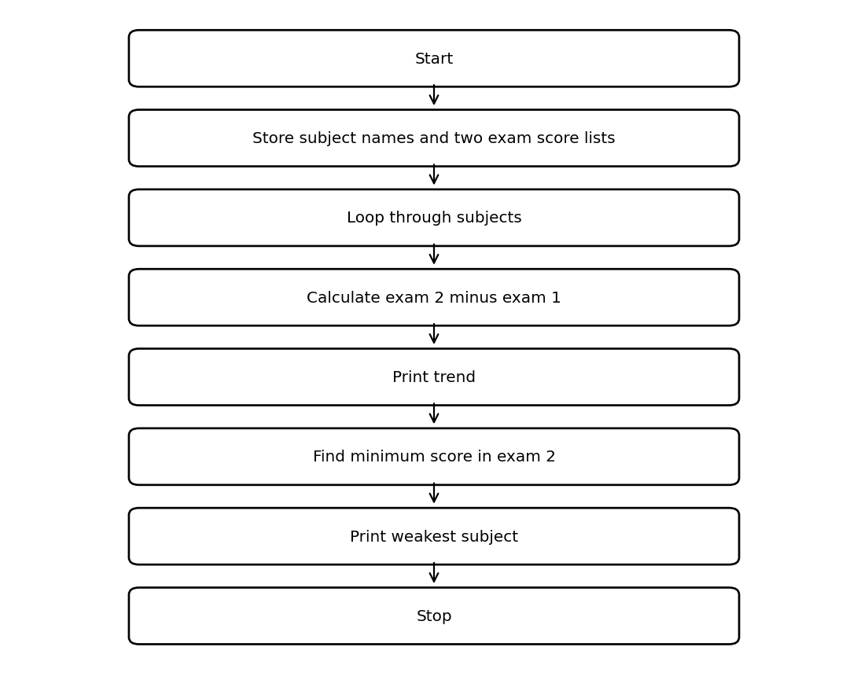

6. Pseudocode
START
subjects = [Python, Maths, English]
exam1 = [65,72,58]
exam2 = [78,68,64]
FOR i from 0 to 2
change = exam2[i] - exam1[i]
DISPLAY subject and change trend
END FOR
weakest = subject at minimum exam2 score
DISPLAY weakest
STOP

7. Python Source Code
subjects = ["Python", "Maths", "English"]
exam1 = [65, 72, 58]
exam2 = [78, 68, 64]
for i in range(len(subjects)):
change = exam2[i] - exam1[i]
if change > 0:
trend = "Improved"
elif change < 0:
trend = "Declined"
else:
trend = "No change"
print(subjects[i], "change:", change, "-", trend)
weak_index = exam2.index(min(exam2))
print("Weakest subject:", subjects[weak_index])

8. Test Cases
Test | Input / Scenario | Expected Result
1 | Use the sample values defined in the program | Matches sample output below
2 | Invalid / boundary values as applicable | Program handles conditions using stated rules

9. Output Screenshot
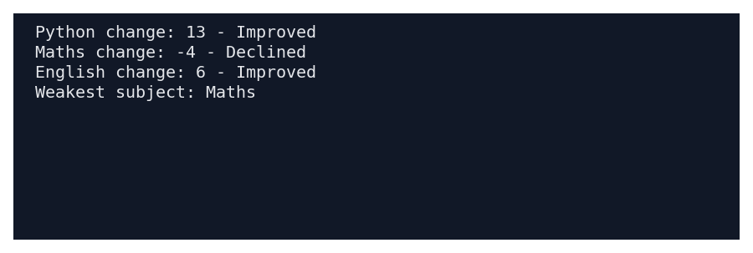

10. Sample Output
Python change: 13 - Improved
Maths change: -4 - Declined
English change: 6 - Improved
Weakest subject: Maths

11. Conclusion
This case study demonstrates how basic Python concepts can be used to solve the problem of student performance trend analysis. The program uses simple data structures, conditions, loops, and calculations to produce the required result.
Submitted by: ____________________ Roll No.: ____________________

