PYTHON ACTIVITY-BASED LEARNING
CASE STUDY 19
Multi-Product Shopping Budget Constraint
B.Tech First Year – CSE | Python Programming

1. Problem Statement
Evaluate a shopping basket containing multiple products and quantities, apply discount conditions, and determine which purchases must be reduced to remain within a fixed budget.

2. Objectives
- Calculate product-wise costs.
- Apply a discount when the subtotal reaches a threshold.
- Compare the final bill with a budget.
- Display the amount over or under budget.

3. Assumptions
- Products are stored in lists.
- A 10% discount applies when subtotal is at least ₹1,000.
- Budget is ₹1,500.
- No tax is included.

4. Algorithm
1. Start
2. Store product names, prices, quantities
3. Calculate each product cost and subtotal
4. Apply 10% discount if subtotal ≥ 1000
5. Calculate final bill
6. Compare bill with budget
7. Display result
8. Stop

5. Flowchart
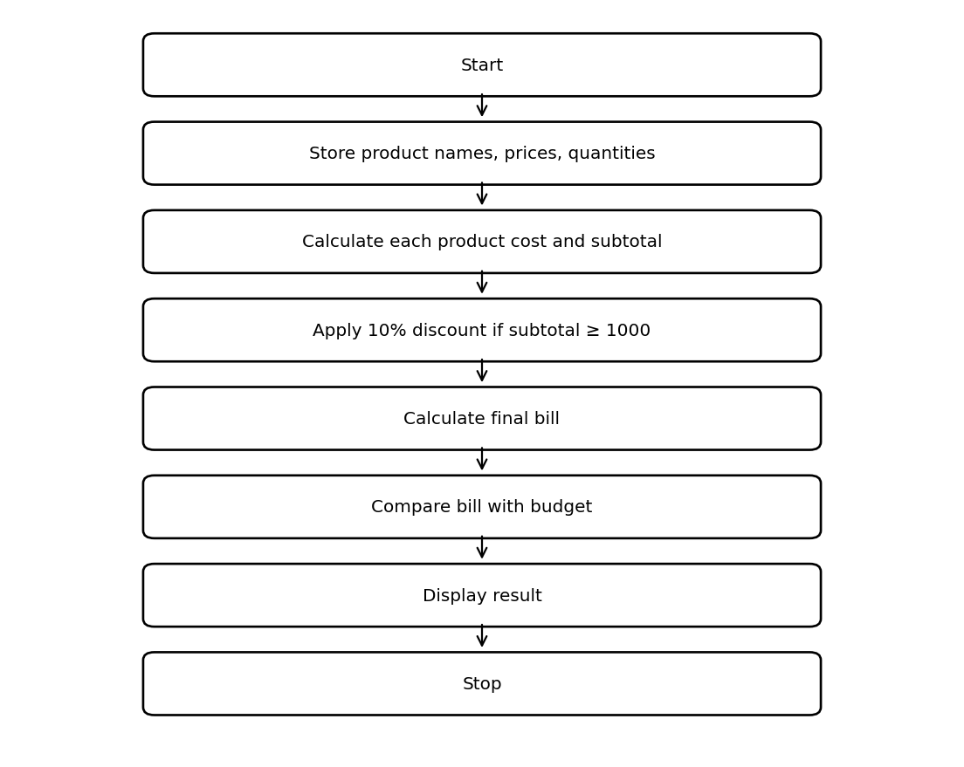

6. Pseudocode
START
subtotal = 0
FOR each product
cost = price * quantity
subtotal = subtotal + cost
END FOR
IF subtotal >= 1000: discount = subtotal * 0.10
ELSE discount = 0
total = subtotal - discount
IF total > budget: DISPLAY over budget
ELSE DISPLAY remaining balance
STOP

7. Python Source Code
products = ["Notebook", "Pen", "Bag"]
prices = [80, 20, 900]
quantities = [3, 5, 1]
subtotal = 0
for i in range(len(products)):
cost = prices[i] * quantities[i]
subtotal += cost
print(products[i], ":", cost)
discount = 0
if subtotal >= 1000:
discount = subtotal * 0.10
total = subtotal - discount
budget = 1500
print("Subtotal:", subtotal)
print("Discount:", discount)
print("Final bill:", total)
if total > budget:
print("Over budget by:", total - budget)
else:
print("Within budget. Balance:", budget - total)

8. Test Cases
Test | Input / Scenario | Expected Result
1 | Use the sample values defined in the program | Matches sample output below
2 | Invalid / boundary values as applicable | Program handles conditions using stated rules

9. Output Screenshot
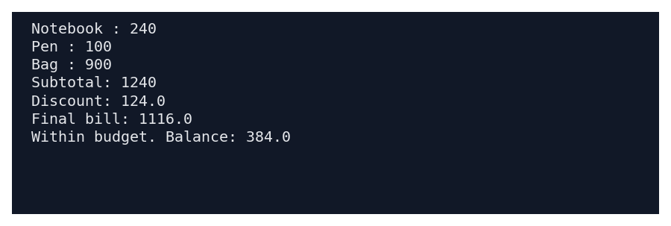

10. Sample Output
Notebook : 240
Pen : 100
Bag : 900
Subtotal: 1240
Discount: 124.0
Final bill: 1116.0
Within budget. Balance: 384.0

11. Conclusion
This case study demonstrates how basic Python concepts can be used to solve the problem of multi-product shopping budget constraint. The program uses simple data structures, conditions, loops, and calculations to produce the required result.
Submitted by: ____________________ Roll No.: ____________________

