PYTHON ACTIVITY-BASED LEARNING
CASE STUDY 20
University Admission Decision Engine
B.Tech First Year – CSE | Python Programming

1. Problem Statement
Evaluate candidates using subject eligibility, aggregate marks, course-specific thresholds, and tie-breaking criteria; generate a ranked list of eligible applicants.

2. Objectives
- Check eligibility conditions.
- Calculate aggregate percentage.
- Select eligible candidates.
- Rank candidates by score.

3. Assumptions
- Each candidate has Math, Physics, and Computer marks.
- Minimum mark in each subject is 40.
- Aggregate percentage must be at least 60.
- Candidates are ranked by aggregate percentage, highest first.

4. Algorithm
1. Start
2. Store candidate records
3. Calculate each candidate's average
4. Check minimum subject marks and average threshold
5. Add eligible candidate to list
6. Sort eligible candidates by average descending
7. Display ranked list
8. Stop

5. Flowchart
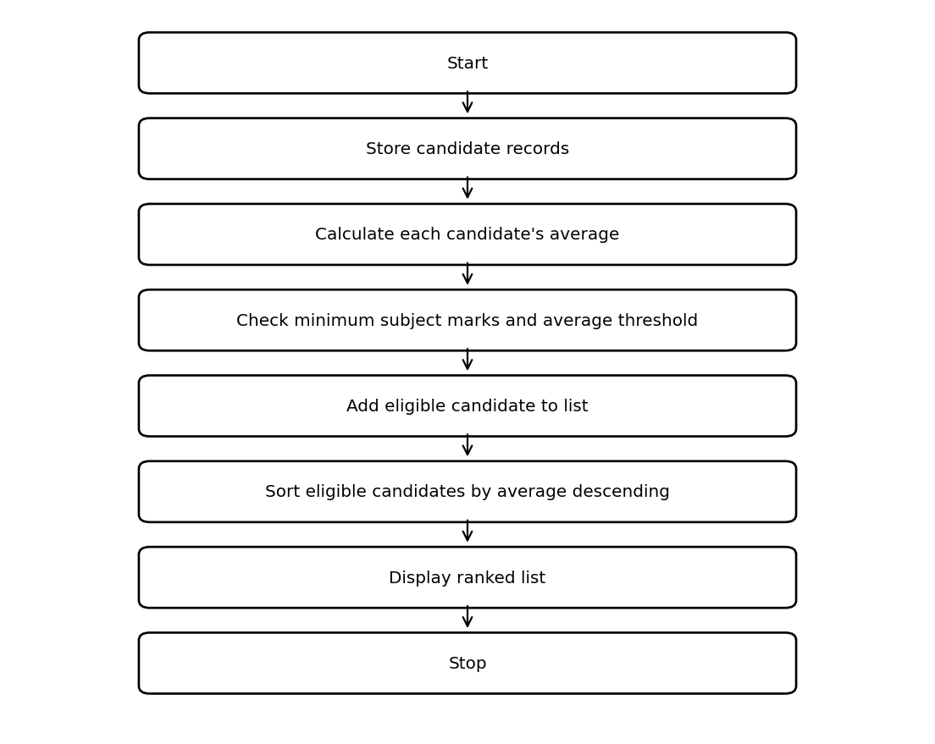

6. Pseudocode
START
eligible = empty list
FOR each candidate tuple
average = sum(subject marks) / 3
IF every subject >= 40 AND average >= 60
ADD (name, average) to eligible
END IF
END FOR
SORT eligible by average descending
DISPLAY ranking
STOP

7. Python Source Code
candidates = [
("Asha", 80, 75, 90),
("Ravi", 55, 62, 70),
("Mina", 35, 88, 91),
("Kiran", 70, 70, 70)
]
eligible = []
for name, math, physics, computer in candidates:
average = (math + physics + computer) / 3
if math >= 40 and physics >= 40 and computer >= 40 and average >= 60:
eligible.append((name, average))
eligible.sort(key=lambda item: item[1], reverse=True)
print("Admission ranking")
for rank, candidate in enumerate(eligible, start=1):
print(rank, candidate[0], round(candidate[1], 2))

8. Test Cases
Test | Input / Scenario | Expected Result
1 | Use the sample values defined in the program | Matches sample output below
2 | Invalid / boundary values as applicable | Program handles conditions using stated rules

9. Output Screenshot


10. Sample Output
Admission ranking
1 Asha 81.67
2 Kiran 70.0
3 Ravi 62.33

11. Conclusion
This case study demonstrates how basic Python concepts can be used to solve the problem of university admission decision engine. The program uses simple data structures, conditions, loops, and calculations to produce the required result.
Submitted by: ____________________ Roll No.: ____________________

