PYTHON ACTIVITY-BASED LEARNING
CASE STUDY 21
Traffic Violation Penalty Calculator
B.Tech First Year – CSE | Python Programming

1. Problem Statement
Process multiple violations using vehicle category, offence type, repeat-offence status, and predefined fine rules; calculate the final penalty and identify disqualification conditions.

2. Objectives
- Store violation types and fines.
- Apply repeat-offence penalties.
- Calculate total fine.
- Identify disqualification when a severe offence occurs.

3. Assumptions
- Fine amounts are sample values for this programming exercise only.
- Helmet violation = ₹500; signal violation = ₹1,000; overspeeding = ₹2,000.
- Repeat offences double the fine.
- A severe overspeeding offence is marked for review.

4. Algorithm
1. Start
2. Store violation list, repeat flags, and fine table
3. Loop through violations
4. Get base fine
5. Double fine if repeat offence
6. Add fine to total
7. Check severe violation
8. Display total and review status
9. Stop

5. Flowchart
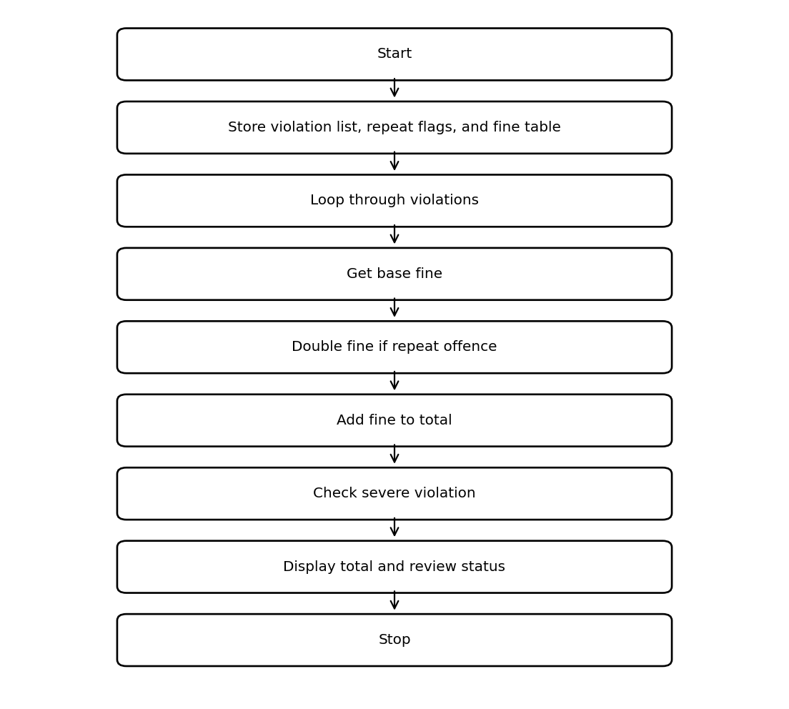

6. Pseudocode
START
total = 0
FOR each violation
fine = fine_table[violation]
IF repeat: fine = fine * 2
total = total + fine
IF violation is overspeed: review = True
END FOR
DISPLAY total
IF review: DISPLAY review message
STOP

7. Python Source Code
violations = ["helmet", "signal", "overspeed"]
repeat = [False, True, False]
fine_table = {"helmet": 500, "signal": 1000, "overspeed": 2000}
total = 0
review = False
for i in range(len(violations)):
fine = fine_table[violations[i]]
if repeat[i]:
fine = fine * 2
total += fine
print(violations[i], "fine:", fine)
if violations[i] == "overspeed":
review = True
print("Total fine:", total)
if review:
print("Status: Requires review")

8. Test Cases
Test | Input / Scenario | Expected Result
1 | Use the sample values defined in the program | Matches sample output below
2 | Invalid / boundary values as applicable | Program handles conditions using stated rules

9. Output Screenshot
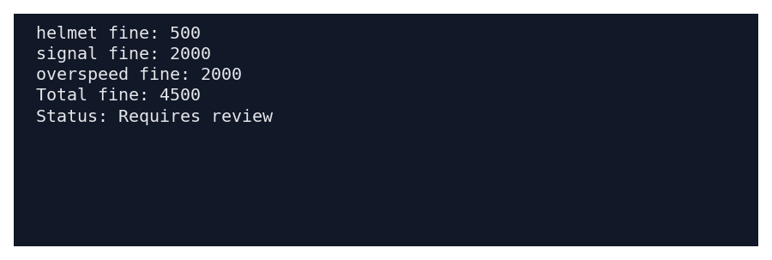

10. Sample Output
helmet fine: 500
signal fine: 2000
overspeed fine: 2000
Total fine: 4500
Status: Requires review

11. Conclusion
This case study demonstrates how basic Python concepts can be used to solve the problem of traffic violation penalty calculator. The program uses simple data structures, conditions, loops, and calculations to produce the required result.
Submitted by: ____________________ Roll No.: ____________________

