PYTHON ACTIVITY-BASED LEARNING
CASE STUDY 26
Nested Loop Examination Seating Generator
B.Tech First Year – CSE | Python Programming

1. Problem Statement
Generate a seating arrangement with row and column identifiers, reserved positions, alternate seating restrictions, and fixed classroom capacities.

2. Objectives
- Generate seats using nested loops.
- Mark reserved positions.
- Apply alternate seating restrictions.
- Display the seating layout.

3. Assumptions
- Classroom has 3 rows and 4 columns.
- Seats (1,2) and (2,3) are reserved.
- Only odd-numbered columns are available for this exercise.

4. Algorithm
1. Start
2. Set row and column counts
3. Store reserved seats
4. For each row, create an empty row
5. For each column, check reserved status
6. Otherwise mark even columns unavailable and odd columns available
7. Print each row
8. Stop

5. Flowchart
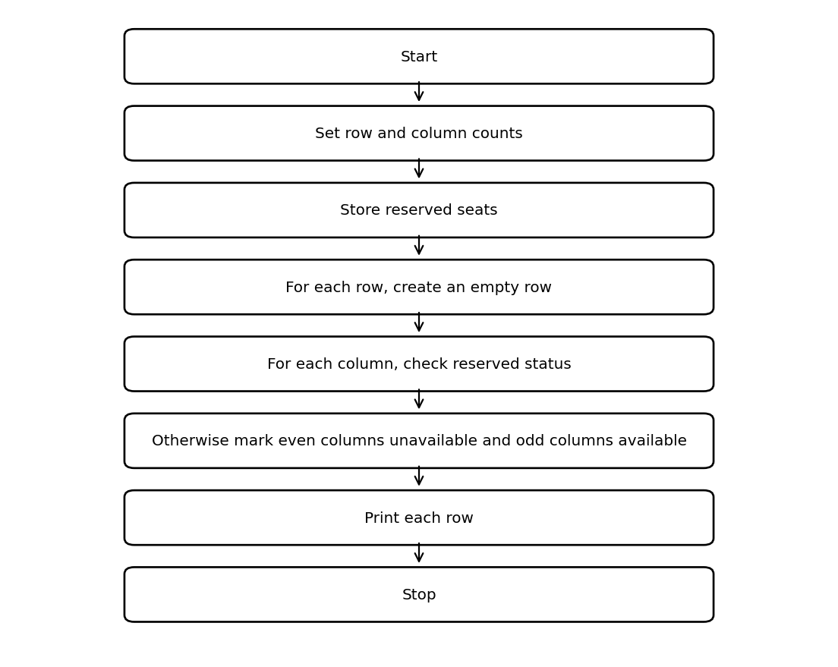

6. Pseudocode
START
rows = 3; columns = 4
reserved = [(1,2),(2,3)]
FOR r = 1 to rows
FOR c = 1 to columns
IF (r,c) reserved: seat = R
ELSE IF c even: seat = X
ELSE: seat = S
DISPLAY seat
END FOR
END FOR
STOP

7. Python Source Code
rows = 3
columns = 4
reserved = [(1, 2), (2, 3)]
for r in range(1, rows + 1):
line = []
for c in range(1, columns + 1):
if (r, c) in reserved:
seat = "R"
elif c % 2 == 0:
seat = "X"
else:
seat = "S"
line.append(seat)
print("Row", r, ":", " ".join(line))

8. Test Cases
Test | Input / Scenario | Expected Result
1 | Use the sample values defined in the program | Matches sample output below
2 | Invalid / boundary values as applicable | Program handles conditions using stated rules

9. Output Screenshot
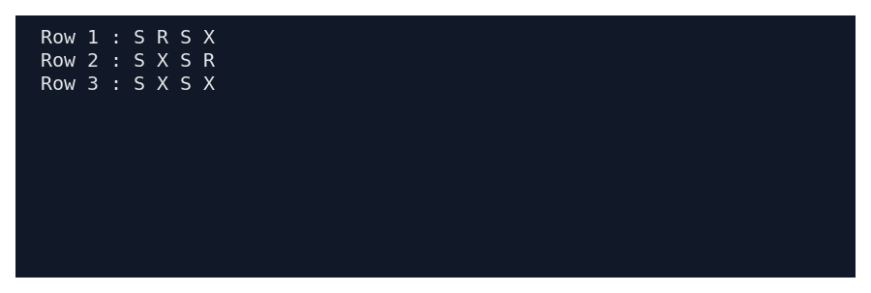

10. Sample Output
Row 1 : S R S X
Row 2 : S X S R
Row 3 : S X S X

11. Conclusion
This case study demonstrates how basic Python concepts can be used to solve the problem of nested loop examination seating generator. The program uses simple data structures, conditions, loops, and calculations to produce the required result.
Submitted by: ____________________ Roll No.: ____________________

