PYTHON ACTIVITY-BASED LEARNING
CASE STUDY 27
Advanced Numeric Pattern Generator
B.Tech First Year – CSE | Python Programming

1. Problem Statement
Produce a hollow diamond or symmetric numerical pattern based on user-specified dimensions, with validation for invalid dimensions and carefully aligned output.

2. Objectives
- Read a pattern size.
- Validate that size is positive.
- Generate a symmetric number pattern using loops.
- Display the pattern.

3. Assumptions
- The example uses size 4.
- The pattern is a centered number pyramid.
- Each row prints numbers from 1 through its row number.

4. Algorithm
1. Start
2. Read size n
3. If n ≤ 0, display invalid size
4. Otherwise loop i from 1 to n
5. Print leading spaces
6. Print numbers 1 through i
7. Move to next line
8. Stop

5. Flowchart
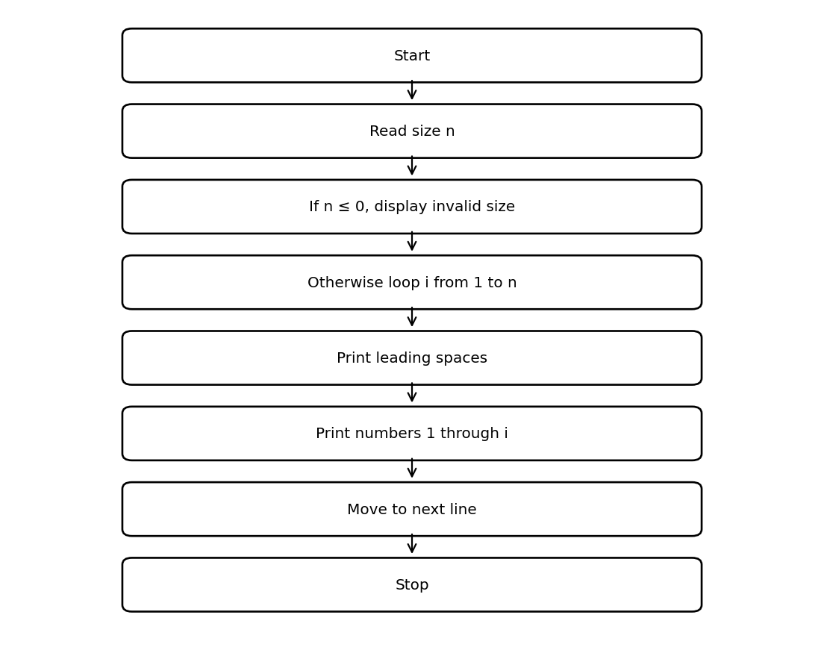

6. Pseudocode
START
INPUT n
IF n <= 0
DISPLAY Invalid size
ELSE
FOR i = 1 to n
PRINT n-i spaces
FOR j = 1 to i: PRINT j
PRINT newline
END FOR
END IF
STOP

7. Python Source Code
n = int(input("Enter pattern size: "))
if n <= 0:
print("Invalid size")
else:
for i in range(1, n + 1):
print(" " * (n - i), end="")
for j in range(1, i + 1):
print(j, end=" ")
print()

8. Test Cases
Test | Input / Scenario | Expected Result
1 | Pattern size: 4 | Matches sample output below
2 | Invalid / boundary values as applicable | Program handles conditions using stated rules

9. Output Screenshot
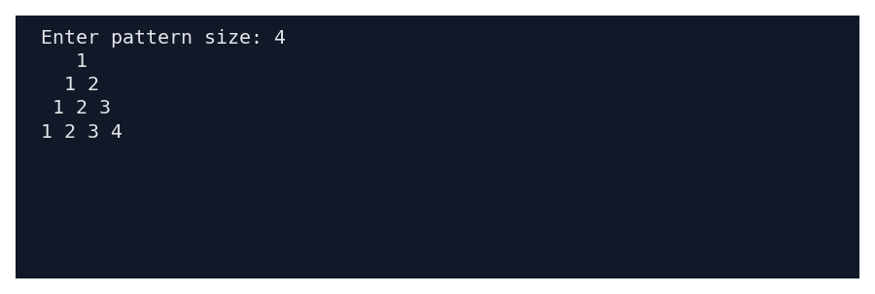

10. Sample Output
Enter pattern size: 4
1
1 2
1 2 3
1 2 3 4

11. Conclusion
This case study demonstrates how basic Python concepts can be used to solve the problem of advanced numeric pattern generator. The program uses simple data structures, conditions, loops, and calculations to produce the required result.
Submitted by: ____________________ Roll No.: ____________________

