PYTHON ACTIVITY-BASED LEARNING
CASE STUDY 31
String-Based Examination Answer Evaluation
B.Tech First Year – CSE | Python Programming

1. Problem Statement
Compare answer strings against an answer key, calculate correct, incorrect, and unanswered responses, apply negative marking, and produce student-wise results.

2. Objectives
- Compare student answers with an answer key.
- Count correct, wrong, and blank answers.
- Apply negative marking.
- Calculate final score.

3. Assumptions
- Each correct answer gives 2 marks.
- Each wrong answer deducts 0.5 marks.
- Blank answers give 0 marks.
- Answers are case-insensitive.

4. Algorithm
1. Start
2. Store answer key and student answers
3. Initialize counters
4. Loop through each answer
5. Count blank, correct, or wrong
6. Calculate score using marking rules
7. Display counts and score
8. Stop

5. Flowchart
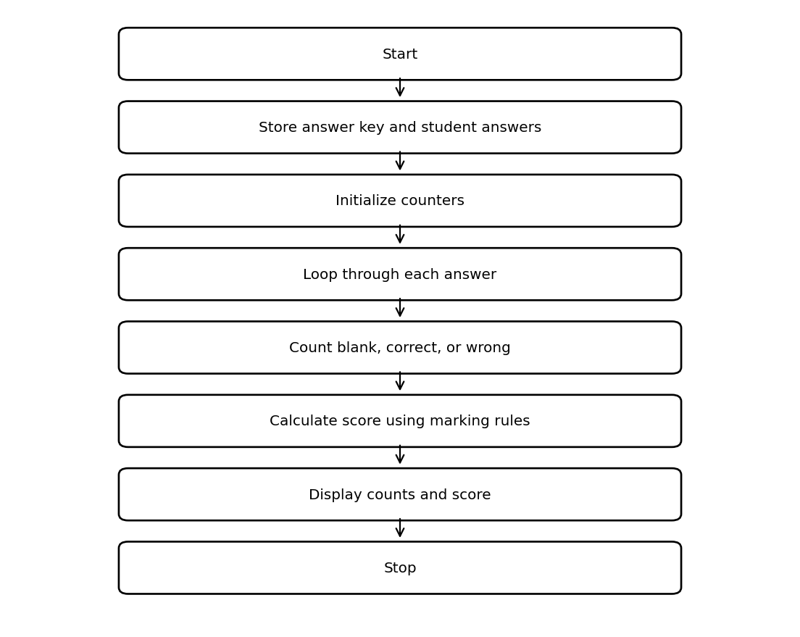

6. Pseudocode
START
key = answer key
answers = student answers
correct = wrong = blank = 0
FOR each answer index
IF answer blank: blank += 1
ELSE IF uppercase answer equals key: correct += 1
ELSE: wrong += 1
END FOR
score = correct*2 - wrong*0.5
DISPLAY counts and score
STOP

7. Python Source Code
key = ["A", "C", "B", "D", "A"]
answers = ["a", "C", "D", "", "A"]
correct = 0
wrong = 0
blank = 0
for i in range(len(key)):
answer = answers[i].upper()
if answer == "":
blank += 1
elif answer == key[i]:
correct += 1
else:
wrong += 1
score = correct * 2 - wrong * 0.5
print("Correct:", correct)
print("Wrong:", wrong)
print("Unanswered:", blank)
print("Final score:", score)

8. Test Cases
Test | Input / Scenario | Expected Result
1 | Use the sample values defined in the program | Matches sample output below
2 | Invalid / boundary values as applicable | Program handles conditions using stated rules

9. Output Screenshot
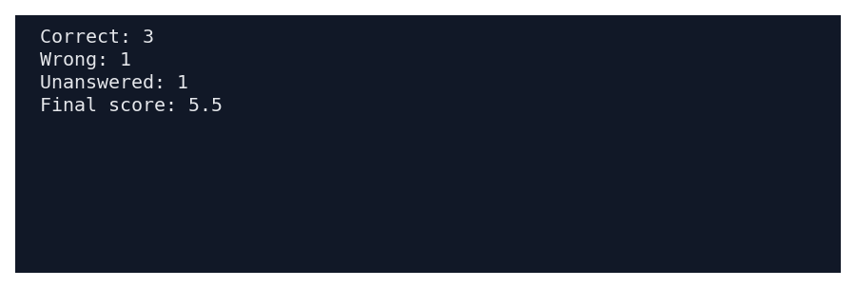

10. Sample Output
Correct: 3
Wrong: 1
Unanswered: 1
Final score: 5.5

11. Conclusion
This case study demonstrates how basic Python concepts can be used to solve the problem of string-based examination answer evaluation. The program uses simple data structures, conditions, loops, and calculations to produce the required result.
Submitted by: ____________________ Roll No.: ____________________

