PYTHON ACTIVITY-BASED LEARNING
CASE STUDY 47
Sports Tournament Ranking System
B.Tech First Year – CSE | Python Programming

1. Problem Statement
Store match results and team scores, calculate total points and tie-break values, and produce rankings under a specified competition policy.

2. Objectives
- Store team match points.
- Calculate total points.
- Use score difference as tie-break.
- Display ranked teams.

3. Assumptions
- Win gives 3 points, draw gives 1, loss gives 0.
- For this simplified example, supplied total points and score difference are used.
- Ranking is by points, then score difference.

4. Algorithm
1. Start
2. Store team name, points, and score difference in tuples
3. Sort teams by points descending
4. Use score difference descending for ties
5. Display rank and team details
6. Stop

5. Flowchart
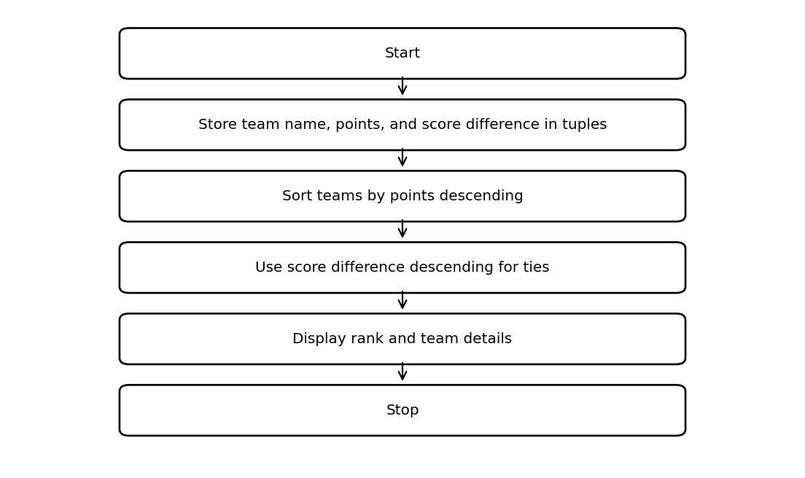

6. Pseudocode
START
teams = list of (name, points, difference) tuples
SORT by points descending, then difference descending
rank = 1
FOR each team
DISPLAY rank, name, points, difference
rank = rank + 1
END FOR
STOP

7. Python Source Code
teams = [
("Falcons", 7, 8),
("Tigers", 7, 12),
("Wolves", 5, 4),
("Eagles", 9, 6)
]
teams.sort(key=lambda team: (team[1], team[2]), reverse=True)
print("Tournament ranking")
for rank, (name, points, difference) in enumerate(teams, start=1):
print(rank, name, "Points:", points, "Difference:", difference)

8. Test Cases
Test | Input / Scenario | Expected Result
1 | Use the sample values defined in the program | Matches sample output below
2 | Invalid / boundary values as applicable | Program handles conditions using stated rules

9. Output Screenshot
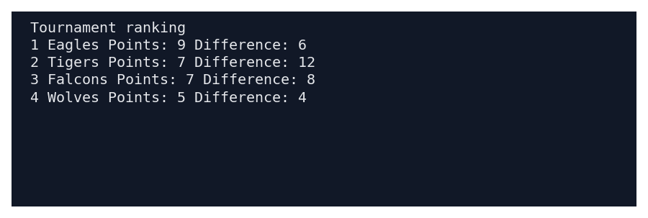

10. Sample Output
Tournament ranking
1 Eagles Points: 9 Difference: 6
2 Tigers Points: 7 Difference: 12
3 Falcons Points: 7 Difference: 8
4 Wolves Points: 5 Difference: 4

11. Conclusion
This case study demonstrates how basic Python concepts can be used to solve the problem of sports tournament ranking system. The program uses simple data structures, conditions, loops, and calculations to produce the required result.
Submitted by: ____________________ Roll No.: ____________________

