PYTHON ACTIVITY-BASED LEARNING
CASE STUDY 52
Hackathon Team Formation and Ranking
B.Tech First Year – CSE | Python Programming

1. Problem Statement
Analyse student scores and team compositions, validate team sizes, aggregate round-wise scores, and resolve tied rankings using predefined rules.

2. Objectives
- Check team size.
- Add scores from multiple rounds.
- Rank valid teams.
- Display invalid team-size warnings.

3. Assumptions
- Each team must have 3 to 5 members.
- Two round scores are provided.
- Teams are ranked by total score, highest first.
- This example contains team names and member counts, not personal data.

4. Algorithm
1. Start
2. Store teams, member counts, and round scores
3. Check each team size
4. If valid, calculate total score and add team to valid list
5. Otherwise display invalid size
6. Sort valid teams by total score descending
7. Display ranking
8. Stop

5. Flowchart
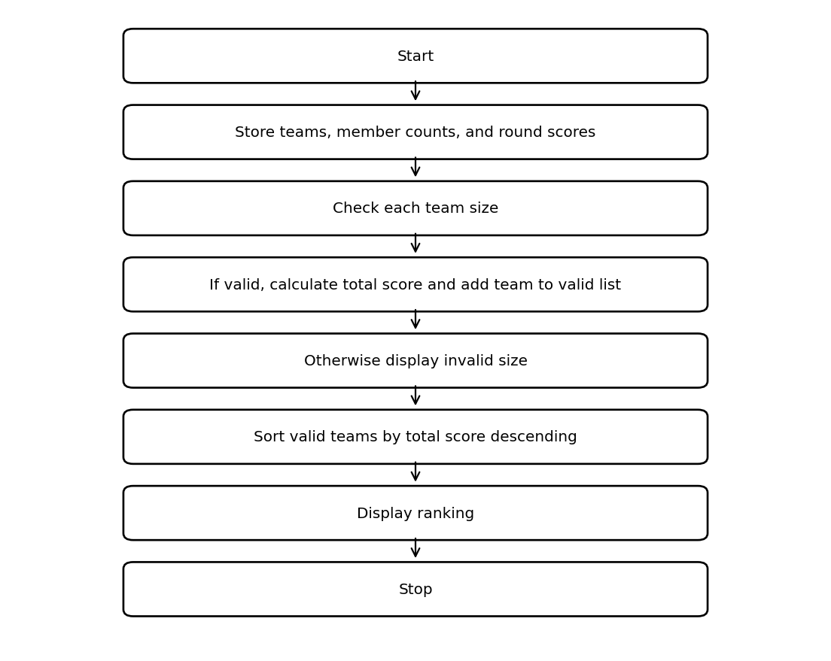

6. Pseudocode
START
valid = empty list
FOR each team
IF members >= 3 AND members <= 5
total = SUM(round scores)
ADD (name,total) to valid
ELSE DISPLAY invalid team size
END FOR
SORT valid by total descending
DISPLAY ranked teams
STOP

7. Python Source Code
teams = [
("CodeStars", 4, [80, 90]),
("ByteBuilders", 3, [85, 85]),
("LogicCrew", 2, [95, 90]),
("Debuggers", 5, [70, 88])
]
valid = []
for name, members, scores in teams:
if 3 <= members <= 5:
total = sum(scores)
valid.append((name, total))
else:
print(name, "invalid team size:", members)
valid.sort(key=lambda team: team[1], reverse=True)
print("Valid team ranking")
for rank, (name, total) in enumerate(valid, start=1):
print(rank, name, "Total:", total)

8. Test Cases
Test | Input / Scenario | Expected Result
1 | Use the sample values defined in the program | Matches sample output below
2 | Invalid / boundary values as applicable | Program handles conditions using stated rules

9. Output Screenshot
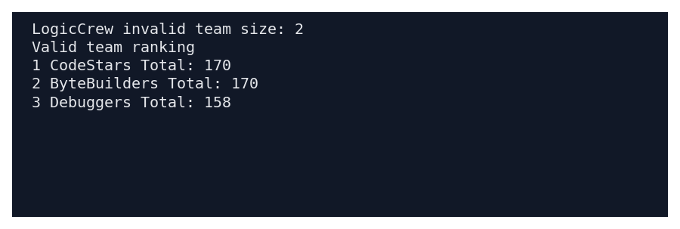

10. Sample Output
LogicCrew invalid team size: 2
Valid team ranking
1 CodeStars Total: 170
2 ByteBuilders Total: 170
3 Debuggers Total: 158

11. Conclusion
This case study demonstrates how basic Python concepts can be used to solve the problem of hackathon team formation and ranking. The program uses simple data structures, conditions, loops, and calculations to produce the required result.
Submitted by: ____________________ Roll No.: ____________________

