LAB 1 – PRACTICE QUESTIONS
Total packets analysed: 11,843

Task1
Filters to apply: `tcp`, `udp`, `icmp`; for protocol hierarchy use Statistics → Protocol Hierarchy.
Requested item | Result
Total packets captured | 11,843
TCP packets (`tcp`) | 283
UDP packets (`udp`) | 6,430
IPv4 ICMP packets (`icmp`) | 0
ICMPv6 packets (`icmpv6`) | 15
ARP packets | 5,024
IPv4 packets | 4,320
IPv6 packets | 2,456

Top five protocol/layer counts observed (protocol hierarchy is layered, so a packet can contribute to more than one protocol row):
Protocol / layer | Count
UDP | 6,430
ARP | 5,024
IPv4 | 4,320
IPv6 | 2,456
TCP | 283

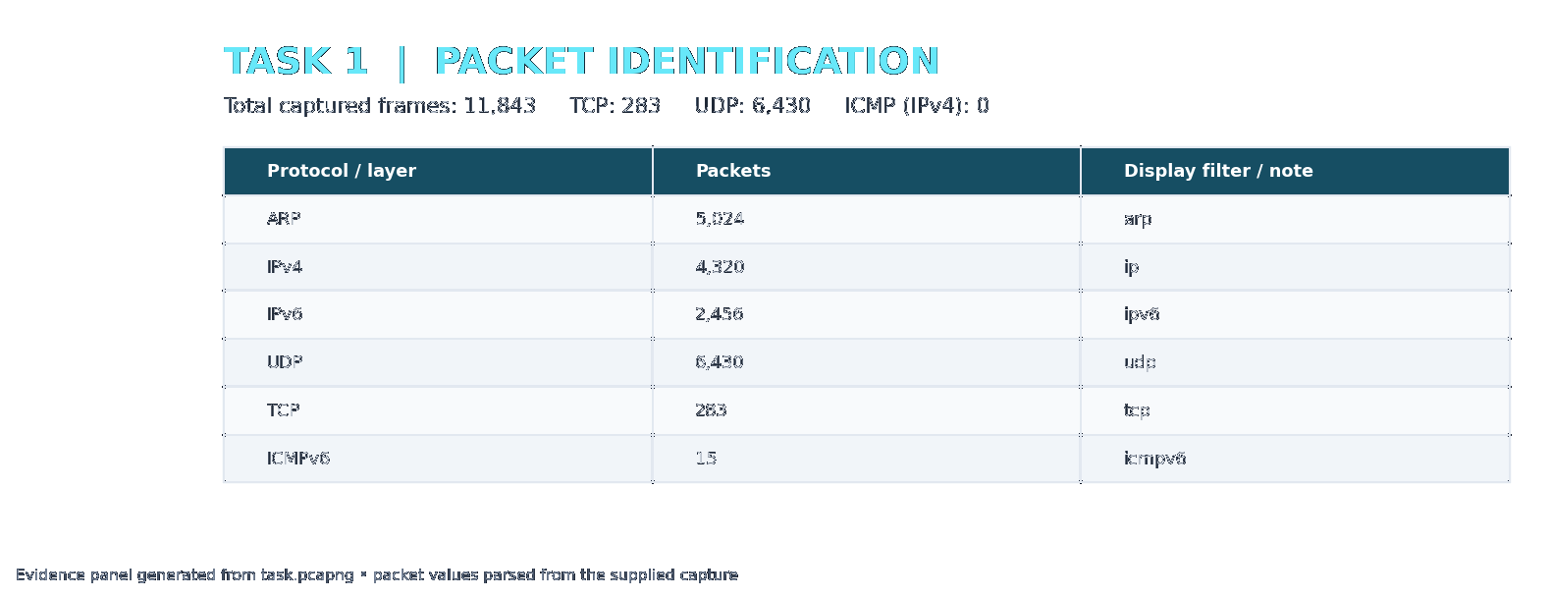

Task2
Display filter: `eth`. Five different frames are listed below.
Frame | Frame length (bytes) | Source MAC | Destination MAC | EtherType
1 | 195 | 28:ad:18:a8:fd:c8 | 01:00:5e:00:00:fb | 0x0800
3 | 227 | 28:ad:18:a8:fd:c8 | 33:33:00:00:00:fb | 0x86DD
5 | 128 | ac:74:b1:1b:d4:6a | 01:00:5e:00:00:fb | 0x0800
7 | 433 | 36:e4:4a:84:39:d2 | 01:00:5e:00:00:fb | 0x0800
90 | 1466 | 4c:d5:87:52:c1:00 | 8c:c6:81:83:77:69 | 0x0800

IPv4 traffic: 4,320 packets (EtherType 0x0800). IPv6 traffic: 2,456 packets (EtherType 0x86DD).
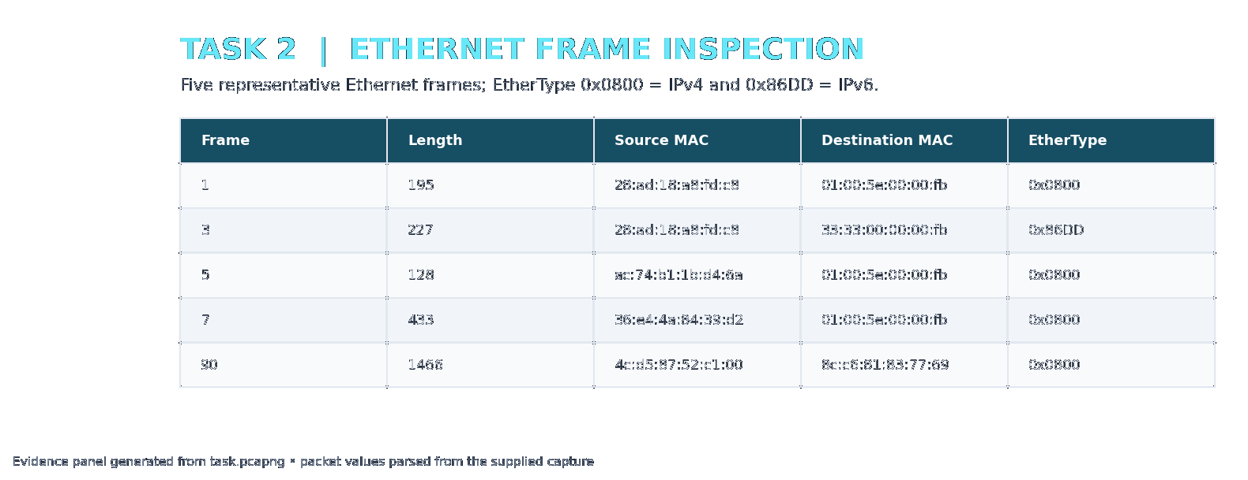

Task3
Display filter: `ip`. Five IPv4 packets are listed.
Frame | Source IP | Destination IP | Header length | Total length | TTL | Identification
1 | 10.250.11.3 | 224.0.0.251 | 20 bytes | 181 bytes | 255 | 58086
2 | 10.250.11.3 | 224.0.0.251 | 20 bytes | 181 bytes | 255 | 58087
5 | 10.250.15.141 | 224.0.0.251 | 20 bytes | 114 bytes | 1 | 42209
7 | 10.250.23.15 | 224.0.0.251 | 20 bytes | 419 bytes | 255 | 29867
11 | 10.250.11.3 | 224.0.0.251 | 20 bytes | 181 bytes | 255 | 58088

Maximum IPv4 total length: frame 1987, 1500 bytes (20.184.175.0 → 10.250.19.206).
Different IPv4 TTL values observed: 1 (2766 packets), 4 (48 packets), 46 (34 packets), 48 (4 packets), 51 (19 packets), 53 (2 packets), 57 (2 packets), 63 (5 packets), 64 (126 packets), 87 (42 packets), 108 (12 packets), 109 (2 packets), 111 (1 packets), 112 (1 packets), 115 (1 packets), 118 (26 packets), 127 (1 packets), 128 (297 packets), 255 (931 packets)
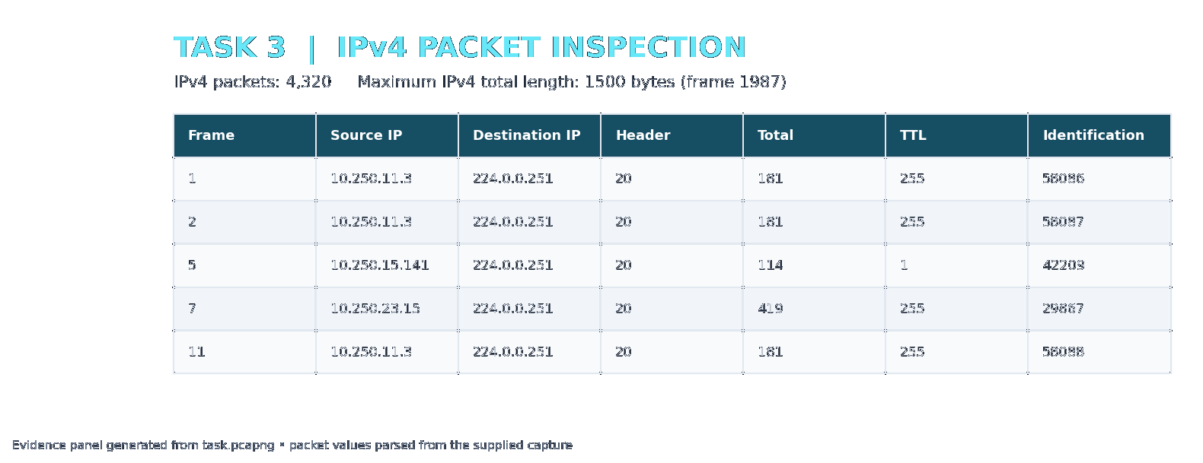

Task4
Display filter: `tcp`. Five TCP packets are listed.
Frame | Source port | Destination port | Sequence number | Acknowledgement number | TCP header | Payload
90 | 443 | 62273 | 3052640498 | 198605378 | 20 bytes | 1412 bytes
91 | 443 | 62273 | 3052641910 | 198605378 | 20 bytes | 334 bytes
92 | 443 | 62273 | 3052642244 | 198605378 | 20 bytes | 132 bytes
93 | 443 | 62273 | 3052642376 | 198605378 | 20 bytes | 59 bytes
94 | 443 | 62273 | 3052642435 | 198605378 | 20 bytes | 31 bytes

SYN filter `tcp.flags.syn == 1`: 9 packets. Frames: 1347, 1759, 6256, 7943, 7947, 7951, 8052, 8058, 8201
FIN filter `tcp.flags.fin == 1`: 9 packets. Frames: 938, 3187, 3352, 4522, 7246, 7440, 8939, 8942, 10825
Packets with TCP options (TCP header length greater than 20 bytes): 31. Example frames: 1347, 1759, 3185, 3355, 3356, 5179, 6256, 6952, 6956, 7943
Maximum TCP payload: frame 1987, 1460 bytes (443 → 62275).
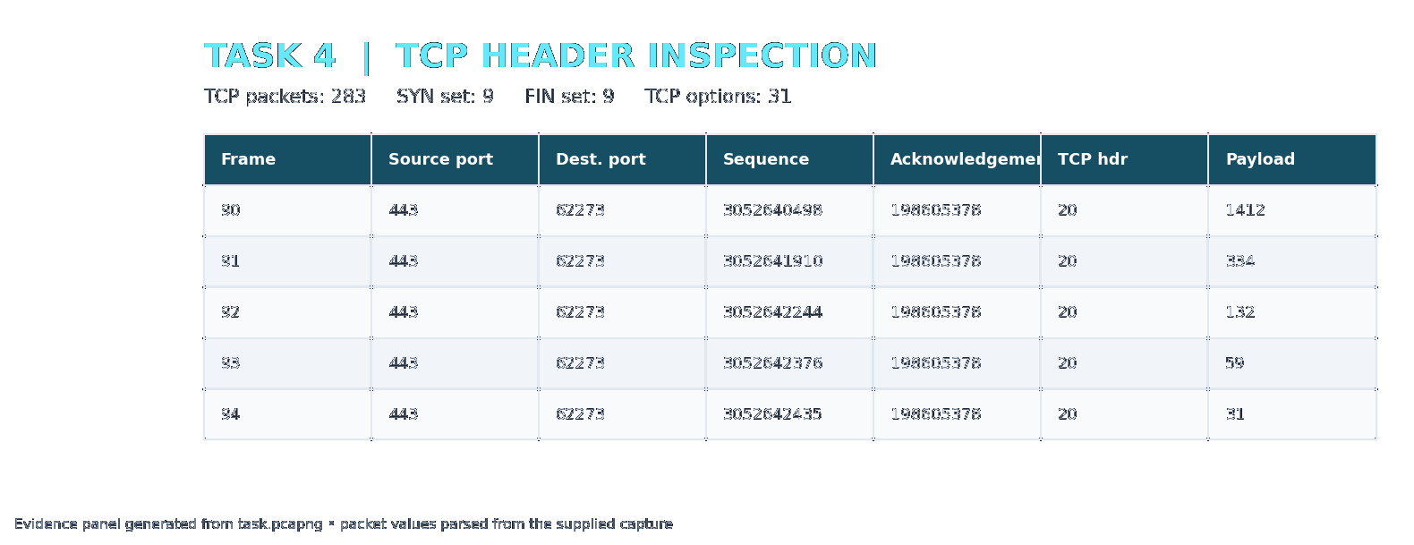

Task5
Display filter: `udp`. Five UDP packets are listed.
Frame | Source port | Destination port | UDP length | Captured payload length
1 | 5353 | 5353 | 161 bytes | 153 bytes
2 | 5353 | 5353 | 161 bytes | 153 bytes
3 | 5353 | 5353 | 173 bytes | 165 bytes
4 | 5353 | 5353 | 173 bytes | 165 bytes
5 | 5353 | 5353 | 94 bytes | 86 bytes

Maximum captured UDP payload: frame 2520, 1472 bytes (ports 5353 → 5353).
DNS over the conventional port 53: 6 UDP packets; frame numbers: 1344, 1345, 5187, 5520, 6094, 6095.
The capture also contains multicast DNS (mDNS) on port 5353 (5892 UDP packets) and LLMNR on port 5355 (67 UDP packets). The DNS-family UDP traffic identified by the conventional DNS/mDNS/LLMNR port set totals 5965 packets; conventional DNS on port 53 accounts for 6 packets. In Wireshark, use the `dns` display filter to inspect the packets decoded by its DNS dissector.
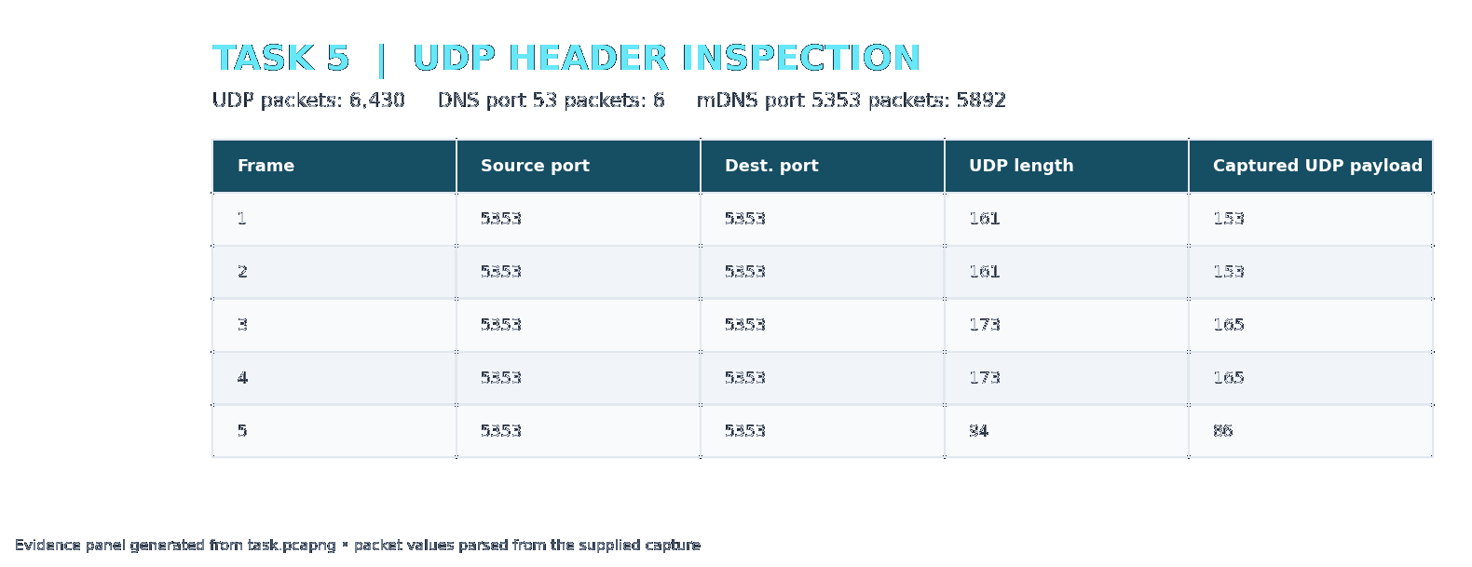

Task6
TCP example: frame 90. UDP example: frame 7. Both carry application data.
Measurement | TCP – frame 90 | UDP – frame 7
Ethernet header | 14 bytes | 14 bytes
IPv4 header | 20 bytes | 20 bytes
TCP / UDP header | 20 bytes | 8 bytes
Total protocol header overhead | 54 bytes | 42 bytes
Application payload | 1412 bytes | 391 bytes
Captured Ethernet frame length | 1466 bytes | 433 bytes
Payload efficiency | 96.32% | 90.30%

Calculations
TCP overhead = Ethernet 14 + IPv4 20 + TCP 20 = 54 bytes.
TCP application payload = IPv4 total length 1452 − IPv4 header 20 − TCP header 20 = 1412 bytes.
TCP payload efficiency = 1412 ÷ 1466 × 100 = 96.32%.
UDP overhead = Ethernet 14 + IPv4 20 + UDP 8 = 42 bytes.
UDP application payload = UDP length 399 − UDP header 8 = 391 bytes.
UDP payload efficiency = 391 ÷ 433 × 100 = 90.30%.
Comparison: the selected TCP frame has 54 bytes of headers and 96.32% payload efficiency. The selected UDP frame has 42 bytes of headers and 90.30% payload efficiency. UDP uses a smaller transport header (8 bytes) than the selected TCP header (20 bytes), so its protocol overhead is lower. Efficiency also depends on the payload size of the particular packet.
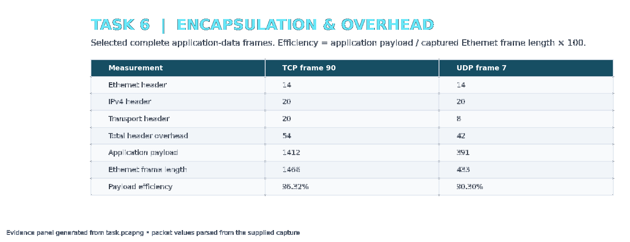

Conclusion
The supplied capture contains 11,843 packets, with UDP as the most frequent decoded transport protocol. Both IPv4 (4,320) and IPv6 (2,456) traffic are present. TCP connection setup and teardown indicators, TCP options, DNS traffic, packet sizes, and encapsulation overhead were identified from the captured frames.

