EXPLORATORY DATA ANALYSIS (EDA) REPORT
Traffic Flow Pattern Clustering
Using K-Means and DBSCAN for Smart Urban Traffic Congestion Analysis

Project Details | Information
Students | N. Yeswanth Kumar (2520030183); B. Sai Sashank (2520030454)
Guide | Mr. Shaik Asif
Department | Department of CSE
Academic Year | 2026–27
Institution | Koneru Lakshmaiah Education Foundation
Dataset size | 588 records × 8 columns
EDA source | Supplied Jupyter Notebook and project presentation

1. Abstract
This report presents the Exploratory Data Analysis (EDA) performed for the Traffic Flow Pattern Clustering project. The analysis examines traffic observations using vehicle count, average speed, traffic density and road occupancy. The supplied notebook performs data loading, structural inspection, data-quality checks, descriptive statistics, distributions, relationship analysis, correlation analysis, outlier inspection, traffic-condition summaries and hourly traffic analysis. The project presentation positions these findings as preparation for an unsupervised-learning stage using K-Means and DBSCAN.
The supplied notebook contains the EDA stage, but the K-Means and DBSCAN modeling stage described in the project presentation is not implemented in that notebook. Therefore, this report reports EDA findings only and does not claim clustering results or model scores.

2. Problem Context and Objectives
The project addresses urban traffic congestion by analyzing traffic-flow observations and discovering patterns without relying on predefined machine-learning labels. The stated objectives are to understand traffic behavior, discover similar traffic patterns, detect abnormal congestion and support traffic-management decisions.
Objective | EDA relevance
Understand traffic behavior | Study vehicle count, speed, density and road occupancy.
Discover traffic patterns | Explore distributions and relationships before clustering.
Detect abnormal congestion | Inspect feature ranges and boxplots for unusual observations.
Support decisions | Examine hourly variation and traffic-condition profiles.

3. Dataset Overview
The notebook loads the traffic_flow_clustering_dataset_clean (1).csv dataset. It contains 588 observations and 8 columns: Record_ID, Hour, Day_of_Week, Vehicle_Count, Average_Speed_kmph, Traffic_Density_veh_per_km, Road_Occupancy_percent and Traffic_Condition.
Column | Type | Description
Record_ID | Integer | Record identifier
Hour | Integer | Hour of day (0–23)
Day_of_Week | Integer | Day index (0–6)
Vehicle_Count | Float | Number of vehicles
Average_Speed_kmph | Float | Average traffic speed in km/h
Traffic_Density_veh_per_km | Float | Vehicles per kilometre
Road_Occupancy_percent | Float | Road occupancy percentage
Traffic_Condition | Object | Low, Moderate or High

4. Data Quality Assessment
Check | Result | Interpretation
Rows | 588 | Dataset contains 588 observations.
Columns | 8 | Seven numeric/integer fields plus one categorical field.
Missing values | 0 in every column | No missing-value treatment was required for the supplied dataset.
Duplicate rows | 0 | No duplicate rows were detected.
Traffic conditions | Low / Moderate / High | Three condition categories are present.

The final notebook check confirms the same dataset shape, zero missing values, zero duplicate rows and the three traffic-condition counts.

5. Descriptive Statistics
Feature | Mean | Std. Dev. | Min | 25% | Median | 75% | Max
Vehicle Count | 116.38 | 77.27 | 15 | 58 | 89 | 161 | 300
Average Speed (km/h) | 42.86 | 15.33 | 10.03 | 31.01 | 44.73 | 54.35 | 69.96
Traffic Density (veh/km) | 40.03 | 21.72 | 10.00 | 22.51 | 34.11 | 53.95 | 89.82
Road Occupancy (%) | 39.86 | 21.32 | 10.12 | 22.69 | 32.69 | 54.10 | 89.70

Vehicle count shows the largest spread among the four principal traffic variables. The median vehicle count is 89, while the maximum is 300. Average speed ranges from 10.03 to 69.96 km/h. Density and occupancy have similar central values and ranges, consistent with their strong positive relationship.

6. Univariate Analysis
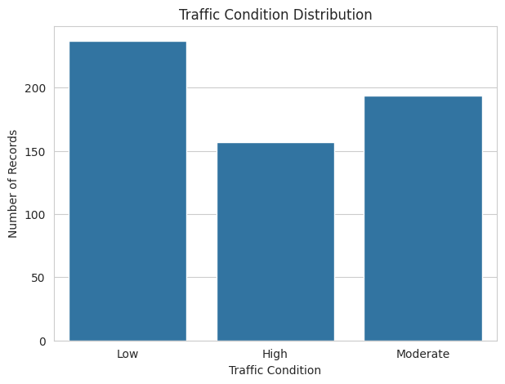
Figure 1. Traffic condition distribution from the supplied notebook.
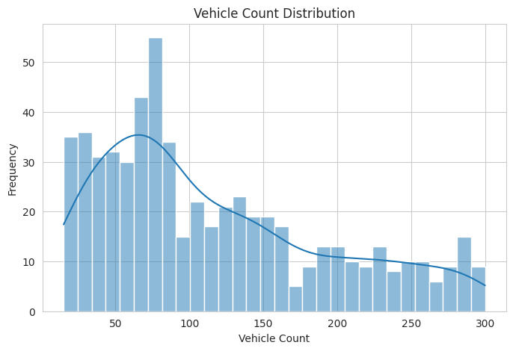
Figure 2. Vehicle count distribution.
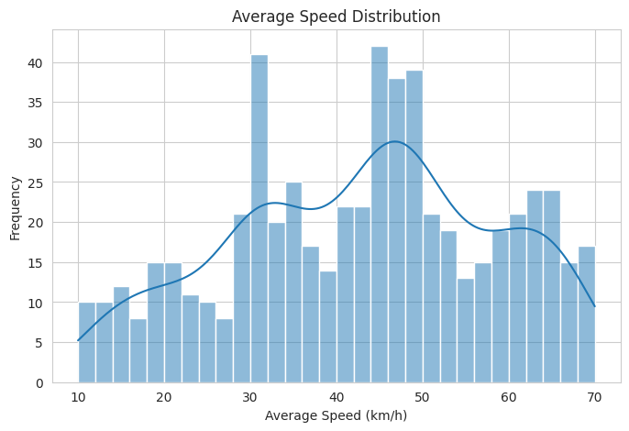
Figure 3. Average speed distribution.
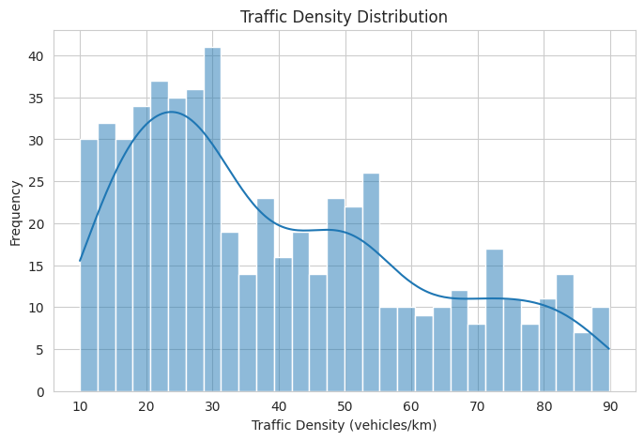
Figure 4. Traffic density distribution.
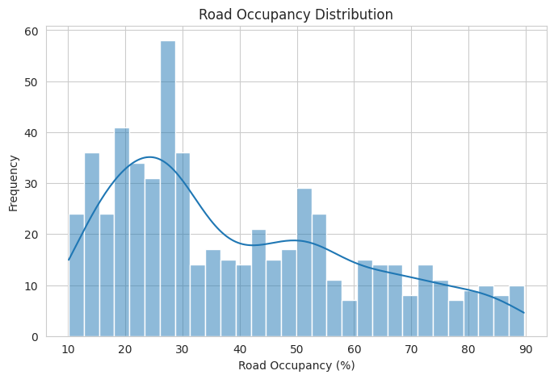
Figure 5. Road occupancy distribution.
The traffic-condition distribution contains 237 Low records, 194 Moderate records and 157 High records. The four numerical distributions provide the basis for understanding the scale and variability of the features used in the proposed clustering stage.

7. Bivariate and Relationship Analysis
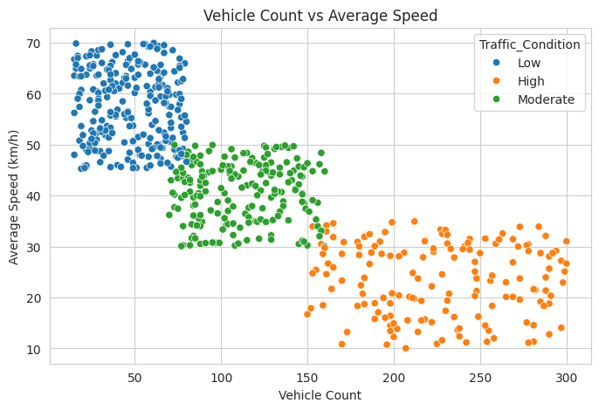
Figure 6. Vehicle count versus average speed, grouped by traffic condition.
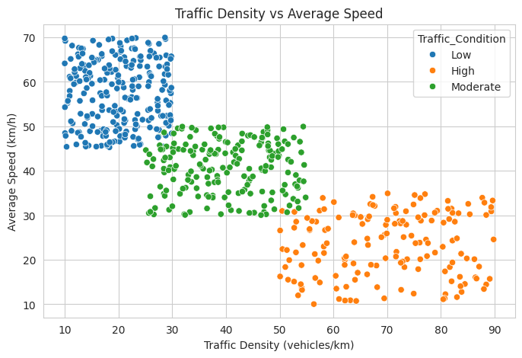
Figure 7. Traffic density versus average speed, grouped by traffic condition.
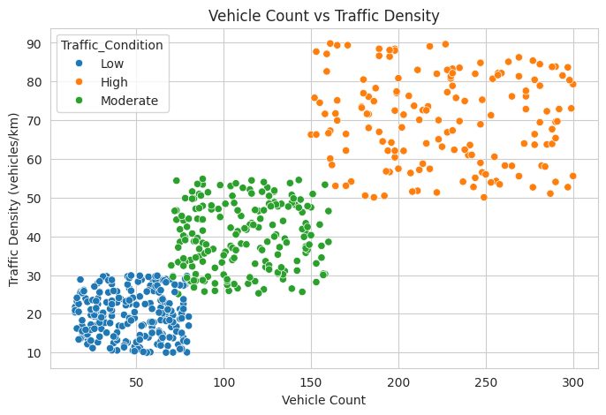
Figure 8. Vehicle count versus traffic density, grouped by traffic condition.
The scatter plots show the relationship among the main traffic variables and visually separate the existing Low, Moderate and High traffic-condition observations. In particular, higher traffic volume is associated with lower average speed, while higher volume is associated with higher density.

8. Correlation Analysis
 | Vehicle Count | Avg Speed | Density | Occupancy
Vehicle Count | 1.000 | -0.826 | 0.851 | 0.846
Avg Speed | -0.826 | 1.000 | -0.816 | -0.820
Density | 0.851 | -0.816 | 1.000 | 0.850
Occupancy | 0.846 | -0.820 | 0.850 | 1.000

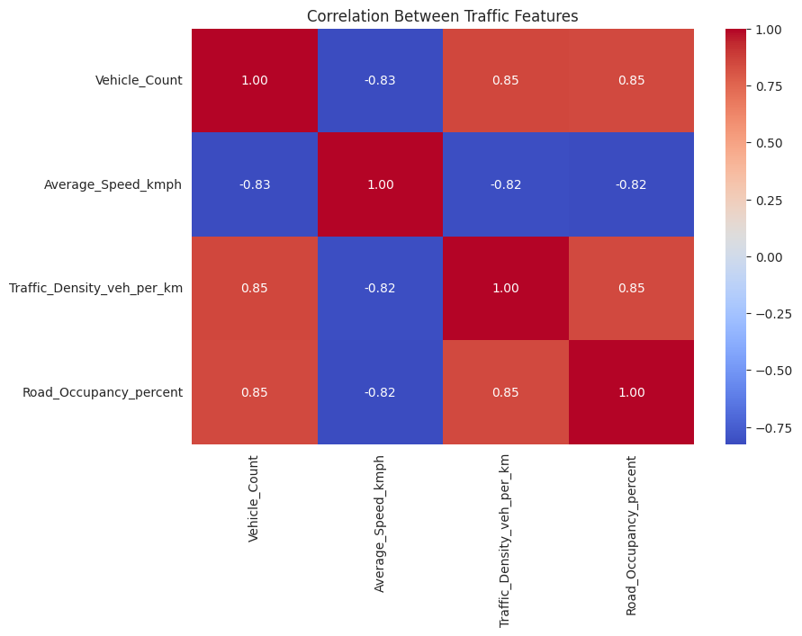
Figure 9. Correlation heatmap of the four main traffic features.
Vehicle count has strong positive correlations with traffic density (0.851) and road occupancy (0.846). Average speed has strong negative correlations with vehicle count (-0.826), density (-0.816) and occupancy (-0.820). Density and occupancy are also strongly positively correlated (0.850). These relationships indicate that the four variables contain closely connected signals of traffic-flow state.

9. Outlier Analysis
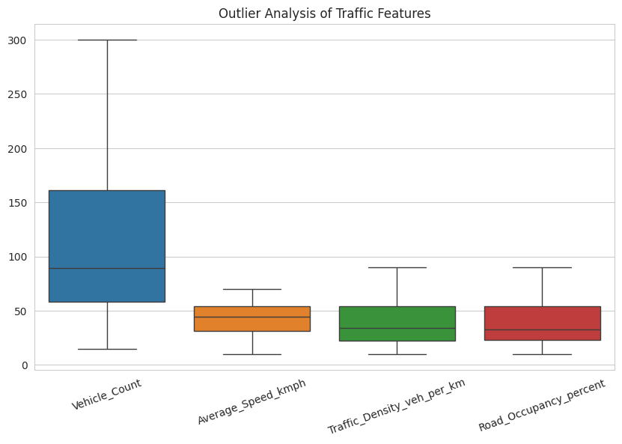
Figure 10. Boxplot-based outlier analysis of the main traffic features.
The notebook uses boxplots to inspect the spread and potential outliers of the four principal traffic features. This is an exploratory diagnostic; the supplied notebook does not document removal of any observations based on the boxplot results.

10. Traffic Condition Profiles
Condition | Records | Vehicle Count | Avg Speed (km/h) | Density (veh/km) | Occupancy (%)
Low | 237 | 47.82 | 57.52 | 20.10 | 20.40
Moderate | 194 | 111.52 | 40.72 | 40.09 | 39.88
High | 157 | 225.87 | 23.37 | 70.02 | 69.22

Low traffic is characterized by lower vehicle count, density and occupancy together with higher average speed. Moderate traffic occupies an intermediate range. High traffic has the highest average vehicle count, density and occupancy and the lowest average speed.

11. Hourly Traffic Pattern
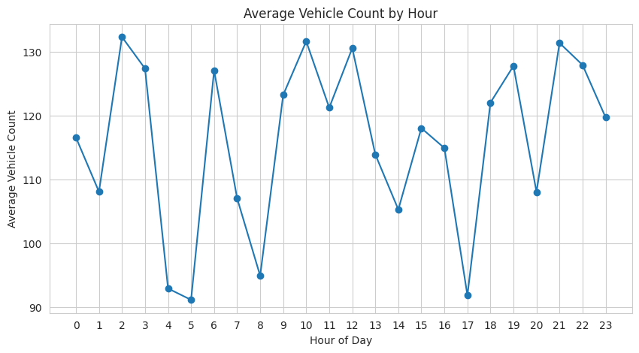
Figure 11. Average vehicle count by hour.
Metric | Value
Highest observed hourly average | 132.29 vehicles at hour 2
Lowest observed hourly average | 91.10 vehicles at hour 5
Hours analyzed | 0–23

Average vehicle count varies across the 24-hour period rather than remaining constant. The observed variation indicates that time of day is a useful contextual variable for traffic analysis and subsequent traffic-management interpretation.

12. EDA Findings
- The dataset is complete for the supplied analysis: no missing values and no duplicate rows were found.
- The four principal traffic variables show substantial variation across observations.
- Vehicle count, density and road occupancy increase together, while average speed decreases as congestion-related measures increase.
- The existing Low, Moderate and High traffic-condition groups have clearly different average profiles.
- Traffic demand varies by hour, with the highest observed hourly average occurring at hour 2.
- The EDA supports the project's planned use of unsupervised clustering because the numerical features contain strong, structured relationships.

13. Preparation for K-Means and DBSCAN
Stage | Status in supplied notebook/report
Data loading | Implemented
Data-quality checks | Implemented
Exploratory distributions | Implemented
Correlation analysis | Implemented
Condition summaries | Implemented
Hourly analysis | Implemented
Feature selection | Implemented for four main traffic variables
K-Means clustering | Described in project presentation; not implemented in supplied notebook
DBSCAN clustering | Described in project presentation; not implemented in supplied notebook
Silhouette / Davies–Bouldin evaluation | Planned in presentation; no clustering scores available in supplied notebook

For the next modeling stage, the project presentation specifies K-Means for grouping regular traffic-flow patterns and DBSCAN for density-based identification of irregular or noisy traffic regions. The presentation also specifies Silhouette Score, Davies–Bouldin Index and visual cluster representations for evaluation.

14. Conclusion
The EDA establishes a clear statistical and visual understanding of the traffic-flow dataset before unsupervised learning. The 588 observations contain four closely related numerical traffic features, and the data-quality checks show no missing values or duplicate rows. Correlation analysis demonstrates strong positive relationships among traffic volume, density and occupancy and strong negative relationships between average speed and the congestion-related variables. Condition-level summaries further show distinct Low, Moderate and High traffic profiles. Hourly analysis demonstrates meaningful temporal variation in vehicle count. Overall, these findings provide the exploratory foundation for the project's planned K-Means and DBSCAN clustering stage.

15. Source Basis and Scope
This report was prepared from the supplied TrafficFlow_Clustering Jupyter Notebook and the supplied Traffic Flow Clustering project presentation. Numerical EDA values and figures are taken from the notebook outputs. Project objectives, methodology and the stated K-Means/DBSCAN plan are taken from the presentation. No unsupported clustering results have been added.

