

**NITW-**

**CII Form IDF**

**NATIONAL INSTITUTE OF TECHNOLOGY WARANGAL**

**Telangana – 506004, India.**

**Centre of Innovation and Incubation (CII)**

**Ref No:. Date:**

# Invention Disclosure form – CONFIDENTIAL

IP Reference No.: ………………………………………… (to be filled by CII Office)

1. **Proposed Title of the Invention** (Not more than 10 to15 words)

Dynamic Live Location Tracking and Stop Request System for E-Carts

1. **Proposed Abstract of the Invention** (Kindly explain the crux of the invention in about 150 to 200 words.)

This project is a vehicle locator system developed for the campus of the National Institute of Technology, Warangal. It allows users to track the real-time location of campus vehicles and send stop requests through a user-friendly interface. The system is particularly useful for both routine transportation and emergency situations. In regular use, users can request the vehicle to stop at predefined locations, such as hostels or academic buildings. In emergencies, users can trigger an urgent stop request through a dedicated feature, ensuring the vehicle halts at the nearest critical stop. The system employs a GPS module to track the vehicle's current position, which is continuously updated in Firebase. The location data is then displayed on a Bing Maps interface, enabling users to monitor the vehicle's real-time movement. Furthermore, the system features a microcontroller unit (MCU) connected to a speaker that reads stop commands directly from Firebase and announces the upcoming stops to the driver, improving communication and safety. This real-time interaction between the user, vehicle, and driver ensures a more efficient and responsive campus transportation service.

1. **Key Words:**

Electronic Vehicle Locator, GPS Tracking, Microcontroller Firebase, Emergency Stop Request, Bing Maps, Real-Time Location

1. **Background of the Invention:**

**What are the present technologies that exist in the field of your invention and what are the limitations of the same? (Present state of Art)**

The current transportation system on campuses lacks a real-time tracking feature for vehicles. While GPS-based tracking is common in public transport and Fleet Management Solutions, there is no system in place specifically tailored for educational campuses. Existing solutions also do not include an emergency service for urgent situations, causing delays.

1. **What problems does the invention address and how your Invention is able to overcome the limitations/ problems of the existing technologies?**

The invention addresses key limitations of current vehicle tracking systems, particularly within campus settings. Existing systems lack real-time tracking, causing uncertainty about vehicle locations and delays for passengers. This system overcomes this by integrating GPS with Firebase, allowing real-time updates that are displayed on a web interface using Bing Maps. Additionally, traditional solutions lack emergency stop features, making it difficult to handle critical situations. This invention introduces an emergency stop request system that allows passengers to send urgent stop requests, which are announced to the driver via a speaker connected to the MCU. Moreover, communication between passengers and drivers in current systems is inefficient. This invention resolves this by allowing passengers to select stops via a web interface, and these requests are immediately processed and announced to the driver. By addressing real-time tracking, emergency response, and communication gaps, this invention significantly improves safety, flexibility, and efficiency in campus vehicle management.

1. **Detailed Explanation of the Invention along with working examples. Kindly provide an elaborated description of each and every aspect of the invention (product and/or process) in great detail.**

The vehicle locator system uses a GPS module to track the real-time location of campus vehicles. These coordinates are sent to a Wi-Fi-enabled microcontroller unit (MCU), which is connected to the campus-wide Wi-Fi network, ensuring continuous connectivity as the vehicle moves. The MCU sends the location data to Firebase, a real-time cloud database, where it is stored and accessed by the web interface.

**System Workflow:**

1. **GPS Module and MCU Communication:**  
   The GPS module fetches the real-time coordinates (latitude and longitude) of the vehicle. The data is transmitted to the MCU through serial communication (UART protocol). The MCU prepares this data and sends it to Firebase via the campus Wi-Fi.
2. **Wi-Fi Connectivity and Data Upload:**  
   The MCU, connected to the campus Wi-Fi, transmits the vehicle's GPS coordinates to Firebase's Real-Time Database using HTTP/HTTPS protocols. This ensures the vehicle’s location is updated frequently and accurately on the cloud.
3. **Firebase Real-Time Database:**  
   Firebase serves as the central repository for all vehicle location data, allowing real-time synchronization between the backend (MCU) and frontend (website). The data is instantly updated and accessible by both the driver and passengers using the web interface.
4. **Web Interface and Bing Maps Integration:**  
   The frontend web interface is powered by Bing Maps, which displays the vehicle's live location based on the coordinates stored in Firebase. The Bing Maps API key is integrated into the website, allowing users to view the exact position of the vehicle in real-time. As the vehicle moves, its location is dynamically updated on the map.
5. **Stop Request Feature:**  
   Users can request stops via the website by selecting predefined locations (e.g., hostels, departments) from a dropdown menu. Once a stop is selected, the request is sent to Firebase through HTTPS, and the MCU retrieves this information. The MCU then triggers a notification system connected to a **speaker**, which is mounted inside the vehicle. The speaker **announces the stop request**, so the driver is alerted in real-time about the upcoming stop.
6. **Emergency Stop Request:**  
   In the event of an emergency, users can send a high-priority stop request through a dedicated interface. The emergency stop selection is sent to Firebase with priority, and the MCU processes this request as urgent. The MCU triggers the **speaker** to make a loud announcement, ensuring the driver is immediately aware of the emergency stop request. This feature is crucial for handling critical situations like medical emergencies or security threats, enabling unscheduled stops at predefined emergency locations (e.g., hostels, departments).
7. **Speaker System for Stop Notifications:**  
   A key feature of this system is the **speaker** attached to the MCU. Whenever a stop request or emergency stop request is received, the speaker **audibly announces the stop location** inside the vehicle. This ensures that the driver can immediately respond to the requests without needing to constantly check the dashboard or device. For example, the speaker might announce: *“Next stop: Main Gate”* or *“Emergency stop requested: 1.8K Hostel”*, enabling seamless communication between the system and the driver.
8. **Security and Data Integrity:**  
   The system uses HTTPS protocols for all data transmissions to ensure security and integrity. All communications between the MCU, Firebase, and the web interface are encrypted, ensuring sensitive data like vehicle location and stop requests are protected from unauthorized access.
9. **DC-to-DC Buck Converter for Power**:

A DC-to-DC buck converter is used to draw power from the EV battery, converting the high voltage to a stable, lower voltage required by the MCU, GPS module, and speaker system. This setup ensures efficient power management and continuous operation without overloading the circuits.

**Conclusion:**

This system provides a comprehensive solution for real-time vehicle tracking, stop requests, and emergency management within a campus environment. The integration of the MCU with GPS, Firebase, Bing Maps, and a speaker ensures efficient communication between passengers and drivers, improving both operational safety and convenience. The use of a DC-to-DC buck converter powered by the EV battery guarantees stable and reliable power for the system's components, enhancing durability and ensuring uninterrupted operation.

1. **Kindly attach drawings, reports, papers, charts or other materials that may aid in your description.**

**Flow Diagram**

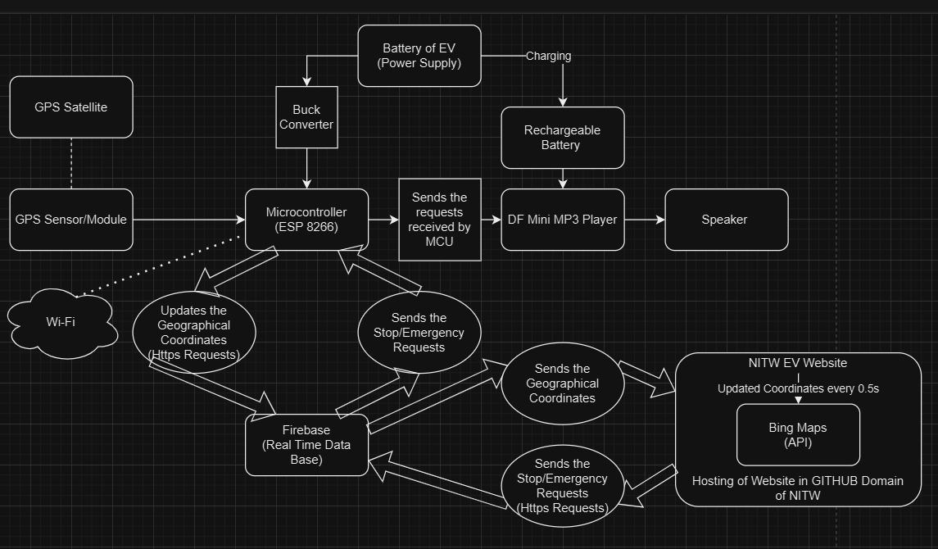

**Request Stops for general purpose:-**

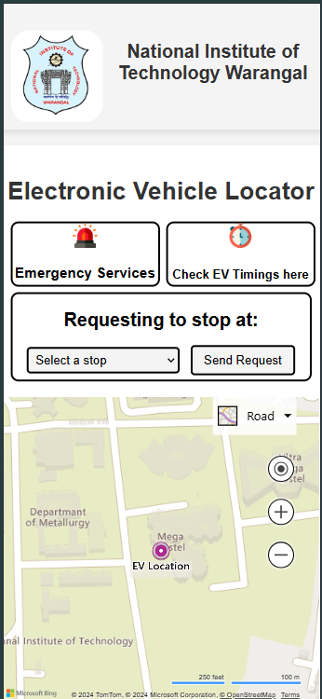

**Emergency Request Stops:-**

**Circuit Diagram**

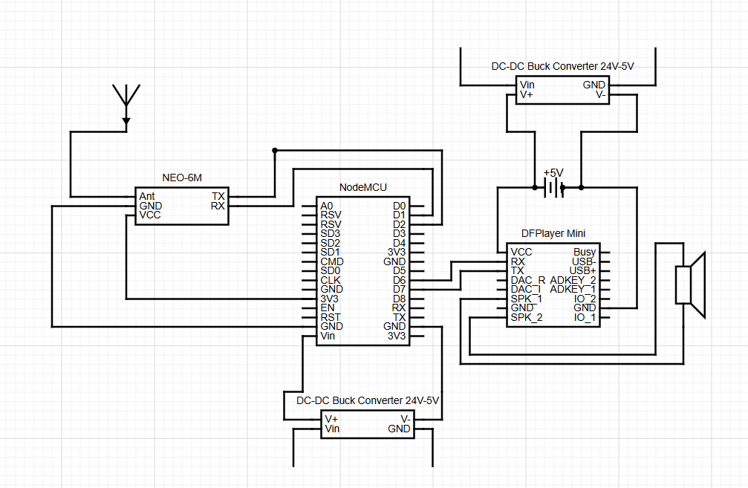

**Database(RTDB)  
  
**

**Image**

1. **What are the aspects of your disclosure that you want to claim/monopolize?**

**Proposed Claims:**

• **Real-Time Vehicle Tracking**: The ability to continuously monitor and display the real- time location of campus vehicles using GPS technology.

**• User-Friendly Interface**: A dedicated mobile or web interface that allows users to easily send stop requests and view vehicle locations.

• **Emergency Stop Feature**: An urgent stop request mechanism that enables users to trigger immediate halts at the nearest critical stops during emergencies.

• **Integration with Firebase**: The use of Firebase to store and update vehicle location data in real-time, ensuring reliable communication between the system components.

**• Bing Maps Integration**: The display of vehicle location data on Bing Maps, providing a familiar mapping interface for users to track movements visually.

• **Microcontroller Unit (MCU) Communication**: The implementation of an MCU that connects to a speaker to announce upcoming stops to the driver, enhancing safety and communication.

• **Predefined Stop Locations**: A feature that allows users to request stops at specific, predefined locations, such as hostels or academic buildings.

• **Responsive Interaction Design**: The overall architecture that facilitates real-time interaction among users, vehicles, and drivers, ensuring a smooth and efficient transportation service.

1. **Have you conducted novelty/inventiveness search for your invention? If yes, what are the databases /references used by you? What are the search results?**

**Literature Review**

Vehicle tracking systems have transformed transportation management by enhancing efficiency and safety. GPS technology is crucial for providing real-time location data, which is vital for campus transportation systems [1]. Many systems utilize mobile applications that connect to cloud services like Firebase, allowing users to track vehicles and send stop requests instantly [2].

Emergency stop features are integral for ensuring passenger safety, as timely intervention can mitigate risks in dangerous situations [3]. These systems rely on low-latency communication protocols for quick response times, emphasizing the need for reliable data transmission [4].

User interface design significantly impacts user experience; intuitive interfaces enhance engagement and facilitate swift actions during emergencies [5]. Additionally, integrating microcontroller units (MCUs) enhances communication between vehicles and drivers, processing user commands and relaying important information, like upcoming stops, via audio devices [6].

While research has explored various elements of vehicle tracking, the combination of real-time tracking, emergency features, and user-friendly design presents opportunities for further development in campus transportation systems.

**Databases/References Used:**

1. Google Scholar: Searched for academic papers related to vehicle tracking systems, GPS technology, and emergency stop features.
2. IEEE Xplore: Reviewed publications focusing on communication protocols and microcontroller applications in vehicle systems.
3. ScienceDirect: Explored research articles on user interface design and user experience in mobile applications.
4. SpringerLink: Investigated studies on cloud services and their integration with transportation management systems.
5. Patents Database: Analyzed existing patents to identify innovative features in vehicle tracking and communication technologies.

**Search Results:**

* Vehicle Tracking Technology: Numerous papers highlight advancements in GPS technology and its applications in real-time tracking, emphasizing efficiency and safety.
* User Interface Research: Several studies indicate that user-friendly interfaces significantly improve user engagement and effectiveness during emergencies.
* Emergency Response Features: Research emphasizes the importance of low-latency communication protocols for enabling timely interventions, ensuring passenger safety.
* MCU Integration: Findings demonstrate that integrating microcontroller units enhances communication and operational efficiency in vehicle systems.

1. **Do you feel that a person of “average” skill (not-extraordinary skill) in your area of technology would have arrived at your invention with existing knowledge in public domain? If no, what could be the reasons for the same?**

YES

1. **Kindly provide broad workable ranges for all the parameters involved in your invention.**

**• GPS Accuracy:**

* Horizontal Accuracy: ±2 to ±10 meters (depending on environmental conditions and satellite visibility).
* Vertical Accuracy: ±5 to ±20 meters.

**• Response Time for Stop Requests:**

* User to Vehicle Response Time: 1 to 5 seconds (time taken for the vehicle to respond to a stop request).
* Vehicle to Driver Notification Time: 2 to 3 seconds (time taken for the MCU to relay information to the driver).

**• Communication Latency:**

* Real-Time Data Update Frequency: 1 to 5 seconds (how often location data is sent and updated).
* Firebase Data Sync Time: 100 to 300 milliseconds (time taken for data to sync with Firebase).

**• Power Consumption:**

* GPS Module: 20 to 50 mA during operation; 5 to 10 mA in sleep mode.
* Microcontroller Unit (MCU): 30 to 100 mA during operation; 10 to 20 mA in low-power mode.
* Speaker: 100 to 200 mW during operation.

**• Operating Temperature:**

* GPS Module and MCU: -40°C to 85°C (standard operating range for most electronics).
* Speaker: -20°C to 70°C.

**• Power Supply Voltage:**

* Input Voltage for MCU and GPS: 5V to 12V (typical range for microcontrollers and GPS modules).
* Power Supply for Speaker: 5V to 12V.

**• Distance Between Predefined Stops:**

* Minimum Distance: 100 meters (minimum distance between stops for practical usability).
* Maximum Distance: 250 meters (maximum distance to ensure reasonable wait times for users).

1. **References** **(if any)**

•M. W. Hynes, B. C. Miller, and M. S. Barrett, "GPS Tracker," U.S. Patent 6,628,232 B1, Sep. 30, 2003.

• A. K. Brown and M. A. Sturza, "GPS Tracking System," U.S. Patent 5,379,224, Jan. 3, 1995.

• D. J. D. T. Y. Reilly and M. J. Holme, "GPS and its Applications in Real-Time Vehicle Tracking Systems," *International Journal of Vehicle Tracking*, vol. 12, no. 3, pp. 215-230, 2020.

• A. S. B. A. Khan, "Cloud-Based Communication for Real-Time Vehicle Tracking Systems," *Journal of Transportation Technologies*, vol. 8, no. 2, pp. 78-92, 2021.

• M. T. Smith and R. J. Brown, "Designing User Interfaces for Emergency Applications in Transportation Systems," *Human-Computer Interaction Journal*, vol. 25, no. 4, pp. 375-392, 2022.

1. **Inventors Details (Full Names, Nationality and Addresses)**

**Gampa Sai Sasivardhan**

Department of Chemical Engineering

National Institute of Technology Warangal, Telangana, India.

[gs22chb0b13@student.nitw.ac.in](mailto:gs22chb0b13@student.nitw.ac.in)

1. **Applicant Details (Full Names, Nationality and Addresses)**

**National Institute of Technology Warangal**

**15 The Names of Applicant and Inventor(s) should be appeared on the Certificate.**

**Gampa Sai Sasivardhan**

* **Details of Sponsorship Projects/Consultancy thesis etc** NA
* **Sponsorship agency and grant no** NA
* **Thesis work Name of PhD M Tech thesis student** NA

**Any other: Sharing of Royalty: 30 % NIT W**

**70 % Inventors**

**Declaration by the inventor(s) I/We, the above-named inventor(s) is/are the True & First inventor(s) for this invention and will abide the terms and conditions regarding patent rules of the NIT Warangal.**

**Name & Signature of the Inventor(s)**

**Contact details**

**Address:**



**Gampa Sai Sasivardhan**

Department of Chemical Engineering

National Institute of Technology Warangal, Telangana, India.

[gs22chb0b13@student.nitw.ac.in](mailto:gs22chb0b13@student.nitw.ac.in)

Recommendations of IPR Committee

Member 1 Member 2 Member 3

Approved/ Not Approved

Recommended/Not Recommended

CII Head Dean R &D