**Steps to Install python environment**

**Python installation:**

* First install Python 3.7.4 in your machine.
* Use this link to download python 3.7.4 https://www.python.org/downloads/windows/

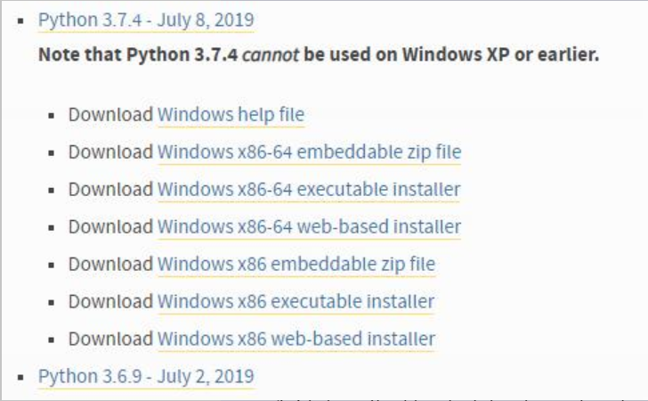

* Click on windows x86-64 executable installer.
* Click on the file which has been downloaded.
* Click on the checkbox which marked on the below image

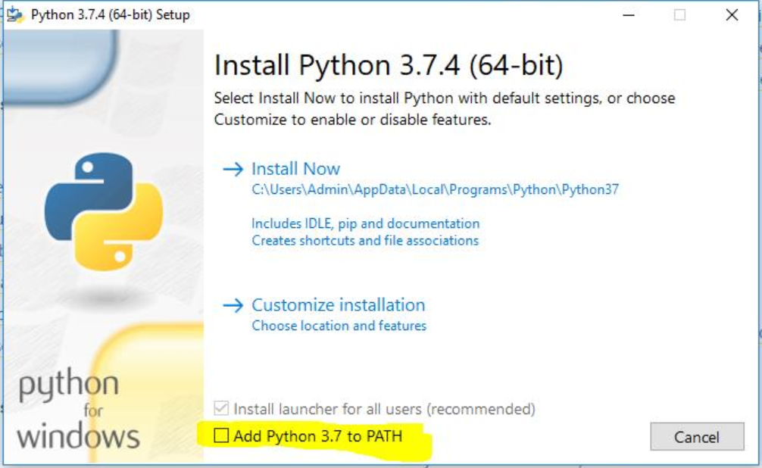

**Create virtual environment:**

* Create a folder for project and clone our project there.
* Open cmd prompt with that path.
* Use this command “python –m venv venv” in cmd prompt.
* Activate virtual environment using this command “venv\Scripts\activate”.

**Install requirement.txt:**

* To install requirements use this command “pip install –r requirements.txt”

**Chromedriver installation:**

* Install chromedriver which is suitable for your chrome browser.
* Copy the path of the chromedriver in your machine and paste the path in the main.py file line number 13.
* browser = webdriver.Chrome('D:/chromedriver.exe')
* Replace your path here.

**How to run the Python file:**

* To run the python file use this command “ python main.py”