WD-Activity-Based-Learning

Case Study-1

Experiment: Personal Portfolio Website Using HTML and CSS

1. Introduction
A Personal Portfolio Website is a website used to display an individual's personal details, educational qualifications, technical skills, hobbies, projects, achievements, and contact information.
HTML is used to create the structure of the website, while CSS is used to design and style the webpage. This website helps students showcase their skills, knowledge, and achievements in a professional way.

2. Explanation
This Personal Portfolio Website is designed using HTML and CSS. It contains the following sections:
- Home: Displays the student's name, welcome message, and course details.
- About Me: Provides personal information, career goals, and languages known.
- Education: Displays educational qualifications such as B.Tech, Intermediate, and SSC.
- Technical Skills: Shows skills like HTML, CSS, Python, and Artificial Intelligence using progress bars.
- Hobbies: Displays hobbies such as reading, coding, and listening to music.
- Projects: Shows the projects developed by the student.
- Achievements: Displays learning achievements and technical activities.
- Resume: Provides options to view and download the resume.
- Contact: Displays email address and location for communication.
- Footer: Displays copyright information and a Back to Top link.
Technologies Used:
- HTML – To create the structure of the webpage.
- CSS – To add colors, layouts, animations, and responsive design.

3. HTML Code
The following HTML code creates the basic structure of the Personal Portfolio Website.

<!DOCTYPE html>
<html lang="en">
<head>
<meta charset="UTF-8">
<meta name="viewport" content="width=device-width, initial-scale=1.0">
<title>My Personal Portfolio</title>
<link rel="stylesheet" href="task1.css">
</head>
<body>

<header>
<nav class="navbar">
<a href="#home" class="logo">MyPortfolio</a>

<ul class="nav-links">
<li><a href="#home">Home</a></li>
<li><a href="#about">About</a></li>
<li><a href="#education">Education</a></li>
<li><a href="#skills">Skills</a></li>
<li><a href="#projects">Projects</a></li>
<li><a href="#contact">Contact</a></li>
</ul>
</nav>
</header>

<section id="home" class="hero">
<div class="hero-content">
<p class="welcome">WELCOME TO MY PORTFOLIO</p>
<h1>Hello, I'm <span>Saisathvika</span></h1>
<h2>B.Tech CSE Student</h2>
<p>
I am passionate about programming,
Artificial Intelligence,
and learning new technologies.
</p>
<a href="#about" class="btn">
Explore My Portfolio
</a>
</div>

<div class="profile-image">
<div class="avatar">👩‍💻</div>
</div>
</section>

<section id="about" class="section">
<h2 class="section-title">About Me</h2>
<div class="about-card">
<h3>Who Am I?</h3>
<p>
I am a first-year B.Tech Computer Science
and Engineering student. I enjoy learning
programming, developing websites, and
exploring Artificial Intelligence and
Machine Learning.
</p>
<p><strong>Career Goal:</strong>
To become a skilled software developer.</p>
<p><strong>Languages:</strong> English, Telugu</p>
</div>
</section>

<section id="education" class="section alternate">
<h2 class="section-title">
Educational Qualifications
</h2>

<div class="cards">
<div class="card">
<h3>B.Tech - CSE</h3>
<p>College: NRI UNIVERSITY</p>
<p>Year: First Year</p>
<p>Special Interest: AI and ML</p>
</div>

<div class="card">
<h3>Intermediate</h3>
<p>College: SRI CHAITHANYA JR COLLEGE</p>
<p>Stream: MPC</p>
<p>Year: 2026</p>
</div>

<div class="card">
<h3>SSC</h3>
<p>School: MONTIRRORI</p>
<p>Qualification: Class 10</p>
<p>Year: 2023</p>
</div>
</div>
</section>

<section id="skills" class="section">
<h2 class="section-title">Technical Skills</h2>

<div class="skills-container">
<div class="skill">
<span>HTML</span>
<div class="progress">
<div class="fill html"></div>
</div>
</div>

<div class="skill">
<span>CSS</span>
<div class="progress">
<div class="fill css"></div>
</div>
</div>

<div class="skill">
<span>Python</span>
<div class="progress">
<div class="fill python"></div>
</div>
</div>

<div class="skill">
<span>Artificial Intelligence</span>
<div class="progress">
<div class="fill ai"></div>
</div>
</div>
</div>
</section>

<section id="hobbies" class="section alternate">
<h2 class="section-title">My Hobbies</h2>

<div class="cards">
<div class="card hobby">
📚
<h3>Reading</h3>
<p>Learning new things and technology.</p>
</div>

<div class="card hobby">
💻
<h3>Coding</h3>
<p>Practising programming and solving problems.</p>
</div>

<div class="card hobby">
🎵
<h3>Music</h3>
<p>Listening to music in my free time.</p>
</div>
</div>
</section>

<section id="projects" class="section">
<h2 class="section-title">My Projects</h2>

<div class="cards">
<div class="card">
<h3>Personal Portfolio</h3>
<p>A responsive website to showcase my profile and skills.</p>
<span class="tag">HTML | CSS</span>
</div>

<div class="card">
<h3>Simple Calculator</h3>
<p>A beginner project for basic calculations.</p>
<span class="tag">Python</span>
</div>

<div class="card">
<h3>AI Learning Project</h3>
<p>Exploring basic Artificial Intelligence concepts.</p>
<span class="tag">Artificial Intelligence</span>
</div>
</div>
</section>

<section id="achievements" class="section alternate">
<h2 class="section-title">Achievements</h2>
<div class="about-card">
<ul>
<li>Learning Python programming and web development.</li>
<li>Exploring Artificial Intelligence and Machine Learning.</li>
<li>Developing academic mini-projects.</li>
</ul>
</div>
</section>

<section id="resume" class="section">
<h2 class="section-title">My Resume</h2>
<div class="about-card resume-card">
<p>View or download my resume.</p>
<a href="resume.pdf" class="btn" target="_blank">
View Resume
</a>
<a href="resume.pdf" class="btn secondary" download>
Download Resume
</a>
</div>
</section>

<section id="contact" class="section alternate">
<h2 class="section-title">Contact Me</h2>

<div class="about-card contact-card">
<p>I'd love to connect and learn together!</p>
<p>Email:
<a href="mailto:saisathvikat4@gmail.com">
saisathvikat4@gmail.com
</a>
</p>
<p>Location: Andhra Pradesh, India</p>

<a href="mailto:saisathvika@gmail.com" class="btn">
Send Email
</a>
</div>
</section>

<footer>
<p>© 2026 Saisathvika | Personal Portfolio Website</p>
<a href="#home">Back to Top ↑</a>
</footer>

</body>
</html>

4. CSS Code
CSS is used to improve the appearance of the webpage by adding background colors, fonts, spacing, card layouts, hover effects, and responsive designs.

/* General Styling */
* {
margin: 0;
padding: 0;
box-sizing: border-box;
scroll-behavior: smooth;
}

body {
font-family: Arial, sans-serif;
background-color: #f4f7fc;
color: #333;
line-height: 1.6;
}

/* Navigation Bar */
header {
background-color: #172554;
padding: 15px 8%;
}

.navbar {
display: flex;
justify-content: space-between;
align-items: center;
}

.logo {
color: white;
font-size: 25px;
font-weight: bold;
text-decoration: none;
}

.nav-links {
display: flex;
list-style: none;
gap: 20px;
}

.nav-links a {
color: white;
text-decoration: none;
transition: 0.3s;
}

.nav-links a:hover {
color: #38bdf8;
}

/* Home Section */
.hero {
min-height: 450px;
background: linear-gradient(135deg, #dbeafe, #bfdbfe);
display: flex;
justify-content: space-around;
align-items: center;
padding: 60px 8%;
}

.hero-content {
max-width: 550px;
}

.welcome {
color: #2563eb;
font-weight: bold;
}

.hero h1 {
font-size: 38px;
margin: 10px 0;
}

.hero h1 span {
color: #2563eb;
}

.hero h2 {
margin-bottom: 15px;
}

.profile-image {
width: 180px;
height: 180px;
border-radius: 50%;
background-color: #2563eb;
display: flex;
justify-content: center;
align-items: center;
}

.avatar {
font-size: 85px;
}

/* Buttons */
.btn {
display: inline-block;
background-color: #2563eb;
color: white;
padding: 12px 22px;
margin-top: 15px;
border-radius: 6px;
text-decoration: none;
transition: 0.3s;
}

.btn:hover {
background-color: #172554;
transform: translateY(-3px);
}

.secondary {
background-color: #475569;
}

/* Common Sections */
.section {
padding: 60px 8%;
text-align: center;
}

.alternate {
background-color: #eaf0fa;
}

.section-title {
color: #172554;
font-size: 30px;
margin-bottom: 30px;
}

/* About Section */
.about-card {
max-width: 800px;
margin: auto;
padding: 30px;
background-color: white;
border-radius: 12px;
box-shadow: 0 4px 12px rgba(0,0,0,0.1);
text-align: left;
}

.about-card h3 {
color: #2563eb;
margin-bottom: 12px;
}

/* Cards */
.cards {
display: flex;
justify-content: center;
gap: 25px;
flex-wrap: wrap;
}

.card {
background-color: white;
padding: 25px;
width: 280px;
border-radius: 12px;
box-shadow: 0 4px 12px rgba(0,0,0,0.1);
transition: 0.3s;
}

.card:hover {
transform: translateY(-8px);
box-shadow: 0 8px 18px rgba(0,0,0,0.15);
}

.card h3 {
color: #2563eb;
margin-bottom: 10px;
}

.hobby {
font-size: 25px;
}

/* Skills Section */
.skills-container {
max-width: 600px;
margin: auto;
text-align: left;
}

.skill {
margin-bottom: 20px;
}

.progress {
height: 12px;
background-color: #ddd;
border-radius: 10px;
overflow: hidden;
}

.fill {
height: 100%;
border-radius: 10px;
background-color: #2563eb;
}

.html {
width: 90%;
}

.css {
width: 80%;
}

.python {
width: 70%;
}

.ai {
width: 60%;
}

/* Project Tags */
.tag {
display: inline-block;
margin-top: 12px;
padding: 5px 12px;
background-color: #dbeafe;
color: #1d4ed8;
border-radius: 15px;
font-size: 13px;
}

/* Contact Section */
.contact-card {
text-align: center;
}

.contact-card a {
color: #2563eb;
}

/* Footer */
footer {
background-color: #172554;
color: white;
text-align: center;
padding: 20px;
}

footer a {
color: #38bdf8;
text-decoration: none;
}

/* Responsive Design */
@media (max-width: 768px) {
.navbar {
flex-direction: column;
gap: 15px;
}

.nav-links {
flex-wrap: wrap;
justify-content: center;
}

.hero {
flex-direction: column;
text-align: center;
gap: 30px;
}

.hero h1 {
font-size: 28px;
}

.cards {
flex-direction: column;
align-items: center;
}

.card {
width: 100%;
max-width: 350px;
}
}

5.Output

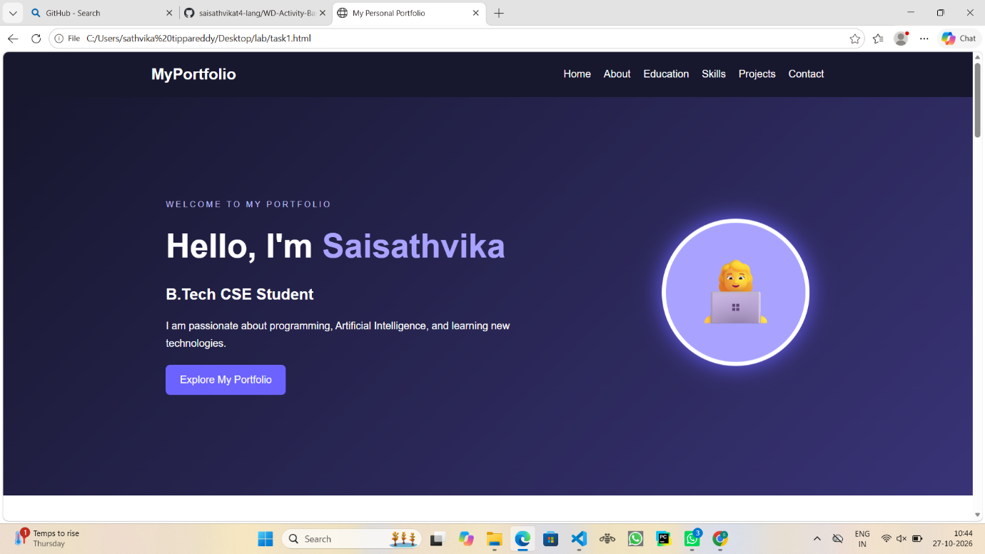

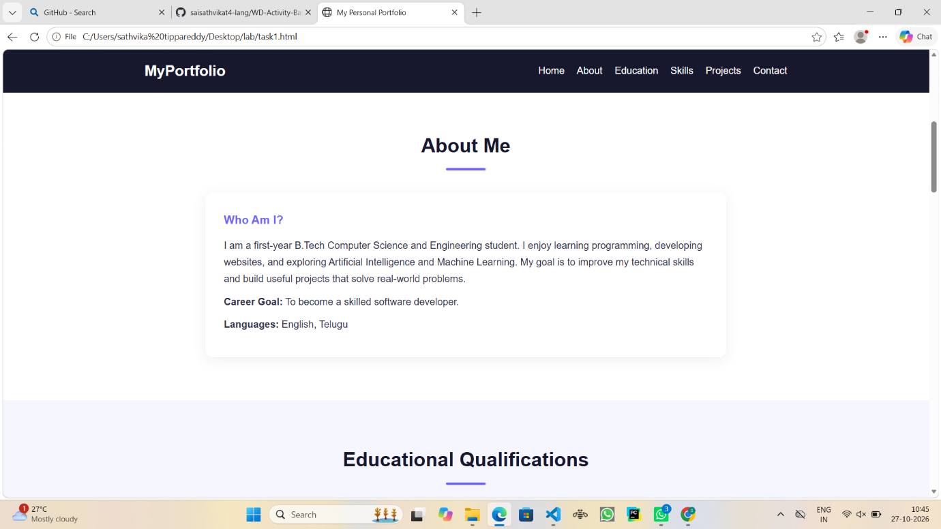

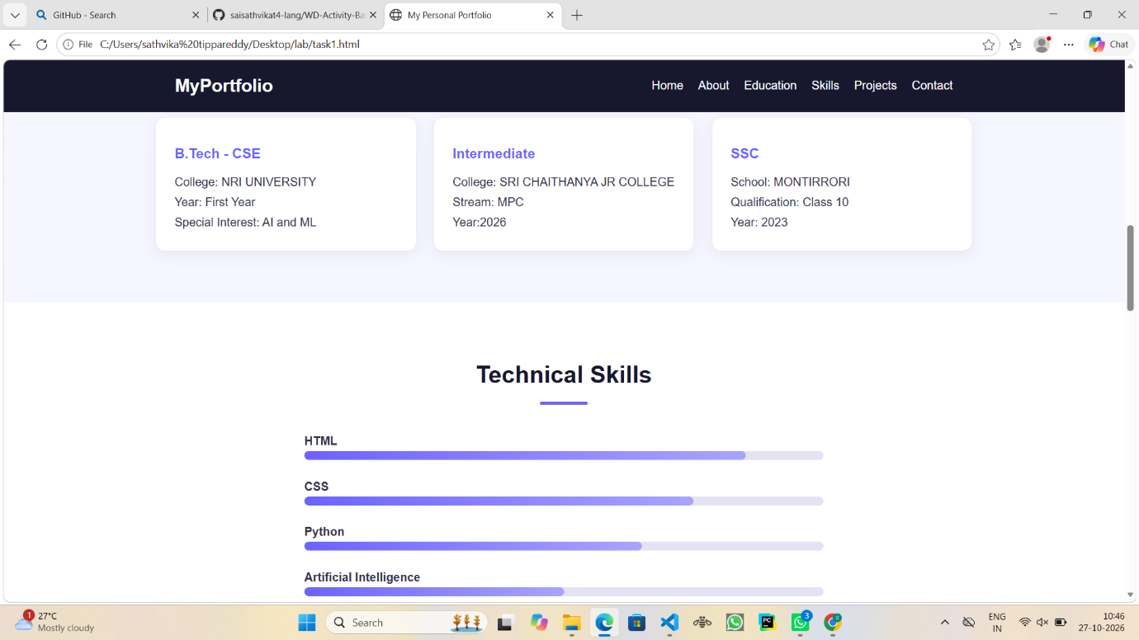

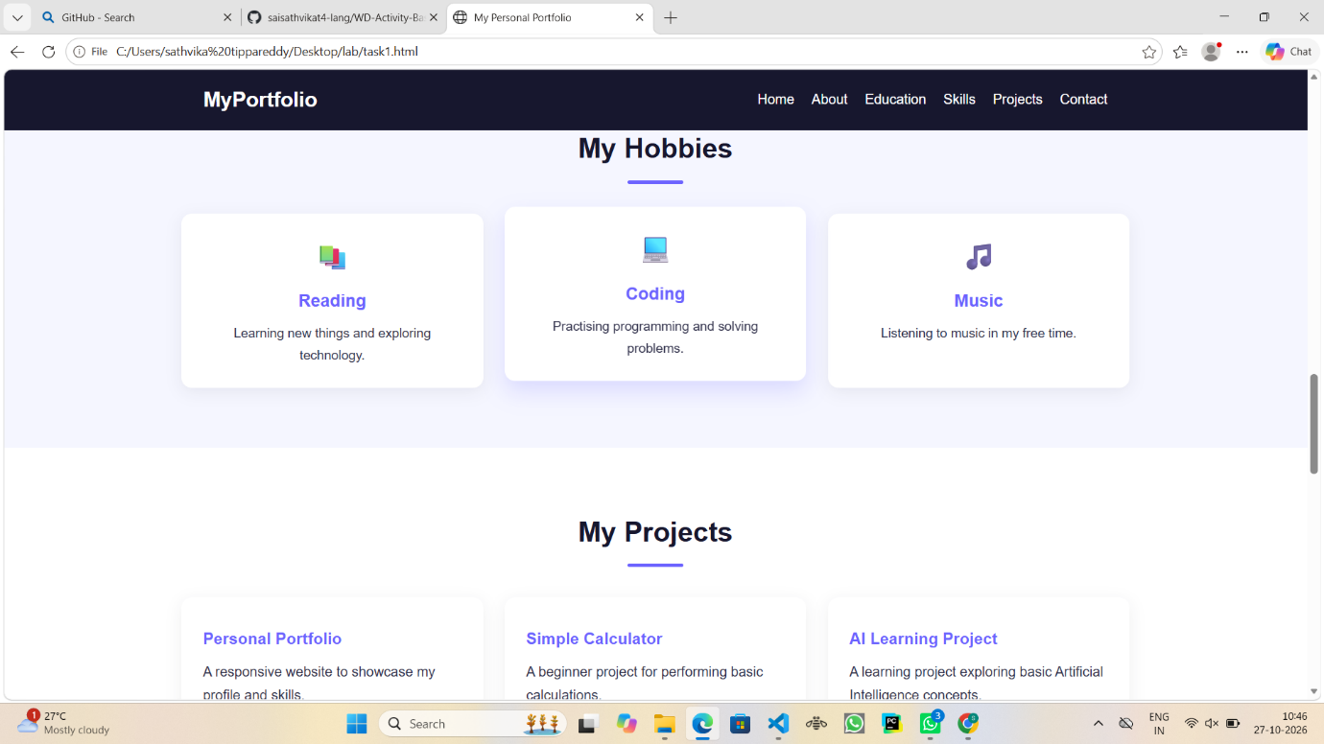

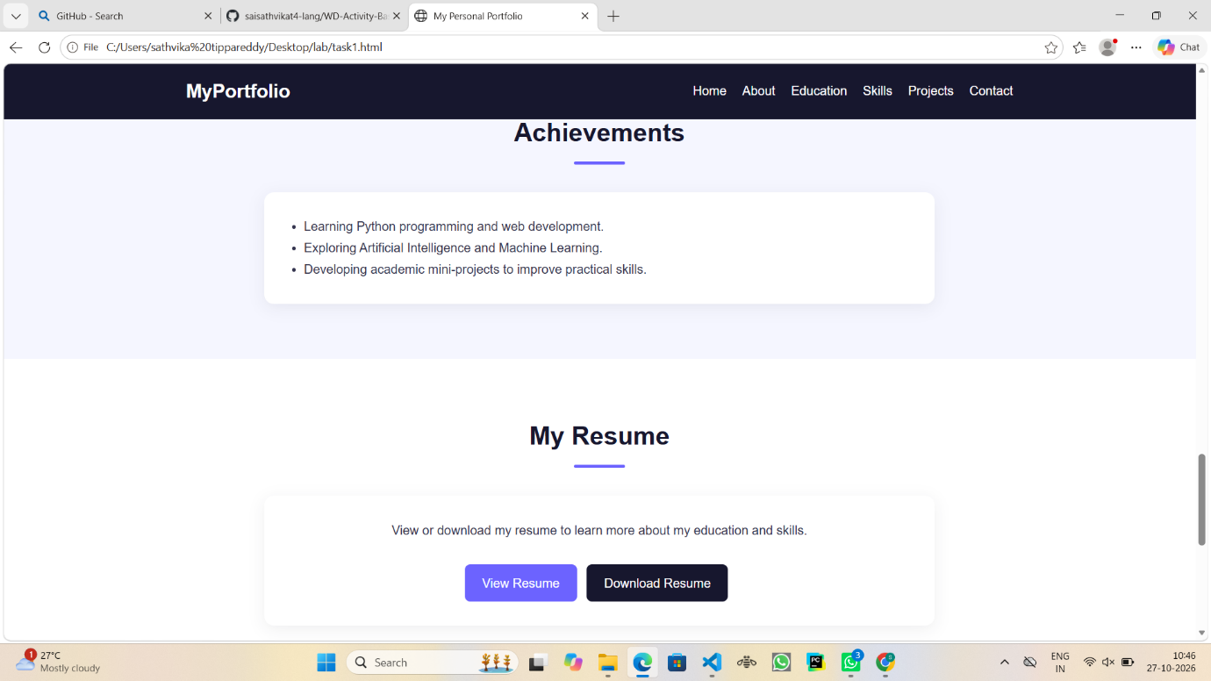

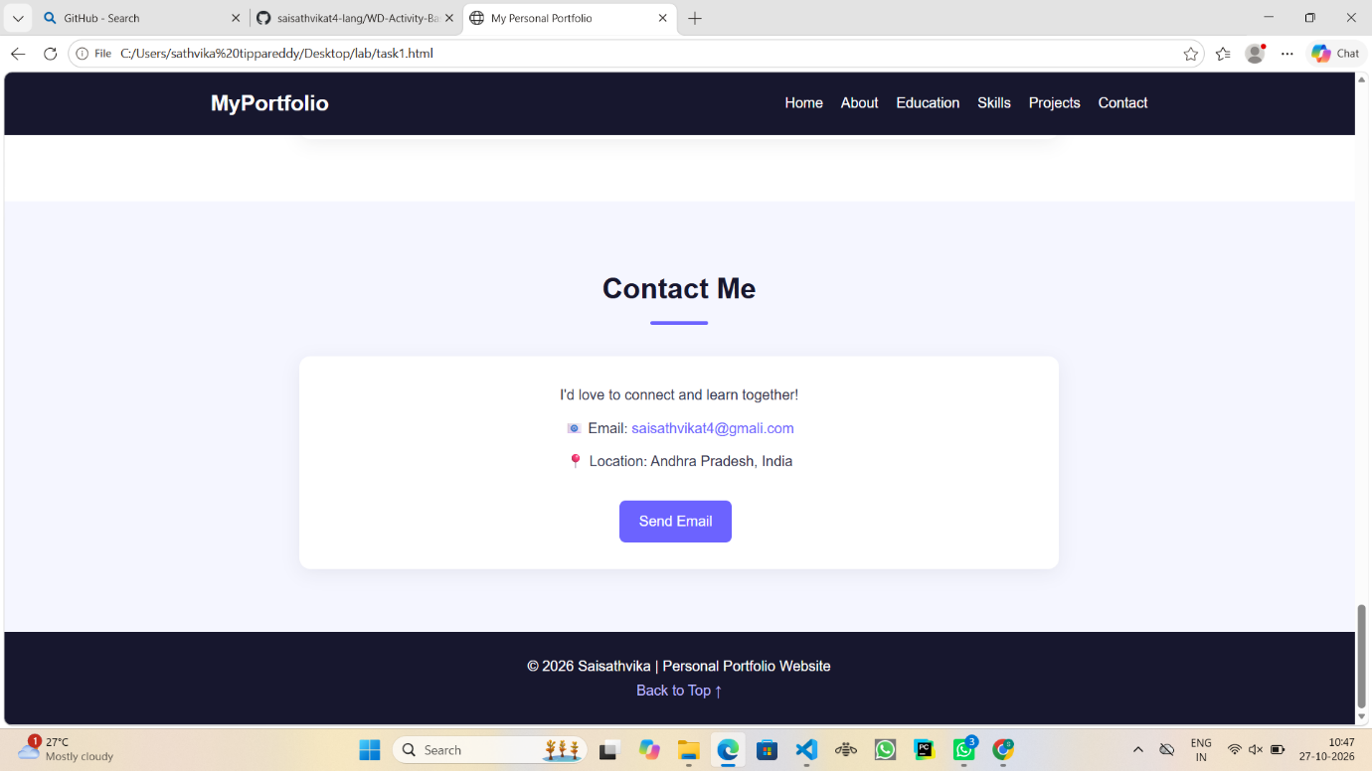

6. Conclusion
Thus, I successfully created a Personal Portfolio Website using HTML and CSS. This website displays my personal information, educational qualifications, technical skills, hobbies, projects, achievements, resume, and contact details. Through this project, I learned how to create webpages using HTML and design attractive, responsive websites using CSS.

Case Study-2

Experiment: Student Academic Dashboard Using HTML and CSS

1. Introduction
A Student Academic Dashboard is a web-based application used to display student details, semester results, attendance percentage, subject information, and important announcements.
HTML is used to create the structure of the dashboard, while CSS is used to design the layout, colors, cards, tables, animations, and responsive features. It helps students easily view and understand their academic performance.

2. Explanation
This Student Academic Dashboard is designed using HTML and CSS. It contains the following sections:
- Sidebar: Provides navigation links to different dashboard sections such as Overview, Results, Attendance, Subjects, and Announcements.
- Dashboard Header: Displays the dashboard title and student profile information.
- Student Information: Displays the student's name, roll number, department, and academic details.
- Summary Cards: Shows important academic details such as GPA, attendance, subjects, and completed credits.
- Semester Results: Displays subject names, marks, grades, and results in a table format.
- Attendance: Shows attendance percentages using graphical progress bars.
- Subjects: Displays the subjects studied by the student using cards.
- Announcements: Displays important academic notifications and updates.
- Footer: Displays the footer information of the dashboard.
Technologies Used:
- HTML – Used to create the structure of the dashboard.
- CSS – Used to add colors, styling, layouts, animations, and responsive design.

3. HTML Code
Create a file named index.html.

<!DOCTYPE html>
<html lang="en">
<head>
<meta charset="UTF-8">
<meta name="viewport" content="width=device-width, initial-scale=1.0">
<title>Student Academic Dashboard</title>
<link rel="stylesheet" href="task2.css">
</head>
<body>

<div class="dashboard">

<!-- Sidebar -->
<aside class="sidebar">
<h2>Student Portal</h2>
<a href="#overview">Dashboard</a>
<a href="#results">Semester Results</a>
<a href="#attendance">Attendance</a>
<a href="#subjects">Subjects</a>
<a href="#announcements">Announcements</a>
</aside>

<!-- Main Content -->
<main class="main-content">

<header>
<div>
<h1>Academic Dashboard</h1>
<p>Welcome to your student portal</p>
</div>
<div class="profile">👩‍🎓 Saisathvika</div>
</header>

<!-- Student Information -->
<section class="student-card">
<div class="student-icon">👩‍💻</div>
<div>
<h2>Saisathvika</h2>
<p>Roll No: 26CSE001</p>
<p>Department: Computer Science Engineering</p>
<p>Year: First Year</p>
</div>
</section>

<!-- Summary Cards -->
<section class="stats" id="overview">
<div class="card">
<h3>Current CGPA</h3>
<p class="number">8.8</p>
</div>

<div class="card">
<h3>Attendance</h3>
<p class="number">92%</p>
</div>

<div class="card">
<h3>Total Subjects</h3>
<p class="number">6</p>
</div>

<div class="card">
<h3>Credits</h3>
<p class="number">24</p>
</div>
</section>

<!-- Semester Results -->
<section class="panel" id="results">
<h2>Semester Results</h2>

<table>
<tr>
<th>Subject</th>
<th>Marks</th>
<th>Grade</th>
<th>Result</th>
</tr>

<tr>
<td>Mathematics</td>
<td>90</td>
<td>A+</td>
<td>Pass</td>
</tr>

<tr>
<td>Programming</td>
<td>95</td>
<td>O</td>
<td>Pass</td>
</tr>

<tr>
<td>Physics</td>
<td>85</td>
<td>A</td>
<td>Pass</td>
</tr>

<tr>
<td>English</td>
<td>88</td>
<td>A</td>
<td>Pass</td>
</tr>
</table>

<p class="note">Sample academic results for demonstration.</p>
</section>

<!-- Attendance -->
<section class="panel" id="attendance">
<h2>Attendance Details</h2>

<div class="attendance-item">
<span>Mathematics</span>
<span>95%</span>
<div class="progress">
<div class="fill" style="width:95%"></div>
</div>
</div>

<div class="attendance-item">
<span>Programming</span>
<span>90%</span>
<div class="progress">
<div class="fill" style="width:90%"></div>
</div>
</div>

<div class="attendance-item">
<span>Physics</span>
<span>85%</span>
<div class="progress">
<div class="fill" style="width:85%"></div>
</div>
</div>

<div class="attendance-item">
<span>English</span>
<span>92%</span>
<div class="progress">
<div class="fill" style="width:92%"></div>
</div>
</div>
</section>

<!-- Subjects -->
<section class="panel" id="subjects">
<h2>My Subjects</h2>

<div class="subject-grid">
<div class="subject">
<h3>Mathematics</h3>
<p>Subject Code: MATH101</p>
<p>Credits: 4</p>
</div>

<div class="subject">
<h3>Programming</h3>
<p>Subject Code: CSE101</p>
<p>Credits: 4</p>
</div>

<div class="subject">
<h3>Physics</h3>
<p>Subject Code: PHY101</p>
<p>Credits: 3</p>
</div>

<div class="subject">
<h3>English</h3>
<p>Subject Code: ENG101</p>
<p>Credits: 2</p>
</div>
</div>
</section>

<!-- Announcements -->
<section class="panel" id="announcements">
<h2>Announcements</h2>

<div class="announcement">
<h3>Examination Notice</h3>
<p>Semester examinations will begin soon.</p>
</div>

<div class="announcement">
<h3>Assignment Submission</h3>
<p>Submit all pending assignments before the deadline.</p>
</div>

<div class="announcement">
<h3>College Event</h3>
<p>Technical events and workshops are coming soon.</p>
</div>
</section>

<footer>
<p>© 2026 Student Academic Dashboard</p>
</footer>

</main>
</div>

</body>
</html>

4. CSS Code
Create another file named task2.css.
The following CSS code is used to style the dashboard with an attractive sidebar, summary cards, tables, attendance progress bars, animations, and responsive layouts.

/* General Styling */
* {
margin: 0;
padding: 0;
box-sizing: border-box;
scroll-behavior: smooth;
}

body {
font-family: Arial, sans-serif;
background: #f1f4f9;
color: #273248;
}

.dashboard {
display: flex;
min-height: 100vh;
}

/* Sidebar */
.sidebar {
width: 240px;
background: #172554;
color: white;
padding: 25px 15px;
position: fixed;
height: 100vh;
}

.sidebar h2 {
font-size: 21px;
margin-bottom: 30px;
text-align: center;
}

.sidebar a {
display: block;
padding: 13px 10px;
margin-bottom: 8px;
color: white;
text-decoration: none;
border-radius: 6px;
transition: 0.3s;
}

.sidebar a:hover {
background: #3b82f6;
padding-left: 18px;
}

/* Main Content */
.main-content {
margin-left: 240px;
padding: 30px;
width: calc(100% - 240px);
}

header {
display: flex;
justify-content: space-between;
align-items: center;
gap: 15px;
margin-bottom: 25px;
}

header h1 {
color: #172554;
font-size: 28px;
}

header p {
color: #64748b;
}

.profile {
background: white;
padding: 12px 18px;
border-radius: 8px;
font-weight: bold;
}

/* Student Information */
.student-card {
display: flex;
align-items: center;
gap: 22px;
background: linear-gradient(120deg, #2563eb, #7c3aed);
color: white;
padding: 25px;
border-radius: 12px;
margin-bottom: 25px;
animation: appear 0.8s ease;
}

.student-icon {
font-size: 55px;
background: #ffffff30;
padding: 12px;
border-radius: 50%;
}

.student-card p {
margin-top: 5px;
}

/* Summary Cards */
.stats {
display: grid;
grid-template-columns: repeat(4, 1fr);
gap: 18px;
margin-bottom: 25px;
}

.card {
background: white;
padding: 22px;
border-radius: 10px;
box-shadow: 0 3px 12px #17255410;
transition: transform 0.3s;
}

.card:hover {
transform: translateY(-6px);
}

.card h3 {
font-size: 14px;
color: #64748b;
}

.number {
font-size: 30px;
font-weight: bold;
color: #2563eb;
margin-top: 10px;
}

/* Content Panels */
.panel {
background: white;
padding: 25px;
border-radius: 10px;
margin-bottom: 25px;
box-shadow: 0 3px 12px #17255410;
scroll-margin-top: 20px;
}

.panel h2 {
margin-bottom: 20px;
color: #172554;
}

/* Tables */
table {
width: 100%;
border-collapse: collapse;
}

th, td {
padding: 13px;
text-align: left;
border-bottom: 1px solid #e2e8f0;
}

th {
background: #eff6ff;
color: #1d4ed8;
}

tr:hover td {
background: #f8fafc;
}

.note {
font-size: 12px;
color: #64748b;
margin-top: 12px;
}

/* Attendance Progress Bars */
.attendance-item {
margin-bottom: 20px;
}

.attendance-item span {
display: inline-block;
margin-bottom: 8px;
}

.attendance-item span:nth-child(2) {
float: right;
font-weight: bold;
color: #2563eb;
}

.progress {
height: 10px;
background: #e2e8f0;
border-radius: 10px;
overflow: hidden;
}

.fill {
height: 100%;
background: #22c55e;
border-radius: 10px;
animation: grow 1.2s ease;
}

/* Subject Cards */
.subject-grid {
display: grid;
grid-template-columns: repeat(2, 1fr);
gap: 18px;
}

.subject {
background: #eff6ff;
border-left: 4px solid #2563eb;
padding: 18px;
border-radius: 7px;
transition: 0.3s;
}

.subject:hover {
background: #dbeafe;
transform: translateX(5px);
}

.subject h3 {
color: #1d4ed8;
margin-bottom: 8px;
}

/* Announcements */
.announcement {
background: #fffbeb;
border-left: 4px solid #f59e0b;
padding: 16px;
margin-bottom: 14px;
border-radius: 6px;
}

.announcement h3 {
margin-bottom: 6px;
color: #92400e;
}

/* Footer */
footer {
text-align: center;
padding: 20px;
color: #64748b;
}

/* Animations */
@keyframes appear {
from {
opacity: 0;
transform: translateY(15px);
}
to {
opacity: 1;
transform: translateY(0);
}
}

@keyframes grow {
from {
width: 0;
}
}

/* Responsive Layout */
@media (max-width: 1000px) {
.sidebar {
width: 200px;
}

.main-content {
margin-left: 200px;
width: calc(100% - 200px);
padding: 20px;
}

.stats {
grid-template-columns: repeat(2, 1fr);
}
}

@media (max-width: 650px) {
.dashboard {
display: block;
}

.sidebar {
position: relative;
width: 100%;
height: auto;
}

.sidebar h2 {
margin-bottom: 12px;
}

.sidebar a {
display: inline-block;
padding: 8px;
margin: 3px;
font-size: 13px;
}

.main-content {
margin-left: 0;
width: 100%;
padding: 15px;
}

header {
align-items: flex-start;
flex-direction: column;
}

.stats,
.subject-grid {
grid-template-columns: 1fr;
}

.student-card {
align-items: flex-start;
flex-direction: column;
}

.panel {
padding: 15px;
overflow-x: auto;
}

table {
min-width: 400px;
}
}

5.Output

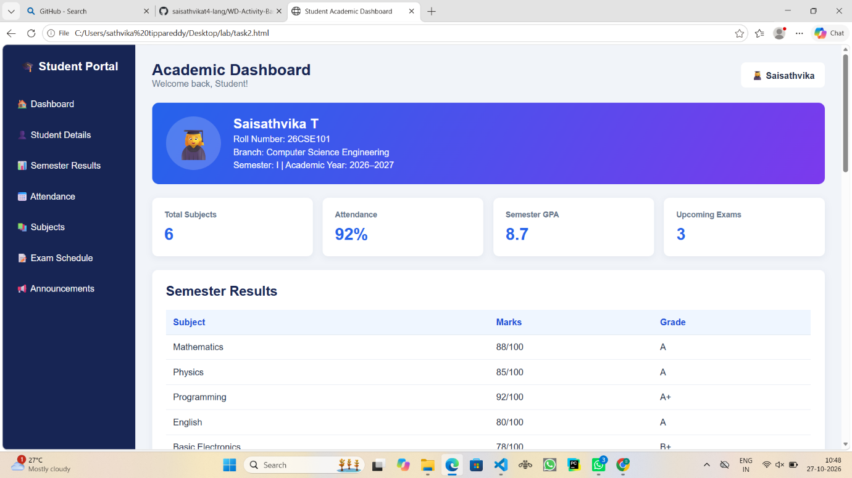

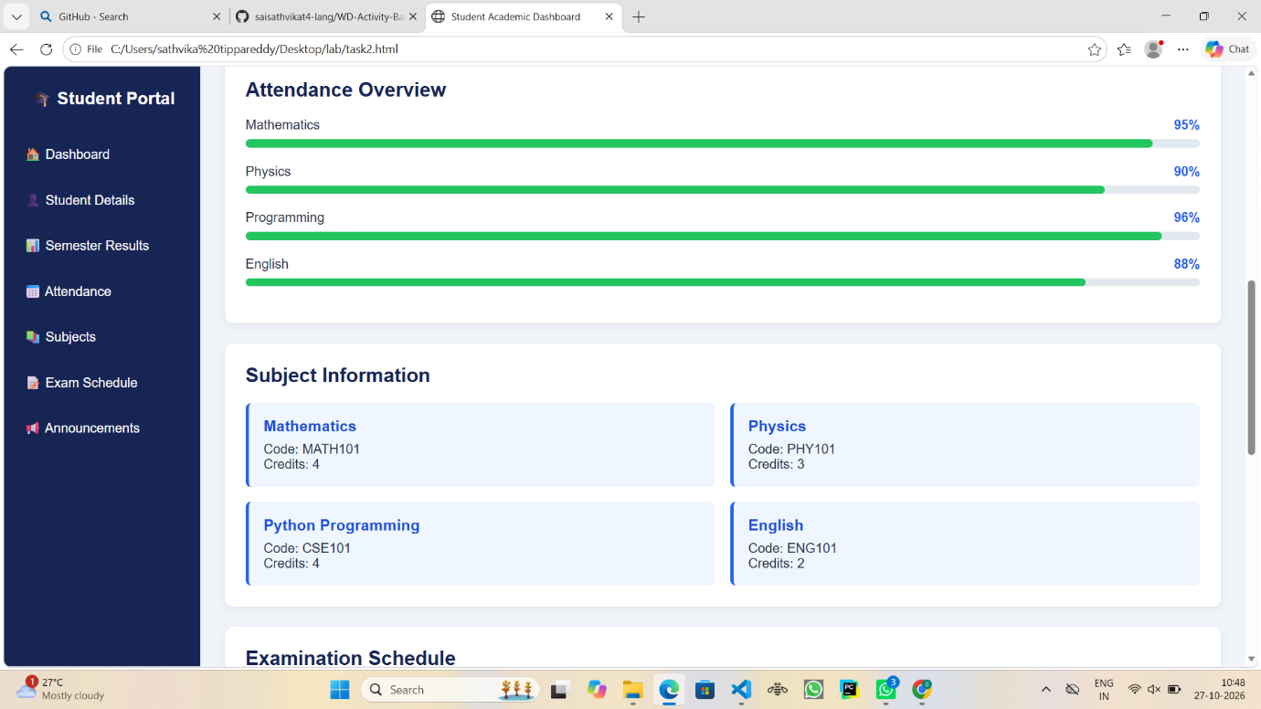

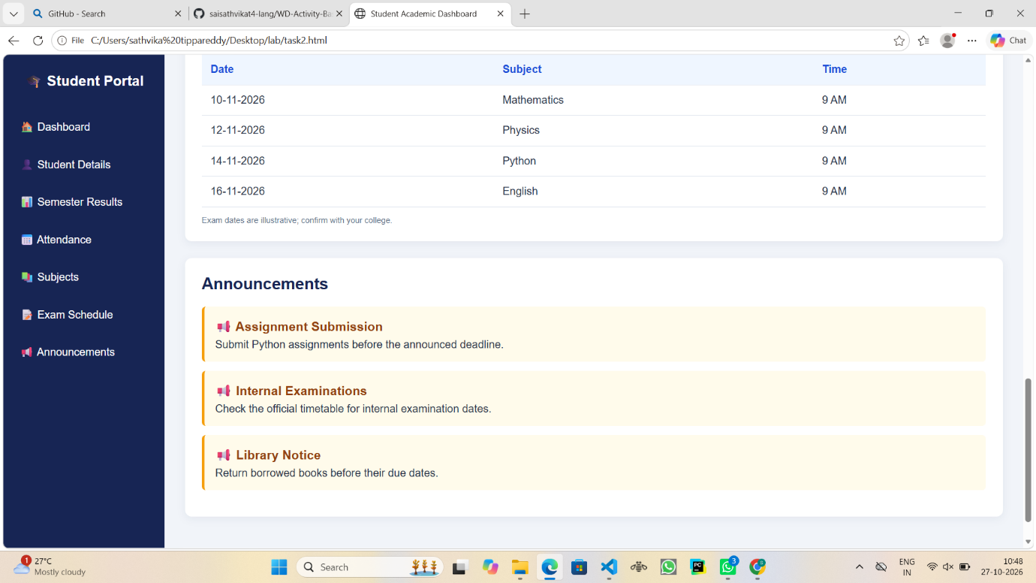

6. Conclusion
Thus, I successfully created a Student Academic Dashboard using HTML and CSS. This dashboard displays student information, academic results, attendance percentages, subject details, and important announcements. Through this project, I learned how to create tables, cards, navigation bars, progress bars, CSS animations, and responsive web layouts.

Case Study-3

Experiment 3: Online Food Ordering Website Using HTML and CSS

1. Introduction
An Online Food Ordering Website is a web application that allows customers to view food items, check prices, explore special offers, read customer reviews, and order their favourite food online.
HTML is used to create the structure of the website, while CSS is used to design the webpage with attractive colors, images, layouts, animations, and responsive features.
The main purpose of this website is to provide an easy and user-friendly food ordering experience.

2. Explanation
This Online Food Ordering Website is developed using HTML and CSS. It contains the following sections:
1. Navigation Bar: Provides links to Home, Menu, Offers, Reviews, and Contact sections. It also contains an Order Now button.
2. Hero Section: Displays a welcome message, attractive food image, and Explore Menu button.
3. Restaurant Details: Displays restaurant information such as rating, delivery time, price, and location.
4. Special Offers: Displays offers such as 50% discount, free delivery, and combo deals.
5. Food Categories: Displays different food categories such as Pizza, Burgers, Biryani, and Desserts.
6. Food Menu: Displays food images, food names, descriptions, prices, and Order Now buttons.
7. Customer Reviews: Displays customer feedback and star ratings about the restaurant.
8. Contact Section: Displays email address, phone number, and restaurant location.
9. Footer: Displays copyright information and a message for food lovers.
Technologies Used:
- HTML – Used to create the structure and content of the website.
- CSS – Used to add colors, styles, layouts, hover effects, animations, and responsive design.

3. HTML Code
File name: index.html

<!DOCTYPE html>
<html lang="en">
<head>
<meta charset="UTF-8">
<meta name="viewport" content="width=device-width, initial-scale=1.0">
<title>Foodie - Online Food Ordering</title>
<link rel="stylesheet" href="task3.css">
</head>
<body>

<!-- Navigation Bar -->
<header>
<nav class="navbar">
<h2 class="logo">🍔 Foodie</h2>

<ul class="nav-links">
<li><a href="#home">Home</a></li>
<li><a href="#menu">Menu</a></li>
<li><a href="#offers">Offers</a></li>
<li><a href="#reviews">Reviews</a></li>
<li><a href="#contact">Contact</a></li>
</ul>

<a href="#menu" class="cart-btn">Order Now 🛒</a>
</nav>
</header>

<!-- Hero Section -->
<section class="hero" id="home">
<div class="hero-content">
<p class="tagline">FRESH FOOD, HAPPY MOOD!</p>

<h1>Delicious Food<br>Delivered to You</h1>

<p>
Enjoy your favourite meals prepared fresh
and delivered straight to your doorstep.
</p>

<a href="#menu" class="btn">Explore Menu</a>
</div>

<div class="hero-image">
<img src="https://images.unsplash.com/photo-1568901346375-23c9450c58cd?auto=format&fit=crop&w=700&q=80"
alt="Delicious burger">
</div>
</section>

<!-- Restaurant Details -->
<section class="restaurant">
<h2>Welcome to Foodie Restaurant</h2>

<p>Serving delicious food with love and quality ingredients.</p>

<div class="restaurant-info">
<div>⭐ 4.8 Rating</div>
<div>🕒 25–35 min delivery</div>
<div>💰 ₹150 for two</div>
<div>📍 Vijayawada</div>
</div>
</section>

<!-- Special Offers -->
<section class="offers" id="offers">
<h2>🎉 Special Offers</h2>

<div class="offer-container">

<div class="offer-card">
<h3>50% OFF</h3>
<p>On your first food order.</p>
<a href="#menu" class="btn">Order Now</a>
</div>

<div class="offer-card">
<h3>FREE DELIVERY</h3>
<p>On selected menu items.</p>
<a href="#menu" class="btn">Explore</a>
</div>

<div class="offer-card">
<h3>COMBO DEAL</h3>
<p>Burger and fries at a special price.</p>
<a href="#menu" class="btn">View Combo</a>
</div>

</div>
</section>

<!-- Food Categories -->
<section class="categories">
<h2>Food Categories</h2>

<div class="category-list">
<a href="#pizza">🍕 Pizza</a>
<a href="#burger">🍔 Burgers</a>
<a href="#biryani">🍛 Biryani</a>
<a href="#dessert">🍰 Desserts</a>
</div>
</section>

<!-- Food Menu -->
<section class="menu" id="menu">
<h2>Our Popular Menu</h2>
<p class="subtitle">Choose your favourite dish</p>

<div class="food-container">

<div class="food-card" id="pizza">
<img src="https://images.unsplash.com/photo-1571407970349-bc81e7e96d47?auto=format&fit=crop&w=600&q=80"
alt="Pizza">

<div class="food-details">
<h3>Cheese Pizza</h3>
<p>Cheesy pizza topped with fresh vegetables.</p>

<div class="price-row">
<span class="price">₹199</span>
<button onclick="alert('Cheese Pizza selected!')">
Order Now
</button>
</div>
</div>
</div>

<div class="food-card" id="burger">
<img src="https://images.unsplash.com/photo-1568901346375-23c9450c58cd?auto=format&fit=crop&w=600&q=80"
alt="Burger">

<div class="food-details">
<h3>Classic Burger</h3>
<p>Juicy burger with cheese, lettuce and sauce.</p>

<div class="price-row">
<span class="price">₹149</span>
<button onclick="alert('Classic Burger selected!')">
Order Now
</button>
</div>
</div>
</div>

<div class="food-card" id="biryani">
<img src="https://images.unsplash.com/photo-1563379091339-03246963d96c?auto=format&fit=crop&w=600&q=80"
alt="Biryani">

<div class="food-details">
<h3>Chicken Biryani</h3>
<p>Flavourful rice cooked with aromatic spices.</p>

<div class="price-row">
<span class="price">₹249</span>
<button onclick="alert('Chicken Biryani selected!')">
Order Now
</button>
</div>
</div>
</div>

<div class="food-card" id="dessert">
<img src="https://images.unsplash.com/photo-1563805042-7684c019e1cb?auto=format&fit=crop&w=600&q=80"
alt="Ice Cream">

<div class="food-details">
<h3>Ice Cream</h3>
<p>Sweet and creamy dessert for every occasion.</p>

<div class="price-row">
<span class="price">₹99</span>
<button onclick="alert('Ice Cream selected!')">
Order Now
</button>
</div>
</div>
</div>

</div>
</section>

<!-- Customer Reviews -->
<section class="reviews" id="reviews">
<h2>What Our Customers Say</h2>

<div class="review-container">

<div class="review-card">
<div class="stars">⭐⭐⭐⭐⭐</div>
<p>"The food was delicious and delivery was quick!"</p>
<h3>- Ananya</h3>
</div>

<div class="review-card">
<div class="stars">⭐⭐⭐⭐⭐</div>
<p>"Amazing biryani and excellent service."</p>
<h3>- Rahul</h3>
</div>

<div class="review-card">
<div class="stars">⭐⭐⭐⭐</div>
<p>"Great offers and tasty food at good prices."</p>
<h3>- Priya</h3>
</div>

</div>
</section>

<!-- Contact Section -->
<section class="contact" id="contact">
<h2>Contact Us</h2>

<p>Have questions? We are happy to help!</p>
<p>📧 Email: food@example.com</p>
<p>📞 Phone: +91 98765 43210</p>
<p>📍 Location: Vijayawada, Andhra Pradesh</p>

<a href="mailto:food@example.com" class="btn">
Send an Email
</a>
</section>

<!-- Footer -->
<footer>
<p>© 2026 Foodie Restaurant | All Rights Reserved</p>
<p>Made with ❤️ for food lovers</p>
</footer>

</body>
</html>

4. CSS Code
File name: task3.css
The following CSS code is used to design the food ordering website with attractive backgrounds, food cards, images, buttons, hover effects, animations, and responsive layouts.

/* General Styling */
* {
margin: 0;
padding: 0;
box-sizing: border-box;
scroll-behavior: smooth;
}

body {
font-family: Arial, sans-serif;
color: #292323;
background: #fffaf5;
line-height: 1.6;
}

/* Navigation Bar */
header {
background: #251815;
position: sticky;
top: 0;
z-index: 100;
}

.navbar {
max-width: 1200px;
margin: auto;
padding: 15px 5%;
display: flex;
align-items: center;
justify-content: space-between;
gap: 20px;
}

.logo {
color: #ffb347;
font-size: 27px;
}

.nav-links {
display: flex;
list-style: none;
gap: 22px;
flex-wrap: wrap;
}

.nav-links a {
color: white;
text-decoration: none;
transition: color 0.3s;
}

.nav-links a:hover {
color: #ffb347;
}

.cart-btn {
background: #ff6b35;
color: white;
text-decoration: none;
padding: 9px 15px;
border-radius: 6px;
}

/* Hero Section */
.hero {
min-height: 480px;
padding: 60px 8%;
display: flex;
align-items: center;
justify-content: space-between;
gap: 35px;
background: linear-gradient(120deg, #fff0dc, #ffe1c2);
}

.hero-content {
max-width: 520px;
animation: slideIn 1s ease;
}

.tagline {
color: #e85d04;
font-weight: bold;
letter-spacing: 2px;
}

.hero h1 {
font-size: clamp(34px, 5vw, 55px);
line-height: 1.2;
margin: 15px 0;
color: #382019;
}

.hero-content p {
margin-bottom: 12px;
}

.hero-image img {
width: 100%;
max-width: 440px;
height: 320px;
object-fit: cover;
border-radius: 50% 20% 50% 20%;
box-shadow: 0 10px 25px #5b291d30;
}

/* Buttons */
.btn {
display: inline-block;
background: #ff6b35;
color: white;
text-decoration: none;
padding: 11px 22px;
border-radius: 6px;
margin-top: 15px;
transition: 0.3s;
}

.btn:hover {
background: #d94b1b;
transform: translateY(-3px);
}

/* Restaurant Details */
.restaurant {
text-align: center;
padding: 40px 5%;
}

.restaurant h2,
section h2 {
color: #382019;
}

.restaurant-info {
display: flex;
justify-content: center;
flex-wrap: wrap;
gap: 18px;
margin-top: 20px;
}

.restaurant-info div {
background: white;
padding: 13px 20px;
border-radius: 8px;
box-shadow: 0 3px 12px #00000010;
}

/* Special Offers */
.offers {
padding: 50px 8%;
background: #fff0dc;
text-align: center;
}

.offer-container,
.review-container {
display: grid;
grid-template-columns: repeat(3, 1fr);
gap: 22px;
margin-top: 25px;
}

.offer-card {
padding: 25px;
background: linear-gradient(135deg, #ff6b35, #ff9f1c);
color: white;
border-radius: 12px;
transition: transform 0.3s;
}

.offer-card:hover {
transform: scale(1.04);
}

.offer-card h3 {
font-size: 23px;
}

.offer-card .btn {
background: #382019;
}

/* Food Categories */
.categories {
padding: 40px 5%;
text-align: center;
}

.category-list {
display: flex;
justify-content: center;
flex-wrap: wrap;
gap: 15px;
margin-top: 20px;
}

.category-list a {
background: white;
padding: 12px 24px;
border-radius: 25px;
border: 1px solid #ffb347;
color: #382019;
text-decoration: none;
transition: 0.3s;
}

.category-list a:hover {
background: #ff6b35;
color: white;
}

/* Food Menu */
.menu {
padding: 50px 8%;
text-align: center;
}

.subtitle {
margin-top: 8px;
color: #777;
}

.food-container {
display: grid;
grid-template-columns: repeat(4, minmax(0, 1fr));
gap: 22px;
margin-top: 30px;
text-align: left;
}

.food-card {
background: white;
border-radius: 12px;
overflow: hidden;
box-shadow: 0 5px 18px #00000012;
transition: transform 0.3s;
}

.food-card:hover {
transform: translateY(-7px);
}

.food-card img {
width: 100%;
height: 180px;
object-fit: cover;
}

.food-details {
padding: 17px;
}

.food-details h3 {
color: #382019;
margin-bottom: 8px;
}

.food-details p {
font-size: 14px;
color: #666;
min-height: 65px;
}

.price-row {
display: flex;
align-items: center;
justify-content: space-between;
gap: 8px;
margin-top: 15px;
}

.price {
font-size: 21px;
color: #e85d04;
font-weight: bold;
}

.price-row button {
background: #ff6b35;
color: white;
border: none;
padding: 9px 12px;
border-radius: 5px;
cursor: pointer;
}

.price-row button:hover {
background: #d94b1b;
}

/* Customer Reviews */
.reviews {
padding: 50px 8%;
background: #fff0dc;
text-align: center;
}

.review-card {
background: white;
padding: 25px;
border-radius: 10px;
box-shadow: 0 3px 12px #00000010;
}

.stars {
margin-bottom: 12px;
}

/* Contact Section */
.contact {
text-align: center;
padding: 50px 20px;
}

.contact p {
margin-top: 10px;
}

/* Footer */
footer {
background: #251815;
color: white;
text-align: center;
padding: 25px;
}

/* Animations */
@keyframes slideIn {
from {
opacity: 0;
transform: translateX(-35px);
}
to {
opacity: 1;
transform: translateX(0);
}
}

/* Tablets */
@media (max-width: 1000px) {
.food-container {
grid-template-columns: repeat(2, minmax(0, 1fr));
}

.navbar {
flex-wrap: wrap;
}

.hero-image img {
max-width: 350px;
}
}

/* Mobile Phones */
@media (max-width: 650px) {
.navbar {
flex-direction: column;
}

.nav-links {
justify-content: center;
gap: 10px 15px;
}

.hero {
flex-direction: column;
text-align: center;
padding: 40px 6%;
}

.hero-image img {
height: 230px;
border-radius: 20px;
}

.offer-container,
.review-container,
.food-container {
grid-template-columns: 1fr;
}

.food-card img {
height: 230px;
}

.restaurant-info {
flex-direction: column;
}
}

5.Output

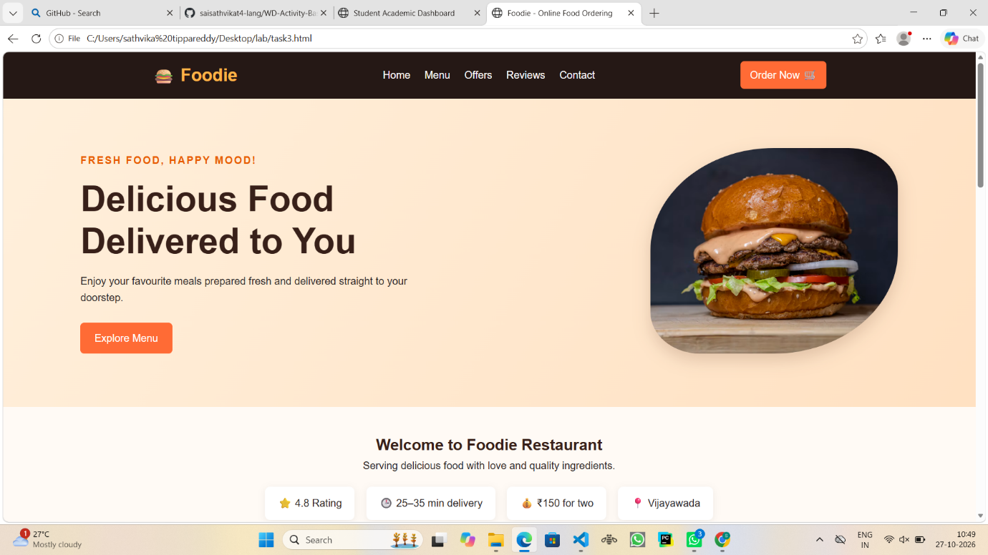

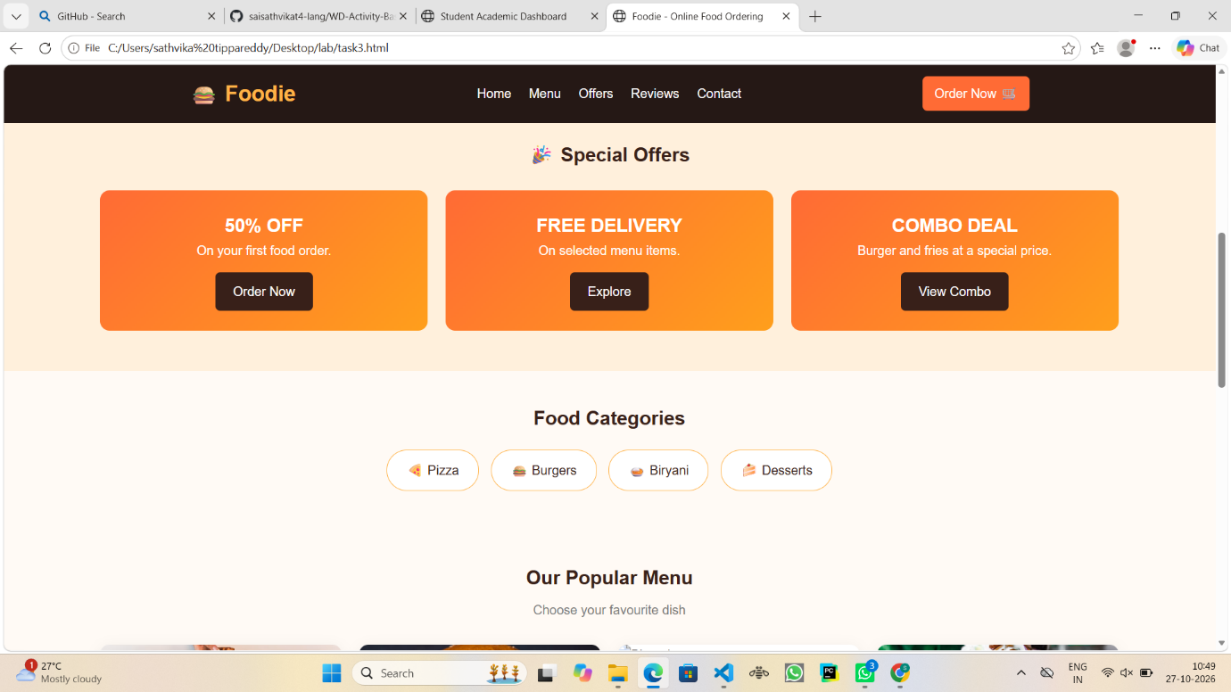

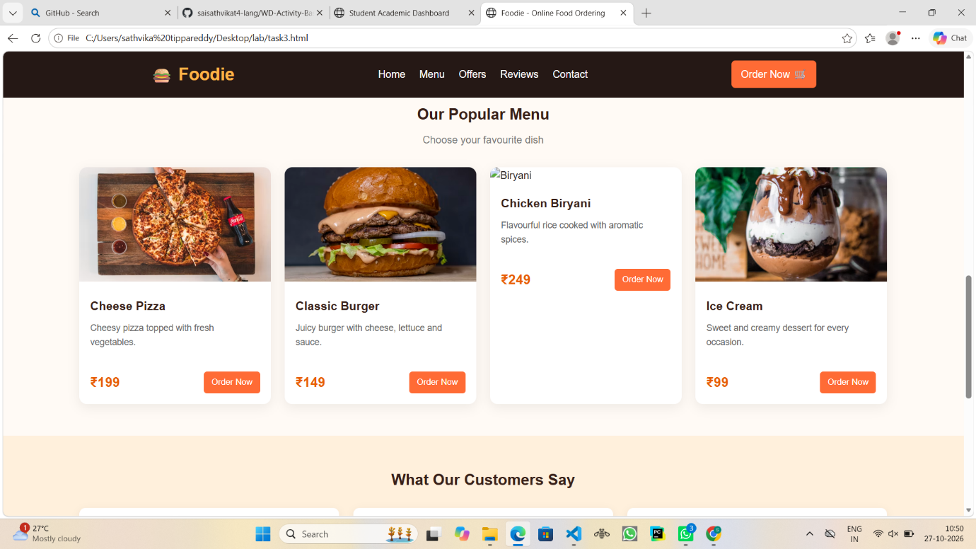

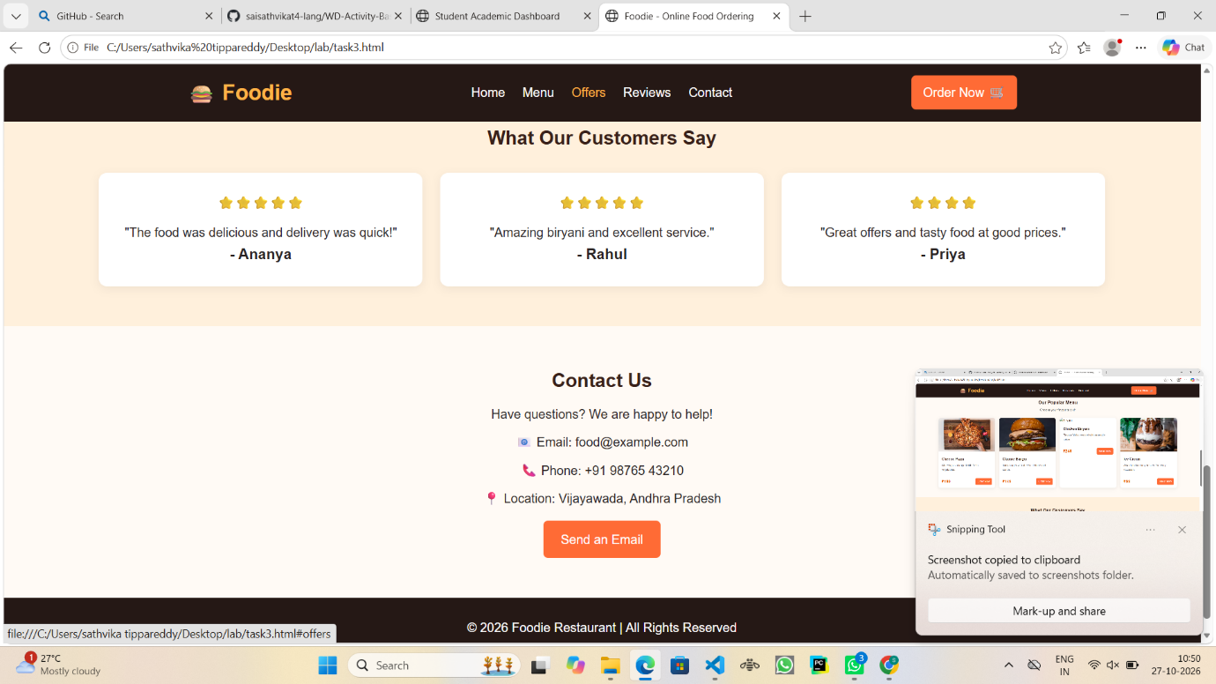

6. Conclusion
Thus, I successfully designed an Online Food Ordering Website using HTML and CSS. This website displays restaurant details, food categories, menu items, prices, special offers, customer reviews, and contact information. Through this project, I learned how to create attractive food cards, navigation bars, image layouts, hover effects, CSS animations, and responsive web pages.

