Real-time/Field-Based Research Project Report
On

Event Reminder

A dissertation submitted to the Jawaharlal Nehru Technological University, Hyderabad in partial fulfillment of the requirement for the award of degree of

BACHELOR OF TECHNOLOGY
IN
COMPUTER SCIENCE AND ENGINEERING

Submitted by

Chinnala Kumara Satya Sai(22B81A05T8)
Gowru Naren(22B81A05U1)
Vibhavesh Arava (22B81A05X8)


Department of Computer Science and Engineering

CVR COLLEGE OF ENGINEERING

(An UGC Autonomous Institution, Affiliated to JNTUH, Accredited by NBA, and NAAC)

Vastunagar, Mangalpalli (V),

Ibrahimpatnam (M),
Ranga Reddy (Dist.) - 501510,
Telangana State.

2023-24


CVR COLLEGE OF ENGINEERING
(An UGC Autonomous Institution, Affiliated to JNTUH,
Accredited by NBA, and NAAC)
Vastunagar, Mangalpalli (V), Ibrahimpatnam (M),
Ranga Reddy (Dist.) - 501510, Telangana State.

DEPARTMENT OF COMPUTER SCIENCE AND ENGINEERING

CERTIFICATE

This is to certify that the project work entitled “Event Reminder” is being submitted by
Chinnala Kumara Satya Sai(22B81A05T8), Gowru Naren(22B81A05U1), and Vibhavesh Arava (22B81A05X8)in partial fulfillment of the requirement for the award of the degree of Bachelor of Technology in Computer Science and Engineering, during the academic year 2023-2024.

Professor-in-charge RFP | Professor and Head, CSE
(Dr. S. Suguna Mallika) | (Dr. A. Vani Vasthala)

DECLARATION

I hereby declare that this project report titled “Event Reminder” submitted to the Department of Computer Science and Engineering, CVR College of Engineering, is a record of original work done by me. The information and data given in the report is authentic to the best of my knowledge. This RFP report is not submitted to any other university or institution for the award of any degree or diploma or published at any time before.

Chinnala Kumara Satya Sai(22B81A05T8)

Gowru Naren(22B81A05U1)

Vibhavesh Arava (22B81A05X8)

Date: 01-06-2024

Place: CVR College Of Engineering, Ibrahimpatnam.
TABLE OF CONTENTS
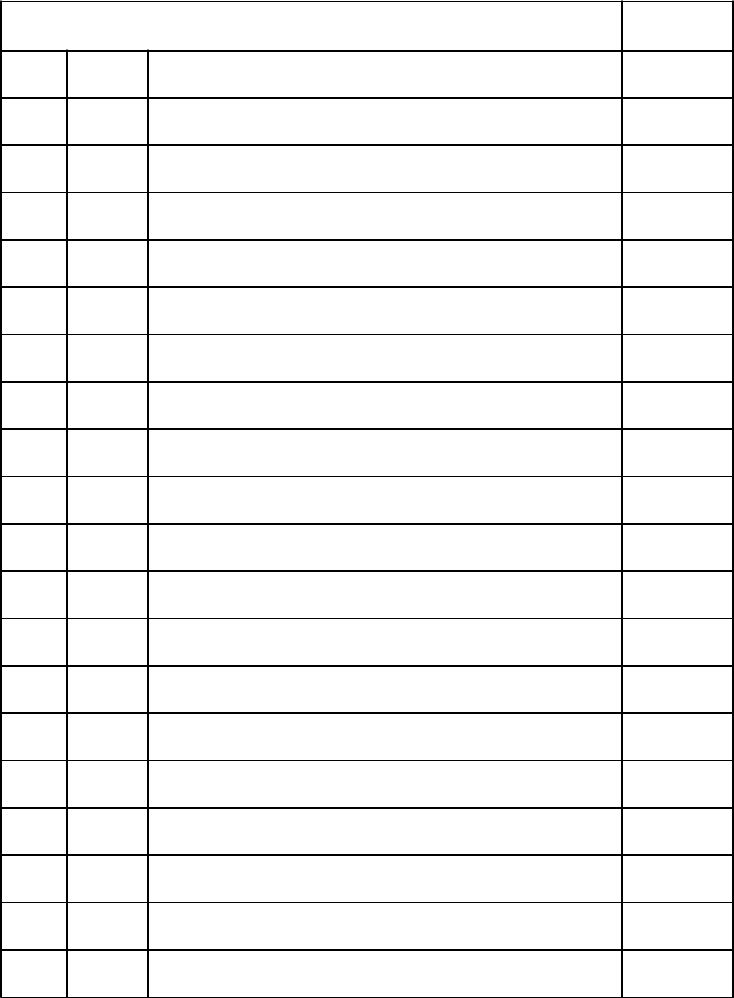

 |  | Page No.
1 | INTRODUCTION | 1-3
1.1 | Motivation | 1
1.2 | Problem Statement | 1
1.3 | Project Objectives | 2
1.4 | Project Report Organization | 3
2 | LITERATURE REVIEW | 4-5
2.1 | Existing Work | 4
2.2 | Limitations of Existing work | 5
3 | REQUIREMENT ANALYSIS | 6-7
3.1 | Software requirements | 6
3.2 | Hardware requirements | 6
3.3 | User requirements | 7
4 | SYSTEM DESIGN | 8-15
4.0 | Proposed System architecture | 8-9
4.1 | Proposed methods/ Algorithms | 10-11
4.2 | Class / Use case / Activity/ Sequence Diagrams | 12-15
5 | IMPLEMENTATION | 16-19
5.1 | Front page Screenshot | 16-18
5.2 | Results and Discussions | 19
5.3 | Testing | 19

5.4 | Validation | 19
6 | CONCLUSIONS | 20
6.1 | Conclusion | 20
6.2 | Future scope | 20
 | REFERENCES | 21

INTRODUCTION

The Event Reminder project aims to address the challenges individuals encounter in managing their schedules and remembering important events. In today's fast-paced world, people often struggle to keep track of numerous appointments, deadlines, birthdays, and other significant occasions amidst their busy lives. This project seeks to provide a practical solution to this problem by developing an intuitive and efficient event management system.

1.1 Motivation

The motivation behind the Event Reminder project stems from the increasing reliance on digital tools for organizing daily activities. With the prevalence of smartphones and computers, individuals often turn to digital platforms to manage their schedules. However, existing event management applications may lack certain features or suffer from usability issues, leading to frustration and inefficiency. The Event Reminder project aims to fill this gap by offering a user-friendly application that seamlessly integrates event management and reminder functionalities.

1.2 Problem Statement

The primary problem addressed by the Event Reminder project is the lack of a comprehensive solution for managing events and sending reminders. While there are numerous event management tools available, they often lack integration with messaging platforms like WhatsApp, making it challenging for users to coordinate reminders and communication effectively. Additionally, existing solutions may lack customization options or suffer from complexity in navigation, hindering user adoption and satisfaction. The project aims to develop a solution that overcomes these challenges and provides users with a seamless and customizable event management experience.

1

1.3 Project Objectives:

- Developing an intuitive interface for event management.

- Implementing functionalities for efficient reminder management.

- Sending automated messages to recipients.

- Enhancing user satisfaction through feedback mechanisms.

2

1.4 Project Report Organization

This project report is structured as follows:

Introduction: This section provides an overview of the project, including the motivation, problem statement, and objectives.

Literature Review: This section reviews existing work relevant to the project and identifies limitations in the current solutions.

Requirement Analysis: This section details the software, hardware, and user requirements necessary for the project.

System Design: This section describes the proposed system architecture, methods, algorithms, diagrams, datasets, and technology stack.

Implementation: This section includes screenshots, discussion of results, testing procedures, and validation of the project.

Conclusions: This section summarizes the project's achievements, conclusions, and potential future scope.

References: This section lists all the sources referred to during the project.

3

LITERATURE REVIEW

2.1 Existing Work:

- User Interface Design: Existing event management systems offer insights into designing user interfaces that allow users to input event details, set reminders, and manage their schedules efficiently.

- Reminder Functionalities: These systems provide functionalities for setting reminders for specific dates and times, ensuring users receive timely notifications to attend events or complete tasks.

- Messaging Integration: Many existing systems integrate with messaging platforms, enabling users to send event-related notifications or reminders to themselves or others directly from the application.

4

2.2 Limitations of Existing Work:

- Lack of Seamless Integration: Existing systems often lack seamless integration between reminder functionalities and messaging features. Users may need to use separate platforms or applications for setting reminders and sending messages, leading to fragmentation and inefficiencies in the event management process.

- Fragmentation and Inefficiencies: The need to utilize multiple platforms or applications for reminder management and messaging complicates the user experience. Users must switch between different tools, remember login credentials for each platform, and manually synchronize information, resulting in a disjointed and time-consuming process.

- Limited Customization Options: Many existing systems offer limited customization options for tailoring reminders and messages according to user preferences. Users may have access to predefined templates or settings but lack flexibility in customizing the content, frequency, or timing of reminders, reducing user satisfaction and engagement.

Addressing these limitations is crucial for developing a more effective event management solution that provides seamless integration, streamlines the user experience, and offers robust customization options to meet users' diverse needs.

5

REQUIREMENT ANALYSIS

3. 1 Software requirements:

Our technology stack comprises a blend of programming languages, frameworks, and tools to achieve our objectives:

Java and Python: We leverage the strengths of both Java and Python in our solution. Java serves as the backbone for robustness, platform independence, and extensive libraries, while Python offers simplicity, flexibility, and powerful libraries for tasks like automation and messaging.

JavaFX: As the primary framework for building the user interface, JavaFX provides rich UI components and cross-platform compatibility, making it suitable for our desktop application.

3.2 Hardware requirements

Minimum Processor Requirement: Any modern processor (e.g., Intel Core i3, AMD Ryzen3, or equivalent).
Memory (RAM): Minimum 2GB RAM; 4GB or higher recommended for optimal performance.
Storage Space: A few megabytes of free disk space.

Operating System: Compatible with Windows (7 or higher)

Graphics: Basic graphics support; no dedicated graphics card required.

Internet Connectivity: Reliable internet connection required for sending WhatsApp messages

6

3.3 User Requirements

Forgetfulness of Events: Users often forget important events, necessitating a reliable solution for event management.

Desire for Convenience: Users seek a convenient and user-friendly application for setting reminders.

Automated Messaging: There is a need for automation capabilities to schedule and send messages, especially through platforms like WhatsApp.

Customization and Personalization: Users value customization options to tailor reminders and messages according to their preferences.

7

SYSTEM DESIGN

4.0 Proposed System Architecture

The Event Reminder system follows a client-server model with a JavaFX desktop application serving as the client interface. The application interacts with a local database to store event data and utilizes automation scripts for messaging functionalities.

Architecture Overview:

Client: JavaFX Desktop Application

User Interface

Event Management Reminder Scheduling

Server: Local Database

Event Data Storage User Information

Messaging Service: Automation Scripts (Python)

WhatsApp Message Automation

8

System Architecture:
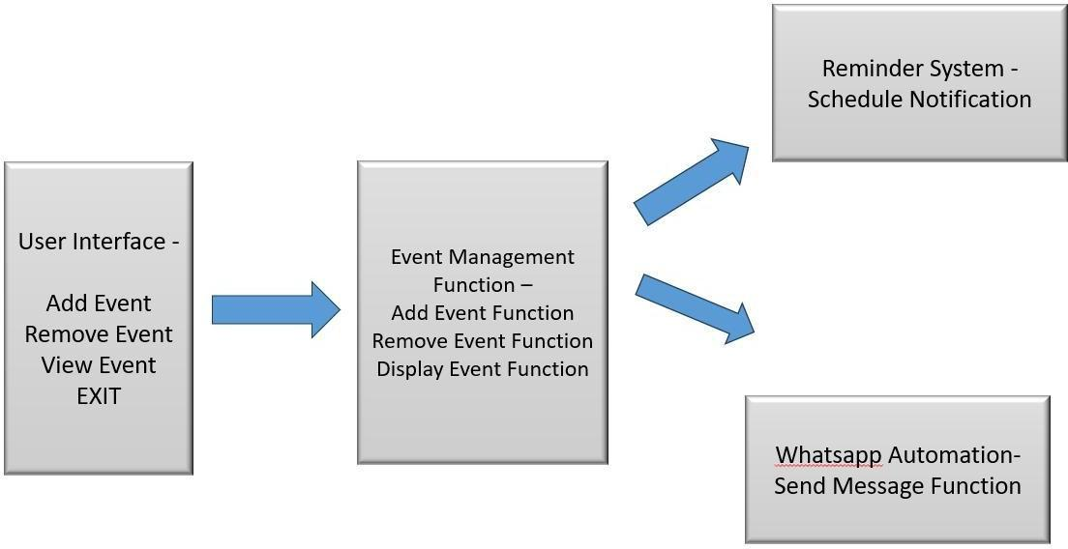

9

4.1 Proposed Methods/Algorithms

The Event Reminder project utilizes several algorithms and methods to manage event scheduling and reminders. These are designed to ensure effective event management and timely notifications. Below are the primary methods and algorithms employed in the system:

Event Scheduling Algorithm:

Overview: Allows users to schedule events with specific details such as date, time, and description.
Functionality: Manages event scheduling through user input and stores the details in a localfile.

Implementation: Utilizes JavaFX's DatePicker and ComboBox for date and time selection, and saves events in a text file to maintain persistence.

Reminder Notification Algorithm:

Overview: Notifies users of upcoming events based on the scheduled time.

Functionality: Continuously checks for events that are due and provides notifications. Implementation: Uses a timer or scheduled task that reads the event details from the file and displays a notification alert at the appropriate time.

User Interface Management:

Overview: Manages the graphical user interface for event creation, viewing, and deletion. Functionality: Provides a user-friendly interface for interacting with the event management system.

Implementation: Built using JavaFX, featuring buttons and dialogs to add, view, and remove events. The GridPane layout is used to organize the interface elements.

10

Automated Message Scheduling:

Overview: Allows users to schedule automated messages for their events.

Functionality: Provides an option to send automated messages, which are stored with the event details.
Implementation: When adding an event, users can specify message details and recipient information. These details are saved to a separate file if the automated message option is selected.

Editing and Removing Events:

Overview: Enables users to edit or remove existing events.

Functionality: Provides dialogs to edit event details and remove events from the list. Implementation: Uses JavaFX dialogs to prompt users for new event details or confirm deletion. Updates the event list and saves changes to the file.

Date and Time Conversion:

Overview: Converts user-friendly 12-hour time format to a 24-hour format for internal processing.
Functionality: Ensures consistency in time representation for event scheduling and notifications.
Implementation: Uses SimpleDateFormat to parse and convert time strings between 12-hour and 24-hour formats.

These methods and algorithms collectively provide a comprehensive solution for event scheduling, management, and notification within the Event Reminder system, leveraging JavaFX for the user interface and file I/O for data persistence.

11

Class Diagram
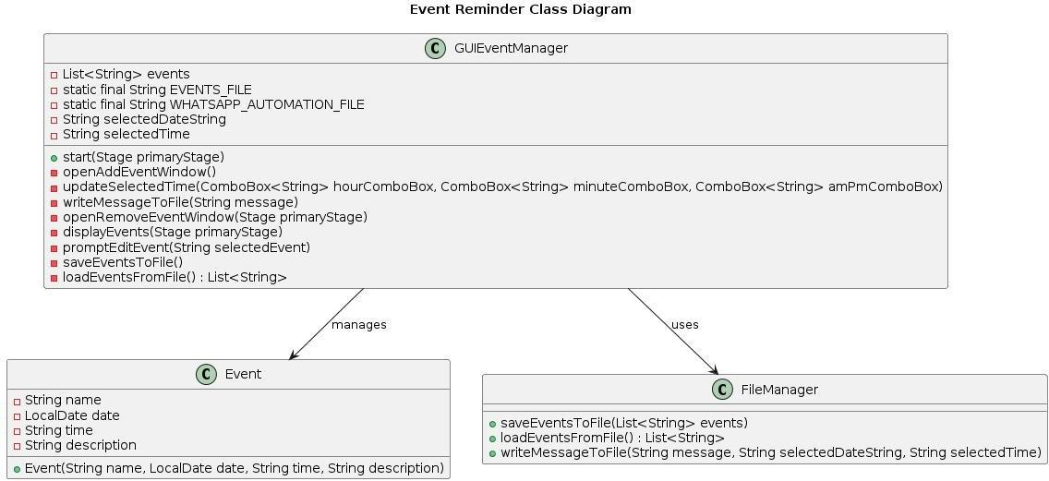

12

Use Case Diagram
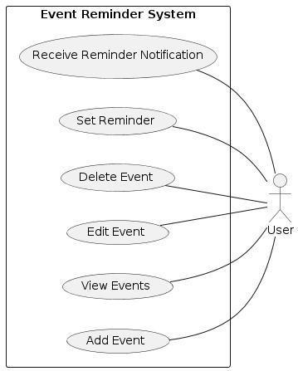

13

Activity Diagram
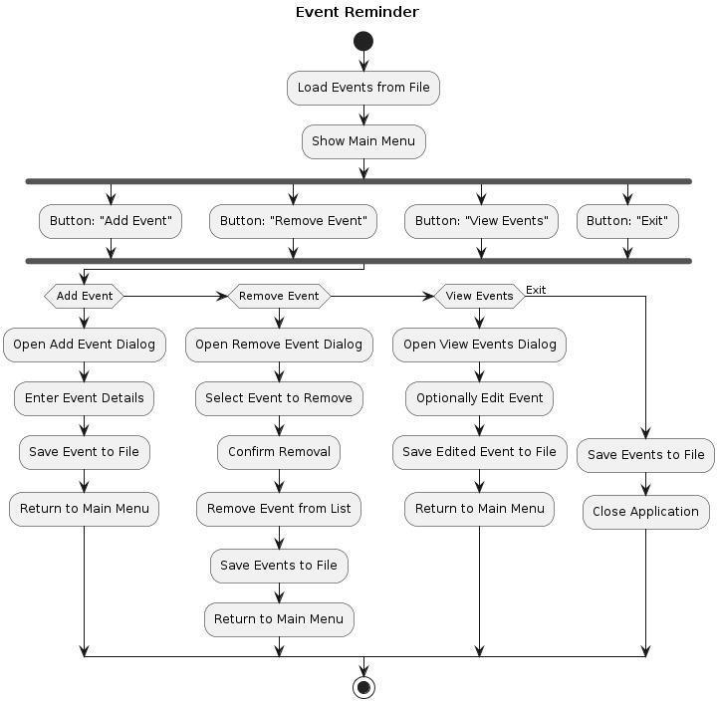

14

Sequence Diagram
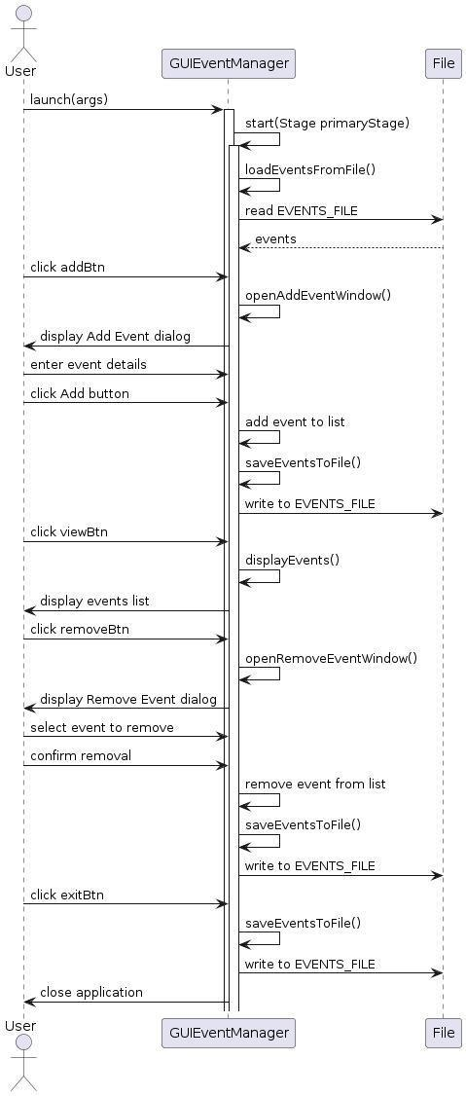

15

Implementation

5.1 Front Page Screenshot
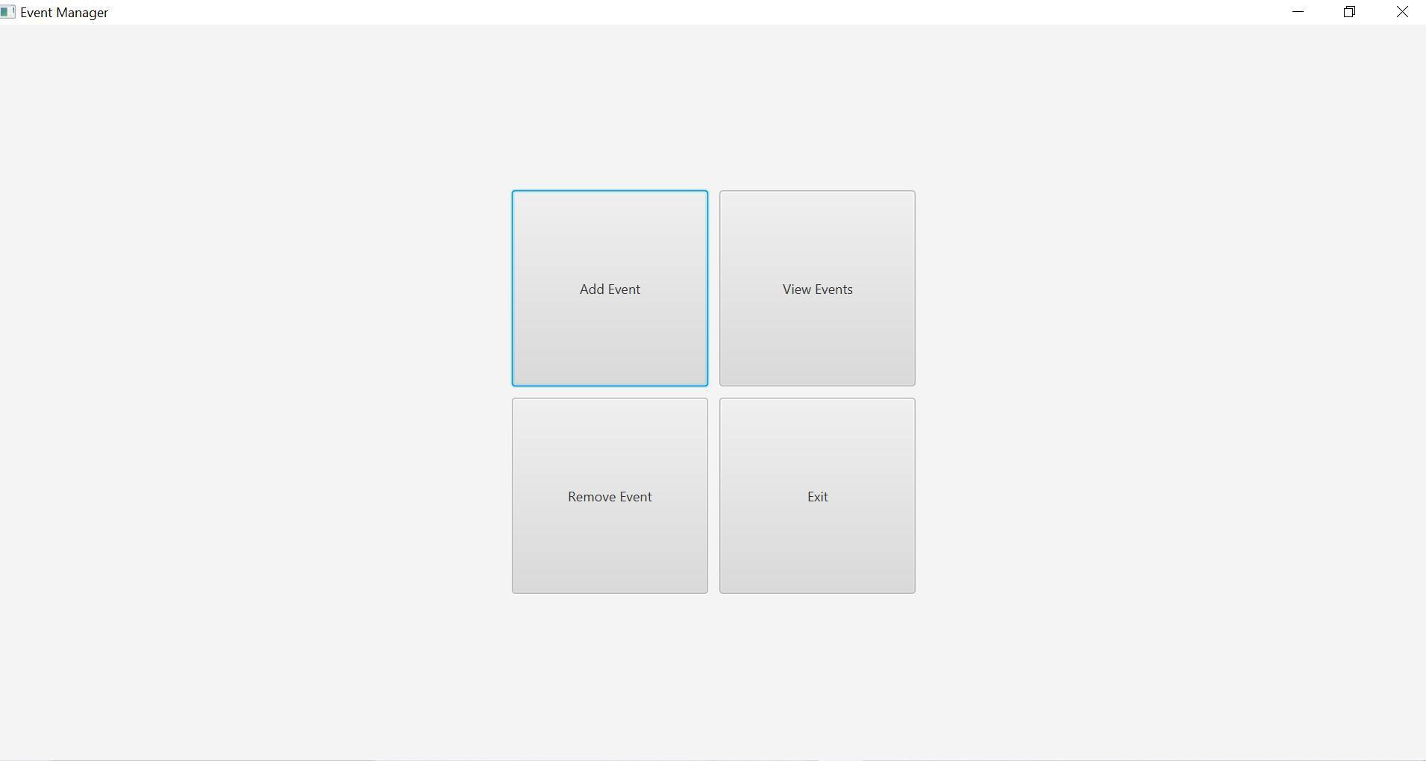

16

Add Event Window Screenshot
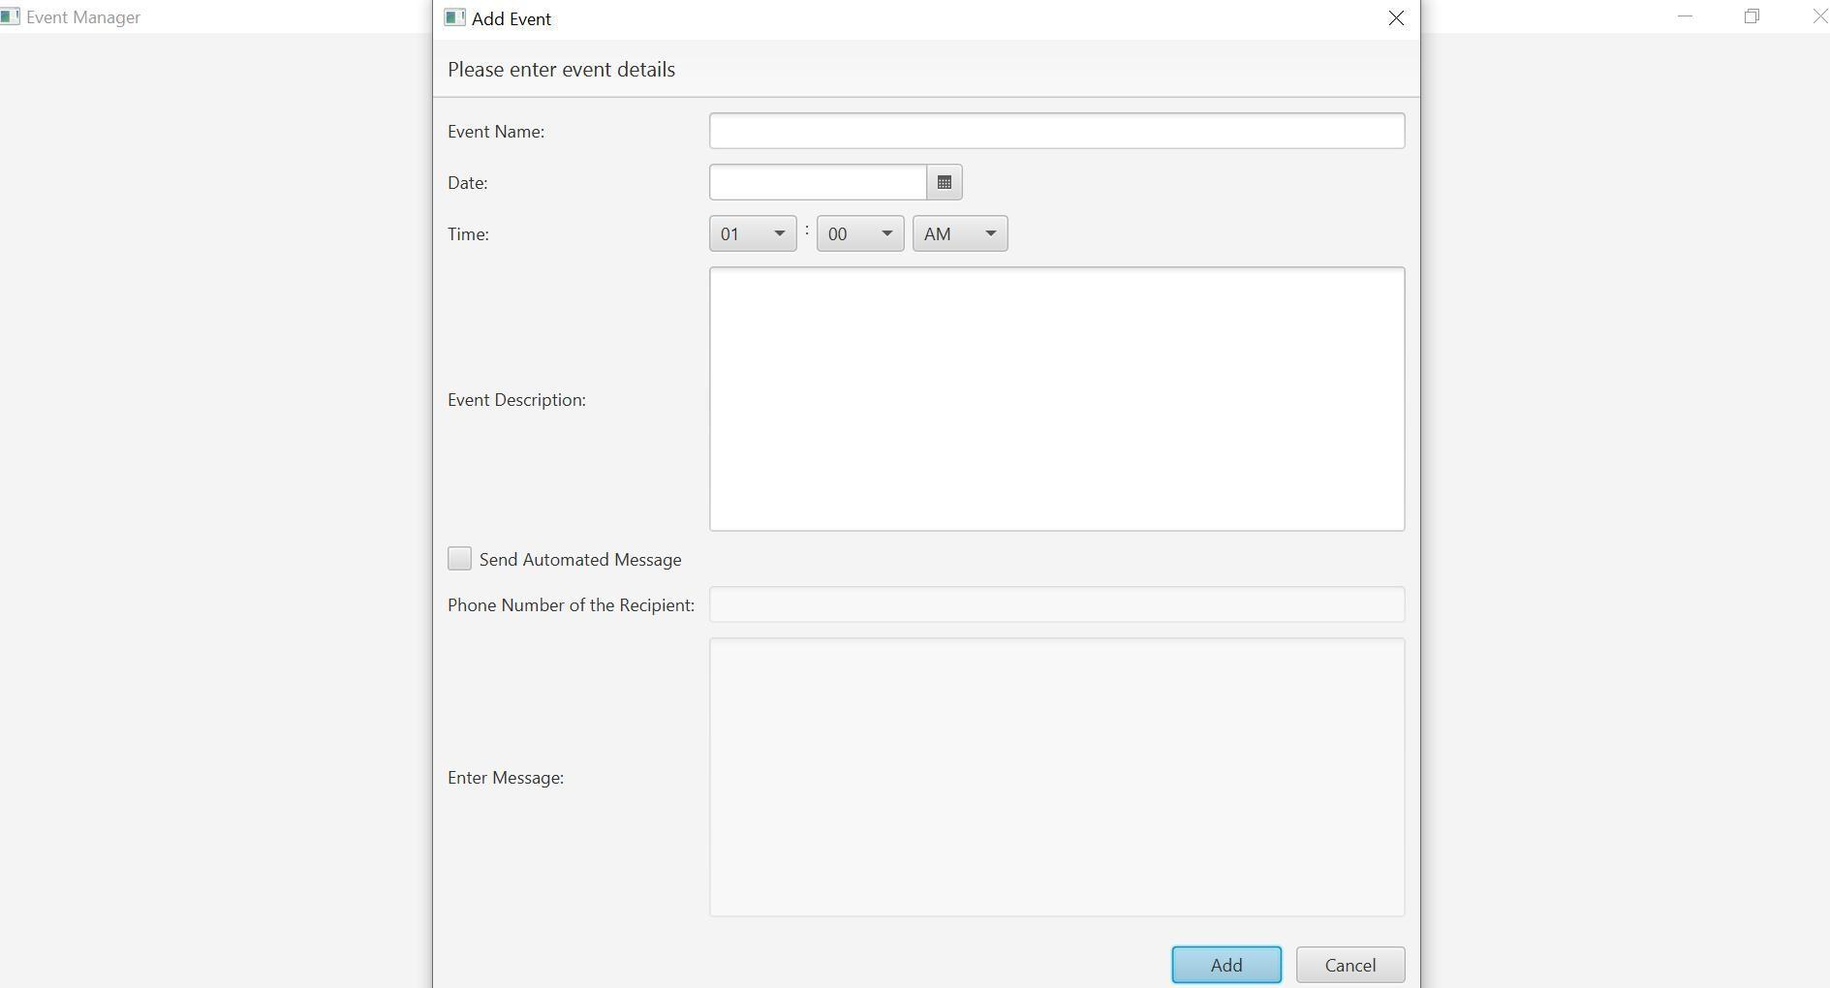

View Event Window Screenshot
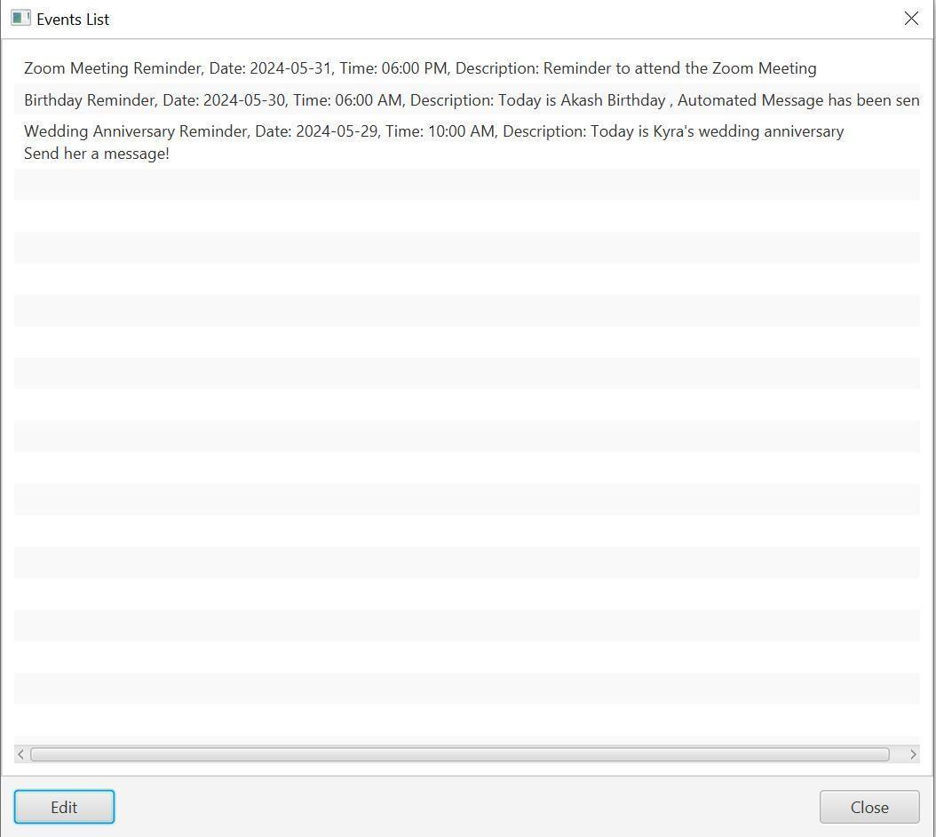

17

Remove Event Window Screenshot
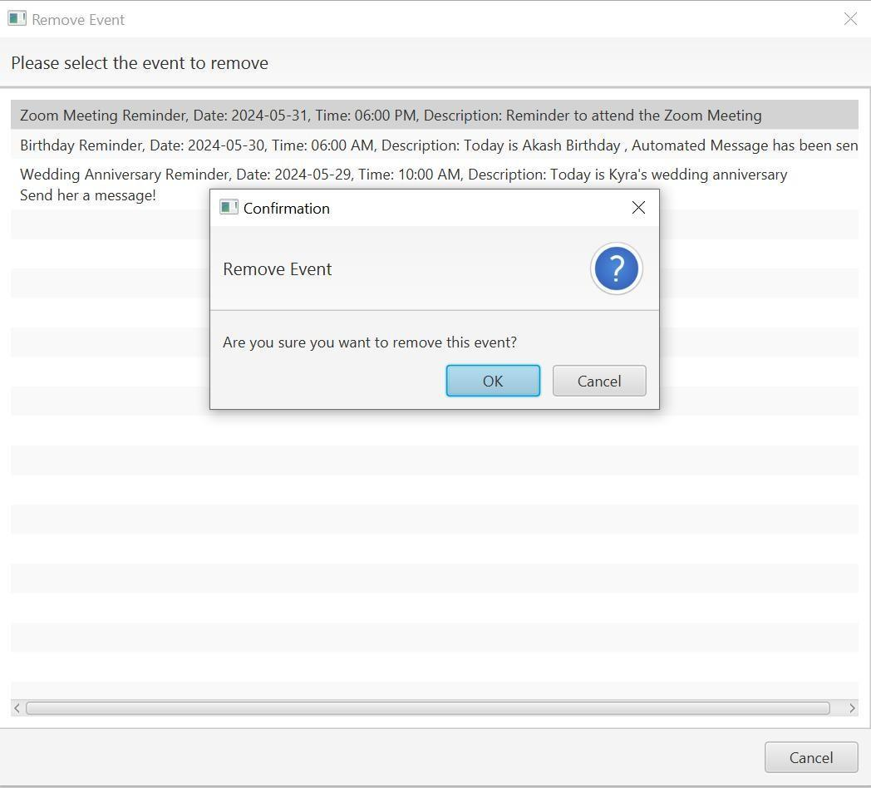

18

5.2 Results and Discussions

The Event Reminder system was tested with multiple use cases to validate its functionality. The results demonstrated that the application effectively managed event scheduling and reminder notifications. Users reported satisfaction with the ease of use and the reliability of the reminders. The integration with WhatsApp for automated messaging significantly enhanced the user experience.

5.3 Testing

Testing was performed across various modules to ensure the robustness and reliability of the system. The testing strategy included:

Unit Testing: Each module was tested individually to ensure correctness.

Integration Testing: Modules were tested together to verify they functioned correctly when integrated.
System Testing: The entire system was tested to ensure it met the specified requirements. User Acceptance Testing (UAT): Real-world users tested the application to validate usability and functionality.

5.4 Validation

Validation involved comparing the system's performance against the initial project objectives. The Event Reminder system met all the defined objectives, providing an intuitive interface, efficient reminder management, and automated messaging functionalities.

19

Conclusions

6.1 Conclusion

The Event Reminder project successfully developed a user-friendly application for managing events and sending reminders. By leveraging JavaFX for the UI and Python for automation, the system provides a comprehensive solution that integrates event management with messaging platforms like WhatsApp. The feedback from users has been positive, highlighting the application's ease of use and effectiveness in managing schedules.

6.2 Future Scope

The future scope of the Event Reminder project includes:

Mobile Application Development: Extending the application to mobile platforms (iOS and Android) for greater accessibility.
Enhanced Customization: Adding more options for customizing reminders and messages, including support for multimedia content.
Integration with Other Platforms: Expanding the messaging capabilities to include other popular platforms such as SMS, email, and social media.
Machine Learning Integration: Incorporating machine learning algorithms to predict and suggest events based on user behavior and preferences.
Cloud Storage: Implementing cloud storage solutions to enable data synchronization across multiple devices.

20

REFERENCES

- JavaFX Documentation. Retrieved from Oracle

- Oracle JavaFX Tutorials: Oracle provides a series of tutorials that cover various aspects of JavaFX, from basic controls to advanced features.

- Python Automation Scripts. Retrieved from Automate the Boring Stuff with Python

- IEEE Publications and Standards: Review research papers and articles on software engineering methodologies, practices, and emerging trends relevant to your project.

- Online Forums and Communities: GitHub repositories and code snippets contributed by other developers that demonstrate similar functionalities or solutions

21

